SVKM’s NMIMS
MPSTME/School of Technology Management & Engineering,
Computer Engineering Department
Program: MBA Tech/BTECH. Sem IV

Design and Analysis of Algorithms
LAB Manual
PART A
(PART A: TO BE REFERRED BY STUDENTS)
Experiment No.07
A.1 Aim:
Implementation and Analysis of Dynamic Approach Design paradigm-through Longest Common Subsequence problem. Find the longest common subsequence among the two given strings X [1 . . . m] and y [1 . . . n].
A.2 Prerequisite:
1. Knowledge of Array Handling and
2. Concept of Dynamic Approach.
3. Knowledge of recursive programming.
A.3 Outcome:
After successful completion of this experiment students will be able to,

- Understanding the dynamic programming strategy significance
- Analyse the time and space complexities of the dynamic programming approach for the LCS problem
- With Implementation finds the longest common subsequence of the given two strings.

A.4 Theory:
Given two sequences X[1 . . m] and Y[1 . . n], find a longest subsequence common to them both.
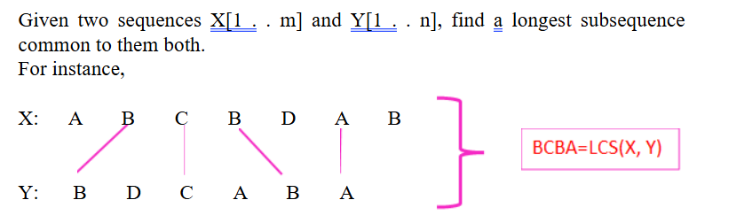

Brute-force LCS algorithm
Check every subsequence of X [1…m] to see if it is also a subsequence of Y[1 . . n].
Analysis

- Checking = O (n) time per subsequence.
- 2m2m
Sub-sequences of X (each bit-vector of length m determines a distinct subsequence of (x).
- Worst-case running time = O(n∗2^{m})
= exponential time.

Towards a better algorithm Simplification: Dynamic programming based LCS
1. Look at the length of a longest-common subsequence.
2. Extend the algorithm to find the LCS itself
Strategy: Consider prefixes of X and Y.
• Define c [i, j] = | LCS(X [1 . . i], Y[1 . . j])|.
• Then, c [m, n] = | LCS(X, Y)|.
Recursive formulation
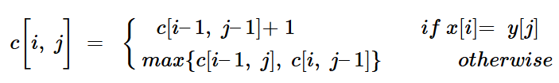
For instance:
If x and y values are equal then
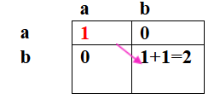
Otherwise
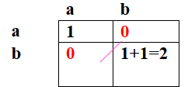
Max of these two locations.
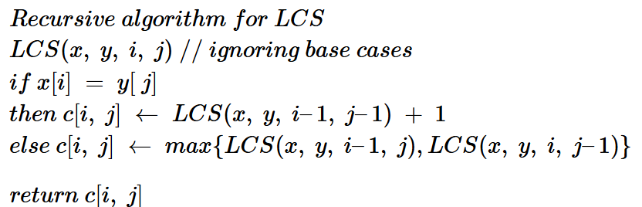
LCS Bottom Approach

LCS-Length(X, Y)
1. m = length(X) // get the # of symbols in X
2. n = length(Y) // get the # of symbols in Y
3. for i = 1 to m c[i,0] = 0 // special case: Y₀
4. for j = 1 to n c[0,j] = 0 // special case: X₀
5. for i = 1 to m // for all X_{i}
6. for j = 1 to n // for all Y_{j}
7. if ( X_{i} == Y_{j} )
8. c[i,j] = c[i-1,j-1] + 1
9. else c[i,j] = max( c[i-1,j], c[i,j-1] )
10. return c

Numerical based example:
X = ABCB; m = |X| = 4
Y = BDCAB; n = |Y| = 5
Allocate array c[5,4]
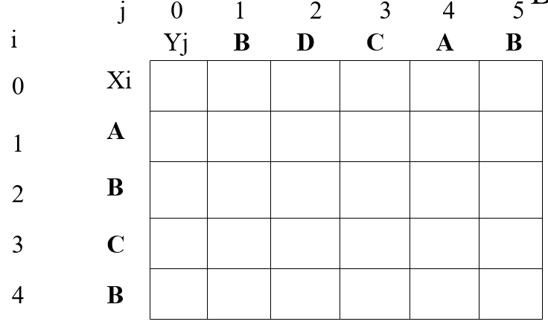
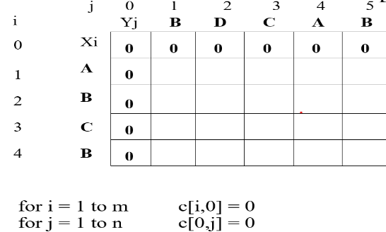
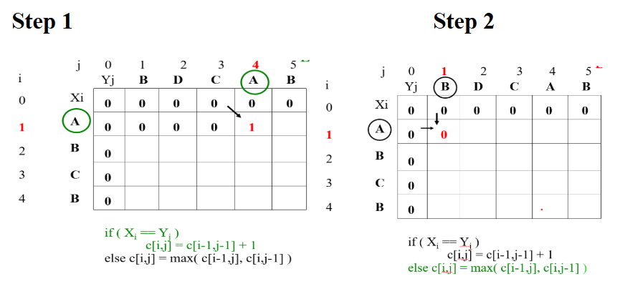

Step 3
Repeat step 1 and 2 to fill all the elements in matrix
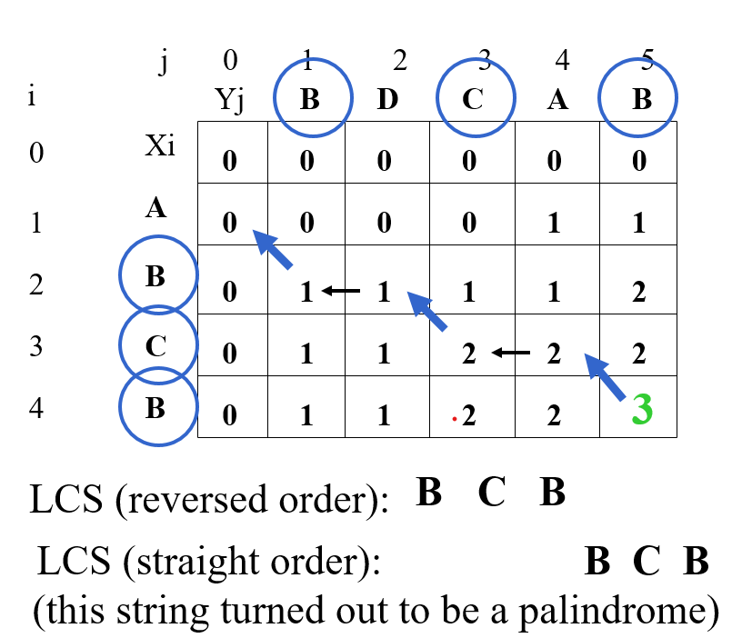

PART B
(PART B : TO BE COMPLETED BY STUDENTS)
(Students must submit the soft copy as per following segments within two hours of the practical.
The soft copy must be uploaded on the Portal.)

Program: BTI | Sem: VIII
Roll No. C172 | Name:Parva Gaglani
Division: D | Batch : D2
Date of Experiment: | Date of Submission:
Grade :

B.1 Software Code written by student:
(Paste your code completed during the 2 hours of practical in the lab here)
1.brute force lcd
#include <iostream>
#include <string>
using namespace std;

int main() {
string X, Y;
cin >> X >> Y;

int m = X.length();
int n = Y.length();

int dp[1001][1001];

for (int i = 0; i <= m; i++)
for (int j = 0; j <= n; j++)
dp[i][j] = 0;

for (int i = 1; i <= m; i++) {
for (int j = 1; j <= n; j++) {
if (X[i - 1] == Y[j - 1])
dp[i][j] = dp[i - 1][j - 1] + 1;
else if (dp[i - 1][j] > dp[i][j - 1])
dp[i][j] = dp[i - 1][j];
else
dp[i][j] = dp[i][j - 1];
}
}

int i = m, j = n;
string lcs = "";

while (i > 0 && j > 0) {
if (X[i - 1] == Y[j - 1]) {
lcs = X[i - 1] + lcs;
i--;
j--;
} else if (dp[i - 1][j] > dp[i][j - 1]) {
i--;
} else {
j--;
}
}

cout << lcs;
return 0;
}
2.dynamic programming lcs
#include <iostream>
#include <string>
using namespace std;

int main() {
string X, Y;
cin >> X >> Y;

int m = X.length();
int n = Y.length();

int c[1001][1001];

for (int i = 0; i <= m; i++)
c[i][0] = 0;

for (int j = 0; j <= n; j++)
c[0][j] = 0;

for (int i = 1; i <= m; i++) {
for (int j = 1; j <= n; j++) {
if (X[i - 1] == Y[j - 1])
c[i][j] = c[i - 1][j - 1] + 1;
else if (c[i - 1][j] > c[i][j - 1])
c[i][j] = c[i - 1][j];
else
c[i][j] = c[i][j - 1];
}
}

cout << c[m][n];
return 0;
}

B.2 Input and Output:
(Paste your commented program input and output in following format, If there is error then paste
the specific error in the output part. In case of error with due permission of the faculty extension
can be given to submit the error free code with output in due course of time.)

1.brute force lcd
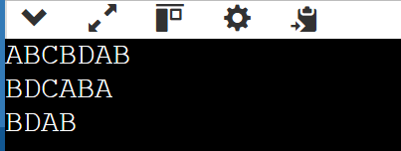
2.dynamic programming lcs
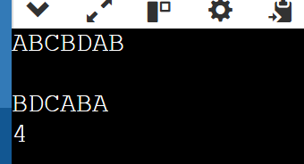
B.3 Observations and learning:
(Students are expected to comment on the output obtained with clear observations and learning for each task/ sub part assigned)
From the above two LCS codes, the key observation is that dynamic programming avoids the exponential time complexity of the recursive/brute-force approach by storing intermediate results in a 2D table and building the solution bottom-up using the recurrence relation ( c[i][j] = c[i-1][j-1] + 1 ) when characters match, otherwise ( \max(c[i-1][j], c[i][j-1]) ). The first code reconstructs the actual LCS string by backtracking through the DP table, while the second code computes only the length of the LCS, making it slightly simpler and more memory-efficient in logic. The main learning is that breaking a problem into overlapping subproblems and storing their results (memoization/tabulation) significantly reduces time complexity from exponential to (O(m \times n)), and understanding the recurrence relation is crucial to correctly implementing dynamic programming solutions.

B.4. Practice Questions:
- Implement and analyze the time and space complexity of the longest common subsequence problem through the dynamic approach.
- Find the longest common subsequence’s for below given input strings and compare your solution with output of above code.
- X= [E, B, T, B, C, A, D, F] and Y= [A, B, B, C, D, G, F]
- X= [A, B, C, B, D, A, B] and Y= [B, D, C, A, B, A]
- X=your name and Y= your best friend's name

Solution:
1.
In the dynamic programming approach, we construct a 2D table of size ((m+1) \times (n+1)), where (m) and (n) are the lengths of strings X and Y.
- Time Complexity:
We fill each cell of the table once using constant-time operations.
Therefore,
[
T(m,n) = O(m \times n)
]
- Space Complexity:
We store a 2D array of size ((m+1)(n+1)).
[
S(m,n) = O(m \times n)
]
Thus, dynamic programming reduces the exponential complexity of the recursive solution to polynomial time.

2.

(a)
X = [E, B, T, B, C, A, D, F]
Y = [A, B, B, C, D, G, F]
LCS = B, B, C, D, F
Length = 5

(b)
X = [A, B, C, B, D, A, B]
Y = [B, D, C, A, B, A]
LCS = B, C, A, B
Length = 4
(Another valid LCS is possible depending on reconstruction order, but length remains 4.)

(c)
X = COMPUTER
Y = KEYBOARD
Common letters: O, E, R
LCS = O, R
Length = 2

B.5 Conclusion:
B.6 Question of Curiosity
(To be answered by student based on the practical performed and learning/observations)
- How to find the longest palindromic sequence in a given string through LCS.
- Enlist the solution approaches to find the longest common sequences.

1.
The Longest Palindromic Subsequence of a string can be found by using the LCS concept. The idea is:
- Take the original string S.
- Create another string R, which is the reverse of S.
- Find the LCS of S and R using dynamic programming.
Since a palindrome reads the same forward and backward, the longest common subsequence between the string and its reverse will be the longest palindromic subsequence.
Time Complexity: O(n²)
Space Complexity: O(n²)
Example:
S = "BBABCBCAB"
Reverse(S) = "BACBCBABB"
LCS = "BABCBAB" (Longest Palindromic Subsequence)

2.
- Brute Force Approach
Generate all subsequences of one string and check if they are present in the other.
Time Complexity: O(2ⁿ) (Exponential)
- Recursive Approach
Use the recursive relation:
  - If characters match → move diagonally
  - Else → take maximum of left and top
Time Complexity: O(2ⁿ)
- Memoization (Top-Down DP)
Store previously computed results to avoid recomputation.
Time Complexity: O(m × n)
- Tabulation (Bottom-Up DP)
Build a DP table iteratively.
Time Complexity: O(m × n)
Space Complexity: O(m × n)
- Space Optimized DP
Use two 1D arrays instead of a full 2D table.
Space Complexity: O(min(m, n))

************************

