SVKM’s NMIMS
MPSTME/School of Technology Management & Engineering,
Computer Engineering Department
Program: MBA Tech / B Tech Semester - IV

Design and Analysis of Algorithms
LAB Manual
PART A
(PART A: TO BE REFERRED BY STUDENTS)
Experiment No.03
A.1 Aim:
In this lab we are implementing problems on Divide & Conquer Algorithm Design paradigm.
Task 1: Show the working of Merge sort on following numbers
3; 41; 52; 26; 38; 57; 9; 49
Task2: Write a program to implement Merge sort Algorithm using divide and conquer approach
(Properly commented code with proper variable names)
Problem Statement:
College would like to prepare the merit list based on CET score of the students. In order to do that they read the data of n number of students with Name, CET score, 12th Percentage. Apply recursive merge sort algorithm to prepare the merit list, where highest test score will appear at the top (list will be in decreasing order of the CET score). Analyze your program for time and space complexity.

A.2 Prerequisite:
1. Knowledge of Array Handling and
2. Concept of divide and conquer paradigm
3. Knowledge of recursive programming

A.3 Outcome:
After successful completion of this experiment students will be able to
- Understand the concept of divide and conquer paradigm with the help of Merge sort Algorithm
- Write complex program based on recursion

A.4 Theory:
A.4.1.
Divide & Conquer Paradigm:

- Given a function to compute on n inputs, the divide-and-conquer strategy consists of:
  - splitting the inputs into k distinct subsets, 1<k≤n, yielding k subproblems.
  - solving these subproblems
  - combining the subsolutions into solution of the whole.
  - if the subproblems are relatively large, then divide_Conquer is applied again.
  - if the subproblems are small, they are solved without splitting.

The Divide and Conquer Abstraction:

Divide_Conquer(problem P)
{
if Small(P) return S(P);
else {

divide P into smaller instances P₁, P₂, …, P_{k}, k≥1;

Apply Divide_Conquer to each of these subproblems;

return Combine(Divide_Conque(P₁), Divide_Conque(P₂),…, Divide_Conque(P_{k}));
}
}

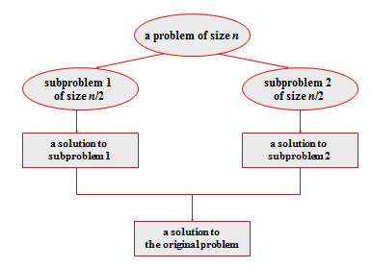
Figure 1: Divide & Conquer Technique

It divides the input array into two halves, calls itself for the two halves, and then merges the two sorted halves. The merge() function is used for merging two halves. The merge(arr, l, m, r) is a key process that assumes that arr[l..m] and arr[m+1..r] are sorted and merges the two sorted sub-arrays into one

MergeSort(arr[], l, r)
If r > l
1. Find the middle point to divide the array into two halves:
middle m = l+ (r-l)/2
2. Call mergeSort for first half:
Call mergeSort(arr, l, m)
3. Call mergeSort for second half:
Call mergeSort(arr, m+1, r)
4. Merge the two halves sorted in step 2 and 3:
Call merge(arr, l, m, r)

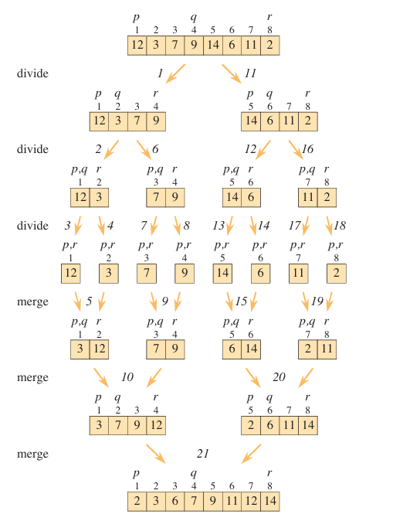
PART B
(PART B : TO BE COMPLETED BY STUDENTS)
(Students must submit the soft copy as per following segments within two hours of the practical.
The soft copy must be uploaded on the Portal.)

Program: BTI CE | Sem: 8
Roll No. C172 | Name: Parva Gaglani
Division: D2 | Batch :D2
Date of Experiment: 19/1/2026 | Date of Submission: 19/1/2026
Grade :

B.1 Software Code written by student:
(Paste your code completed during the 2 hours of practical in the lab here)
Task 1:
Given numbers:
3, 41, 52, 26, 38, 57, 9, 49
Divide Phase:
3, 41, 52, 26 and 38, 57, 9, 49
Each half is further divided:
3, 41 and 52, 26 and 38, 57 and 9, 49
3 and 41 and 52 and 26 and 38 and 57 and 9 and 49
Merge Phase
Single elements are merged in sorted order:
3, 41
26, 52
38, 57
9, 49
Next:
3, 26, 41, 52
9, 38, 49, 57
Final merge:
3, 9, 26, 38, 41, 49, 52, 57
Final Sorted List
3, 9, 26, 38, 41, 49, 52, 57
Task 2:
#include <iostream>
#include <string>
using namespace std;
struct Student {
string name;
int cetScore;
float percentage;
};

void merge(Student students[], int left, int mid, int right) {
int leftSize = mid - left + 1;
int rightSize = right - mid;
Student leftArray[leftSize];
Student rightArray[rightSize];

for (int i = 0; i < leftSize; i++)
leftArray[i] = students[left + i];

for (int j = 0; j < rightSize; j++)
rightArray[j] = students[mid + 1 + j];

int i = 0, j = 0, k = left;
while (i < leftSize && j < rightSize) {
if (leftArray[i].cetScore > rightArray[j].cetScore) {
students[k] = leftArray[i];
i++;
} else {
students[k] = rightArray[j];
j++;
}
k++;
}

while (i < leftSize) {
students[k] = leftArray[i];
i++;
k++;
}

while (j < rightSize) {
students[k] = rightArray[j];
j++;
k++;
}
}
void mergeSort(Student students[], int left, int right) {
if (left < right) {
int mid = left + (right - left) / 2;

mergeSort(students, left, mid);
mergeSort(students, mid + 1, right);

merge(students, left, mid, right);
}
}

int main() {
int n;
cout << "Enter number of students: ";
cin >> n;
Student students[n];
for (int i = 0; i < n; i++) {
cout << "\nEnter details of student " << i + 1 << endl;
cout << "Name: ";
cin >> students[i].name;
cout << "CET Score: ";
cin >> students[i].cetScore;
cout << "12th Percentage: ";
cin >> students[i].percentage;
}
mergeSort(students, 0, n - 1);
cout << "\nMerit List (Descending Order of CET Score):\n";
for (int i = 0; i < n; i++) {
cout << students[i].name << " "
<< students[i].cetScore << " "
<< students[i].percentage << endl;
}
return 0;
}
B.2 Input and Output:
(Paste your commented program input and output in following format, If there is error then paste
the specific error in the output part. In case of error with due permission of the faculty extension
can be given to submit the error free code with output in due course of time.)
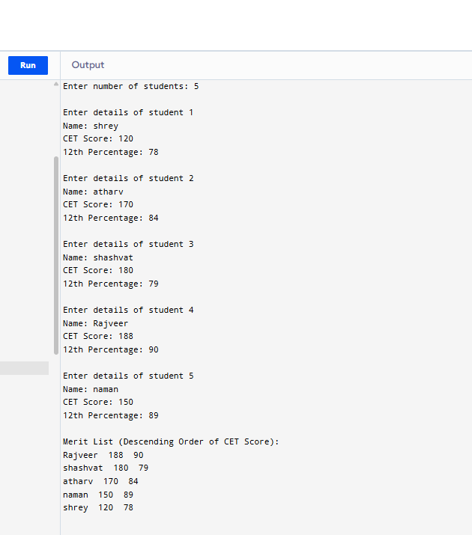
Time Complexity Analysis
- Best Case: O(n log n)
- Average Case: O(n log n)
- Worst Case: O(n log n)
Space Complexity Analysis
- O(n)
B.3 Observations and learning:
(Students are expected to comment on the output obtained with clear observations and learning for each task/ sub part assigned)
B.4. Practice Questions:
Perform Time and Space Complexity Analysis of Merge Sort.
1. Time Complexity
Step 1: Divide
Each time, the array is divided into two halves.
Number of levels of division = log₂(n), because we divide by 2 each time.
Step 2: Merge
Merging two halves takes O(n) time at each level because each element is compared and copied.
Step 3: Total Time
There are log₂(n) levels of division.
Each level takes O(n) time to merge.
Time Complexity=O(nlogn)
2. Space Complexity
Merge Sort uses temporary arrays to store the left and right halves during merging.
For an array of size n, total extra space needed is O(n).
Space Complexity=O(n)
B.5 Conclusion:
(Students must write the conclusion as per the attainment of individual outcome listed above and learning/observation noted in section B.3)
Merge Sort is suitable for large, unpredictable, or linked datasets where stability and consistent performance are important.

B.6 Question of Curiosity
(To be answered by student based on the practical performed and learning/observations)

- When does the worst case occur in Merge Sort?
Merge Sort always divides the array into halves and merges them. It does the same number of comparisons regardless of the input arrangement. Therefore, the worst case occurs for all input datasets. The time complexity in the worst case is O(n log n).
- What types of datasets work best for Merge Sort?
Merge Sort works well for all types of datasets, whether already sorted, reverse sorted, or random order. It is particularly effective for large datasets, linked lists because it can sort them without extra space, and external sorting such as sorting data stored on disk.
- How can we make Merge Sort more efficient?
Some ways to optimize Merge Sort include using insertion sort for small subarrays because insertion sort is faster on small datasets, avoiding repeated copying of arrays by using indices and a single temporary array, and using iterative (bottom-up) merge sort to reduce recursion overhead.
- How is Merge Sort different from Insertion Sort?
Merge Sort uses divide and conquer, whereas Insertion Sort picks one element at a time and inserts it into the correct position. Merge Sort has a time complexity of O(n log n) while Insertion Sort has a best case of O(n) and worst case of O(n²). Merge Sort requires extra space O(n) while Insertion Sort is in-place with O(1) space. Both are stable. Merge Sort is best for large datasets and external sorting, while Insertion Sort is better for small or nearly sorted datasets.
- When to use Merge Sort instead of other algorithms?
Merge Sort is preferred when guaranteed O(n log n) performance is required, when a stable sort is needed, for sorting linked lists efficiently without extra space, for external sorting on large files that cannot fit into memory, and for very large datasets where other algorithms like quick sort may have worst-case issues.

**********************

