Event Driven and UI Programming
Lab – 1
Aim:
- Study and understand the concept of event-driven programming and list down the different events along with their functions.
- Create a small GUI that contains a dialogue box with two buttons – yes and no
- Create a GUI for simple calculator showing all the operations as +, -, * and /
Contents:
A: Read and understand the concepts in event-driven programming with tools and functions that are used in creating the events. Write a one-page summary containing the concept, list of events (any 10), and tools that can be used.
B: Write a code using python/java/C++ to create a GUI that contains two buttons yes and no. The sample GUI (created in Tkinter) is shown below.
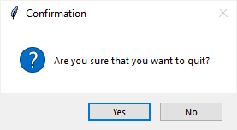

C. Write a code for Simple calculator to with addition subtraction multiplication and division. Student can use any programming language for creating the GUI. The layout of screen should include all the number buttons and operators as well as a small screen for output.
Sample output is shown below for reference:
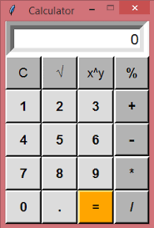
Questions:
- Explain any 2 features of Event-Driven programming.
- Write down pros and cons in event driven programming
A.
Event-Driven Programming: Concept, Events, and Tools
Concept: Event-driven programming is a paradigm where program execution is determined by events like user actions, system signals, or messages. The program listens for events and triggers corresponding handlers to respond, enabling asynchronous and responsive behavior. It is commonly used in GUIs, real-time systems, and web applications.
Key Features:
- Event Listeners: Detect events.
- Event Handlers: Execute responses.
- Event Loop: Manages event dispatching.
- Modular Design: Decouples components for flexibility.
Examples of Events:
- Mouse click
- Key press
- Window resize
- Button hover
- File upload
- Timer expiration
- Form submission
- Network request
- Touch gesture
- Sensor input
Tools:
- JavaScript: For web interactions (e.g., DOM, jQuery).
- Node.js: Non-blocking I/O for server-side apps.
- Python (Tkinter): GUI applications.
- Java (Swing/JavaFX): Desktop applications.
- C# (WinForms/WPF): Windows apps.
- React.js: Synthetic event handling.
- Unity: Game development.
- Electron: Cross-platform desktop apps.
- Android SDK: Mobile app development.
- Qt: Cross-platform GUI framework.

B.
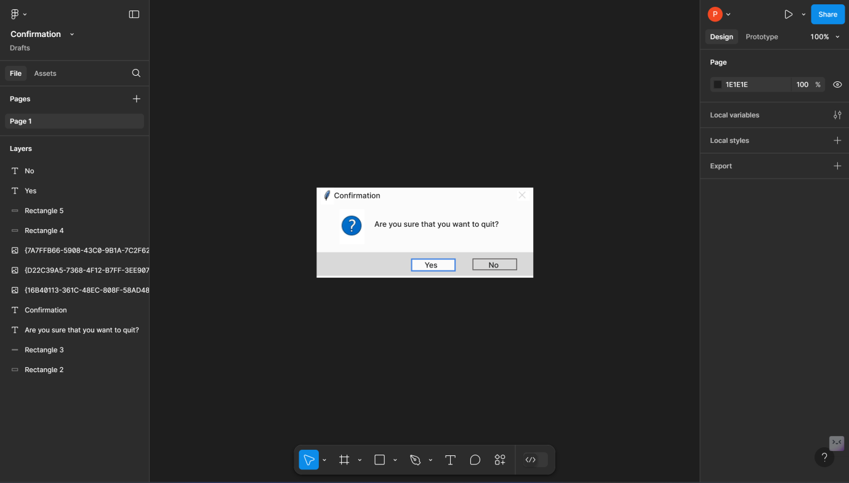
C.
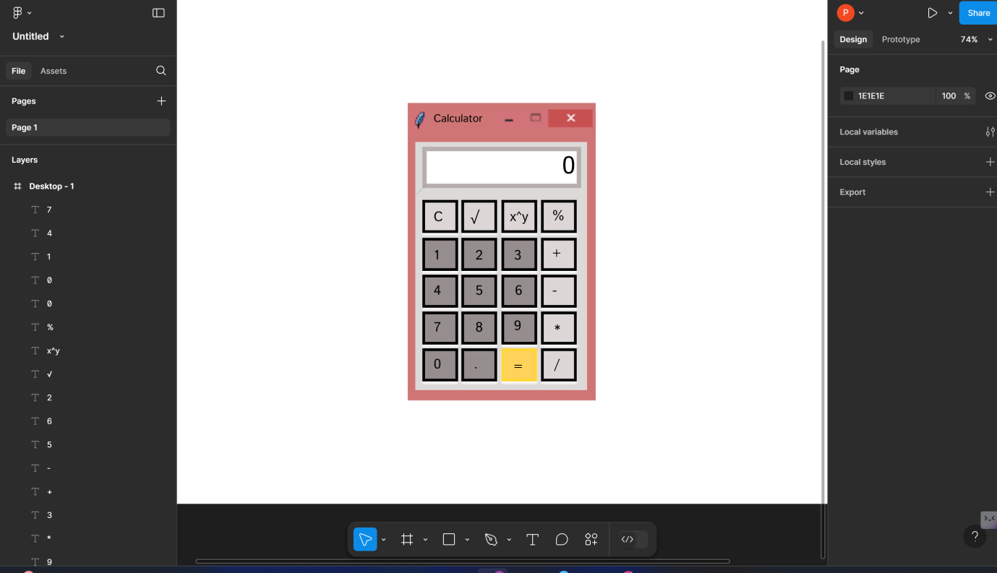

Questions:
1. Features of Event-Driven Programming
a. Event Handling:
In event-driven programming, the flow of the program is determined by events such as user actions (e.g., mouse clicks, key presses) or system-generated signals. Event handlers, which are functions or methods, are associated with these events. When an event occurs, its corresponding handler is triggered to perform a specific task. For example, clicking a button in a GUI triggers a function to execute.
b. Asynchronous Execution:
Event-driven programs often execute tasks asynchronously. This means that an event can be processed independently of the main program flow, allowing the system to remain responsive. For instance, a web server can handle multiple client requests simultaneously without waiting for one request to finish before starting another.

2. Pros and Cons of Event-Driven Programming

Pros:
- Responsive Programs:
Event-driven programs are highly interactive and can quickly respond to user inputs, making them ideal for graphical user interfaces (GUIs) and real-time applications.
- Modularity:
Event-driven programming encourages modular code, as event handlers are separate from the main program. This makes the code easier to maintain and extend.
- Flexibility:
It supports dynamic behaviors, enabling the program to react to unpredictable events, such as user actions or external signals.

Cons:
- Complexity:
Managing multiple events and their interactions can make the codebase complex and harder to debug, especially for large applications.
- Overhead:
Constantly listening for events can introduce performance overhead, as the system needs to monitor and manage event queues.
- Steeper Learning Curve:
Beginners may find it difficult to understand the asynchronous flow of event-driven programs compared to sequential programming.

