Event Driven and UI Programming
Lab – 3

Aim:
- Write a code to find the sum of all elements of an integer array
- Write a code to check the given year is leap year or not using conditional operator

Solutions:
A:
Code:
Imports System

ModuleProgram
SubMain(argsAsString())
Dim Sum AsInteger
Dimarr() AsInteger = {1, 2, 3, 4, 5}
ForEachitemAsIntegerInarr
Sum = Sum + item
Next

Console.WriteLine(Sum)

EndSub
EndModule

Output:
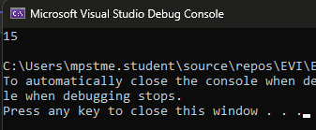
Explanation:
• Declare and Initialize Array: arr() holds integer values {1, 2, 3, 4, 5}.
• Loop through Array: For Each iterates through each element (item).
• Sum Calculation: Adds each item to Sum.
• Print Result: Console.WriteLine(Sum) displays the total sum.
B:
Code:
ModuleProgram
SubMain(argsAsString())

DimnumAsInteger

Console.WriteLine("Enter a year:")
num = (Console.ReadLine())

If (numMod 400 = 0) Or (numMod 4 = 0 AndnumMod 100 <> 0) Then
Console.WriteLine("It is a leap year")
Else
Console.WriteLine("It is not a leap year")
EndIf
EndSub
EndModule

Output:
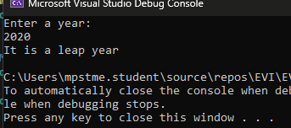
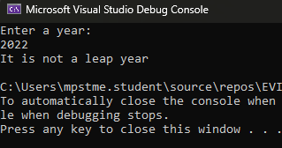
Explanation:
• Takes input from the user (year) and stores it in num.
• Checks leap year conditions:
- A year is a leap year if:
  - It is divisible by 400 (num Mod 400 = 0)
OR
  - It is divisible by 4 but not by 100 (num Mod 4 = 0 And num Mod 100 <> 0)
• Prints the result:
- If conditions are met → "It is a leap year"
- Otherwise → "It is not a leap year"

