Satsang 30/08/2026
Bessent v/s Kevin.
Treasuries v/s Fed.
To be clear, the “policy” of talking tough should be fully expected, while nothing he said changes the facts of 2+ Trillion deficits that MUST be financed and $40 Trillion in debt, with much needing refinancing. As the treasury secretary stated, the ONLY way out is GROWTH; I continue to state there is hardly a chance this Fed is going to be restrictive under these circumstances.
Warsh can talk tough on inflation.... He can't act tough.
- 1980 Debt/GDP: 31% vs 120% today
- Interest/tax receipts: 10% vs 21% today
- Deficit/GDP: 2.6% vs 6.3% today
Today's fiscal position is much weaker than it was during the Volcker era. Warsh has 2 options:
1. Fight inflation and blow up the bond market.
2. Sacrifice the USD to save the bond market.
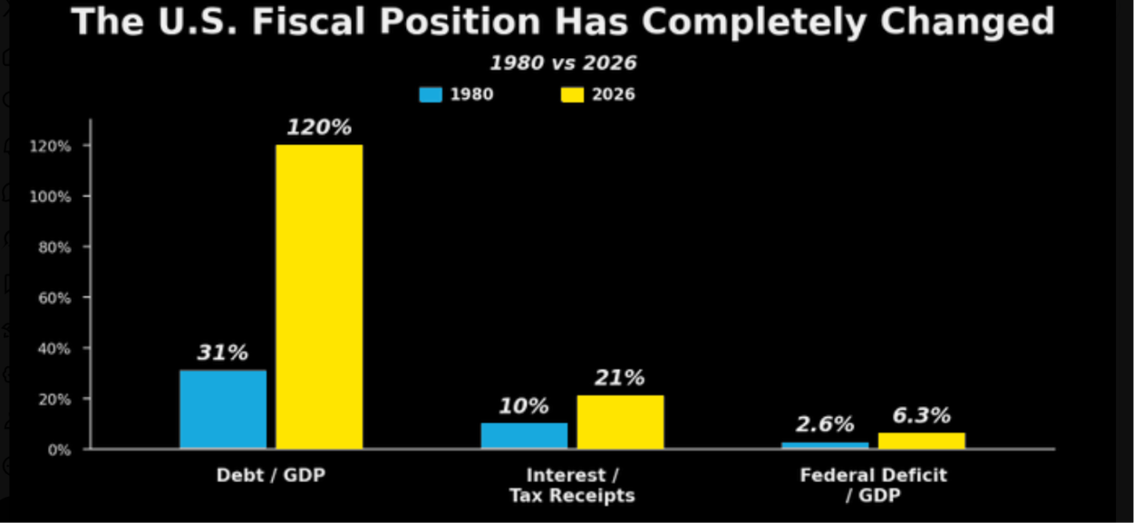
Let us shift our focus to Banana Patterns. It’s a beautiful site I explored last week & it should a site one should bookmark. It makes your life lot more easy.

NHC Foods: Let us focus on a very pertinent question raised with so much of equity dilution whether EPS is sustainable?
Weekly Ideas:
Quess corp , Cyient, Glaxosmithcline, Shyam metallics, Q Power
Morepan & Inox India should also be in radar.

