**ASSIGNMENT-01**

**Linux basic commands:**

1. **Which command is used to know the current working directory?**

**A: PWD-** Present Working directory is used to know the current working directory.

1. **How would you find out its contents?**

**A:** ll- to find the contents.

**3. Identify the commands with inputs to do the following**

**a. create a directory d1**

**b. create a subdirectory d2 in d1**

**c. change to directory d2**

**d. create an empty file “f1.txt”**

**e. display the contents of “f1.txt”**

**f. view the contents of d1 from current directory d2**

1. **Use the ls command with its options. How will you identify directories from the listing?**

**5. Use ls to do the following**

**a. List files with single character names.**

**b. List hidden files also. [ Note : Hidden files are files having name started with a “.” ]**

**c. Suppose there are files tb1.1, tb2.1, tb3.1, ….tb10.1. Write command to list all the files [Hint: use wild card characters]**

**A:** b. We use ls -a for hidden files.



c. We use ls tb*.1

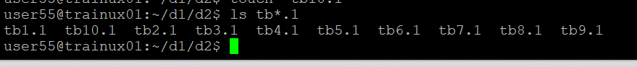

1. **Write the command to list all files in descending order of their size.**

**A: We use the command – ls -lS**

1. **Suppose there are files temp1, temp2, temp3. Write command to remove the files without listing them explicitly**

**A: rm temp\***

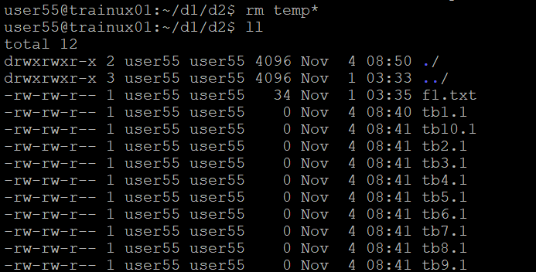

**8.Which command is used to list top few lines in the file?**

**A:** We use command called head to list top few lines in the file.

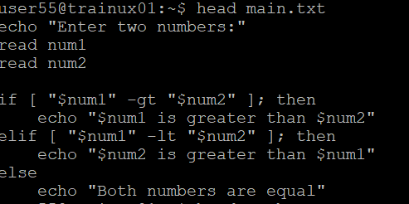

**9.Create a directory “testdir”.**

**A:** We use command called “mkdir”

**10. Use cp command to do the following**

**a. Copy the file tb1.1 (created above) in the same directory.**

**b. Write a command to copy all the files i.e tb1.1,tb2.1,tb3.1,…..tb10.1 in a new directory –“new”**

**A: command----** cp tb*.1 /destination path

**c. Create a subdirectory in new in named“new1”.**

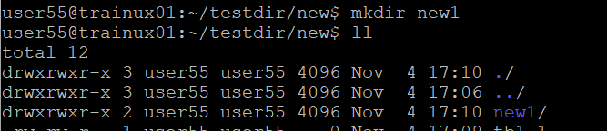

**d. Write a command to copy selectively only tb2.1, tb6.1, tb7.1 and tb10.1 in the directory new1.**

**A: command----** cp tb2.1 tb6.1 tb7.1 tb10.1 /destination path

**e. Write a command to copy the entire directory “new” to a directory “newprogs”. [Note : use the –R option of “cp” command ]**

**A: command---** cp -rf /source path/file name /destination path

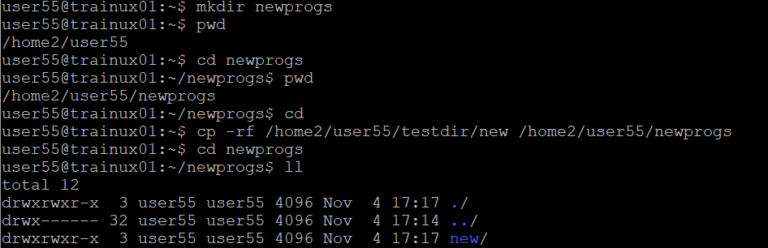

**11. Find out the difference between**

1. **]“mv” & “cp”**

**A: mv----**moves or renames the file or directories but the original file is deleted.

**cp**----create a copy of files or directories, the original file remains unchanged.

1. **“rm”, “rmdir”**

**A: rm---** It is used to remove files and directories.

**rmdir----** It is specifically used to remove empty directories.

1. **“mkdir” and “mkdir -p”**

**A: mkdir----**Creates a single directory; fails if any parent directories are missing or if the directory already exists.

**mkdir -p-----**Creates the directory and any necessary parent directories; does not fail if the directory already exists.

**12. Use a single command rmdir once to remove “testdir” and all its sub directories and files created above.**

**13. Which command is used to get the manual information of a command?**

**A: man—**command is used to get the manual information of a command.



**14. If you are not able to change to a directory what could be the likely cause?**

**A:**

* Directory Does Not Exist
* Permission Denied
* Not a Directory
* Incorrect Path

**15. Explain the differences among the following commands:**

**a. cd /**

**A:** This command changes the current directory to the root directory.

**b. cd ..**

**A:** This command changes to the current directory to the parent directory of the current directory.

**c.cd**

**A:** This command changes to the current directory to the user’s home directory.

**d.cd ../..**

**A:** This command changes the current directory to the grandparent directory of the current directory.

**Advanced Optional Questions**

**1.How could you display the inode number of a file?**

**A:We use command ---**ls -i filename

**2.What is the pipe symbol? What effect does it have?**

**A:** The pipe symbol (|) is a command-line operator used in operating systems to connect the output of one command directly to the input of another command.

**Effects:** Connecting Commands, Data Flow

**3. Find out the details of “ps” command ?**

A: The ps command is used in operating systems to display information about currently running processes.

Command Options: -a, -u, -x, -ef, -l, -p