**LIBRARY MODULE –STATIC LIBRARY**

**1. Create 3 files as below. Let cal_utility.c, .h files be part of the library**

**· libapplication.c – will contain main() and will invoke functions in cal_utility.c**

**A: The file is created in src**

**· cal_utility.c – will contain atleast 2 or more functions [ You may add definitions of the functions in this file ]**

**A: The file is created in src**

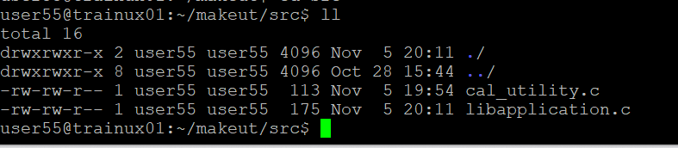

**· cal_utility.h – will contain the extern declarations/prototypes of the functions in cal_utility.c**

**A: The file created in inc**

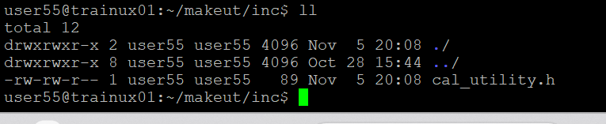

**2. Refer the steps for static library based application and create a static library application using above set of files.**

**A**: gcc -c -I ./inc/ ./src/cal_utility.c -o ./obj/cal_utility.o---cal_utility.o file is created in obj

gcc -c -I ./inc/ ./src/libapplication.c -o ./obj/libapplication.o----libapplication.o file is created in obj

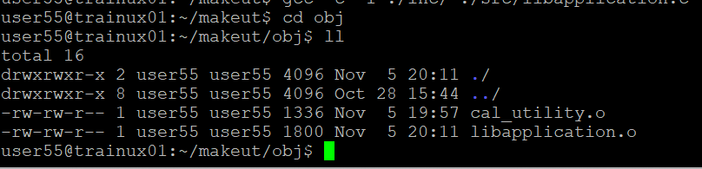

**3. Execute the application created in step #2**

**A:** gcc -o ./bin/app1 ./obj/cal_utility.o ./obj/libapplication.o---executable file app1 is created

To run-----./app1

