**FIND ASSIGNMENT**

**1.Search and display all *.c and *.h files in all subdirectories starting from current directory**

**A:** We use the command  **find /path/ -name “*.c” -o -name “*.h”.**

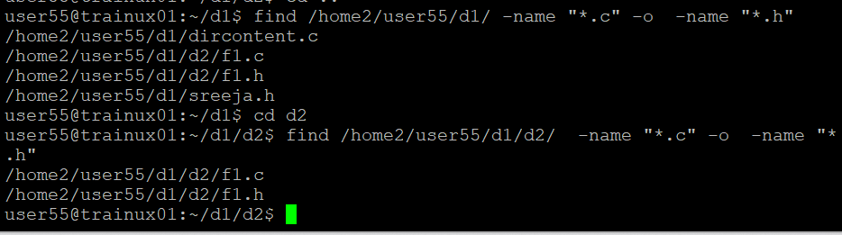

**2. Search and display all directories in all subdirectories starting from current directory**

**A:** We use the command **find . -type d**

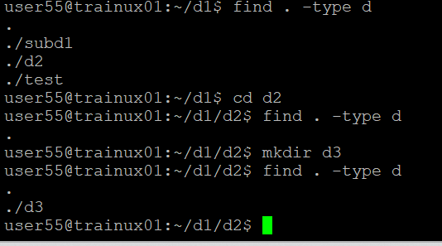

**3. Search and display all files with permissions only rw with user and execute permission for others**

**A:We use the command** find . -type f -perm 667

