**VI EDITOR**

**1.Invoke the vi editor with a filename (which is to be created)**

**A: Command used**----vi filename

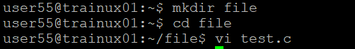

**2. Type a few lines(at least 10) in the editor. Let one or more lines contain the words given below.**

**delhi mumbai chennai Mumbai**

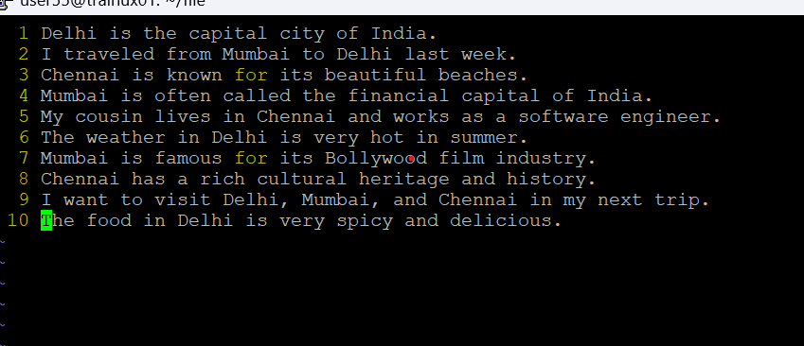

**3. Save the file without exiting the editor**

**A: Command used---:**w

**4. Navigate quickly to the beginning & end of the file**

**A: Command used---**gg—beginning of the file

G--- end of the file

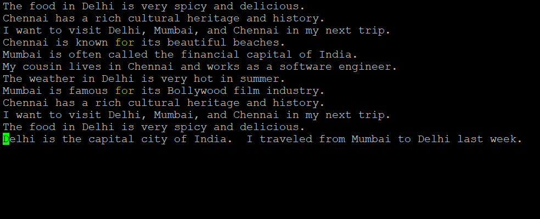

**5. Delete first two lines & copy it after the last line.**

**A: Command used---**d+2—for delete (cursor at first line)

p----paste

**6. Now Copy the last two lines & paste them before the first line.**

**A: Command used---** yy---copying

O—pasting before the line

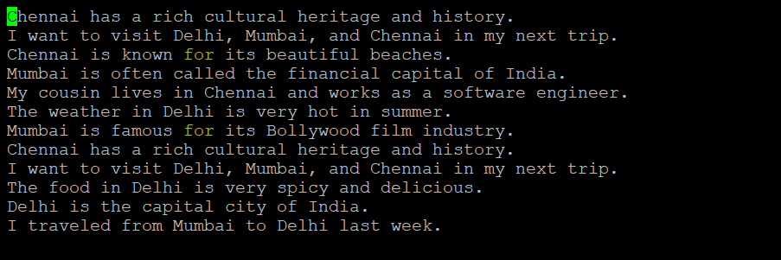

**7. Combine last two lines of the file in a single line.**

**A: Command used---**J---for combining

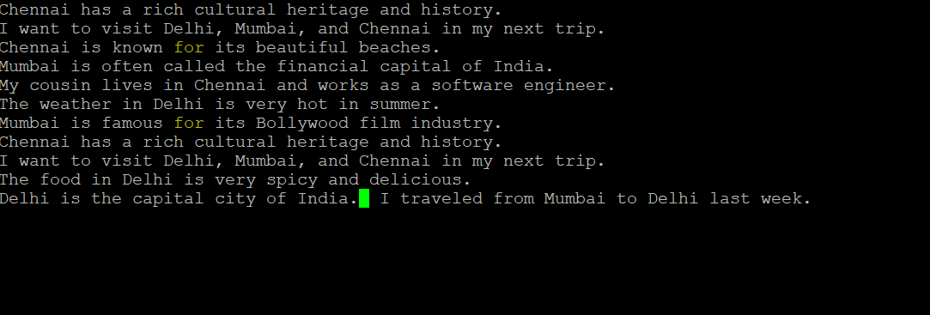

**8. How will you insert a line before the first line? (Hint : Find such an option in the tutorial document)**

**A:Command used---**O—for past before line

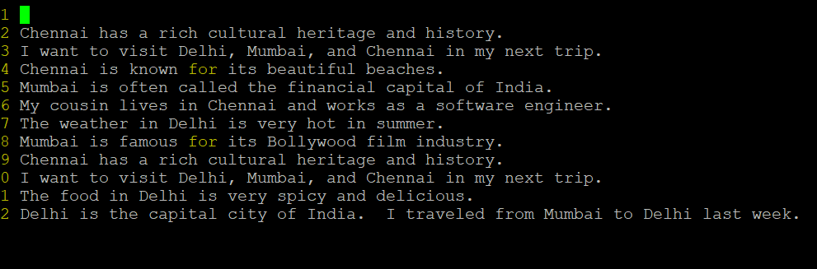

**9. How will you paste a yanked buffer before the current line?**

**A:Command used---**p—for pasting

**10. Search the document for a string “delhi”**

**A:Command used**---?delhi (in esc mode)

**11. Replace a single occurrence of “delhi” with “Mumbai”**

**A:Command used----**R—for replacing

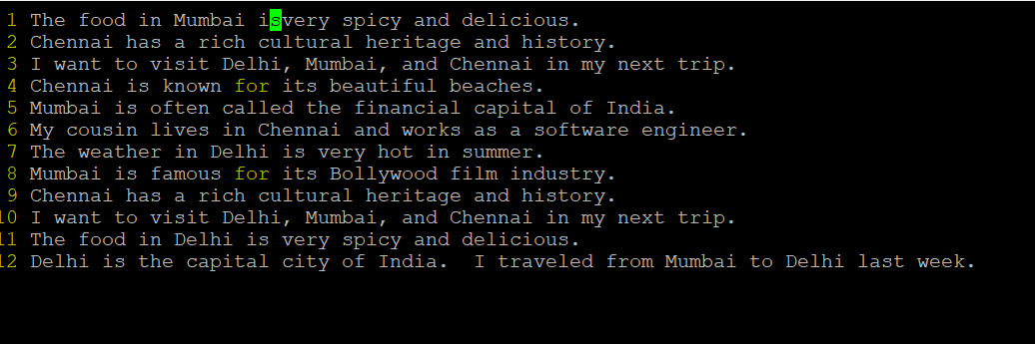

**12. Replace all occurrences of “delhi” on a particular line with “Mumbai” using one command**

**A: Command used**---:s/Delhi/Mumbai/g



**13. Replace “delhi” with “mumbai” for the entire document using one command.**

**A: Command used**---:%s/Delhi/Mumbai**/**

**14. Replace all occurrences of “delhi” with “mumbai” for part of a document (e.g. line number 13 to 37).**

**A: Command used**----:6,10s/Delhi/Mumbai

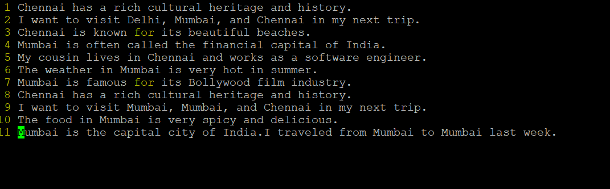

**15. Undo the above command**

**A: Command used---**press u

**16. Replace only the first occurrence of “delhi” with “mumbai” in each line, for part of a document (e.g. line number 13 to 37).**

**A: Command used---** :6,10s/Delhi/Mumbai/

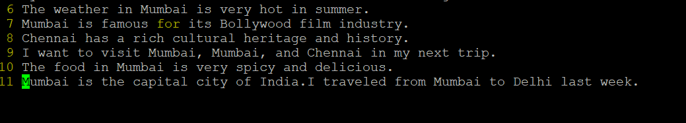

**17. Undo the above comment. Redo it. Undo it again.**

**A: Command to undo---**u

**Command to redo**----:2,5s/Delhi/Mumbai**/**

**18. Replace all occurrences of “delhi” with “mumbai” for complete file interactively.**

**A: Command used----** :%s/Delhi/Mumbai

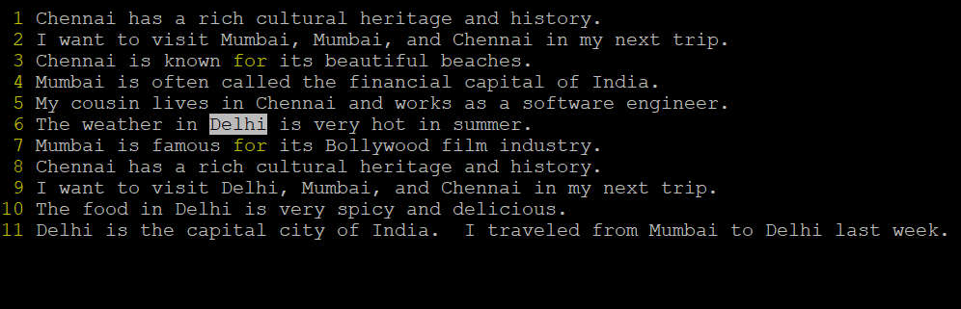

**19. Search for a word backwards. Loop through all matches.**

**A: Command used**----?word(n for repeating backwards)

**20. Search for a word forwards. Loop through all matches**

**A: Command used**---?word(N for repeating forwards)

**21. Join two lines together.**

**A: Command used---** J

**22. Enable line numbering and then disable it**

**A: Command used---** :set nonumber

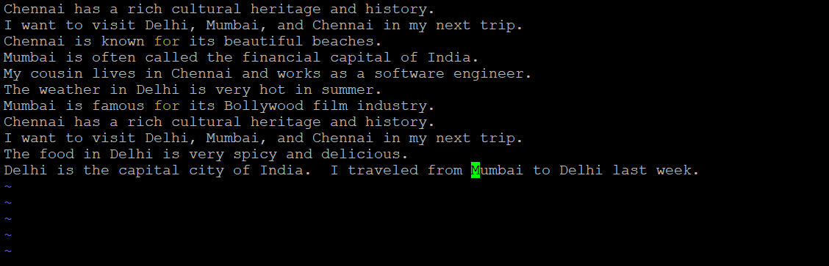

**23. Make the search case insensitive**

**A: Command used---:**set ignorecases

**24. Delete 4 lines (and then paste them somewhere else)**

**A: Command used**---d+4

**25. What is the command to delete part of the line starting from the current cursor position?**

**A:Command used----**d$

**26. What is the command to delete the current word?**

**A: Command used--**dw