**FOR WHILE DO WHILE BREAK CONTINUE ASSIGNMENT**

**1. WAP to read a number n and to display the cumulative sum of factorial of all numbers upto n . (use for or while)**

**Input: 4**

**Ouput: 4!+3!+2!+1! = 32**

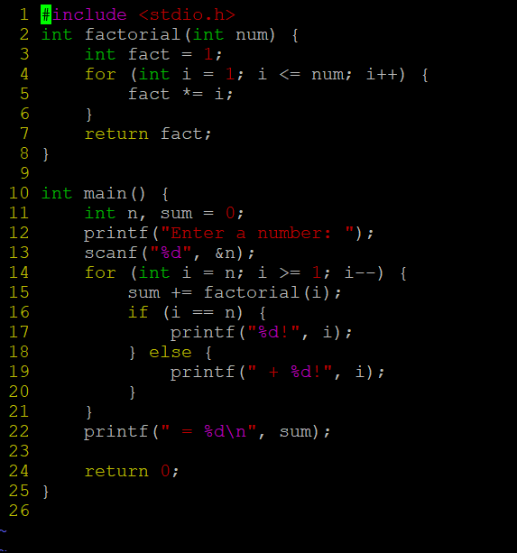

**OUTPUT:**

**2. Write a program to accept “N” integers from the user. “N” also has to be taken from the user. Take the count of +ve numbers, -ve numbers and 0’s.**

**However the program should not accept a non-integer value. If a non-integer value is entered, used must be asked to re-enter.**

**[Hint:**

**a. Use the return value of scanf to find out whether the user has entered integer or not.**

**b. You also will have to clear the input buffer before taking the next input.**

**For clearing the input buffer, use one of the following approaches**

* **while (getchar() != '\n'); // keep reading till newline and discard the characters**
* **scanf(“%*s”); // read and discard one string**

**]**

**

**OUTPUT:**

**3. Write a program to continuously read a string of maximum length 80 chars, End the program if string is END, else convert to upper case, display and continue. (use while)**

**OUTPUT:**

**4. Refer the program “value_out_of_domain.c”. Try to run the program with a large value say 255. Check the output? Is it correct? Fix the issue observed.**

**What improvements do you suggest?**

**A:** While the program works correctly for smaller numbers, it encounters issues with large values like 255 due to the limited size of the int data type in C.

**5. Refer the code below. It does not output anything. Fix it.**

**#include <stdio.h>**

**int main()**

**{**

**int x = 5;**

**while (x > 0);**

**{**

**printf( "Value of x :%d \n", x);**

**x--;**

**}**

**return 0;**

**}**

**A:**

The semicolon after the while (x > 0); means that the while loop does nothing in each iteration. So, remove the semicolon to fix the code.

**OUTPUT:**

**6. Analyse the code, identify the issues**

**#include <stdio.h>**

**int main()**

**{**

**float cnt = 0, num = 1000;**

**do**

**{**

**printf ("\n%d\n%d", num,cnt);**

**num /= cnt;**

**} while (cnt --); /* End of while */**

**return 0;**

**}**

**A:** The issues are:

**Format Specifiers**: Changed %d to %f to correctly print float values.

**Division by Zero**: Changed the initial value of cnt from 0 to 1 to prevent division by zero.

**Infinite Loop**: Modified the loop condition to cnt > 0, so the loop will terminate when cnt becomes non-positive.

OUTPUT:

