**PRINTF AND SCANF ASSIGNMENT**

**Q1. WAP with**

**1a. function readdisplay() to read the following data types only one at a time at run time and to display.**

**1. char type**

**2. integer type**

**3. char array of maximum 80 characters**

**4. short type**

**5. float type**

**TestData:**

**‘c’, 8978, “hello”, 8, 45.678**

**‘H’, 254, “hello Hi How”, 256, 145.2678**

**A:**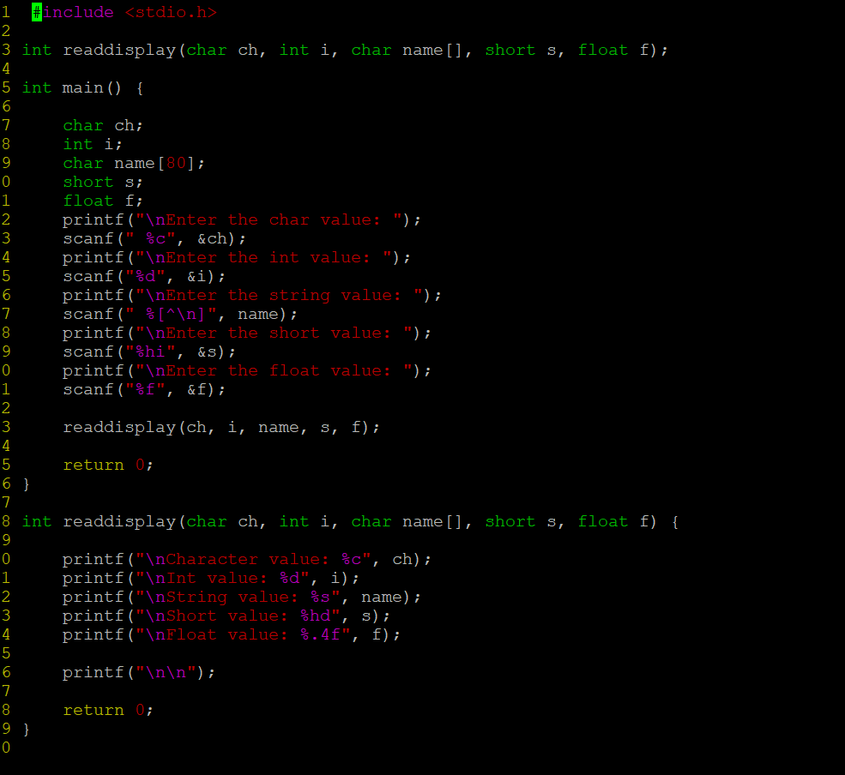

**OUTPUT:**

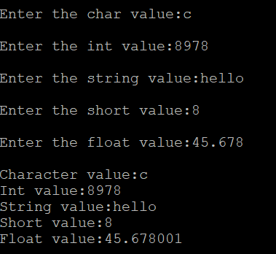

**1b. Create a copy of readdisplay() as function readdisplay2() with changes below**

**Instead of reading 1 data at a time, read all inputs using a single scanf().**

**Test readdisplay2() by changing the read order. Do you observe any issue?**

**1c. display the char array content in upper case**

**1d. Add code to display the size of each data type mentioned in Q1a and sizeof the variables of each datatype (You may refer sample code in data_type_size.c )**

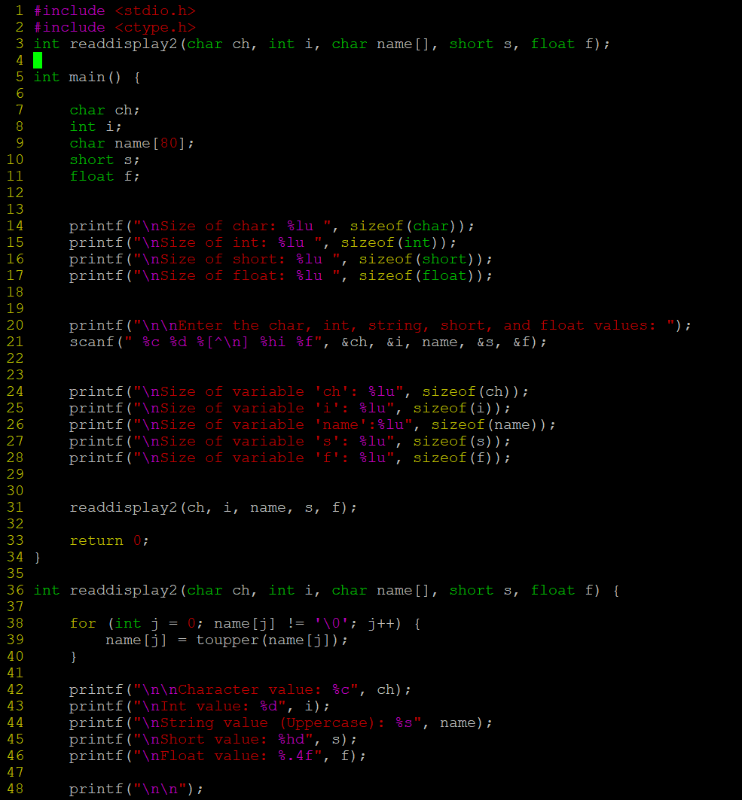

**OUTPUT:**

**Q2. Try to run the program with code snippet below. Check the output and analyse. Fix it to get correct result.**

**#include<stdio.h>**

**int main()**

**{ unsigned long int ul = 200333333334340;**

**printf("value is:%d\n", ul);**

**return 0;**

**}**

**A:** This code contains formatting issue “%d” is used for signed int but the code contain the unsigned long int so we have to use “%lu”.

**OUTPUT:**

