**STRING FUNCTIONS**

**1. WAP to prompt and read a line of text with words separated by space. Tokenise and extract the words. Display them. Impement the following functions for this.**

**a. int tokenise(char *arr); //tokenise and display tokens , return number of tokens to the caller**

**[Use strtok() to tokenise]**

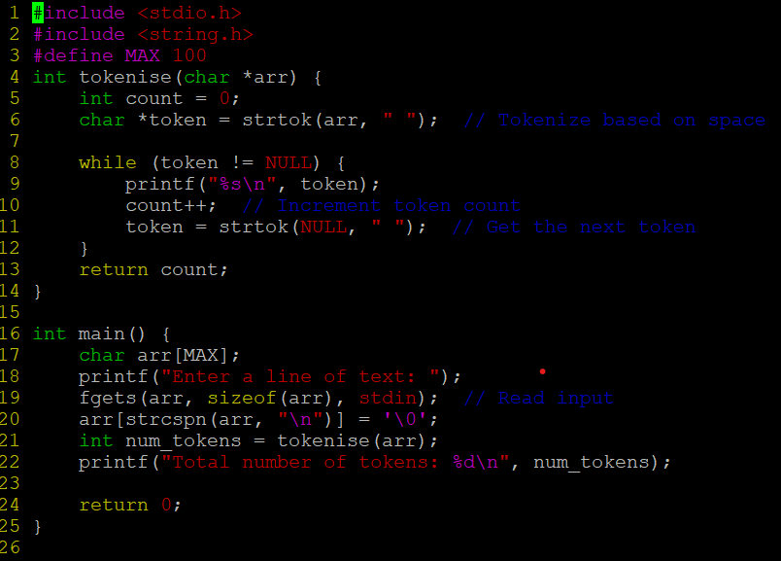

**OUTPUT:**

**2. Implement your own strncat() which shall concatenate n characters from src to dest.**

**char *strncat(char *dest, const char *src, size_t n)**

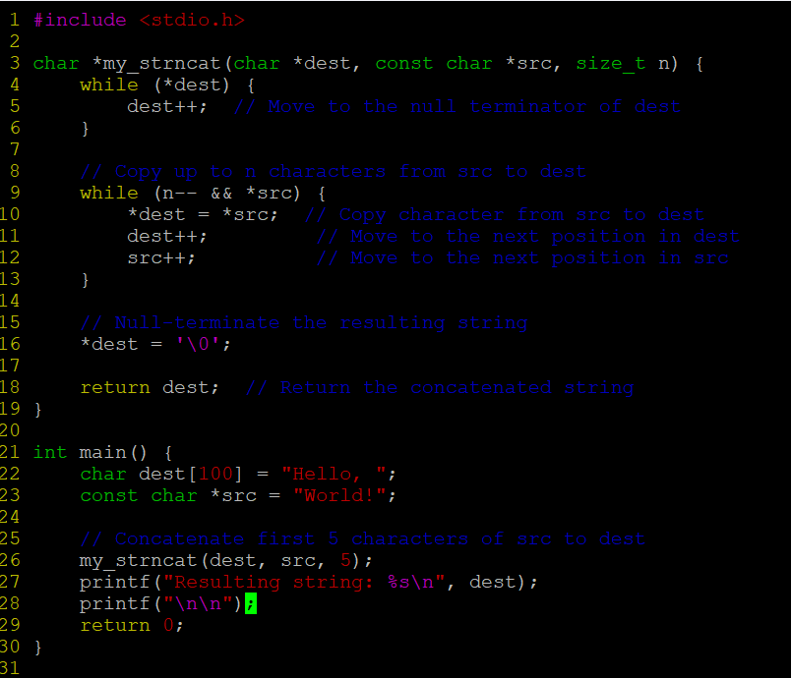

**OUTPUT:**

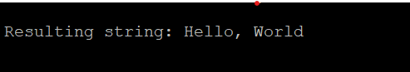

**3. WAP to**

**a. Search for and replace the vowel characters (upper and lower case) with “ay” in a word read from user. Consider a maximum word length of 40 characters.**

**b. Identify the test inputs to be used**

**c. Display updated string**

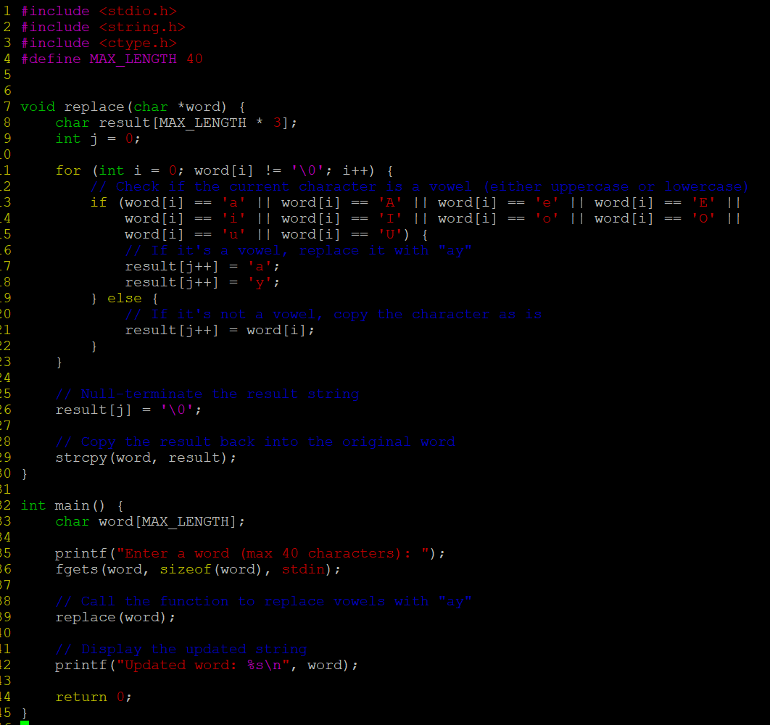

**OUTPUT:**

