**\ RECURSIVE FUNCTIONS**

**1.WAP to calculate the maximum stack depth of a recursive call to a function. (For eg a factorial function ).**

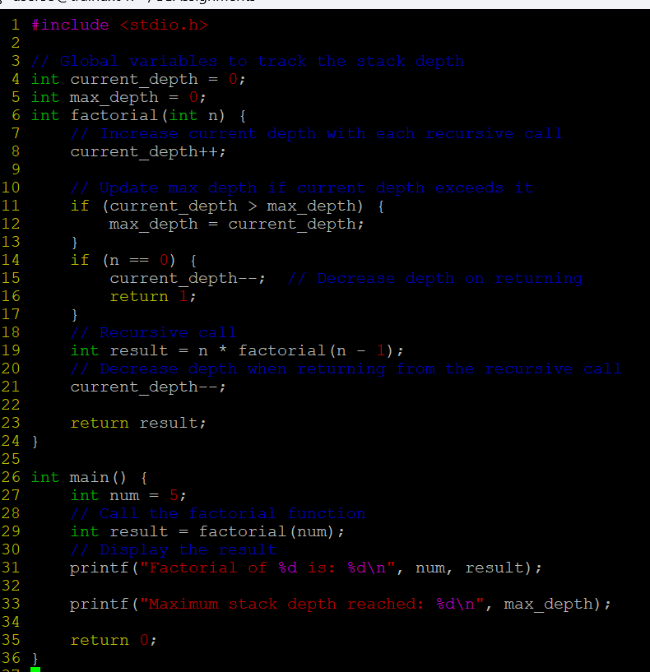

**OUTPUT:**

**2. What is tail recursion? Why is it important? Give an example.**

Tail recursion is a special type of recursion in which the recursive call is the last operation in the function. In other words, the result of the recursive call is returned directly without any further computation after the recursive call.

**Importance:**

* Optimization (Tail Call Optimization - TCO)
* Efficiency

**OUTPUT:**

