EBS

1.CREATE INSTANCE

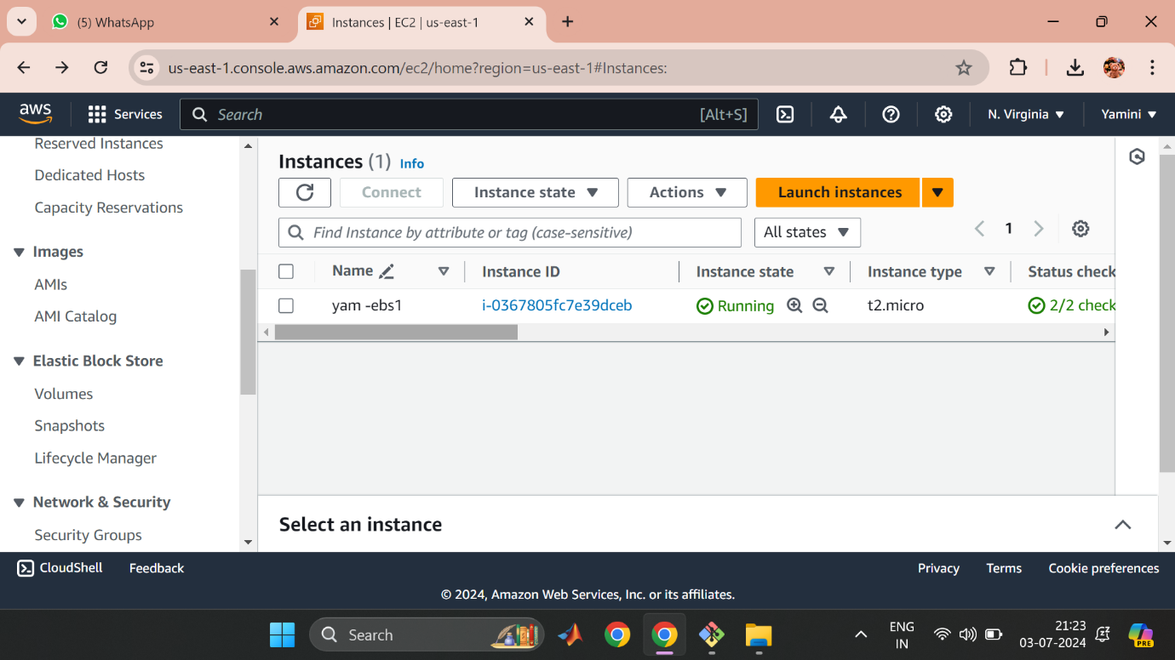

2.CREATE VOLUME

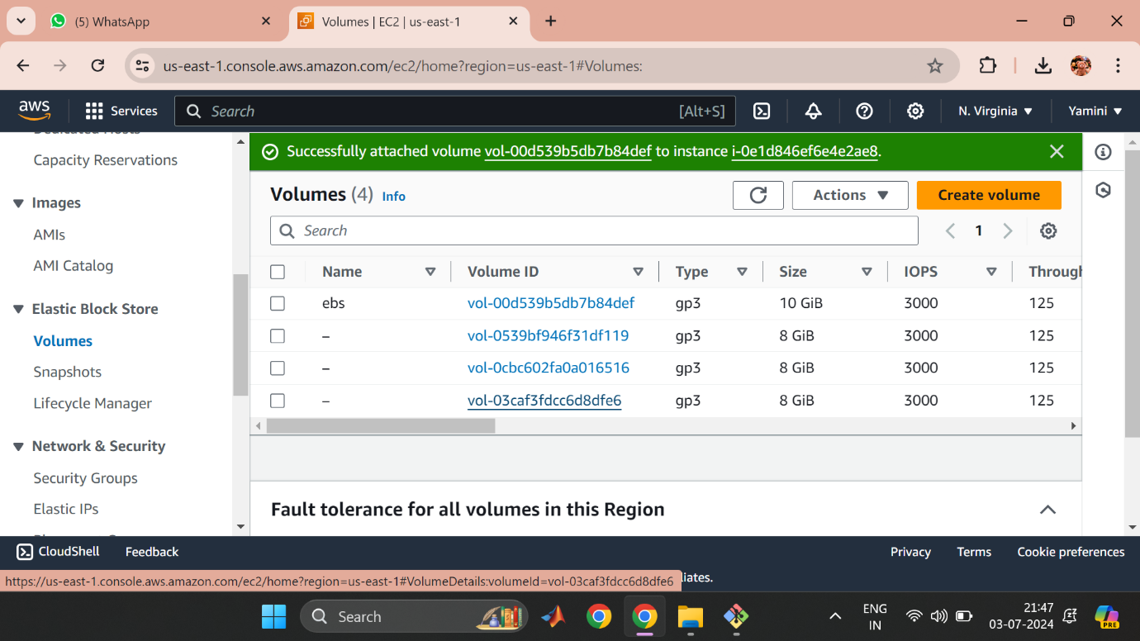

3.CONNECT INSTANCE

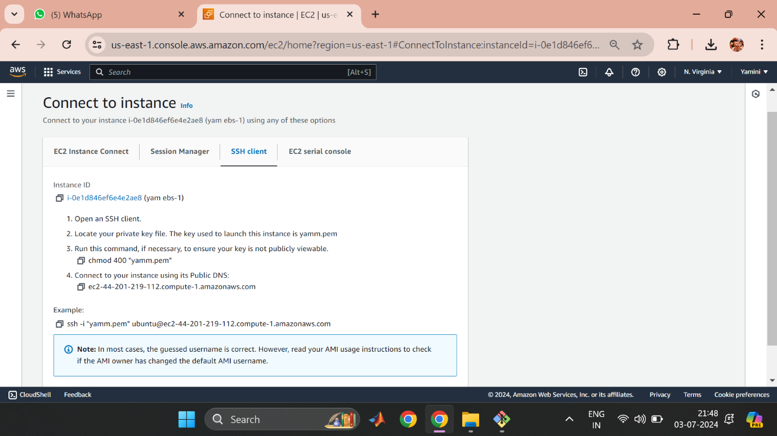

4.CHECK STORAGE

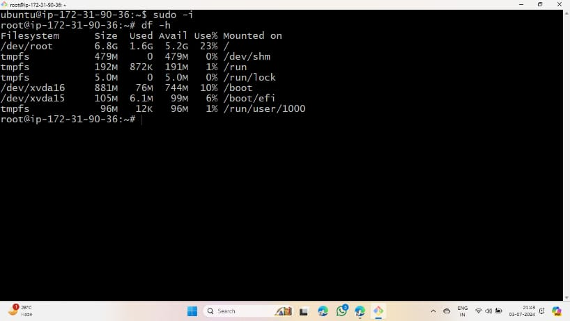

EFS

1.CREATE SECURITY GROUP

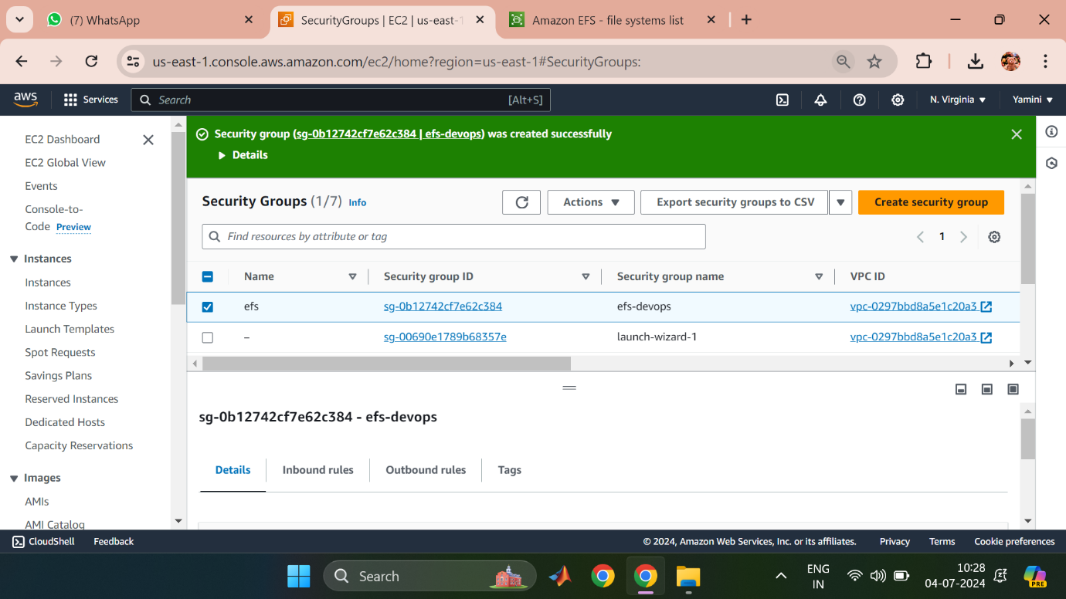

2.CREATE FILE SYSTEM

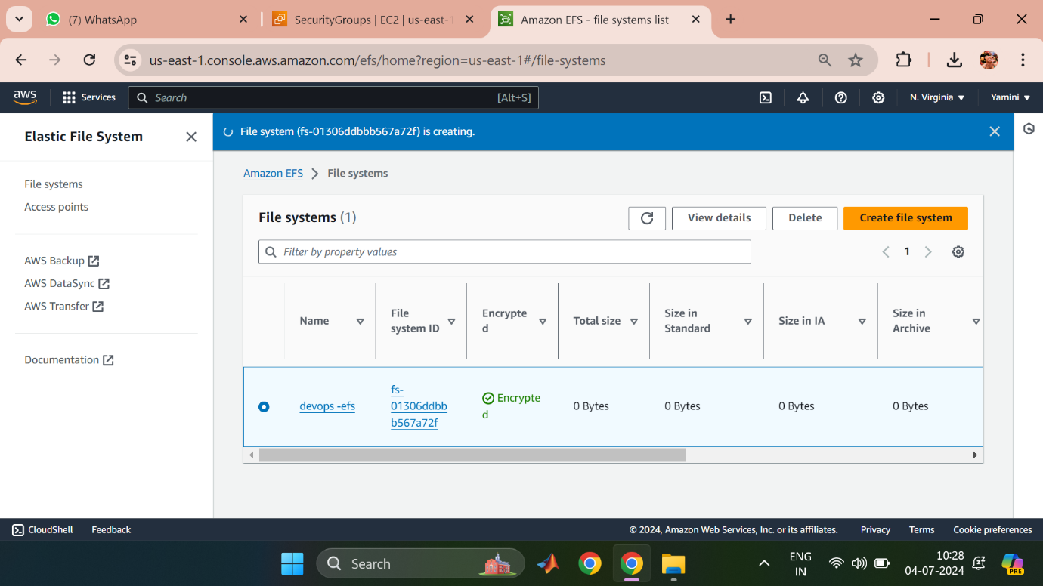

3. CREATE INSTANCE

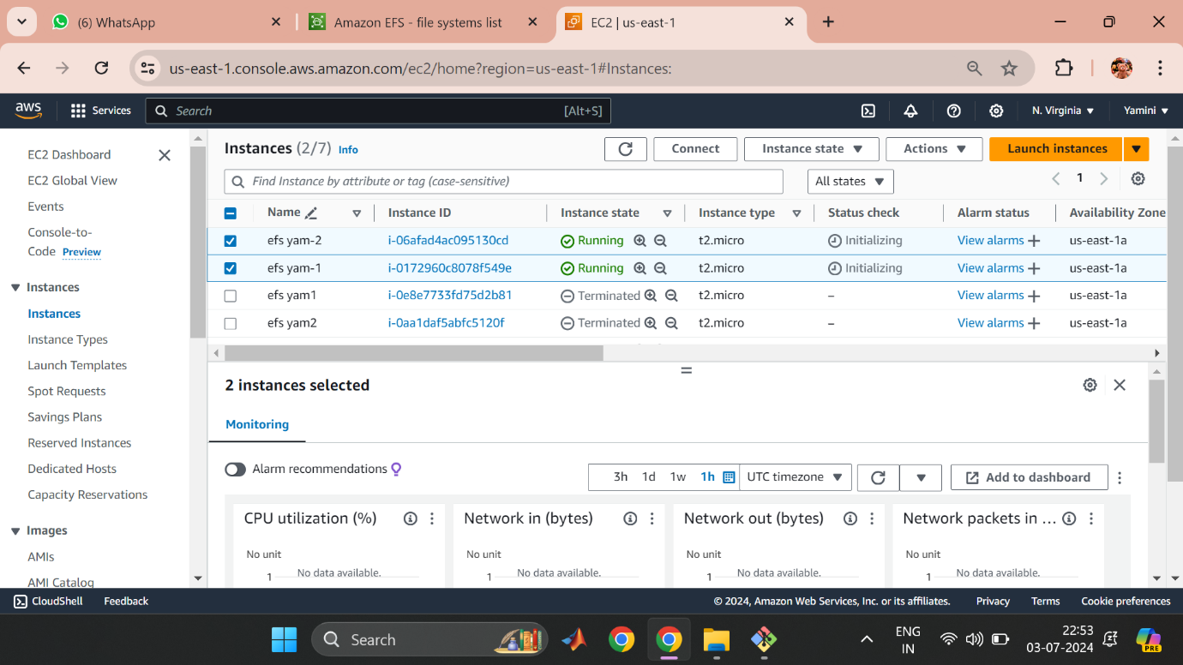

4.CONNECT TO INSTANCES

