**WEEK2** (6397718 - PARVATHAREDDY CHARVI SANKAR)

**Exercise 1: Setting Up JUnit**

**CODE:**

**Calculator.java:**

package example;

public class Calculator {

public int add(int a, int b) {

return a + b;

}

public int subtract(int a, int b) {

return a - b;

}

}

**CalculatorTest.java:**

package example;

import org.junit.Test;

import static org.junit.Assert.*;

public class CalculatorTest {

@Test

public void testAdd() {

Calculator calc = new Calculator();

int result = calc.add(5,3);

assertEquals(8, result);

}

}

**Pom.xml:**

<project xmlns="http://maven.apache.org/POM/4.0.0"

xmlns:xsi="http://www.w3.org/2001/XMLSchema-instance"

xsi:schemaLocation="http://maven.apache.org/POM/4.0.0

http://maven.apache.org/xsd/maven-4.0.0.xsd">

<modelVersion>4.0.0</modelVersion>

<groupId>com.example</groupId>

<artifactId>settingupJUnit</artifactId>

<version>1.0-SNAPSHOT</version>

<name>settingupJUnit</name>

<description>A project for setting up JUnit</description>

<dependencies>

<dependency>

<groupId>junit</groupId>

<artifactId>junit</artifactId>

<version>4.13.2</version>

<scope>test</scope>

</dependency>

</dependencies>

<build>

<plugins>

<plugin>

<groupId>org.apache.maven.plugins</groupId>

<artifactId>maven-surefire-plugin</artifactId>

<version>3.0.0</version>

</plugin>

</plugins>

</build>

</project>

**OUTPUT:**

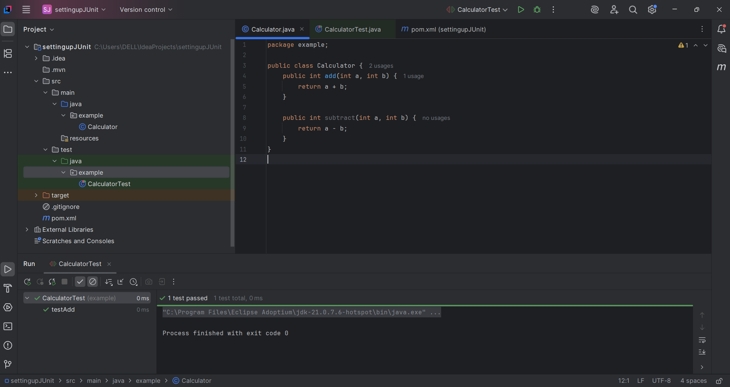

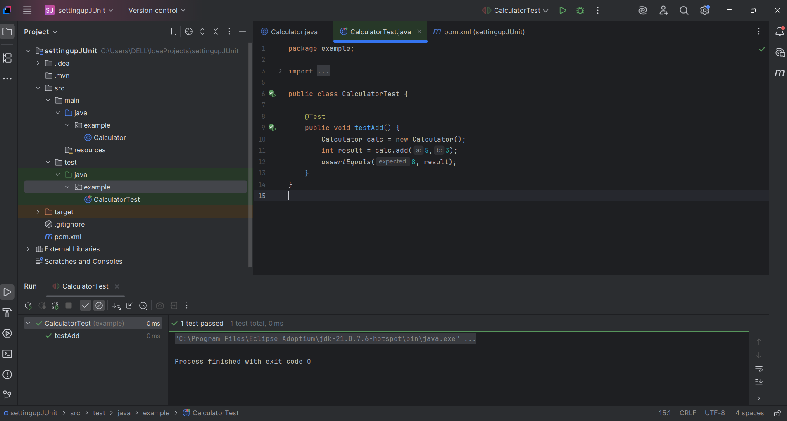

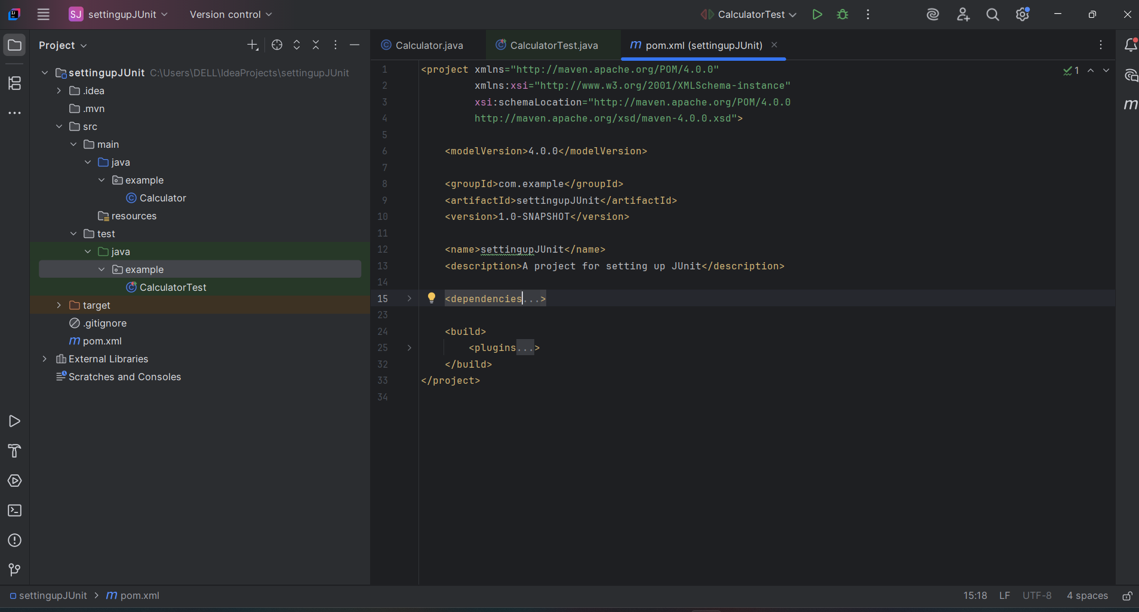

**Exercise 3: Assertions in JUnit**

**CODE:**

**AssertionsTest.java:**

package com.example;  
import org.junit.Test;  
import static org.junit.Assert.*;  
  
public class AssertionsTest {  
  
 @Test  
 public void testAssertions() {  
 // Assert equals  
 *assertEquals*(5, 2 + 3);  
  
 // Assert true  
 *assertTrue*(5 > 3);  
  
 // Assert false  
 *assertFalse*(5 < 3);  
  
 // Assert null  
 *assertNull*(null);  
  
 // Assert not null  
 *assertNotNull*(new Object());  
 }  
}

**Pom.xml:**

<project xmlns="http://maven.apache.org/POM/4.0.0"  
 xmlns:xsi="http://www.w3.org/2001/XMLSchema-instance"  
 xsi:schemaLocation="http://maven.apache.org/POM/4.0.0  
 http://maven.apache.org/xsd/maven-4.0.0.xsd">  
  
 <modelVersion>4.0.0</modelVersion>  
  
 <groupId>com.example</groupId>  
 <artifactId>JUnitDemo</artifactId>  
 <version>1.0-SNAPSHOT</version>  
  
 <dependencies>  
  
 <!-- JUnit 4 -->  
 <dependency>  
 <groupId>junit</groupId>  
 <artifactId>junit</artifactId>  
 <version>4.13.2</version>  
 <scope>test</scope>  
 </dependency>  
  
 </dependencies>  
  
</project>

**OUTPUT:**

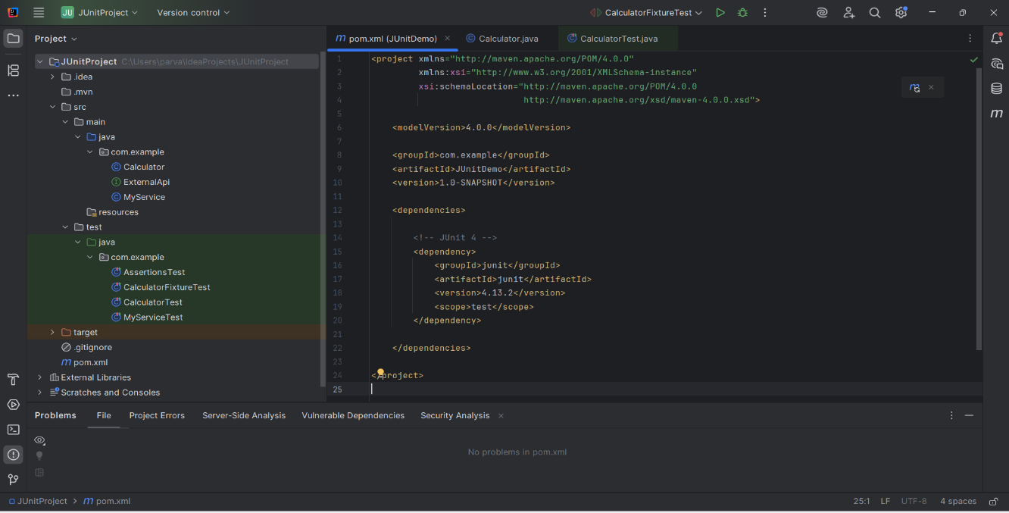

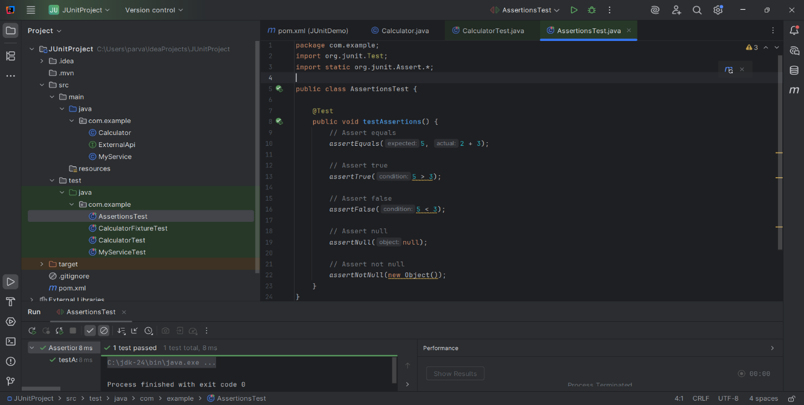

**Exercise 4: Arrange-Act-Assert (AAA) Pattern, Test Fixtures, Setup and Teardown Methods in JUnit**

**CODE:**

**CalculatorFixtureTest.java:**

<project xmlns=”http://maven.apache.org/POM/4.0.0”  
 xmlns:xsi=”http://www.w3.org/2001/XMLSchema-instance”  
 xsi:schemaLocation=”http://maven.apache.org/POM/4.0.0  
 http://maven.apache.org/xsd/maven-4.0.0.xsd”>  
  
 <modelVersion>4.0.0</modelVersion>  
  
 <groupId>com.example</groupId>  
 <artifactId>JunitDemo</artifactId>  
 <version>1.0-SNAPSHOT</version>  
  
 <dependencies>  
  
 <!—JUnit 4 🡪  
 <dependency>  
 <groupId>junit</groupId>  
 <artifactId>junit</artifactId>  
 <version>4.13.2</version>  
 <scope>test</scope>  
 </dependency>  
  
 </dependencies>  
  
</project>

**OUTPUT:**

