**WEEK-2** (6397718 - PARVATHAREDDY CHARVI SANKAR)

**Exercise 1: Mocking and Stubbing**

**Scenario:** You need to test a service that depends on an external API. Use Mockito to mock the

external API and stub its methods

**CODE:**

**ExternalApi:**

package com.example;

public interface ExternalApi {

String getData();

}

**MyService:**

package com.example;

public class MyService {

private final ExternalApi api;

public MyService(ExternalApi api) {

this.api = api;

}

public String fetchData() {

return api.getData();

}

}

**MyServiceTest:**

package com.example;

import org.junit.jupiter.api.Test;

import org.mockito.Mockito;

import static org.mockito.Mockito.when;

import static org.junit.jupiter.api.Assertions.assertEquals;

public class MyServiceTest {

@Test

public void testExternalApi() {

// Step 1: Create mock object

ExternalApi mockApi = Mockito.mock(ExternalApi.class);

// Step 2: Stub method

when(mockApi.getData()).thenReturn("Mock Data");

// Step 3: Inject mock into service

MyService service = new MyService(mockApi);

// Step 4: Assert result

String result = service.fetchData();

assertEquals("Mock Data", result);

}

}

**Pom.xml:**

<project xmlns="http://maven.apache.org/POM/4.0.0"

xmlns:xsi="http://www.w3.org/2001/XMLSchema-instance"

xsi:schemaLocation="http://maven.apache.org/POM/4.0.0

http://maven.apache.org/xsd/maven-4.0.0.xsd">

<modelVersion>4.0.0</modelVersion>

<groupId>com.example</groupId>

<artifactId>MockingandStubbing</artifactId>

<version>1.0-SNAPSHOT</version>

<properties>

<maven.compiler.source>17</maven.compiler.source>

<maven.compiler.target>17</maven.compiler.target>

<project.build.sourceEncoding>UTF-8</project.build.sourceEncoding>

</properties>

<dependencies>

<!-- JUnit 5 -->

<dependency>

<groupId>org.junit.jupiter</groupId>

<artifactId>junit-jupiter</artifactId>

<version>5.9.1</version>

<scope>test</scope>

</dependency>

<!-- Mockito -->

<dependency>

<groupId>org.mockito</groupId>

<artifactId>mockito-core</artifactId>

<version>4.8.0</version>

<scope>test</scope>

</dependency>

</dependencies>

<build>

<plugins>

<!-- Ensure JUnit 5 runs correctly -->

<plugin>

<groupId>org.apache.maven.plugins</groupId>

<artifactId>maven-surefire-plugin</artifactId>

<version>2.22.2</version>

<configuration>

<useModulePath>false</useModulePath>

</configuration>

</plugin>

<!-- Set compiler to Java 17 -->

<plugin>

<groupId>org.apache.maven.plugins</groupId>

<artifactId>maven-compiler-plugin</artifactId>

<version>3.11.0</version>

<configuration>

<source>17</source>

<target>17</target>

</configuration>

</plugin>

</plugins>

</build>

</project>

**OUTPUT:**

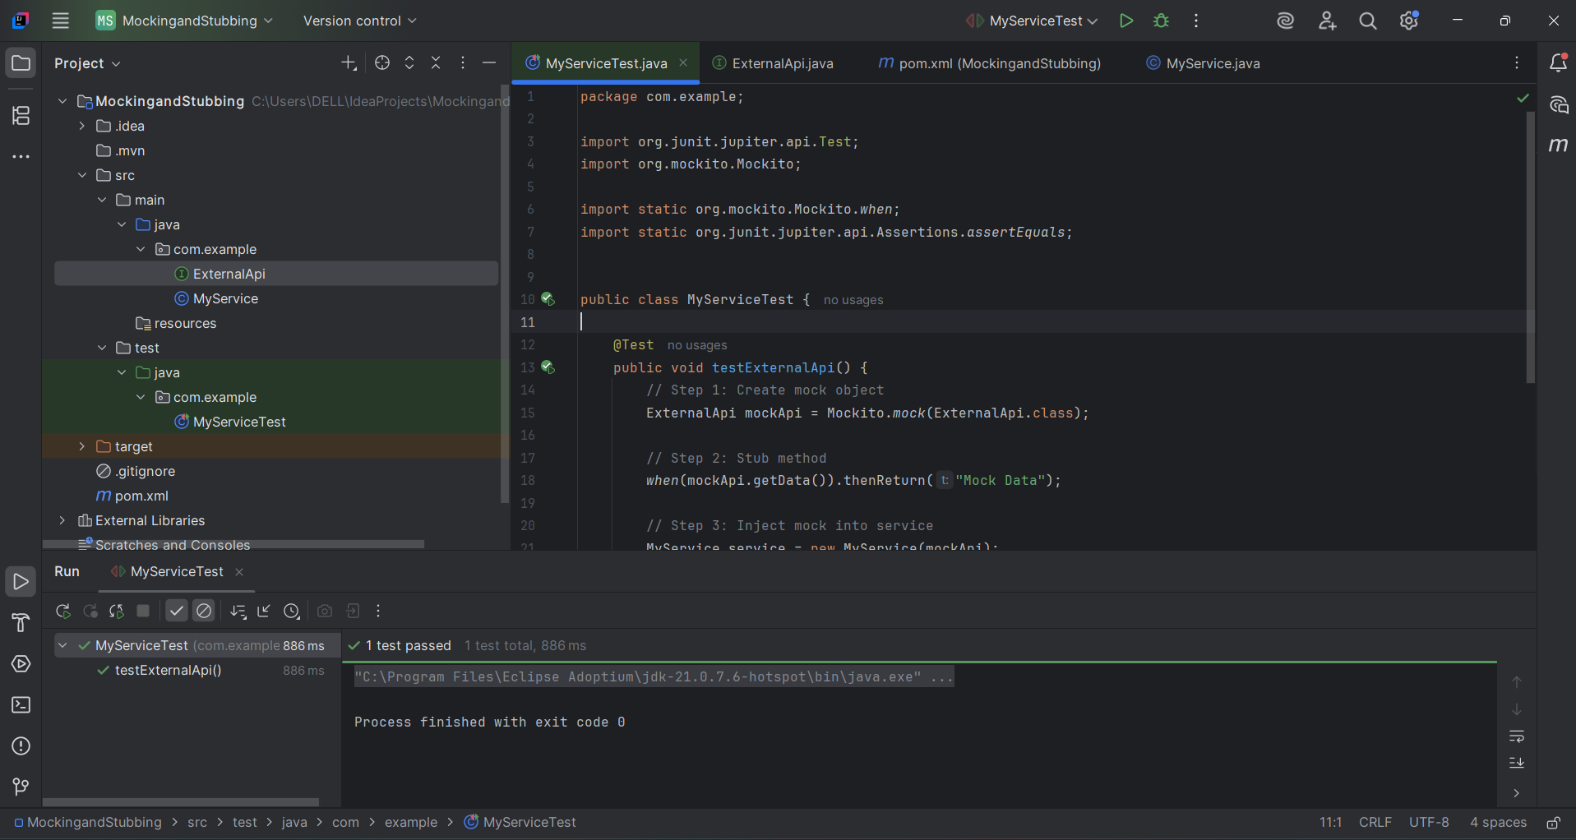

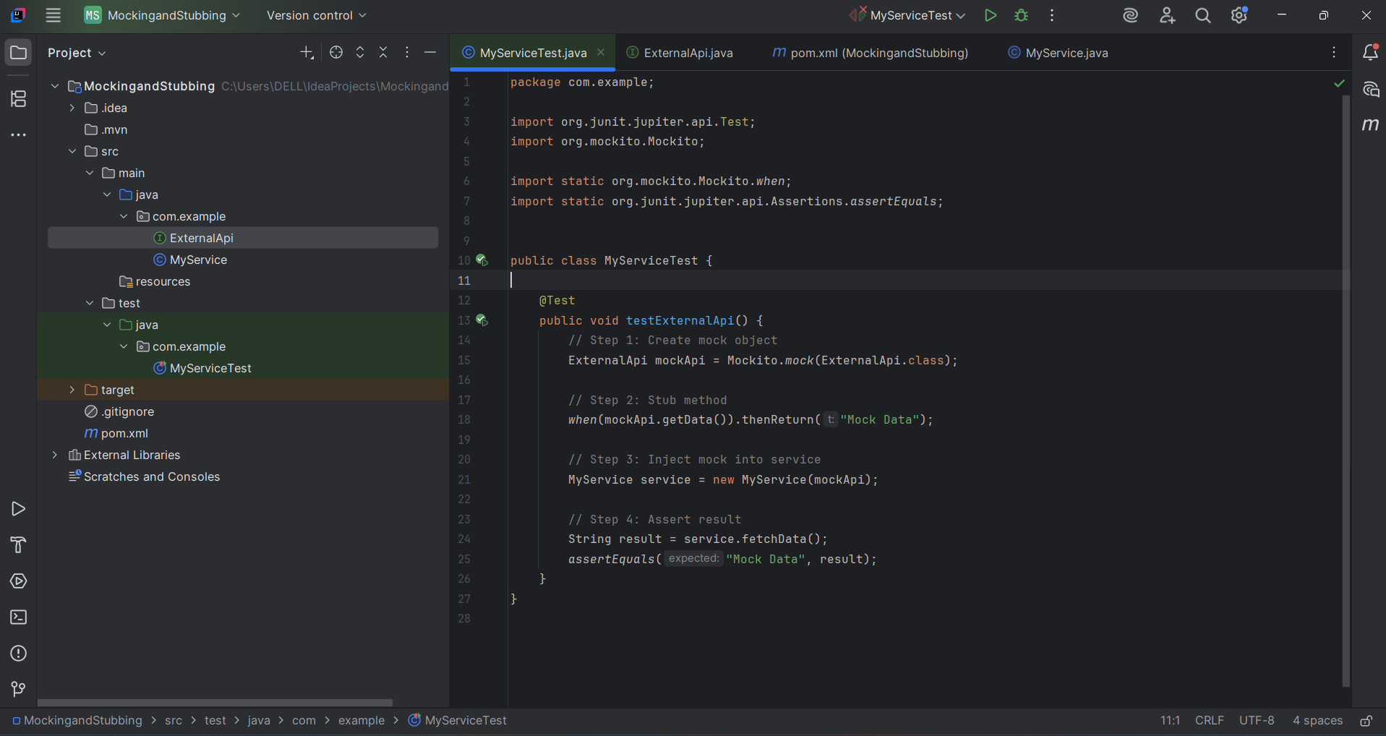

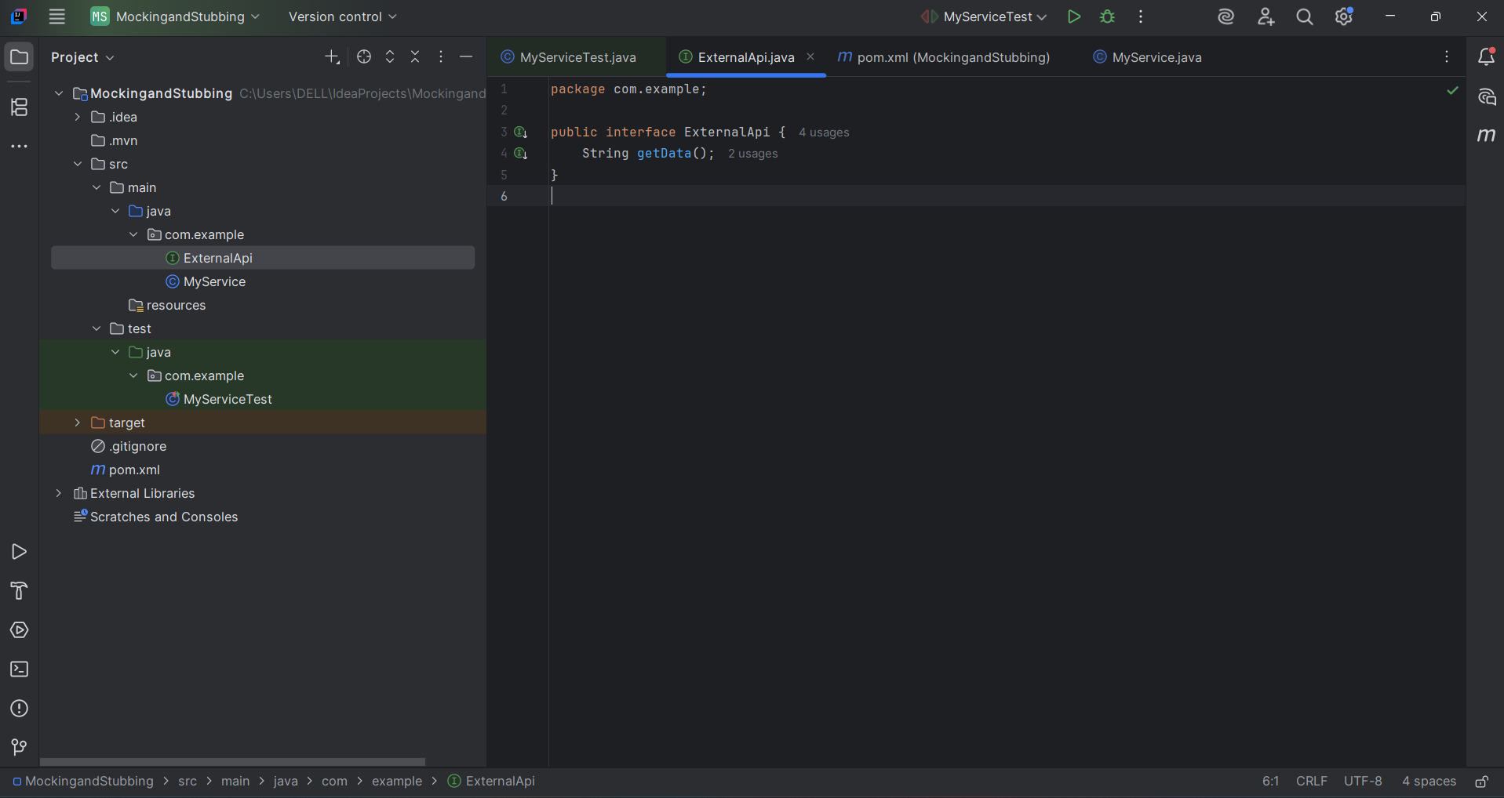

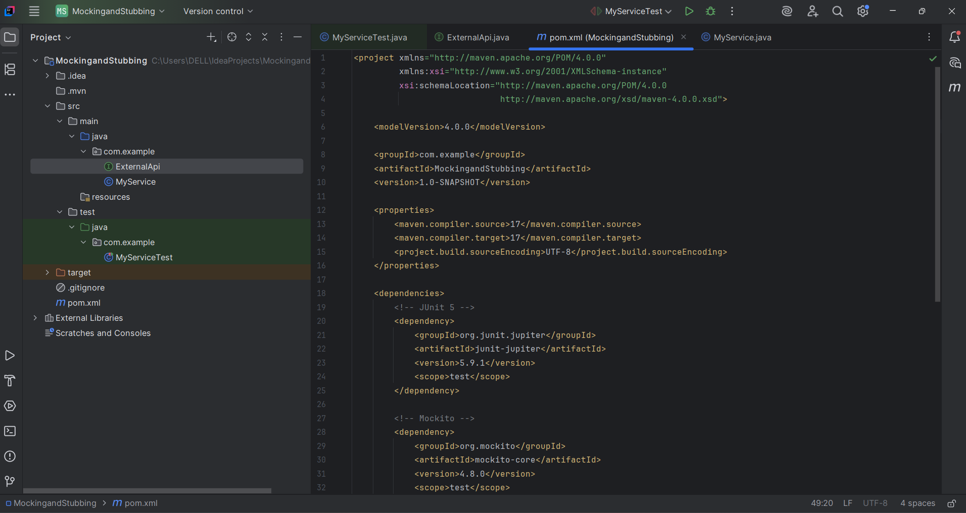

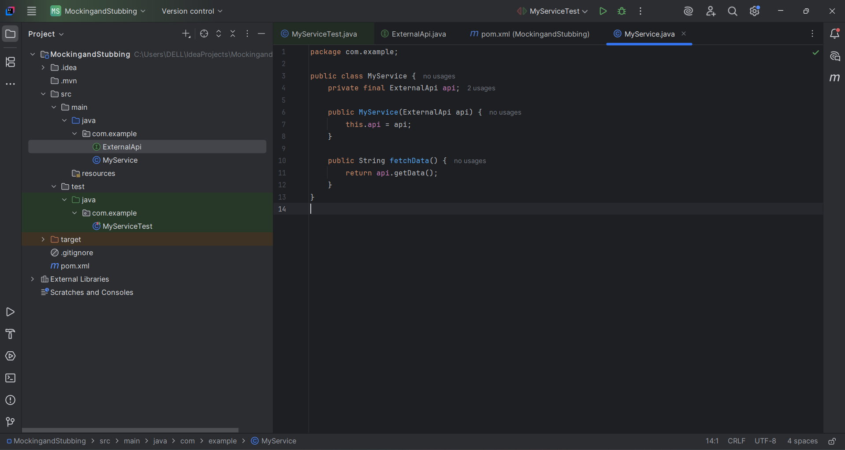

**Exercise 2: Verifying Interactions**

**Scenario: You need to ensure that a method is called with specific arguments.**

**CODE:**

**ExternalApi:**

package com.example;

public interface ExternalApi {

void getData();

}

**MyService.java:**

package com.example;

public class MyService {

private final ExternalApi api;

public MyService(ExternalApi api) {

this.api = api;

}

public void fetchData() {

// Call the API method

api.getData();

}

}

**MyServiceTest.java:**

package com.example;

import org.junit.jupiter.api.Test;

import static org.mockito.Mockito.*;

public class MyServiceTest {

@Test

public void testVerifyInteraction() {

// Step 1: Create a mock object

ExternalApi mockApi = mock(ExternalApi.class);

// Step 2: Inject mock into service

MyService service = new MyService(mockApi);

// Step 3: Call method that uses the mock

service.fetchData();

// Step 4: Verify interaction

verify(mockApi).getData(); // Verifies it was called once

}

}

**Pom.xml:**

<project>

<modelVersion>4.0.0</modelVersion>

<groupId>com.example</groupId>

<artifactId>MockingAndStubbing</artifactId>

<version>1.0-SNAPSHOT</version>

<dependencies>

<!-- JUnit 5 -->

<dependency>

<groupId>org.junit.jupiter</groupId>

<artifactId>junit-jupiter</artifactId>

<version>5.10.0</version>

<scope>test</scope>

</dependency>

<!-- Mockito -->

<dependency>

<groupId>org.mockito</groupId>

<artifactId>mockito-core</artifactId>

<version>5.11.0</version>

<scope>test</scope>

</dependency>

</dependencies>

<build>

<plugins>

<!-- Set Java version -->

<plugin>

<groupId>org.apache.maven.plugins</groupId>

<artifactId>maven-compiler-plugin</artifactId>

<version>3.11.0</version>

<configuration>

<source>17</source>

<target>17</target>

</configuration>

</plugin>

</plugins>

</build>

</project>

**OUTPUT:**

