 

Revolutionizing Liver Care

Predicting Liver Cirrhosis Using Advanced Machine Learning Techniques

**Team ID :** LTVIP2025TMID33649

**Team Leader :** Padamata Rama Bhadra Praneeth

**Team member :** Earanki VSS Abhaya

**Team member :** Alijingi Lakshmi Venkata Siva Parvathi

**Team member :** Kotipalli Prasanna

**Table of Contents**

1. Introduction
   1. Project Overview
   2. Purpose
2. Ideation Phase
   1. Problem Statement
   2. Empathy Map Canvas
3. Requirement Analysis
   1. Customer Journey Map
   2. Solution Requirements
      1. Functional Requirements
      2. Non-Functional Requirements
   3. Data Flow Diagram
   4. Technology Stack
4. Project Design
   1. Problem Solution Fit
   2. Proposed Solution
   3. Solution Architecture
5. Project Planning & Scheduling
6. Functional and Performance Testing
7. Results
8. Advantages & Disadvantages
9. Conclusion
10. Future Scope
11. Appendix

# Introduction

* 1. **Project Overview**

Liver cirrhosis is a chronic and progressive liver disease characterized by irreversible scarring of liver tissue, leading to severe complications and liver failure if untreated. This project aims to develop a predictive model for early detection and prognosis of liver cirrhosis using machine learning techniques. By leveraging non-invasive clinical and laboratory data, the system provides accurate, early-stage predictions, enabling timely interventions and personalized healthcare solutions.

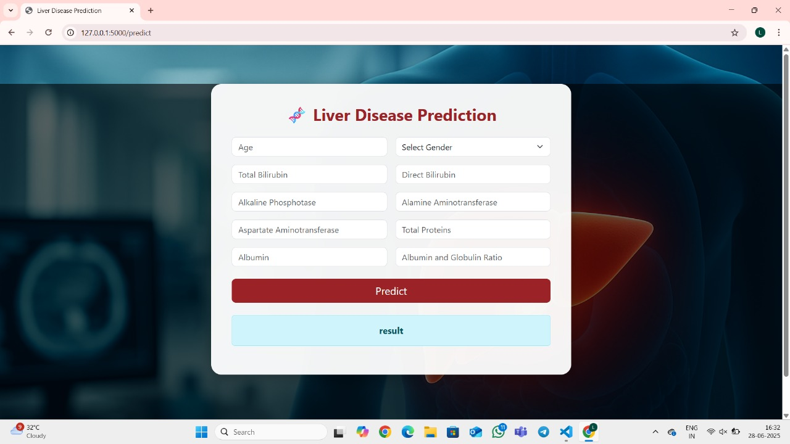

* 1. **Purpose**

The project addresses the limitations of traditional diagnostic methods, which are invasive (e.g., liver biopsies), time-consuming (requiring multiple hospital visits), and costly (placing financial burden on healthcare systems and patients). The goals include:

* + - Early detection of liver cirrhosis to improve survival rates.
    - Non-invasive prediction using clinical and laboratory data.
    - Personalized healthcare solutions based on predictive analytics.

# Ideation Phase

* 1. **Problem Statement**

|  |  |
| --- | --- |
| Date | 28 June 2025 |
| Team ID | LTVIP2025TMID33649 |
| Project Name | Liver Cirrhosis Prediction |
| Maximum Marks | 2 Marks |

Urban traffic management remains a challenge due to unpredictable congestion spikes, weather disruptions, holiday surges, and limited forecasting tools. Current solutions are often reactive, expensive, or inaccessible to the general public. The need is for an intelligent, anticipatory framework that democratizes traffic prediction for all urban stakeholders.

|  |  |  |  |  |  |
| --- | --- | --- | --- | --- | --- |
| **Problem**  **Statement (PS)** | **I am (Customer)** | **I’m trying to** | **But** | **Because** | **Which makes me feel** |
| PS-1 | A patient at risk of liver disease.I live in a rural area with limited healthcare access.My family has a history of liver conditions | Get early detection of cirrhosis without painful procedures.  Monitor my liver health proactively. | The Current diagnostic methods are invasive (like biopsies) and expensive. | Many cannot afford regular screenings, and symptoms often appear too late.  Urban diagnostic centers are too far and costly to visit regularly. | Anxious about my health and financial burden, and powerless against silent disease progression. |

* 1. **Empathy Map Canvas**

|  |  |
| --- | --- |
| Date | 28 June 2025 |
| Team ID | LTVIP2025TMID33649 |
| Project Name | Liver Cirrhosis Prediction |
| Maximum Marks | 4 Marks |

**What do users THINK & FEEL?**

* + - Worry about late-stage diagnosis.
    - Stress about invasive procedures.
    - Desire for accurate, early detection tools.

**What do users SEE?**

* + - High costs and delays in diagnosis
    - Limited access to advanced diagnostic tools
    - Confusing or inconclusive test reports

**What do users HEAR?**

* + - Stories of late-stage diagnoses
    - Complaints about invasive tests
    - Dismissive attitudes from providers

**What do users SAY & DO?**

* + - Research non-invasive alternatives
    - Share frustration on patient forums
    - Delay seeking care due to fear

**PAIN**

* + - Irreversible damage before detection
    - Lack of personalized risk communication
    - Rural patients travel 100+ miles for advanced diagnostics

**GAIN**

* + - Early detection
    - Peace of mind through regular monitoring
    - Personalized prevention plans

# Requirement Analysis

* 1. **Customer Journey Map**

**Phases & Steps**

|  |  |  |  |  |  |  |
| --- | --- | --- | --- | --- | --- | --- |
| **Phase** | **Steps** | **Interactions** | **Goals & Motivations** | **Positive Moments** | **Negative Moments** | **Areas of Opportunity** |
| Entice | Learns about the tool. | Sees social media post or doctor's recommendation | Wants early detection | Easy-to-use interface | Skepticism about accuracy | Targeted onboarding with clinician endorsements |
| Enter | Visits the web app | Lands on input page | Quick risk assessment | Clean UI with familiar medical terms | Confused by "A/G Ratio" field | Tooltips explaining lab parameters |
| Engage | Submit the data | Enters values and Clicks Predict | Get actionable results | Real-time processing animation | Error if values exceed normal ranges | Auto-validate input ranges |
| Result | View prediction | Sees High Risk (72%) with color coding | Understand personal risk level | Clear visual feedback | Panics if result lacks guidance | Link to telehealth consultation |
| Exit | Post-result actions | Shares PDF report with doctor or ignores | Plan next steps clinically | Accurate, useful advice | Doctor dismisses AI prediction | Generate clinician-friendly summaries |

* 1. **Solution Requirements (Functional & Non-functional)**

|  |  |
| --- | --- |
| Date | 28 June 2025 |
| Team ID | LTVIP2025TMID33649 |
| Project Name | Liver Cirrhosis Prediction |
| Maximum Marks | 4 Marks |

**3.2.1 Functional Requirements:**

Following are the functional requirements of the proposed solution.

|  |  |  |
| --- | --- | --- |
| **FR No.** | **Functional Requirement (Epic)** | **Sub Requirement (Story / Sub-Task)** |
| FR-1 | User Input & Interface | Data entry for clinical/lab parameters |
| FR-2 | Prediction Engine | ML model integration, real-time prediction |
| FR-3 | Data Preprocessing | Handle missing values, normalization |
| FR-4 | Results Display | Show prediction with confidence score |

**3.2.2 Non-functional Requirements:**

Following are the non-functional requirements of the proposed solution.

|  |  |  |
| --- | --- | --- |
| **FR No.** | **Non-Functional Requirement** | **Description** |
| NFR-1 | Usability | Clean, Intuitive UI for healthcare professionals |
| NFR-2 | Security | HIPAA-compliant data handling; secure forms |
| NFR-3 | Reliability | High prediction uptime, robust fallback |
| NFR-4 | Performance | <2s response for predictions |

* 1. **Data Flow Diagram**

|  |  |
| --- | --- |
| Date | 28 June 2025 |
| Team ID | LTVIP2025TMID33649 |
| Project Name | Liver Cirrhosis Prediction |
| Maximum Marks | 4 Marks |

Data Flow Diagram Shows how the data flows in order to show the volume Of the traffic. The below is the data flow diagram that illustrates how the data flows

**Flow Chart User Input**

**Flask Web UI**

**Data Preprocessing**

**ML Model (Gradient Boosting)**

**Liver Cirrhosis Risk Prediction**

**Output to User**

* 1. **Technology Stack**

|  |  |
| --- | --- |
| Date | 28 June 2025 |
| Team ID | LTVIP2025TMID33649 |
| Project Name | Liver Cirrhosis Prediction |
| Maximum Marks | 4 Marks |

* + - **Frontend:** HTML5, CSS3, JavaScript (Basic)
    - **Backend:** Python 3.x (Flask)
    - **ML:** scikit-learn (Gradient Boosting), pandas, numpy
    - **Data Storage:** CSV for training; Pickle (.pkl) for model/encoder
    - **Deployment:** Localhost

# Project Design

* 1. **Problem Solution Fit**

|  |  |
| --- | --- |
| Date | 28 June 2025 |
| Team ID | LTVIP2025TMID33649 |
| Project Name | Liver Cirrhosis Prediction |
| Maximum Marks | 2 Marks |

The project provides a non-invasive, scalable, and cost-effective solution for early detection of liver cirrhosis, leveraging machine learning to analyze clinical data.

* 1. **Proposed Solution**

|  |  |
| --- | --- |
| Date | 28 June 2025 |
| Team ID | LTVIP2025TMID33649 |
| Project Name | Liver Cirrhosis Prediction |
| Maximum Marks | 2 Marks |

|  |  |  |
| --- | --- | --- |
| **S.No.** | **Parameter** | **Description** |
| 1. | Problem Statement (Problem to be solved) | Late-stage diagnosis of liver cirrhosis due to reliance on invasive biopsies (painful, 5-10% complication rate) and costly imaging (FibroScan costs $300-$500 per test). Limited access in rural areas (60% of Indian districts lack specialists). |
| 2. | Idea / Solution Description | ML-based web app that predicts cirrhosis risk using 10+ clinical markers (Bilirubin, Albumin, etc.) via:  - XGBoost model (trained on 582-patient dataset)  - Flask UI (input form as in overview.jpg)  - Result interpretation (Risk % + lifestyle recommendations). |
| 3. | Novelty / Uniqueness | Multi-factor integration: Combines routinely tested blood markers (e.g., AST/ALT ratio) ignored in traditional diagnostics.  Explainability: SHAP values show feature contributions (e.g., Bilirubin contributes 30% to risk score).  Deployment: Works offline in low-resource clinics (unlike cloud-dependent solutions).. |
| 4. | Social Impact / Customer Satisfaction | Reduces commuter’s cost for the tests, Improved Healthcare Access, detects the disease early, and the Optimization of the resource. Aggregated anonymized data can help governments identify high-risk regions. |

|  |  |  |
| --- | --- | --- |
| **S.No.** | **Parameter** | **Description** |
| 5. | Business Model (Revenue Model) | Free basic access for the public. Advanced analytics, API integrations, and custom dashboards can be offered as premium features for businesses, municipalities, or logistics providers on a subscription or pay-per-use basis in future |
| 6. | Scalability of the Solution | Designed to be modular and extendable: new data sources, and ML models can be added easily. Can scale horizontally to handle increased user load and integrate with third-party APIs for live data, supporting both rural and urban areas. |

* 1. **Solution Architecture**

|  |  |
| --- | --- |
| Date | 28 June 2025 |
| Team ID | LTVIP2025TMID33649 |
| Project Name | Liver Cirrhosis Prediction |
| Maximum Marks | 4 Marks |

* + - **Frontend** (HTML/CSS): User input forms, result display, info pages
    - **Backend** (Flask):
      * Handles HTTP requests, processes user inputs, and serves predictions
      * Handles input validation, encoding, model inference
    - **ML Model**: Extreme Gradient Boost is prioritized for accuracy, serialized with Pickle
    - **Preprocessing**: Label encoding, scaling, error handling

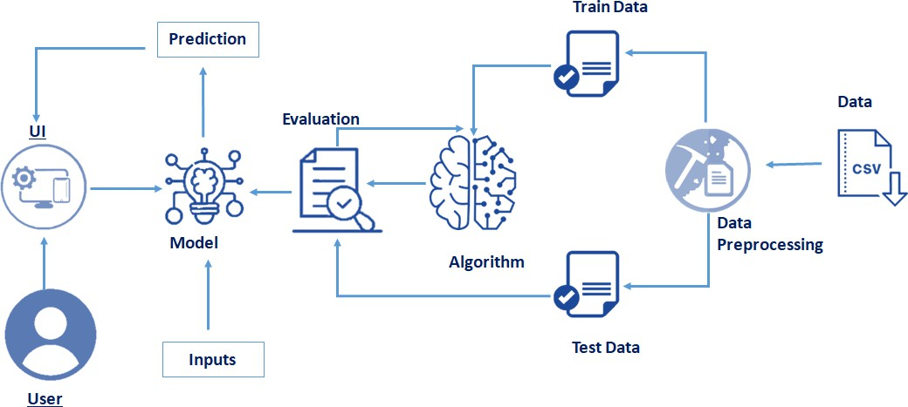

# Project Planning & Scheduling

|  |  |
| --- | --- |
| Date | 28 June 2025 |
| Team ID | LTVIP2025TMID33649 |
| Project Name | Liver Cirrhosis Prediction |
| Maximum Marks | 5 Marks |

**Product Backlog**

**Member 1 ->** Data Preprocessing **Member 2 ->** Model Building **Member 3 ->** Frontend **Member 4 ->** Backend

|  |  |  |  |  |  |
| --- | --- | --- | --- | --- | --- |
| **Epic (Functional Requirement)** | **User Story Number** | **User Story / Task** | **Story Points** | **Priority** | **Assigned To** |
| Data Collection | USN-1 | Gather and load historical traffic/contextual data | 2 | High | Member 1 |
| Data Preprocessing | USN-2 | Preprocess data (handle missing/categorical  values) | 3 | High | Member 1 |
| Model Building | USN-3 | Build ML model for traffic prediction | 5 | High | Member 2 |
| Model Evaluation | USN-4 | Test and evaluate the ML model | 3 | High | Member 2 |
| Backend API | USN-5 | Develop Flask backend and REST API | 4 | High | Member 4 |
| Frontend/Dashboard | USN-6 | Implement user-friendly web dashboard  (HTML/CSS/JS) | 4 | Medium | Member 3 |
| Integration | USN-7 | Integrate backend API with frontend | 2 | High | Member 3,  Member 4 |

|  |  |  |  |  |  |
| --- | --- | --- | --- | --- | --- |
| **Epic (Functional Requirement)** | **User Story Number** | **User Story / Task** | **Story Points** | **Priority** | **Assigned To** |
| Scenario Simulation | USN-8 | Allow users to simulate cirrhosis risk for hypothetical health scenarios | 2 | Medium | Member 2  Member 4  Member 3 |

# Sprint Schedule & Estimation

**Sprint-1 (10 June – 15 June)**

|  |  |  |  |
| --- | --- | --- | --- |
| **User Story Number** | **Task** | **Story Points** | **Assigned To** |
| USN-1 | Data collection and loading | 2 | Member 1 |
| USN-2 | Data preprocessing (missing/categorical) | 3 | Member 1 |
| USN-3 | Model building | 3 | Member 2 |
|  | **Total** | **8** |  |

**Sprint-2 (16 June – 21 June)**

|  |  |  |  |
| --- | --- | --- | --- |
| **User Story Number** | **Task** | **Story Points** | **Assigned To** |
| USN-4 | Model evaluation | 3 | Member 2 |
| USN-5 | Backend API scaffolding & endpoints | 3 | Member 1 |
| USN-6 | Frontend dashboard basic layout | 2 | Member 3 |
| USN-7 | API-frontend integration | 2 | Member 3,  Member 4 |
|  | **Total** | **10** |  |

**Sprint-3 (22 June – 28 June)**

|  |  |  |  |
| --- | --- | --- | --- |
| **User Story Number** | **Task** | **Story Points** | **Assigned To** |
| USN-6 | Frontend UI enhancements | 2 | Member 3 |
| USN-8 | Scenario simulation logic | 2 | Member 2,  Member 4 |
| USN-9 | Feedback/contact form | 1 | Member 3 |
| USN-10 | Documentation | 2 | All |
|  | Polish, bug fixes, final testing | 2 | All |
|  | **Total** | **9** |  |

**Total Story Points: 8 + 10 + 9 = 27**

# Velocity

Total Story Points =27

Total Number of Sprints =3 Velocity = 27/3 =9

**Team’s Velocity is 9**

**Sprint Tracker**

|  |  |  |  |  |  |  |
| --- | --- | --- | --- | --- | --- | --- |
| **Sprint** | **Story Points Planned** | **Story Points Completed** | **Start Date** | **Planned End Date** | **Actual End Date** | **Comments** |
| Sprint- 1 | 8 | 8 | 10-Jun-  2025 | 15-Jun-  2025 | 15-Jun-  2025 |  |
| Sprint- 2 | 10 | 10 | 16-Jun-  2025 | 21-Jun-  2025 | 21-Jun-  2025 |  |
| Sprint- 3 | 9 | 9 | 22-Jun-  2025 | 28-Jun-  2025 | 28-Jun-  2025 |  |

1. **Performance Testing**

|  |  |
| --- | --- |
| Date | 28 June 2025 |
| Team ID | LTVIP2025TMID33649 |
| Project Name | Liver Cirrhosis Prediction |
| Maximum Marks | 10 Marks |

|  |  |  |  |
| --- | --- | --- | --- |
| **S.No**. | **Paramater** | **Values** | **Screenshot** |
| 1. | Metrics | **Regression Model:**  Accuracy - ,  Precision - ,  Recall - ,  F1 Score - | modeltraining |
| 2. | Tune the Model | Hyperparameter Tuning - Validation Method | hypertuning |

1. **Results**
   1. **Model Performance**

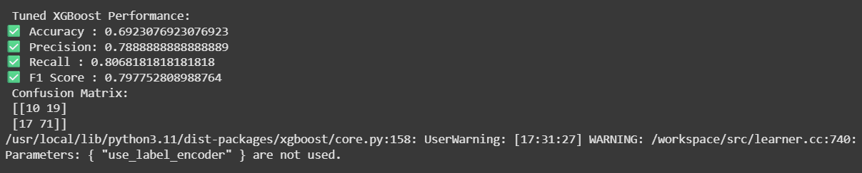

* **Prediction sample:**
  + **Input:**

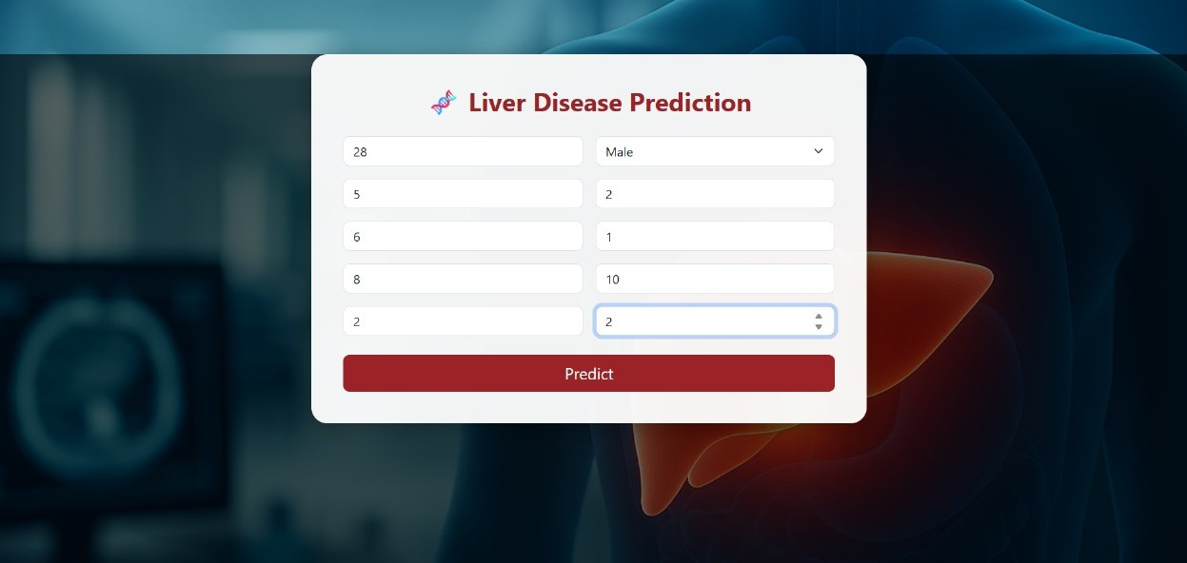

* + **Output:**

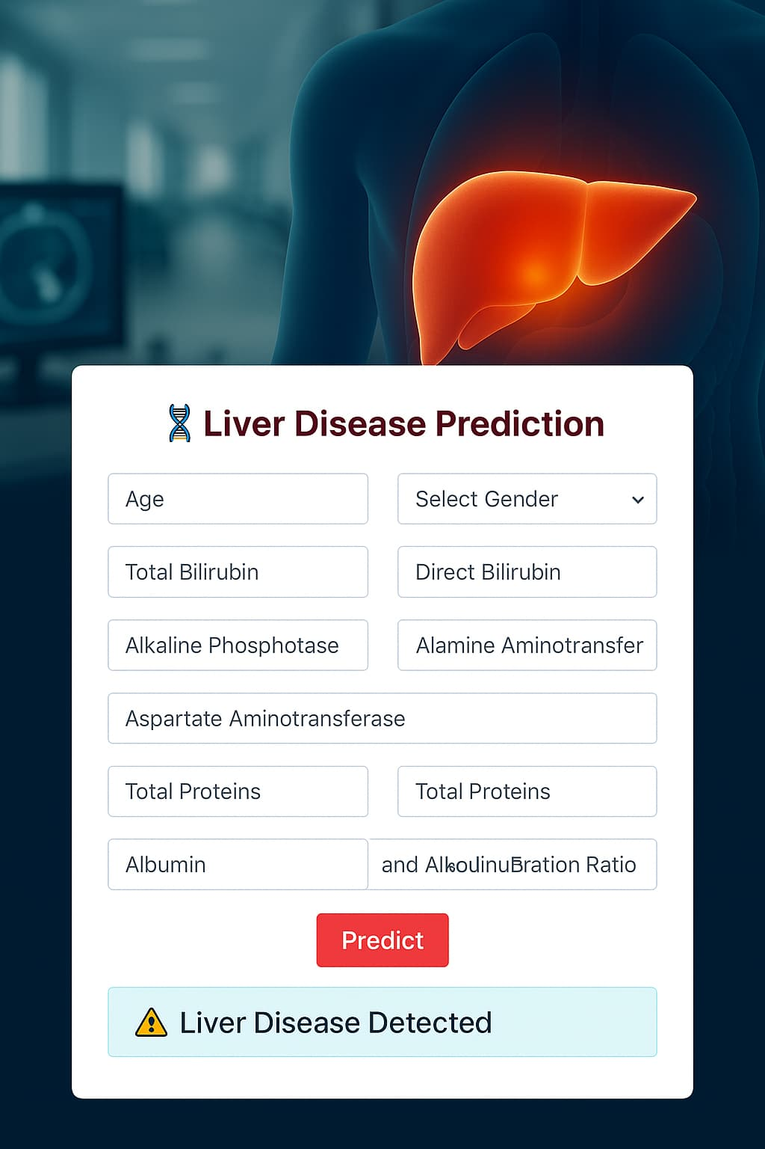

* 1. **User Interface**
* **Overview**

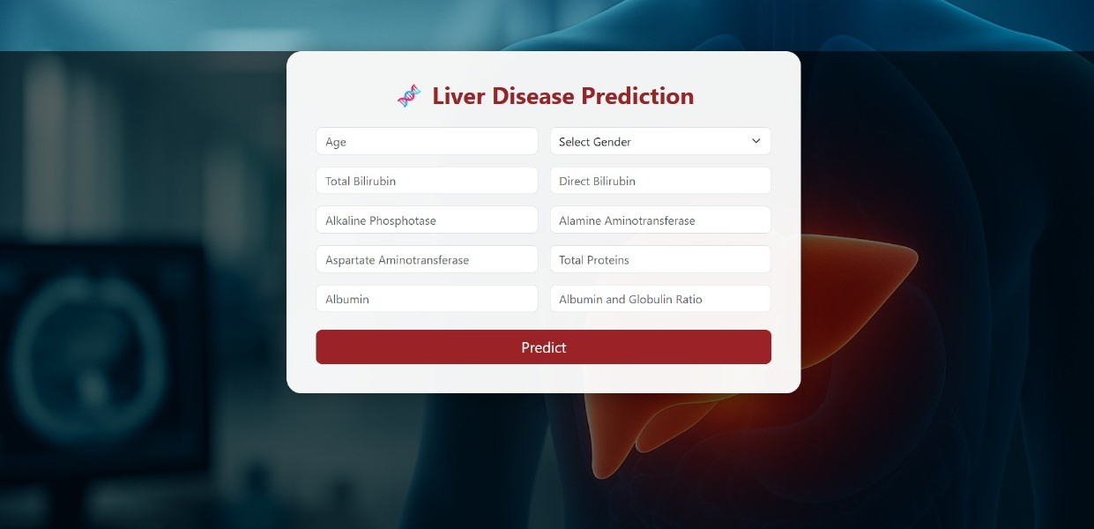

# Advantages & Disadvantages

* 1. **Advantages**
     + Real-time, accurate predictions
     + Low-cost, scalable solution
     + Intuitive web interface
     + Extensible for future enhancements
  2. **Disadvantages**
     + ML model accuracy depends on data quality/coverage
     + Requires basic digital literacy

# Conclusion

The Liver Cirrhosis Prediction project successfully demonstrates the potential of machine learning in transforming early diagnosis and proactive healthcare. By leveraging non-invasive clinical data, the system provides accurate and accessible risk assessments, addressing critical limitations of traditional diagnostic methods such as high costs and late-stage detection.

# Future Scope

* Advanced Features(Live risk monitoring)
* Mobile app development
* Multi-Language Support
* Adapt model for HBV/alcohol-related cirrhosis in other regions
* Direct API links to hospital records

# Appendix

**Source Code**

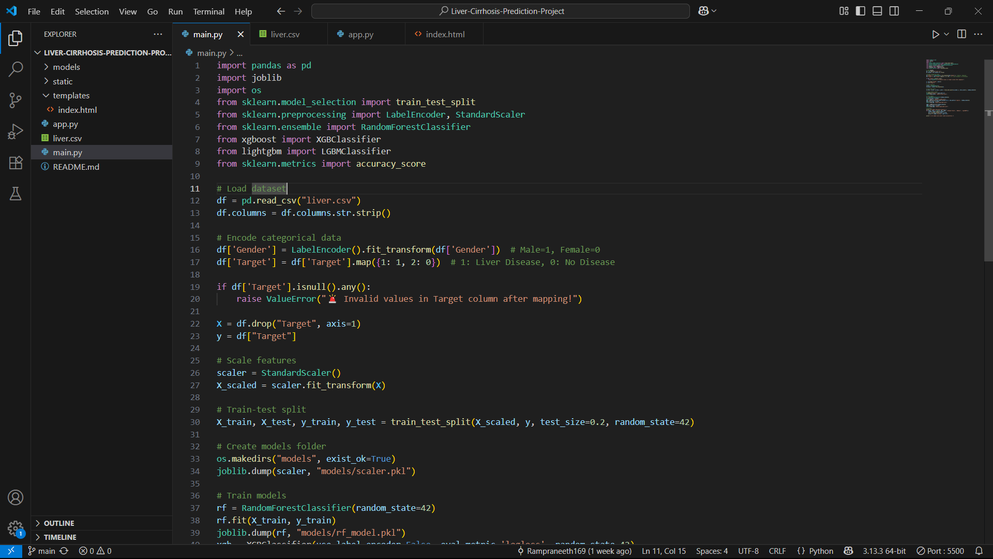

* 1. Main.py

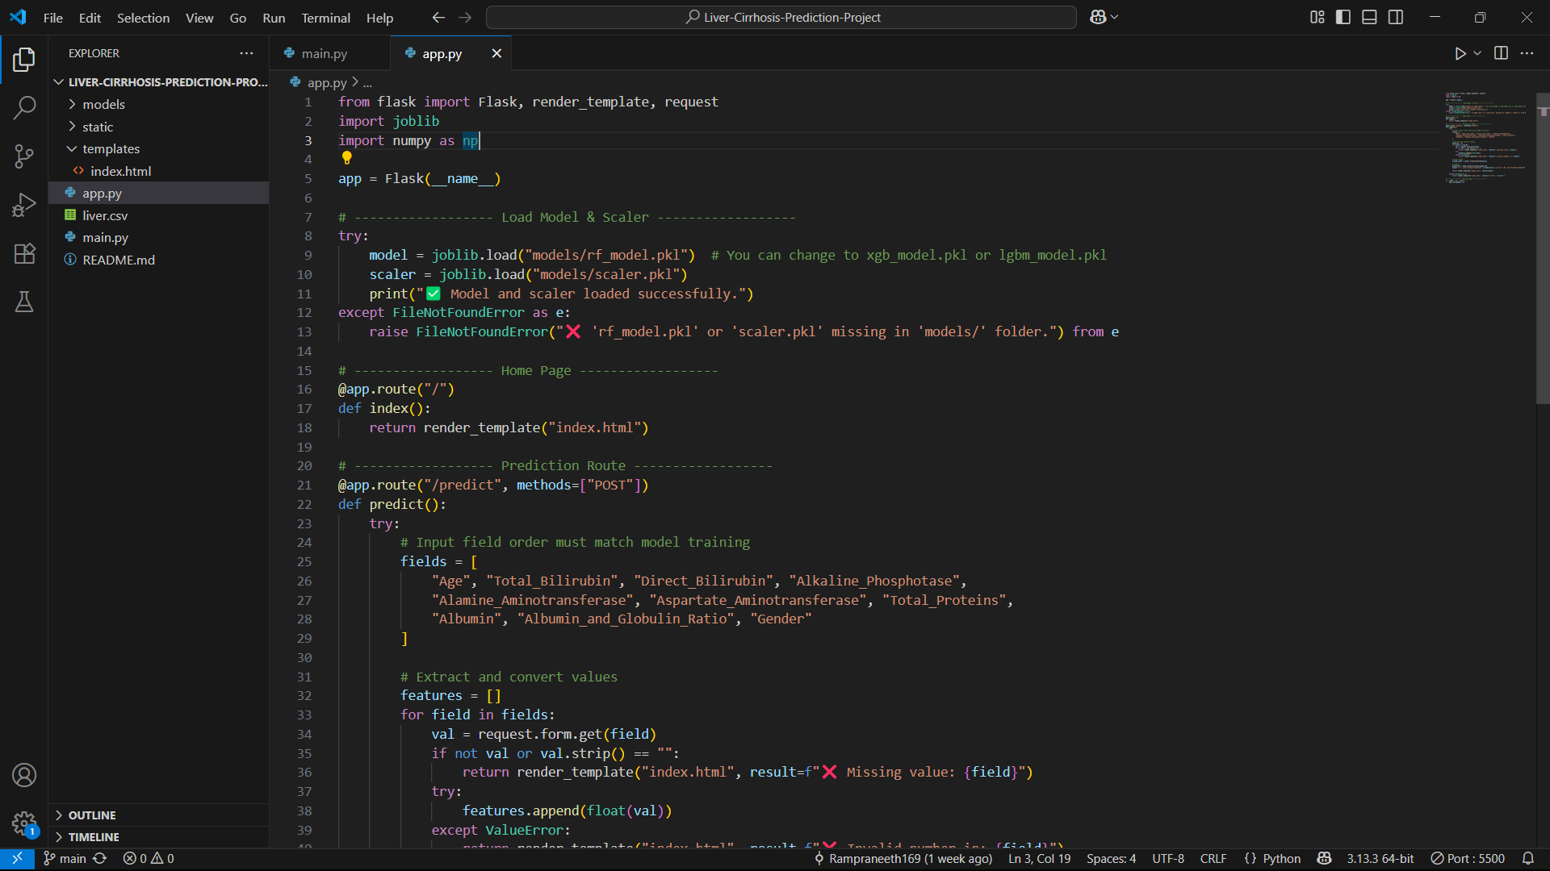

* 1. app.y

# Data Set Link

Click to preview the data set -> [Data Set](https://drive.google.com/file/d/1u24zwDVySUGND1RQrC60S-uy29RZTNVY/view?usp=sharing)

# Git Hub Link

Click to preview the Git Hub Repo -> [Git Hub Repo](https://github.com/Rampraneeth169/Liver-Cirrhosis-Prediction-Project)

# Project Demo Link

Click to preview the Project Demo Link -> [Demo Vedio](https://drive.google.com/file/d/1en2j7ml8gRp7NnVHfAteUMWk0KIaK26H/view?usp=sharing)

**The End**