Docker

Why docker:

Docker is all about speed..Develop faster, build faster, test faster, deploy faster,update faster, retrieve faster.

Two types of docker containers. Windows containers and Linux containers.

Docker commands: docker version -- verified cli can talk to engine

Docker info -- most config values of engine

Docker command line structure -- docker <command> <sub-command> (options)

**Image vs containers :**

An image is an application we want to run.

A container is an instance of that image running as a process.

You can have many of the containers running off the same image.

Docker’s default image “registry” is called docker HUB(hub.docker.com).

**Creating and using containers:**

**docker container run --publish 80:80 nginx**

1. Downloaded image nginx from docker hub.
2. Started new container from that image
3. Opened port 80 on the host IP
4. Routed the trafic to the container IP,Port 80

**List of container :** docker container ls (only running containers)

To stop container docker container stop <container-id>

Docker container ls -a : list of all containers

**Run vs start:** 1.docker container run - always starts a new container

2.docker container start -- start an existing stopped one.

**docker container run --publish 80:80 --detach --name parvathi nginx**

To provide a name to a container.

Docker container logs <container-name> --shows logs for a specific container.

Docker container top <container-name > -- displays process in a container.

Docker container --help -- all the container commands

Docker container rm <container-name> -- deletes container( container should not be in running state)

Docker container rm -f <container-name>-- forcefully deletes running containers also

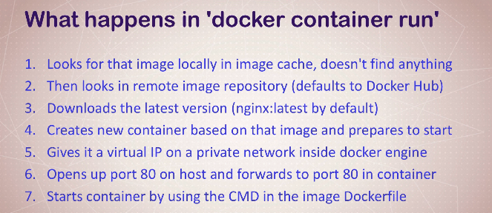

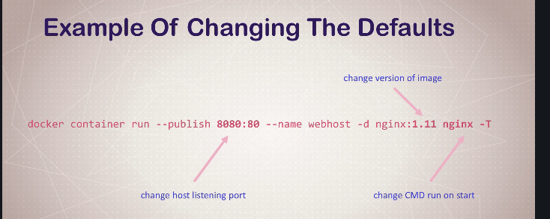

Container vs VM :

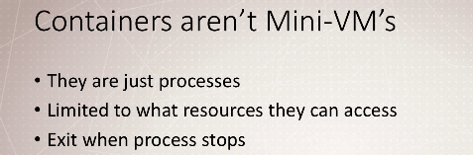

Docker run --name mongo -d mongo

Docker ps