**MERGE TWO SORTED ARRAYS**

**PROGRAM:**

#include<stdio.h>

void read(int *,int);

void read1(int *,int);

int main()

{

int a[20],b[20],c[20],k=0,n1,n2;

printf("Enter the number of element n1\n");

scanf("%d",&n1);

read(a,n1);

printf("Enter the number of element n2\n");

scanf("%d",&n2);

read1(b,n2);

int i=0;

int j=0;

k=0;

while(i<n1 && j<n2)

{

if(a[i]<b[j])

{

c[k]=a[i];

i++;

}

else if(a[i]>b[i])

{

c[k]=b[j];

j++;

}

else

{

c[k]=a[i];

i++;

j++;

}

k++;

}

while(i<n1)

{

c[k]=a[i];

i++;

k++;

}

while(j<n2)

{

c[k]=b[j];

j++;

k++;

}

for(i=0;i<k;i++)

{

printf("%d ",c[i]);

}

}

void read(int *a,int n1)

{

int i;

printf("enter the element\n");

for(i=0; i<n1;i++)

{

scanf("%d",&a[i]);

}

}

void read1(int *b,int n2)

{

int j;

printf("enter the elements\n");

for(j=0 ;j<n2;j++)

{

scanf("%d",&b[j]);

}

}

**OUT PUT:**

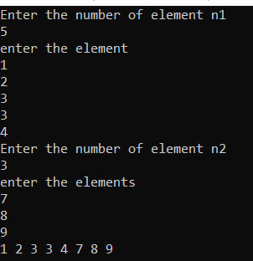

**CIRCULAR QUEUE**

**PROGRAM:**

#include<stdio.h>

void insert(int *);

void display(int *);

void delet(int *);

void search(int *);

int front=-1,rear=-1,sz=4;

void main()

{

int q[20],opt;

do {

printf("\nMenu");

printf("\n1.Insert\n2.Delete\n3.Search\n4.Display\n5.Exit\n");

printf("Select your option\n");

scanf("%d",&opt);

switch(opt)

{

case 1:

insert(q);

break;

case 2:

delet(q);

break;

case 3:

search(q);

break;

case 4:

display(q);

break;

default:

printf("Exited");

}

}while(opt!=5);

}

void insert(int *q)

{

if(front==(rear+1)%sz)

{

printf("Queue is full\n");

return;

}

if(front==-1)

front=0;

rear=(rear+1)%sz;

printf("Enter the element to insert\n");

scanf("%d",&q[rear]);

}

void delet(int *q)

{

if(front==-1)

{

printf("Queue is empty\n");

return;

}

printf("Deleted Element %d",q[front]);

if(front==rear)

front=rear=-1;

else

front=(front+1)%sz;

printf("\n");

return;

}

void display(int *q)

{

int f;

if(front==-1)

{

printf("\nQ is empty");

return;

}

f=front;

printf("\nElements in the queue:");

while(1)

{

printf("%d\t",q[f]);

if(f==rear)

break;

f=(f+1)%sz;

}

printf("\n");

}

void search(int *q)

{

int f,n,c=0;

printf("Enter the element to search\n");

scanf("%d",&n);

if(front==-1)

{

printf("Q is empty");

return;

}

f=front;

while(1)

{

if(n==q[f])

{

printf("%d",q[f]);

printf("\nElement found");

break;

}

if(f==rear)

{

printf("\nElement not found");

break;

}

f=(f+1)%sz;

}

printf("\n");

}

**OUT PUT :**

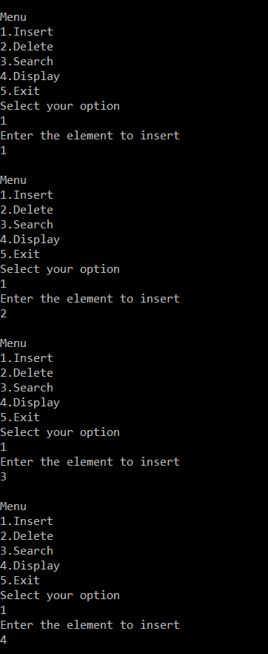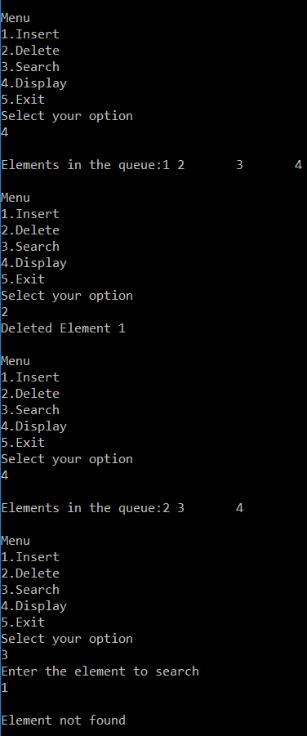

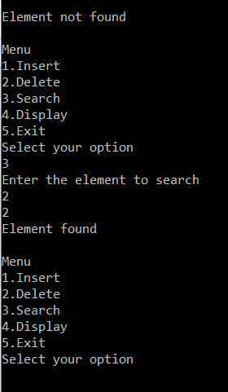

**SINGLY LINKED STACK**

**PROGRAM:**

#include<stdio.h>

#include<stdlib.h>

void push();

void pop();

void search();

void display();

struct node

{

int data;

struct node *next;

};

struct node *top=NULL;

void main()

{

int opt;

do

{

printf("\nMenu");

printf("\n1.push\n2.pop\n3.search\n4.display\n5.Exit");

printf("\nSelect your option:");

scanf("%d",&opt);

switch(opt)

{

case 1:

push();

break;

case 2:

pop();

break;

case 3:

search();

break;

case 4:

display();

break;

default:

printf("Exited");

break;

}

}while(opt!=5);

}

void push()

{

int x;

struct node *ne;

printf("Enter the Element to push:");

scanf("%d",&x);

ne=(struct node *)malloc(sizeof(struct node));

if(ne==NULL)

{

printf("Stack Overflow");

return;

}

ne->data=x;

ne->next=top;

top=ne;

}

void pop()

{

int item;

struct node *ptr;

if(top==NULL)

printf("\nStack is empty");

else

{

item=top->data;

ptr=top;

printf("\nPoped Element=%d",item);

top=top->next;

free(ptr);

}

}

void search()

{

int c=0,x,f=0;

struct node *ptr;

if(top==NULL)

printf("\nStack is empty");

else

{

printf("\nEnter the element to search:");

scanf("%d",&x);

ptr=top;

while(ptr!=NULL)

{

if(ptr->data==x)

{

f=1;

printf("\nElement found at node %d",c);

break;

}

ptr=ptr->next;

c++;

}

if(f==0)

printf("\nElement not found");

}

}

void display()

{

struct node *ptr;

if(top==NULL)

printf("Stack empty");

else

{

ptr=top;

printf("\nElements in stack:");

while(ptr!=NULL)

{

printf("%d\t",ptr->data);

ptr=ptr->next;

}}}

**OUT PUT:**

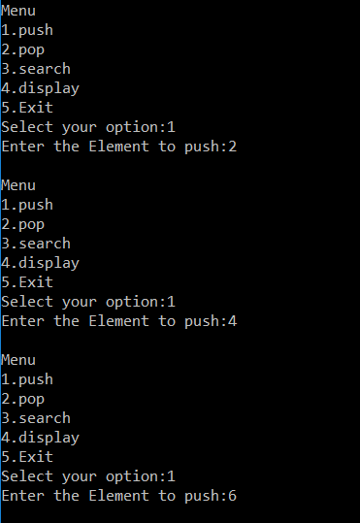

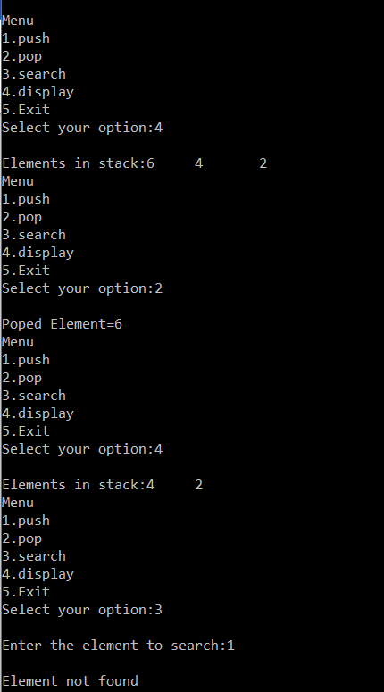

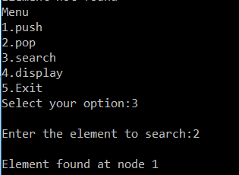

**DOUBLY LINKED LIST**

**PROGRAM:**

#include<stdlib.h>

#include<stdio.h>

void insert_first();

void insert_last();

void insert_pos();

void delete_first();

void delete_last();

void delete_pos();

void search();

void display();

struct node

{

struct node *left;

int data;

struct node *right;

};

struct node *head=NULL;

void main()

{

int opt;

do

{

printf("\nMenu");

printf("\n1.Insert At First\n2.Insert At Last\n3.Search\n4.display\n5.Delete First\n6.Delete Last\n7.Insert at position\n8.Delete At Position\n9.Exit");

printf("\nSelect your option:");

scanf("%d",&opt);

switch(opt)

{

case 1:

insert_first();

break;

case 2:

insert_last();

break;

case 3:

search();

break;

case 4:

display();

break;

case 5:

delete_first();

break;

case 6:

delete_last();

break;

case 7:

insert_pos();

break;

case 8:

delete_pos();

break;

default:

printf("Exited");

}

}while(opt!=9);

}

void insert_first()

{

int x;

struct node *ne;

ne=(struct node *)malloc(sizeof(struct node));

if(ne==NULL)

printf("Insufficient Memory");

else

{

printf("\nEnter the data to insert\n");

scanf("%d",&x);

ne->data=x;

ne->left=NULL;

ne->right=NULL;

if(head==NULL)

head=ne;

else

{

ne->right=head;

head->left=ne;

head=ne;

}}

}

void insert_last()

{

int x;

struct node *ne,*ptr;

ne=(struct node *)malloc(sizeof(struct node));

if(ne==NULL)

printf("Insufficient Memory");

else

{

printf("\nEnter the data to insert\n");

scanf("%d",&x);

ne->data=x;

ne->left=NULL;

ne->right=NULL;

if(head==NULL)

head=ne;

else

{

ptr=head;

while(ptr->right!=NULL)

{

ptr=ptr->right;

}

ptr->right=ne;

ne->left=ptr;

}}}

void insert_pos()

{

int x,k;

struct node *ne,*ptr,*ptr1;

ne=(struct node *)malloc(sizeof(struct node));

if(ne==NULL)

printf("Insufficient Memory");

else

{

printf("\nEnter the data to insert\n");

scanf("%d",&x);

printf("\nEnter the key value\n");

scanf("%d",&k);

ne->data=x;

ne->left=NULL;

ne->right=NULL;

if(head==NULL)

head=ne;

else

{

ptr=head;

while(ptr->right!=NULL && ptr->data!=k)

ptr=ptr->right;

if(ptr->right==NULL)

{

ptr->right=ne;

ne->left=ptr;

}

else

{

ptr1=ptr->right;

ne->right=ptr1;

ptr1->left=ne;

ptr->right=ne;

ne->left=ptr;

}}}}

void delete_first()

{

struct node *ptr;

if(head==NULL)

printf("List is Empty");

else

{

ptr=head;

if(ptr->right==NULL)

{

head=NULL;

free(ptr);

}

else

{

if(head!=NULL)

{

head->left=NULL;

head=head->right;

free(ptr);

}}}}

void delete_last()

{

struct node *ptr,*prev;

if(head==NULL)

printf("List is Empty");

else

{

if(head->right==NULL)

{

free(head);

head=NULL;

}

else

{

ptr=head;

while(ptr->right!=NULL)

{

ptr=ptr->right;

}

prev=ptr->left;

prev->right=NULL;

free(ptr);

}}}

void delete_pos()

{

struct node *ptr,*next,*prev;

int x;

if(head==NULL)

printf("\nList is empty");

else

{

printf("\nEnter the data:\n");

scanf("%d",&x);

if(head->data==x)

{

ptr=head;

head=head->right;

if(head!=NULL)

{

head->left=NULL;

}

free(ptr);return;

}

ptr=head;

while(ptr->data!=x && ptr->right!=NULL)

ptr=ptr->right;

if(ptr->data==x)

{

next=ptr->right;

prev=ptr->left;

prev->right=ptr->right;

if(next!=NULL)

next->left=prev;

free(ptr);

return;

}

printf("\nElement not found");

}}

void display()

{

struct node *ptr;

if(head==NULL)

printf("List is empty");

else

{

ptr=head;

printf("List:");

while(ptr!=NULL)

{

printf("%d\t",ptr->data);

ptr=ptr->right;

}}}

void search()

{

struct node *ptr;

int x,c=0;

if(head==NULL)

printf("List is empty");

else{

printf("Enter the element to search\n");

scanf("%d",&x);

ptr=head;

while(ptr!=NULL)

{

if(ptr->data==x)

{

c=1;

printf("\nElement found:");

break;

}

ptr=ptr->right;

}

if(c==0)

printf("\nElement not found");

}}

**OUTPUT:**

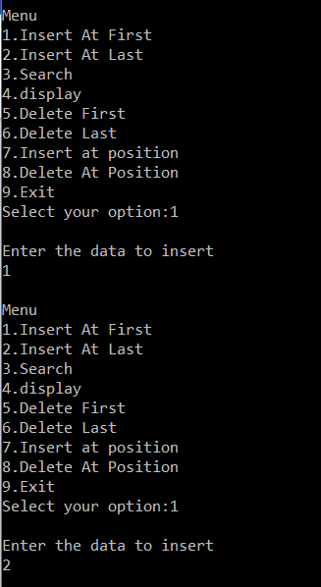

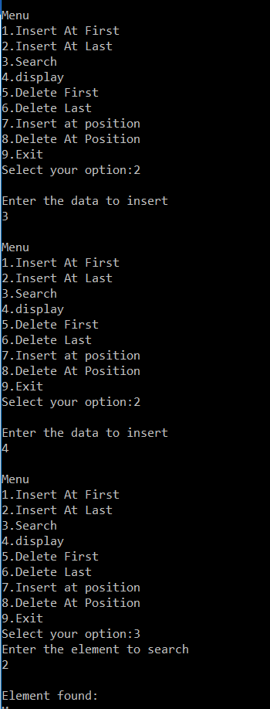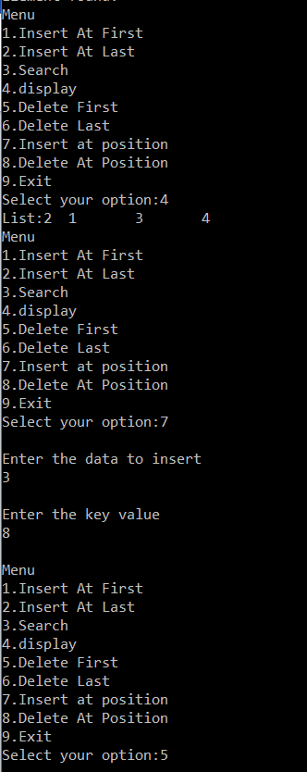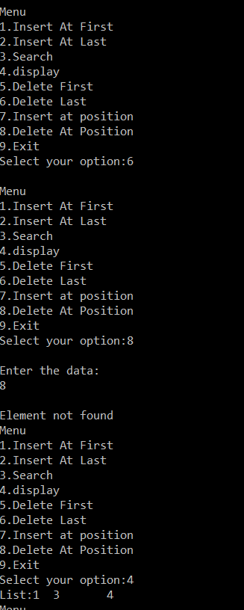

**BINARY SEARCH TREE**

**PROGRAM:**

#include<stdio.h>

#include<stdlib.h>

struct node

{

struct node *left;

int data;

struct node *right;

};

void insert();

void search();

void inorder(struct node *);

void preorder(struct node *);

void postorder(struct node *);

void delet(int);

struct node *root=NULL;

int main()

{

int opt,x;

do

{

printf("\nMenu-Binary Search Tree");

printf("\n1.Insertion\n2.Inorder\n3.Preorder\n4.Postorder\n5.Search\n6.Deletion\n7.Exit");

printf("\nSelect your option:");

scanf("%d",&opt);

switch(opt)

{

case 1:

insert();

break;

case 2:

inorder(root);

break;

case 3:

preorder(root);

break;

case 4:

postorder(root);

break;

case 5:

search();

break;

case 6:

printf("\nEnter the element to delete:\n");

scanf("%d",&x);

delet(x);

break;

default:

printf("Exited\n");

}

}while(opt!=7);

}

void insert()

{

int x;

struct node *ne,*ptr,*ptr1;

ne=(struct node *)malloc(sizeof(struct node));

if(ne==NULL)

{

printf("Insufficient Memory");

return;

}

printf("Enter the data to insert:");

scanf("%d",&x);

ne->left=NULL;

ne->right=NULL;

ne->data=x;

if(root==NULL)

{

root=ne;

return;

}

ptr=root;

while(ptr!=NULL)

{

if(x==ptr->data)

{

printf("Item already exist\n");

return;

}

if(x>ptr->data)

{

ptr1=ptr;

ptr=ptr->right;

}

else

{

ptr1=ptr;

ptr=ptr->left;

}}

if(ptr==NULL)

{

if(x>ptr1->data)

ptr1->right=ne;

else

ptr1->left=ne;

}}

void inorder(struct node * ptr)

{

if(ptr!=NULL)

{

inorder(ptr->left);

printf("%d ",ptr->data);

inorder(ptr->right);

}}

void preorder(struct node * ptr)

{

if(ptr!=NULL)

{

printf("%d ",ptr->data);

preorder(ptr->left);

preorder(ptr->right);

}

}

void postorder(struct node * ptr)

{

if(ptr!=NULL)

{

postorder(ptr->left);

postorder(ptr->right);

printf("%d ",ptr->data);

}}

void search()

{

struct node *ptr;

int x;

ptr=root;

printf("Enter the data to search:");

scanf("%d",&x);

while(ptr!=NULL)

{

if(ptr->data==x)

{

printf("Data present\n");

return;

}

if(x>ptr->data)

ptr=ptr->right;

else

ptr=ptr->left;

}

if(ptr==NULL)

printf("Data not present\n");

}

void delet(int x)

{

struct node *ptr,*parent,*p;

int dat;

if(root==NULL)

{

printf("Tree is empty");

return;

}

parent=NULL;

ptr=root;

while(ptr!=NULL)

{

if(ptr->data==x)

break;

parent=ptr;

if(x>ptr->data)

ptr=ptr->right;

else

ptr=ptr->left;

}

if(ptr==NULL)

{

printf("Item not present");

return;

}

if(ptr->right==NULL && ptr->left==NULL)

{

if(parent==NULL)

root=NULL;

else if(parent->right==ptr)

parent->right=NULL;

else

parent->left=NULL;

printf("Element deleted");

free(ptr);

return;

}

if(ptr->right!=NULL && ptr->left!=NULL)

{

p=ptr->right;

while(p->left!=NULL)

{

p=p->left;

}

dat=p->data;

delet(p->data);

ptr->data=dat;

return;

}

if(parent==NULL)

{

if(ptr->right==NULL)

root=ptr->left;

else

root=ptr->right;

}

else

{

if(parent->right==ptr)

{

if(ptr->right==NULL)

parent->right=ptr->left;

else

parent->right=ptr->right;

}

else

{

if(ptr->left==NULL)

parent->left=ptr->right;

else

parent->left=ptr->left;

}

}

printf("\nElement deleted");

free(ptr);

return;

}

**OUT PUT:**

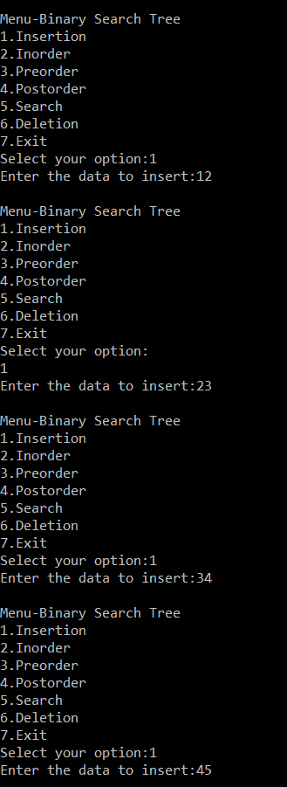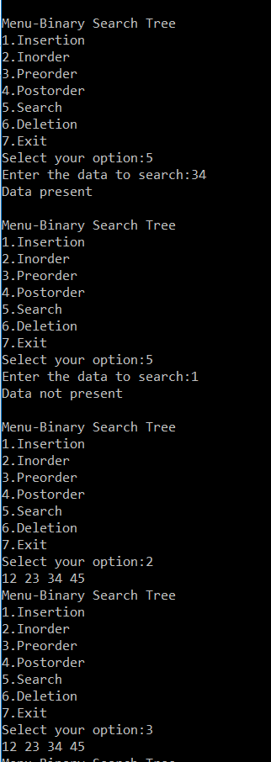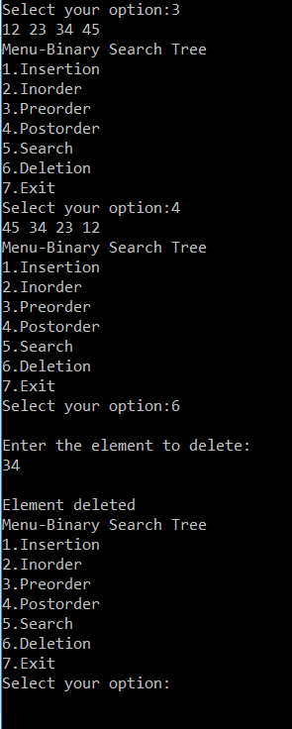

**SET DATASTRUCTURE OPERATIONS USING BITSTRING**

**PROGRAM:**

#include<stdio.h>

#include<stdlib.h>

#include<string.h>

void setunion(char*,char*,char*);

void setintersection(char*,char*,char*);

void setdifference(char*,char*,char*);

void main()

{

char s1[20],s2[20],s3[20];

printf("enter set 1:\n");

scanf("%s",s1);

printf("enter set 2:\n");

scanf("%s",s2);

setunion(s1,s2,s3);

printf("\n union :\n %s",s3);

setintersection(s1,s2,s3);

printf("\n intersection :\n %s",s3);

setdifference(s1,s2,s3);

printf("\n difference :\n %s",s3);

printf("\n");

}

void setunion(char *s1,char *s2,char *s3)

{

int i,l=strlen(s1);

for(i=0;i<l;i++)

{

if(s1[i]=='0' && s2[i]=='0')

{

s3[i]='0';

}

else

{

s3[i]='1';

}}

s3[i]='\0';

}

void setintersection(char *s1,char *s2,char *s3)

{

int i,l=strlen(s1);

for(i=0;i<l;i++)

{

if(s1[i]=='1' && s2[i]=='1')

{

s3[i]='1';

}

else

{

s3[i]='0';

}}

s3[i]='\0';

}

void setdifference(char *s1,char *s2,char *s3)

{

int i,l=strlen(s1);

for(i=0;i<l;i++)

{

if(s1[i]=='1' && s2[i]=='0')

{

s3[i]='1';

}

else

{

s3[i]='0';

}}

s3[i]='\0';

printf("\n");

}

**OUT PUT:**

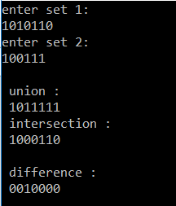

**DISJOINT SETS**

**PROGRAM:**  
#include<stdlib.h>  
#include<stdio.h>  
struct node {  
int data;  
struct node *next;  
};  
void makeset();  
void unionset();  
int find(int);  
void display();  
int n=0;  
struct node *first[20];  
void main()  
{  
int opt,x,i;  
do {  
printf("Menu");  
printf("\n1.makeset\n2.union\n3.find\n4.display\n5.exit");  
printf("\nselect your option");  
scanf("%d",&opt);  
switch(opt)  
{  
case 1:  
makeset();  
break;  
case 2:  
unionset();  
break;  
case 3:  
printf("Enter the value for x:");  
scanf("%d",&x);  
i=find(x);  
if(i==-1)  
printf("Element not found");  
else  
printf("Element=%d",first[i]->data);  
break;  
case 4:  
display();  
break;  
}  
}while(opt!=5);  
}  
void makeset()  
{  
int x,pos;  
printf("\nEnter the element:");  
scanf("%d",&x);  
pos=find(x);  
if (pos==-1)  
{  
first[n]=(struct node *)malloc(sizeof(struct node *));  
first[n]->data=x;  
first[n]->next=NULL;  
n++;  
}  
else  
printf("Element already exist");  
}  
int find(int x)  
{  
int i,flag=0;  
struct node *p;  
for(i=0;i<n;i++)  
{  
p=first[i];  
while(p!=NULL)  
{  
if(p->data==x)  
{  
flag=1;  
break;  
}  
p=p->next;  
}  
if (flag==1)  
break;  
}  
if(flag==1)  
return i;  
else  
return -1;  
}  
void unionset()  
{  
int a,b,i,j;  
struct node *p;  
printf("\nEnter the first element:");  
scanf("%d",&a);  
printf("\nEnter the second element:");  
scanf("%d",&b);  
i=find(a);  
j=find(b);  
if (i==-1 || j ==-1)  
{  
printf("element not found");  
return;  
}  
if (i==j)  
printf("Both are in the same set");  
else  
{  
p=first[i];  
while(p->next!=NULL)  
p=p->next;  
p->next=first[j];  
first[j]=NULL;  
}}  
void display()  
{  
int i;  
struct node *p;  
for(i=0;i<n;i++)  
{  
p=first[i];  
if(p==NULL)  
continue;  
printf("{");  
while(p!=NULL)  
{  
printf("%d ",p->data);  
p=p->next;  
}  
printf("}\n");  
}}

**OUT PUT:**

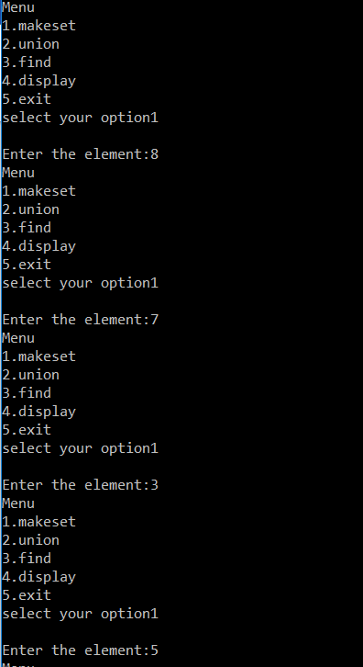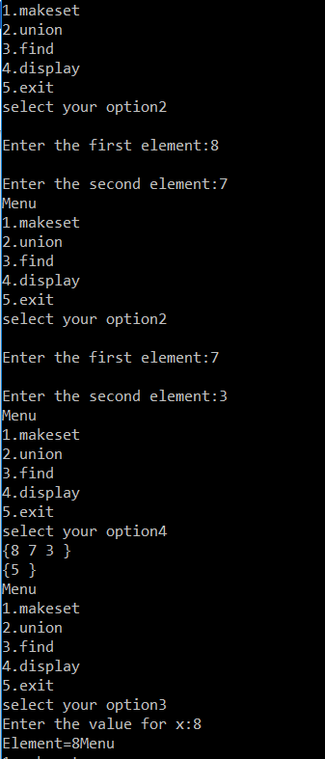

**MINIMUM SPANNING TREE USING KRUSKAL’S ALGORITHM**

**PROGRAM**:

#include<stdio.h>

#include<stdlib.h>

#define MAX 100

#define NIL -1

struct edge

{

int u;

int v;

int weight;

struct edge *link;

}*front = NULL;

void make_tree(struct edge tree[]);

void insert_pque(int i,int j,int wt);

struct edge *del_pque();

int isEmpty_pque( );

void create_graph();

int n;

int main()

{

int i;

struct edge tree[MAX];

int wt_tree = 0;

create_graph();

make_tree(tree);

printf("\nEdges to be included in minimum spanning tree are :\n");

for(i=1; i<=n-1; i++)

{

printf("\n%d->",tree[i].u);

printf("%d\n",tree[i].v);

wt_tree += tree[i].weight;

}

printf("\nWeight of this minimum spanning tree is : %d\n", wt_tree);

return 0;

}

void make_tree(struct edge tree[])

{

struct edge *tmp;

int v1,v2,root_v1,root_v2;

int father[MAX];

int i,count = 0;

for(i=0; i<n; i++)

father[i] = NIL;

while( !isEmpty_pque( ) && count < n-1 )

{

tmp = del_pque();

v1 = tmp->u;

v2 = tmp->v;

while( v1 !=NIL )

{

root_v1 = v1;

v1 = father[v1];

}

while( v2 != NIL )

{

root_v2 = v2;

v2 = father[v2];

}

if( root_v1 != root_v2 )/*Insert the edge (v1, v2)*/

{

count++;

tree[count].u = tmp->u;

tree[count].v = tmp->v;

tree[count].weight = tmp->weight;

father[root_v2]=root_v1;

} }

if(count < n-1)

{

printf("\nGraph is not connected, no spanning tree possible\n");

exit(1);

}

}/*End of make_tree()*/

/*Inserting edges in the linked priority queue */

void insert_pque(int i,int j,int wt)

{

struct edge *tmp,*q;

tmp = (struct edge *)malloc(sizeof(struct edge));

tmp->u = i;

tmp->v = j;

tmp->weight = wt;

/*Queue is empty or edge to be added has weight less than first edge*/

if( front == NULL || tmp->weight < front->weight )

{

tmp->link = front;

front = tmp;

}

else

{

q = front;

while( q->link != NULL && q->link->weight <= tmp->weight )

q = q->link;

tmp->link = q->link;

q->link = tmp;

if(q->link == NULL) /*Edge to be added at the end*/

tmp->link = NULL;

}

}/*End of insert_pque()*/

struct edge *del_pque()

{

struct edge *tmp;

tmp = front;

front = front->link;

return tmp;

}

int isEmpty_pque( )

{

if ( front == NULL )

return 1;

else

return 0;

}

void create_graph()

{

int i,wt,max_edges,origin,destin;

printf("\nEnter number of vertices : ");

scanf("%d",&n);

max_edges = n*(n-1)/2;

for(i=1; i<=max_edges; i++)

{

printf("\nEnter edge %d(-1 -1 to quit): ",i);

scanf("%d %d",&origin,&destin);

if( (origin == -1) && (destin == -1) )

break;

printf("\nEnter weight for this edge : ");

scanf("%d",&wt);

if( origin >= n || destin >= n || origin<0 || destin<0)

{

printf("\nInvalid edge!\n");

i--;

}

else

insert_pque(origin,destin,wt);

}

}

**OUT PUT:**

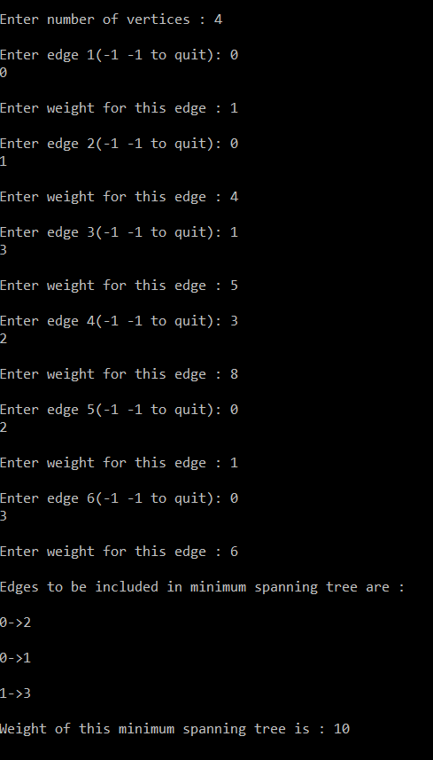

**RED BLACK TREE OPERATIONS**

**PROGRAM:**

#include<stdio.h>

#include<stdlib.h>

#define red 1

#define black 0

struct node

{ int data,color;

struct node *right,*left;

} ;

void doop(struct node *,struct node *,struct node *);

void RRRotation(struct node *);

void LLRotation(struct node *);

struct node *ROOT=NULL;

struct node* findParent(struct node *n) ;

//function to reserve memory for a node

struct node * getNode()

{

struct node *ne;

ne=(struct node *) malloc(sizeof(struct node));

if (ne==NULL)

printf("No Memory");

return ne;

}

//function for inorder traversal

void inorder(struct node *ptr)

{ if (ptr!=NULL)

{ inorder(ptr->left);

printf("%d(%c) ",ptr->data,ptr->color==0?'b':'r');

inorder(ptr->right);

}

}

//function to find the parent node of a node

struct node* findParent(struct node *n)

{ struct node *ptr=ROOT,*parent=NULL;

int x=n->data;

while(ptr!=n)

{ parent=ptr;

if (x>ptr->data)

ptr=ptr->right;

else

ptr=ptr->left;

}

return parent;

}

//function to insert a value in the Binary search tree

void insert()

{ int x;

struct node *ne,*parent,*ptr,*pparent,*uncle;

//Perform standard BST insertion and make the colour of newly inserted nodes as RED.

printf("Enter the element to insert");

scanf("%d",&x);

ne=getNode();

if (ne==NULL)

return;

ne->data=x;

ne->left=ne->right=NULL;

ne->color=red;

//If x is the root, change the colour of x as BLACK and return

if (ROOT==NULL)

{ ROOT=ne;

ne->color=black;

return;

}

ptr=ROOT;

while(ptr!=NULL)

{

if (ptr->data==x)

{

printf("Data already present");

break;

}

parent=ptr;

if (x>ptr->data)

ptr=ptr->right;

else

ptr=ptr->left;

}

if (ptr!=NULL)

return;

if(x>parent->data)

parent->right=ne;

else

parent->left=ne;

while(ne!=ROOT)

{ //find uncle

parent=findParent(ne);

if (parent->color==black)

break;

if (parent->color==red)

{

pparent=findParent(parent);

if (pparent->right==parent)

uncle=pparent->left;

else

uncle=pparent->right;

//If x’s uncle is BLACK, or NULL then call doop()

if (uncle==NULL)

{

doop(ne,parent,pparent);

break;

}

if (uncle->color==black )

{

doop(ne,parent,pparent);

break;

}

/* If x’s uncle is RED (Grandparent must have been black from property 4)

(1)Change the colour of parent and uncle as BLACK.

(ii) Colour of a grandparent as RED.

(iii) Change x = x’s grandparent, repeat steps 2 and 3 for new x. */

if (uncle->color==red)

{

parent->color=uncle->color=black;

if (pparent!=ROOT)

{ if (pparent->color==red)

pparent->color=black;

else

pparent->color=red;

if(pparent->color==red)

ne=pparent;

}

else

break;

}}}}

void doop(struct node *ne,struct node *parent,struct node *pparent)

{

/*(i) Left Left Case (p is left child of g and x is left child of p)

(ii) Left Right Case (p is left child of g and x is the right child of p)

(iii) Right Right Case (Mirror of case i)

(iv) Right Left Case (Mirror of case ii)*/

if(ne==parent->left && parent==pparent->left)

{ struct node *left=pparent->left;

LLRotation(pparent);

parent->color=parent->color==1?0:1;

pparent->color=pparent->color==1?0:1;

if (pparent==ROOT)

ROOT=left;

}

else if (parent==pparent->left && ne==parent->right)

{ struct node *left=parent->right;

RRRotation(parent);

LLRotation(pparent);

ne->color=ne->color==1?0:1 ;

pparent->color=pparent->color==1?0:1;

if (pparent==ROOT)

ROOT=left;

}

else if ( ne==parent->right && parent==pparent->right)

{ struct node *right=pparent->right;

RRRotation(pparent);

parent->color=parent->color==0?1:0;

pparent->color=pparent->color==0?1:0;

if (pparent==ROOT)

ROOT=right;

}

else if (parent==pparent->right && ne==parent->left)

{ struct node *left=parent->left;

LLRotation(parent);

RRRotation(pparent);

pparent->color=pparent->color==1?0:1;

ne->color=ne->color==1?0:1;

if (pparent==ROOT)

ROOT=left;

}

}

void LLRotation(struct node *y) // function for Right Rotation

{ struct node *p=findParent(y);

struct node *x=y->left;

struct node *T2= x->right;

if (x!=NULL)

x->right=y;

y->left=T2;

if (p!=NULL)

if (p->right==y)

p->right=x;

else p->left=x;

}

void RRRotation(struct node *x) // function for left rotation

{ struct node *p=findParent(x);

struct node *y=x->right;

struct node *T2=y->left;

if (y!=NULL)

y->left=x;

x->right=T2;

if (p!=NULL)

if (p->right==x)

p->right=y;

else

p->left=y;

}

int main()

{

int ch;

do{

printf("\n1.Insert \n 2.display 3.Exit\nEnter Your choice");

scanf("%d",&ch);

switch(ch)

{ case 1:insert();

break;

case 2:inorder(ROOT);

break;

}

}while(ch!=3);

**OUT PUT:**

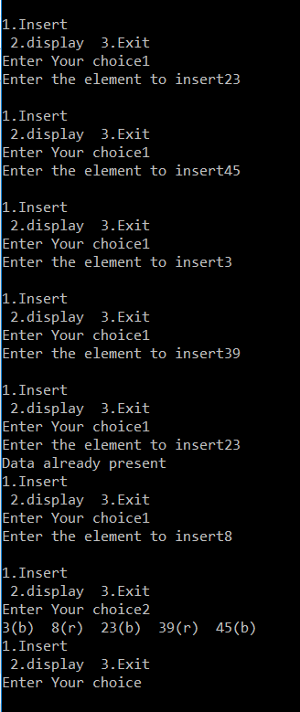

**DFS AND TOPOLOGICAL SORTING ON GRAPHS**

**PROGRAM:**

#include<stdio.h>

#include<stdlib.h>

#include<conio.h>

struct node

{

int vertex;

struct node *next;

}*adj[20];

int v,e;

int visited[20],top[20];

int t=0;

void dfs();

void dfsvisit();

void main()

{

int s,i,en;

struct node *ne;

printf("Enter Number of vertices\n");

scanf("%d",&v);

for(i=0;i<=v;i++)

adj[i]=NULL;

printf("\nEnter number of edjes\n");

scanf("%d",&e);

printf("\nEnter edges\n");

printf("\nstart------End\n");

for(i=0;i<e;i++)

{

scanf("%d%d",&s,&en);

ne=(struct node*)malloc(sizeof(struct node));

ne->vertex=en;

ne->next=adj[s];

adj[s]=ne;

}

dfs();

printf("\nTopological sort order\n");

for(i=t-1;i>=0;i--)

printf("%d ",top[i]);

getch();

}

void dfs()

{

int i;

for(i=0;i<=v;i++)

visited[i]=0;

printf("\nDFS\n");

for(i=1;i<=v;i++)

if(visited[i]==0)

dfsvisit(i);

}

void dfsvisit(int u)

{

int w;

struct node *ptr;

visited[u]=1;

printf("%d ",u);

ptr=adj[u];

while(ptr!=NULL)

{

w=ptr->vertex;

if(visited[w]==0)

dfsvisit(w);

ptr=ptr->next;

}

top[t]=u;

t++;

}

**OUT PUT:**

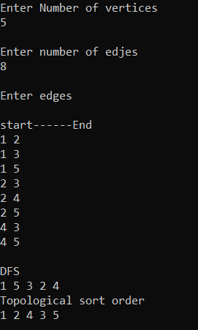

**STRONGLY CONNECTED COMPONENTS**

**PROGRAM:**

#include<stdio.h>

#include<stdlib.h>

#include<conio.h>

struct node

{

int vertex;

struct node *next;

};

int v,e;

struct node *adj[20], *adj1[20];

int t=0,visited[20],ft[20];

void dfs();

void dfsvisit(int);

void dfs1();

void dfsvisit1(int);

void adjlistrep(struct node **adj,int s,int en)

{

struct node *ne=(struct node*)malloc(sizeof(struct node));

ne->vertex=en;

ne->next=adj[s];

adj[s]=ne;

}

void main()

{

int s,i,en;

struct node *ptr;

printf("Enter number of vertices\n");

scanf("%d",&v);

for(i=0;i<=v;i++)

adj[i]=adj1[i]=NULL;

printf("\nEnter nunber of edges:\n");

scanf("%d",&e);

printf("\nEnter the edges\n");

printf("\nStart--------End\n");

for(i=0;i<e;i++)

{

scanf("%d%d",&s,&en);

adjlistrep(adj,s,en);

adjlistrep(adj1,en,s);

}

dfs();

dfs1();

getch();

}

void dfs()

{

int i;

for(i=0;i<=v;i++)

visited[i]=0;

printf("\nDFS\n");

for(i=1;i<=v;i++)

{

if(visited[i]==0)

{

dfsvisit(i);

}}

}

void dfsvisit(int u)

{

int w;

struct node *ptr;

visited[u]=1;

printf("%d ",u);

ptr=adj[u];

while(ptr!=NULL)

{

w=ptr->vertex;

if(visited[w]==0)

dfsvisit(w);

ptr=ptr->next;

}

t++;

ft[u]=t;

}

void dfs1()

{

int i,max=0,ver;

printf("\n components\n");

for(i=0;i<=v;i++)

visited[i]=0;

while(1)

{

max=0;

for(i=1;i<=v;i++)

{

if(visited[i]==0 && ft[i]>max)

{

ver=i;

max=ft[i];

}}

if(max==0)

break;

printf("{");

dfsvisit1(ver);

printf("}\n");

}}

void dfsvisit1(int u)

{

int w;

struct node *ptr;

visited[u]=1;

printf("%d ",u);

ptr=adj1[u];

while(ptr!=NULL)

{

w=ptr->vertex;

if(visited[w]==0)

dfsvisit1(w);

ptr=ptr->next;

}}

**OUT PUT :**

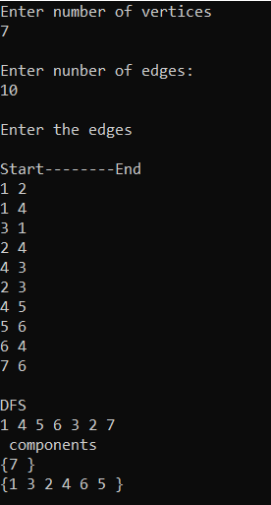

**MINIMUM SPANNING TREE USING PRIM’S ALGORITHM**

**PROGRAM:**

#include<stdio.h>

#include<stdlib.h>

#include<conio.h>

#define inf 999

void addtoadjlist(int s,int en,int w);

int emptyQ();

int extractminQ();

struct node

{

int vertex;

int weight;

struct node *next;

}*adj[20];

int v;

int p[20],key[20],q[20];

void main()

{

int i,s,en,we,e,u,w,sum=0;

struct node *ptr;

printf("Enter Number of vertices: \n");

scanf("%d",&v);

for(i=1;i<=v;i++)

{

p[i]=0;

key[i]=inf;

q[i]=1;

adj[i]=NULL;

}

printf("\nNumber of edges:\n ");

scanf("%d",&e);

printf("\nEnter the adges\n");

printf("\nstart--------end---------weight\n");

for(i=1;i<=e;i++)

{

scanf("%d%d%d",&s,&en,&we);

addtoadjlist(s,en,we);

addtoadjlist(en,s,we);

}

key[1]=0;

while(!emptyQ())

{

u=extractminQ();

ptr=adj[u];

while(ptr!=NULL)

{

w=ptr->vertex;

if (q[w]==1 && ptr->weight < key[w])

{

key[w]=ptr->weight;

p[w]=u;

}

ptr=ptr->next;

}

}

sum=0;

printf("Spanning tree edges\n");

for(i=2;i<=v;i++)

{

printf("(%d-%d) w:%d \n",i,p[i],key[i]);

sum=sum+key[i];

}

printf("\NThe total cost is %d \N",sum);

getch();

}

int emptyQ()

{

int i,flag=1;

for(i=1;i<=v;i++)

{

if (q[i]==1)

{

flag=0;

break;

}

}

return flag;

}

int extractminQ()

{

int i,min=inf,ver;

for(i=1;i<=v;i++)

{

if (key[i]<min && q[i]==1)

{

ver=i;

min=key[i];

}

}

q[ver]=0;

return ver;

}

void addtoadjlist(int s,int en,int w)

{

struct node *ne=(struct node *)malloc(sizeof(struct node));

ne->vertex=en;

ne->weight=w;

ne->next=adj[s];

adj[s]=ne;

}

**OUT PUT:**

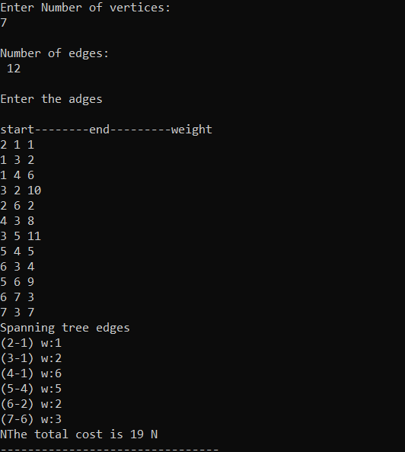

**SINGLE SOURCE SHORTEST PATH**

**PROGRAM:**

#include<stdio.h>

#include<conio.h>

#define inf 999

void printpath(int,int);

int v,adj[20][20],dist[20],visit[20],pred[20];

void main()

{ int e,st,en,w,i,j,src,ver,k;

printf("Enter the no: of vertices");

scanf("%d",&v);

printf("Enter the no: of edges");

scanf("%d",&e);

for(i=0;i<=v;i++)

{ for(j=0;j<=v;j++)

adj[i][j]=inf;

dist[i]=inf;

visit[i]=0}

printf("Enter the edges\n");

printf("start end weight\n");

for(i=1;i<=e;i++)

{ scanf("%d%d%d",&st,&en,&w);

adj[st][en]=w;

} printf("Enter the starting vertex");

scanf("%d",&src);

dist[src]=0;

pred[src]=src;

for(k=1;k<=v;k++)

{ ver=extractmin();

visit[ver]=1;

if (dist[ver]==inf) continue;

for(i=1;i<=v;i++)

if (adj[ver][i]!=inf&& visit[i]==0 )

if (dist[i]>dist[ver]+adj[ver][i])

{ dist[i]=dist[ver]+adj[ver][i] ;

pred[i]=ver;

} }

for(i=1;i<=v;i++)

{ if (dist[i]==inf) continue;

printf("path cost to %d= %d ",i,dist[i]);

if( dist[i]!=inf)

{

printpath(i,src);

printf("->%d",i);

printf("\n");

}}

void printpath(int i,int src)

{ if (pred[i]==src)

{ printf("%d ",src);return;

}

printpath(pred[i],src);

printf("->%d ",pred[i]);

}

int extractmin()

{ int min=inf,i,ver;

for(i=1;i<=v;i++)

{ if (visit[i]==0 && dist[i]<min)

{ min=dist[i];

ver=i;

} } return ver;

**OUT PUT:**

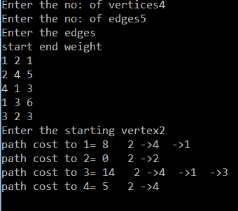

**BREADTH FIRST SEARCH**

**PROGRAM:**

#include<stdlib.h>

struct node

{ int vertex;

struct node *next;

};

int v,e;

struct node **adj;

int que[30],visited[30];

int f=-1,r=-1;

void enq(int x)

{ if (f==-1 && r==-1)

f=0;

r=(r+1)%v;

que[r]=x;

}

int dequ()

{ int data;

data=que[f];

if (f==r)

f=r=-1;

else

f=(f+1)%v;

return data;

}

void bfs()

{ struct node *ptr;

int ver,i,w;

for(i=0;i<=v;i++)

visited[i]=0;

enq(1);

visited[1]=1;

printf("%d",1);

while(!(f==-1))

{ ver=dequ();

ptr=adj[ver];

while(ptr!=NULL)

{ w=ptr->vertex;

if (visited[w]==0)

{ enq(w);

printf("%d",w);

visited[w]=1;

}

ptr=ptr->next;

}}}

void main()

{ int s,i,en;

struct node *ne;

printf("Enter No: of vertices\n");

scanf("%d",&v);

adj= (struct node **)malloc((v+1)*sizeof(struct node *));

for(i=0;i<=v;i++)

adj[i]=NULL;

printf("\nenter number of edges\n");

scanf("%d",&e);

printf("\nenter edges\n");

printf("\nstart-------------end\n");

for(i=0;i<e;i++)

{ scanf("%d%d",&s,&en);

ne=(struct node*)malloc(sizeof(struct node));

ne->vertex=en;

ne->next=adj[s];

adj[s]= ne;

}

printf("\n BFS \n");

bfs();

getch();

}

**OUT PUT:**

