***Co3***

import math

print(math.pi)

import math as m

print(m.pi)

print("===============")

from math import pi,sqrt

print(math.pi)

print(sqrt(4))

print("===============")

print("cos",math.cos(90))

print("===============")

print("sin",math.sin(90))

print("===============")

print("tan",math.tan(0))

print("===============")

import time

print("current time in second",time.time())

print("===============")

print("current time",time.ctime())

print("===============")

print("current time after 30 sec:",time.ctime(time.time()+30))

print("===============")

t=time.localtime()

print("time:",t)

print("===============")

print("current month",t.tm_mon)

print("current year",t.tm_year)

print("current day",t.tm_mday)

print("current hour",t.tm_hour)

print("current miniut",t.tm_min)

print("current second",t.tm_sec)

print("===============")

import calendar

mm=int(input("enter month:"))

yy=int(input("enter the year:"))

print(calendar.month(yy,mm))

print(calendar.calendar(2022))

print("===============")

import datetime

t=datetime.time(22,56,44)

print(t)

print("hour",t.hour)

print("min",t.minute)

print("se",t.second)

print("mis",t.microsecond)

print("***********************")

d=datetime.date.today()

print(d)

print("year",d.year)

print("month",d.month)

print("day",d.day)

print(":::::")

d1=datetime.date.today()

print(d1)

td=datetime.timedelta(days=2)

print(td)

d2=d1+td

print(d2)

print("====")

dt=datetime.datetime.combine(d,t)

print(dt)

***output***

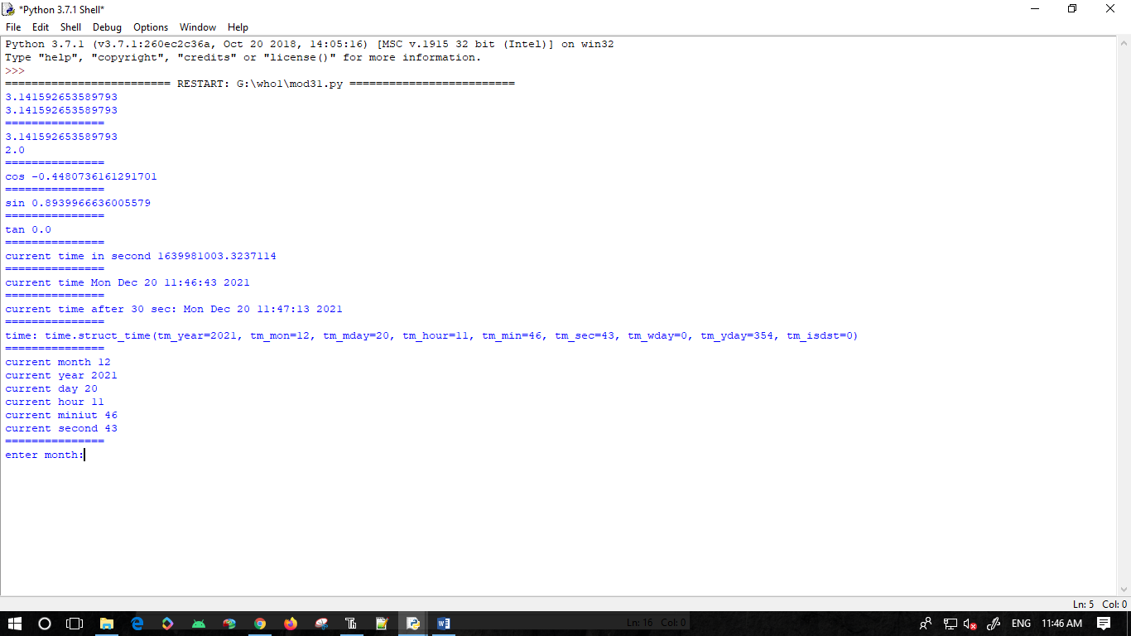

***Random***

import random

list1 = [1, 2, 3, 4, 5, 6]

print(random.choice(list1))

print("*************")

import random

random.seed(5)

print(random.random())

print(random.random())

print("***********")

import random

r1 = random.randint(5, 15)

print("Random number between 5 and 15 is % s" % (r1))

r2 = random.randint(-10, -2)

print("Random number between -10 and -2 is % d" % (r2))

print("**************")

import random

list1 = [1, 2, 3, 4, 5, 6]

print(random.choice(list1))

string = "geeks"

print(random.choice(string))

tuple1 = (1, 2, 3, 4, 5)

print(random.choice(tuple1))

***output***

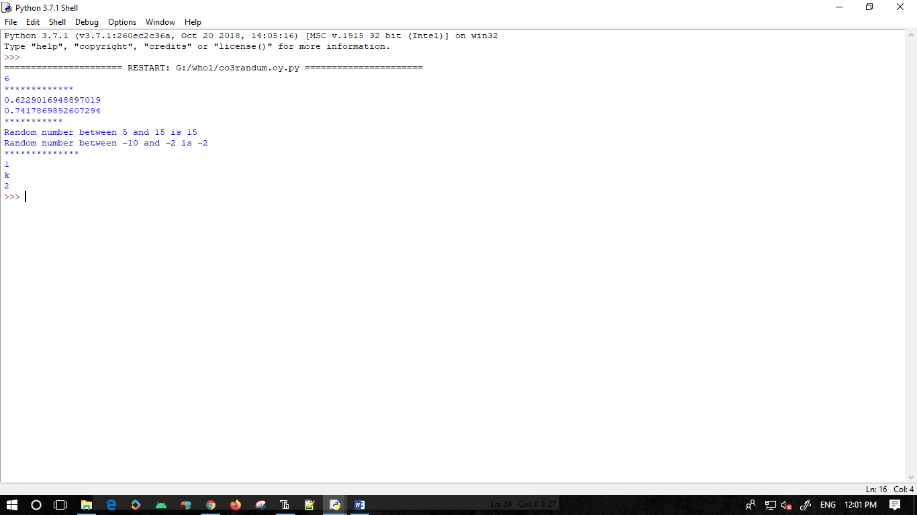

***Package***

* def arear(l,b):

print("area",l*b)

print("per",2*l*b)

def areas(a):

print(a*a)

def areac(pi,r):

print(pi*r*r)

* def arear(l,b):

print(l*b)

def areas(a):

print(a*a)

def areac(pi,r):

print(pi*r*r)

* from graphics import graph

graph.arear(2,2)

graph.areas(2)

graph.areac(3.14,2)

***output***

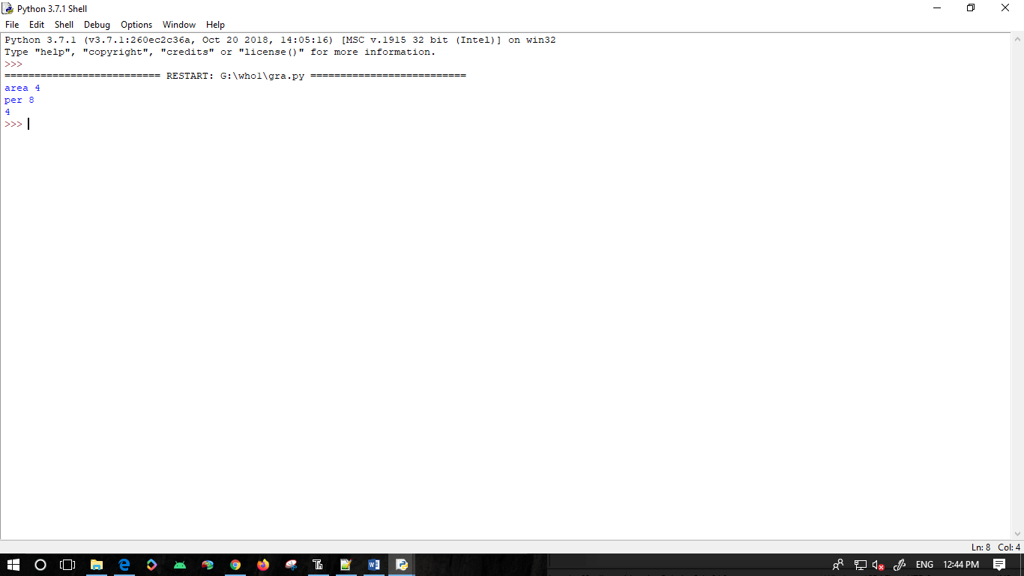

***Statastics***

import statistics

list1 = [5,2,5,6,1,2,6,7,2,6,3,5,5]

x = statistics.mean(list1)

print(x)

y = statistics.median(list1)

print(y)

z = statistics.mode(list1)

print(z)

a = statistics.stdev(list1)

print(a)

b = statistics.variance(list1)

print(b)

***output***

