**ACTIVITY 1**

<HTML>

<HEAD><TITLE>FORMATTINF TEXT</TITLE>

<BODY>

HTML (HYPERTEXT MARKUP LANGUAGE) IS THE CODE THAT IS USED TO STRUCTURE A WEB PAGE AND ITS CONTENT.

<P> FOR EXAMPLE, CONTENT COULD BE STRUCTURED WITHIN A SET OF PARAGRAPHS, A LIST OF BULLETED POINTS, OR USING IMAGES AND DATA TABLES.</P><BR>

IN SHORT,<PRE>HTML IS VERY EASY TO LEARN. </PRE>WHILE IT IS CODE, AND WHILE IT MAY SEEM DAUNTING TO YOU AT FIRST, YOU DON'T NEED TO HAVE ANY KIND OF PROGRAMMING EXPERIENCE.

HTML ISN'T NEARLY AS HARD TO LEARN AS YOU MIGHT THINK.</BODY></HTML>

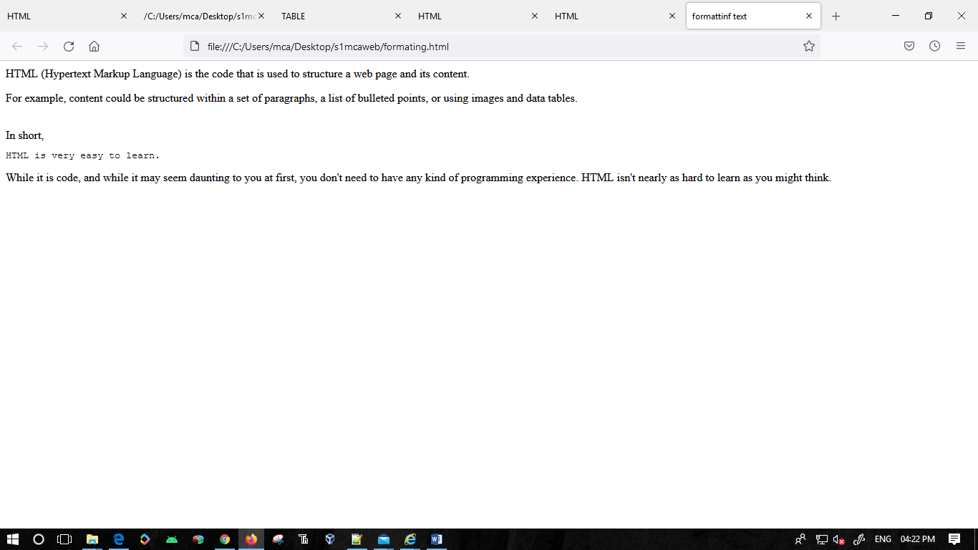

**ACTIVITY 2**

<html>

<head>

<title>HTML

</TITLE>

</HEAD>

<BODY>

<HI>

<B>

HTML</B>

</H1>

<HR>

HTML-HYPER TEXT MARKUP LANGUAGE</HR>

<BR><H5>DISCRIPTION</H5>

<BR>

<P>

USED TO CREATE WEB PAGES</P>

</BODY>

</HTML>

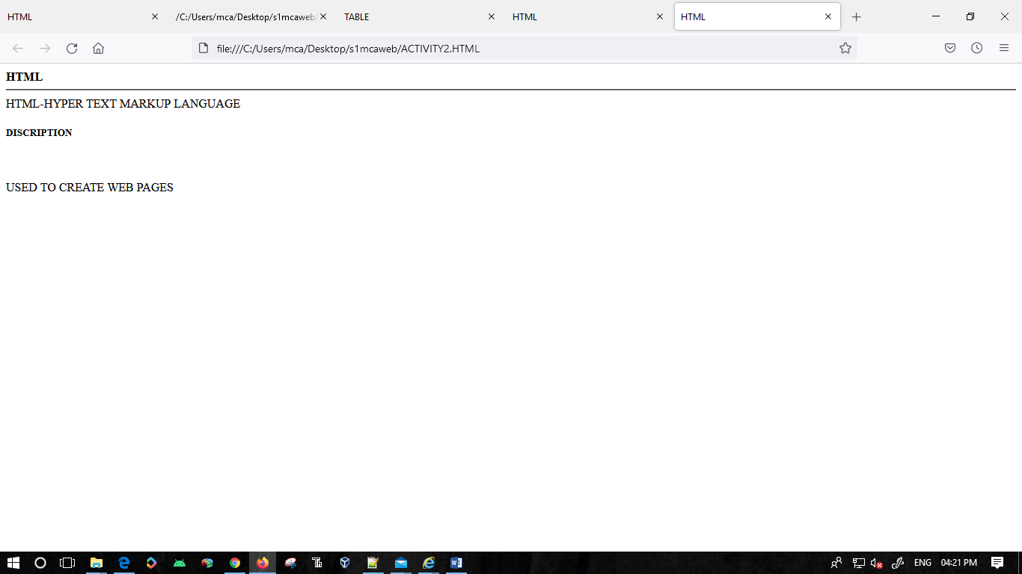

**ACTIVITY 3**

<html>

<head>

<title>HTML

</TITLE>

</HEAD>

<BODY>

<H1>DAYS OF WEEK</H1>

UNORDERED LIST

<CENTER>CIRCLE</CENTER>

<UL>

<LI>SUNDAY

<LI>MONDAY<LI>TUESDAY<LI>WEDNESDAY<LI>THURSDAY<LI>FRIDAY<LI>SATURDAY

</UL>

<BR>

<CENTER>SQUARE</CENTER>

<UL TYPE="SQUARE">

<LI>SUNDAY

<LI>MONDAY<LI>TUESDAY<LI>WEDNESDAY<LI>THURSDAY<LI>FRIDAY<LI>SATURDAY

</UL>

<CENTER>ORDERED LIST</CENTER>

<CENTER>MONTHS OF YEAR</CENTER>

NUMBERS

<OL>

<LI>JAN<LI>FEB<LI>MARCH<LI>APR<LI>MAY<LI>JUN<LI>JUL<LI>AUG<LI>SEPT<LI>OCT<LI>NOV<LI>DEC

</OL>

<BR>

ALPHABETS

<OL TYPE="a">

<LI>JAN<LI>FEB<LI>MARCH<LI>APR<LI>MAY<LI>JUN<LI>JUL<LI>AUG<LI>SEPT<LI>OCT<LI>NOV<LI>DEC

</OL>

ROMAL LETTERS

<OL TYPE="i">

<LI>JAN<LI>FEB<LI>MARCH<LI>APR<LI>MAY<LI>JUN<LI>JUL<LI>AUG<LI>SEPT<LI>OCT<LI>NOV<LI>DEC

</OL>

<BR><BR>

<CENTER>DEFINITION LIST</CENTER>

<DL>

<DT>MCA:

<DD>JOB ORIENTED COURSE

<DT>MSC CS:

<DD>RESEARCH ORIENTED COURSE

<DT>BCA:

<DD>UNDER GRADUATE

<DT>BSC CS:

<DD>COMOUTER SCIENCE</DL>

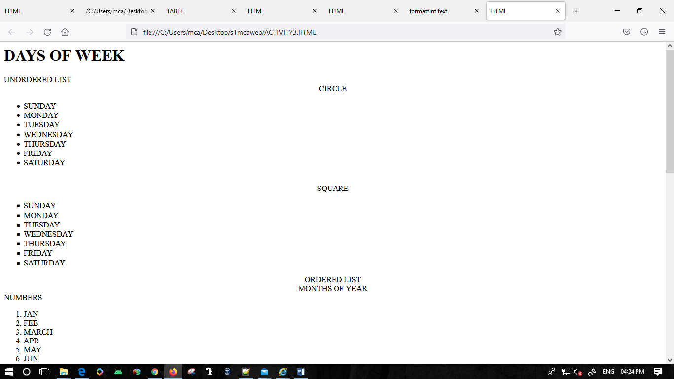

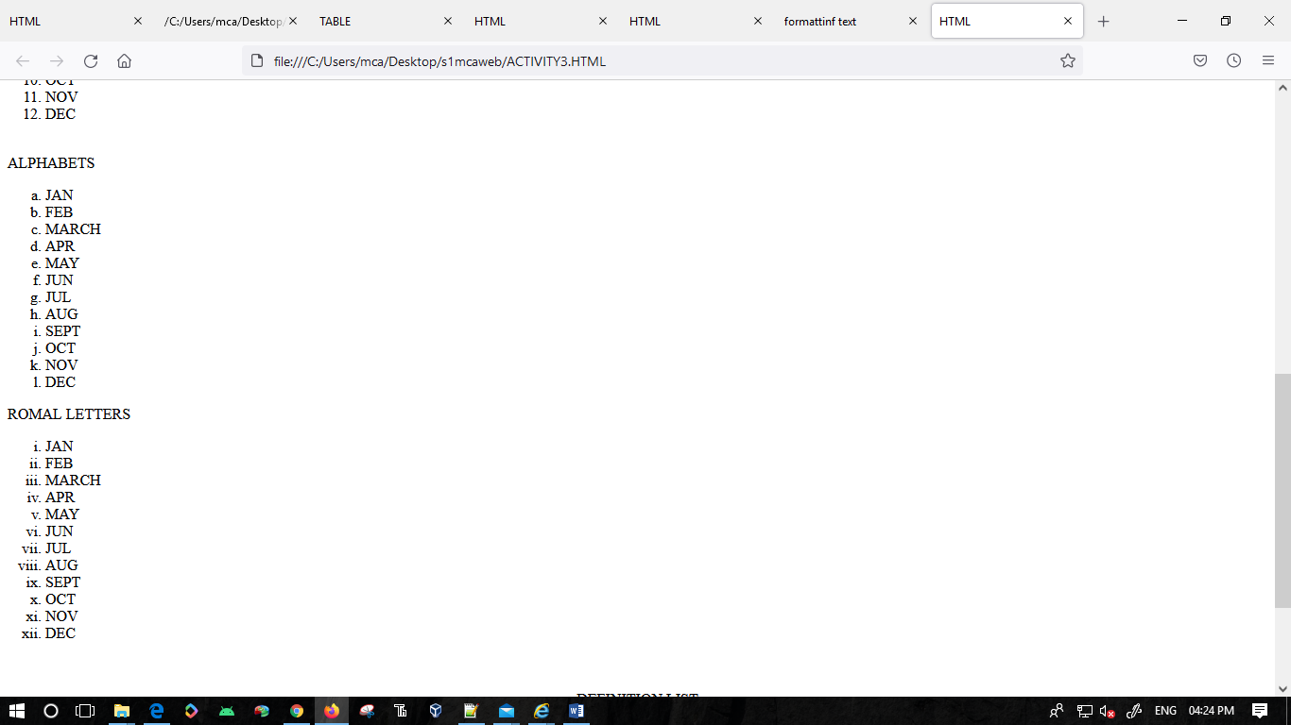

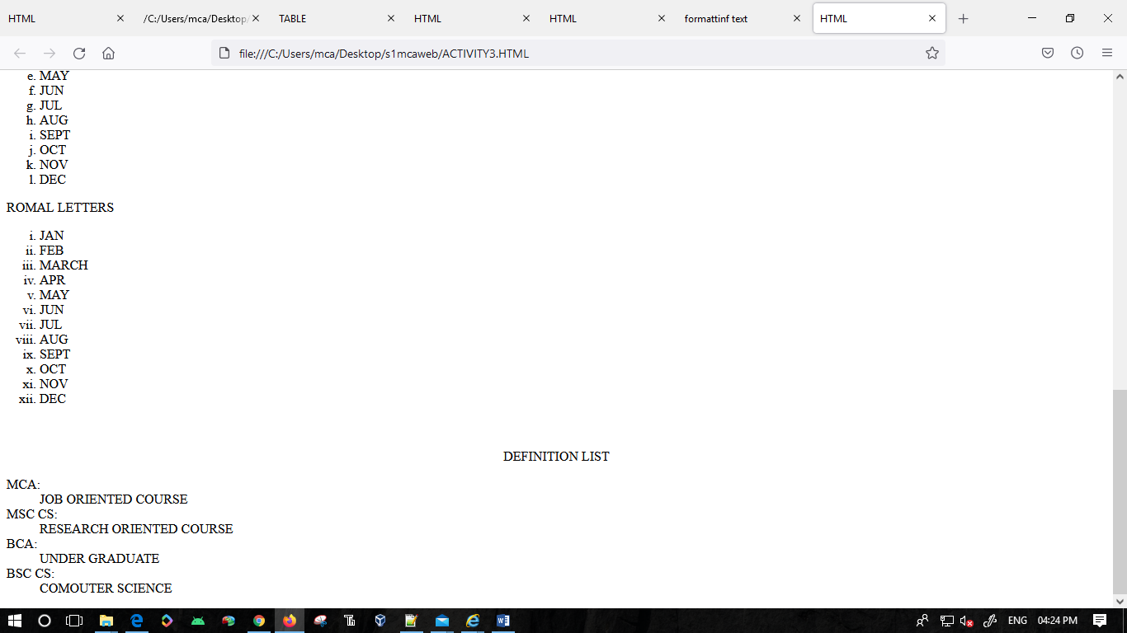

**ACTIVITY 4**

<html>

<head>

<title>HTML

</TITLE>

</HEAD>

<BODY>

<!_LIST>

<H1>DAYS OF WEEK</H1>

UNORDERED LIST

<CENTER>CIRCLE</CENTER>

<UL>

<LI>SUNDAY

<LI>MONDAY<LI>TUESDAY<LI>WEDNESDAY<LI>THURSDAY<LI>FRIDAY<LI>SATURDAY

</UL>

</BODY>

</HTML>

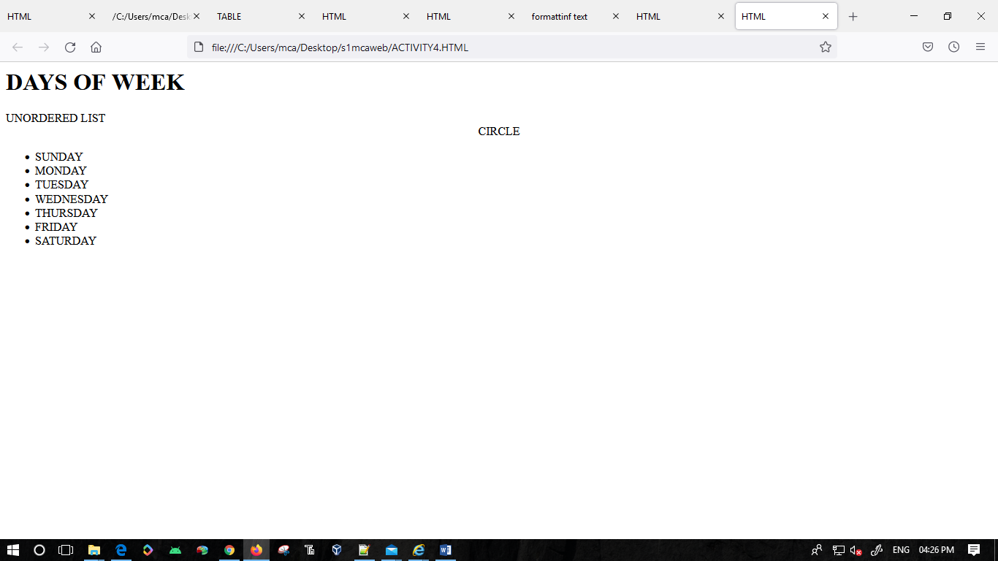

**ACTIVITY 5**

<HTML>

<HEAD>

<A HREF="#SECTION_ONE">SECTION ONE</A>

<A HREF="#SECTION_TWO">SECTION TWO</A>

<A HREF="#SECTION_THREE">SECTION THREE</A>

</HEAD>

<BODY>

<BR>

<BR>

<U><B>SECTION ONE</U></B>

<A NAME="SECTION_ONE"></A>

<P>

LOREM IPSUM DOLOR SIT AMET, CONSECTETUER ADIPISCING ELIT, SED DIAM

NONUMMY NIBH EUISMOD TINCIDUNT UT LAOREET DOLORE MAGNA ALIQUAM

ERAT VOLUTPAT. UT WISI ENIM AD MINIM VENIAM, QUIS NOSTRUD EXERCI

TATION ULLAMCORPER SUSCIPIT LOBORTIS NISL UT ALIQUIP EX EA COMMODO

CONSEQUAT..

<P>

DUIS AUTEM VEL EUM IRIURE DOLOR IN HENDRERIT IN VULPUTATE VELIT ESSE

MOLESTIE CONSEQUAT, VEL ILLUM DOLORE EU FEUGIAT NULLA FACILISIS AT VERO

EROS ET ACCUMSAN ET IUSTO ODIO DIGNISSIM QUI BLANDIT PRAESENT

LUPTATUM ZZRIL DELENIT AUGUE DUIS DAESENT

LUPTATUM ZZRIL DELENIT AUGUE DUIS DOLORE TE FEUGAIT NULLA FACILISI.

NISSIM QUI BLANDIT PRAESENT

<P>

<A HREF="#SECTION_ONE">SECTION ONE</A>

<A HREF="#SECTION_TWO">SECTION TWO</A>

<A HREF="#SECTION_THREE">SECTION THREE</A><P>

<B><U>SECTION TWO</B></U>

<A NAME="SECTION_TWO"></A>

<P>

LOREM IPSUM DOLOR SIT AMET, CONSECTETUER ADIPISCING ELIT, SED DIAM

NONUMMY NIBH EUISMOD TINCIDUNT UT LAOREET DOLORE MAGNA ALIQUAM

ERAT VOLUTPAT. UT WISI ENIM AD MINIM VENIAM, QUIS NOSTRUD EXERCI

TATION ULLAMCORPER SUSCIPIT RE TE FEUGAIT NULLA FACILISI.

DUIS AUTEM VEL EUM IRIURE DOLOR IN HENDRERIT IN VULPUTATE VELIT ESSE

MOLESTIE CONSEQUAT, VEL ILLUM DOLORE EU FEUGIAT NULLA FACILISIS AT VERO

EROS ET ACCUMSAN ET IUSTO ODIO DIGNISSIM QUI BLANDIT PRAESENT

LUPTATUM ZZRIL DELENIT AUGUE DUIS DOLORE TE FEUGAIT NULLA FACILISI.

<P>

DUIS AUTEM VEL EUM IRIURE DOLOR IN HENDRERIT IN VULPUTATE VELIT ESSE

MOLESTIE CONSEQLLA FACILISIS AT VERO

EROS ET ACCUMSAN ET IUSTO ODIO DIGNISSIM QUI BLANDIT PRAESENT

LUPTATUM ZZRIL DELENIT AUGUE DUIS DOLORE TE FEUGAIT NULLA FACILISI.

DUIS AUTEM VEL EUM IRIURE DOLOR IN HENDRERIT IN VULPUTATE VELIT ESSE

MOLESTIE CONSEQUAT, VEL ILLUM DOLORE EU FEUGIAT NULLA FACILISIS AT VERO

EROS ET ACCUMSAN ET IUSTO ODIO DIGNISSIM QUI BLANDIT PRAESENT

LUPTATUM ZZRIL DELENIT AUGUE DUIS DOLORE TE FEUGAIT NULLA FACILISI

<P><A HREF="#SECTION_ONE">SECTION ONE</A>

<A HREF="#SECTION_TWO">SECTION TWO</A>

<A HREF="#SECTION_THREE">SECTION THREE</A>.<P>

<U><B>SECTION THREE</U></B>

<A NAME="SECTION_THREE"></A><P>

DUIS AUTEM VEL EUM IRIURE DOLOR IN HENDRERIT IN VULPUTATE VELIT ESSE

MOLESTIE CONSEQUAT, VEL ILLUM DOLORE EU FEUGIAT NULLA FACILISIS AT VERO

EROS ET ACCUMSAN ET IUSTO ODIO DIGNISSIM QUI BLANDIT PRAESENT

LUPTATUM ZZRIL DELENIT AUGUE DUIS DOLORE TE FEUGAIT NULLA FACILISI.

DUIS AUTEM VEL EUM IRIURE DOLOR IN HENDRERIT IN VULPUTATE VELIT ESSE

MOLESTIE CONSEQUAT, VEL ILLUM DOLORE EU FEUGIAT NULLA FACILISIS AT VERO

EROS ET ACCUMSAN ET IUSTO ODITATE VELIT ESSE

MOLESTIE CONSEQEUGIAT NULLA FACILISIS AT VERO

EROS ET ACCUMSAN ET IUSTO ODIO DIGNISSIM QUI BLANDIT PRAESENT

DUIS AUTEM VEL EUM IRIURE DOLOR IN HENDRERIT IN VULPUTATE VELIT ESSE

MOLESTIE CONSEQUI.

DUIS AUTEM VEL EUM IRIURE DOLOR IN HENDRERIT IN VULPUTATE VELIT ESSE

MOLESTIE CONSEQUAT, VEL ILLUM DOL<P>

<U><B>SECTION ONE</U></B>

<A NAME="SECTION_ONE"></A>

<A HREF="#SECTION_ONE">SECTION ONE</A>

<A HREF="#SECTION_TWO">SECTION TWO</A>

<A HREF="#SECTION_THREE">SECTION THREE</A>

<P>

</BODY>

</HTML>

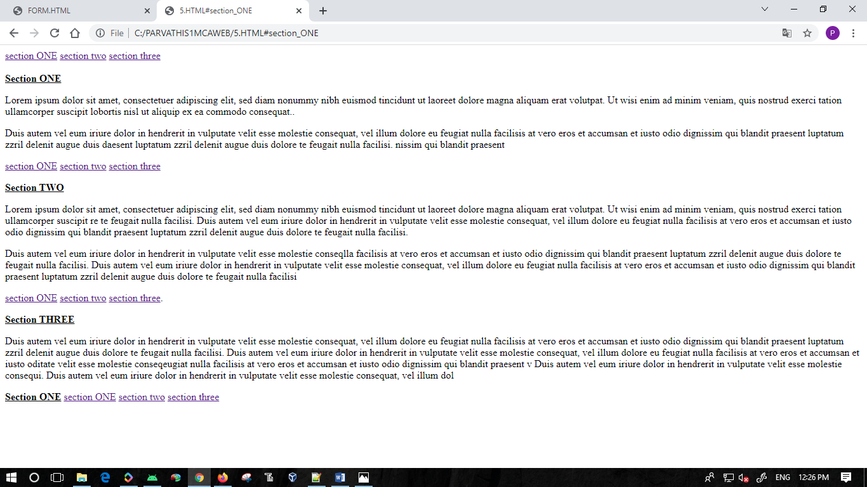

**ACTIVITY 6**

A.

<HTML>

<HEAD>

<TITLE>LINK</TITLE></HEAD>

<BODY BGCOLOR="WHITE"><FONT COLOR="BLACK">LINK

<A HREF="COLOR.HTML" VLINK="RED">LINK</A></BODY>

</HTML>

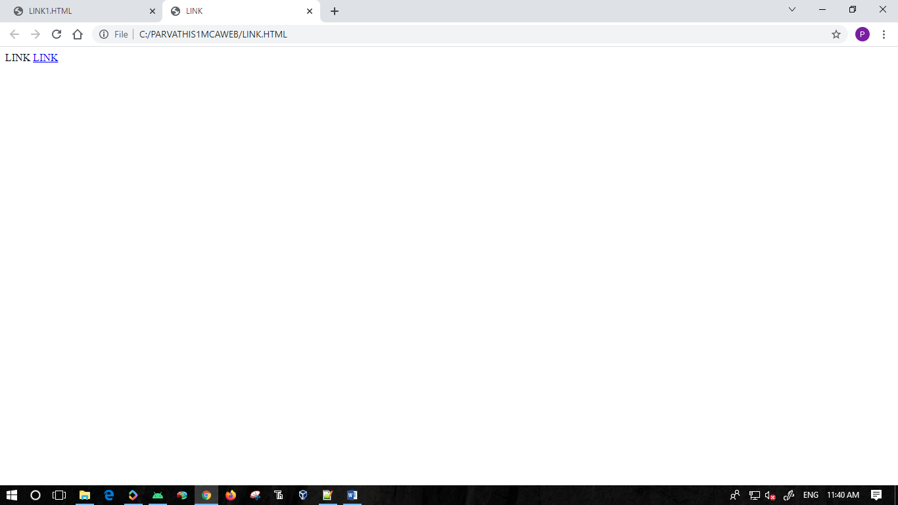

B.

<HTML>

<BODY BGCOLOR="BLACK"><FONT COLOR="WHITE">LINK

<A HREF="COLOR.HTML" VLINK="CYAN">LINK</A></BODY>

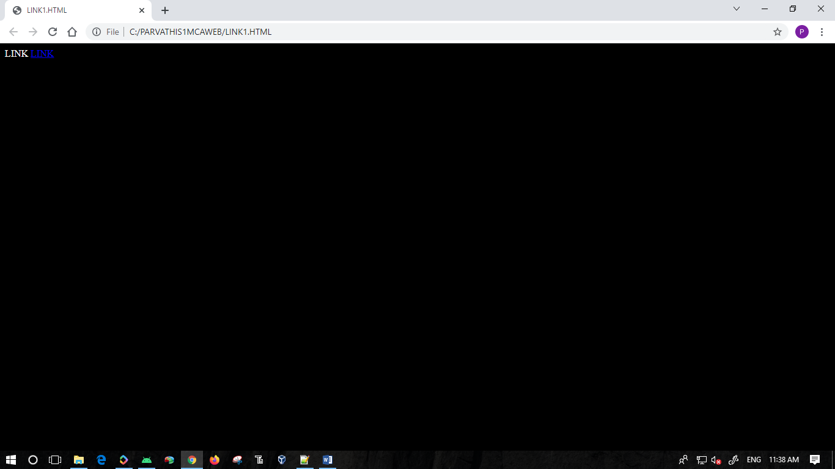

C.

<HTML>

<HEAD>

<TITLE>LINK</TITLE></HEAD>

<BODY BGCOLOR="PINK"><FONT COLOR="BLUE">LINK

<A HREF="COLOR.HTML" VLINK="RED">LINK</A></BODY>

</HTML>

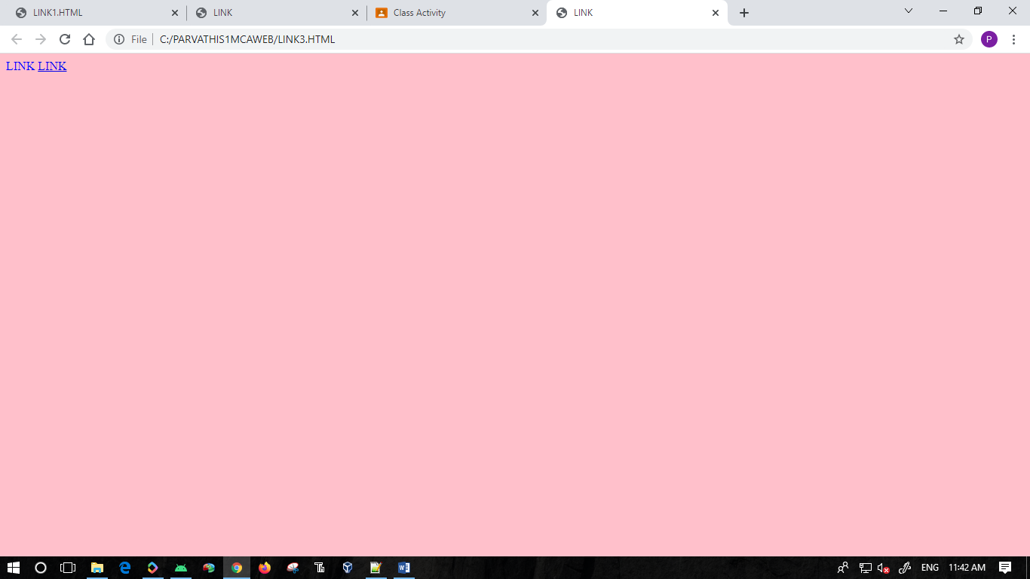

**ACTIVITY 7**

<HTML><HEAD><TITLE>TABLE</TITLE>

</HEAD>

<BODY>

<TABLE BORDER=1>

<TR>

<TH></TH>

<TH>MONDAY<TH>TUESDAY<TH>WEDNESDAY<TH>THURSDAY<TH>FRIDAY

<TR><TH>

6-7PM

<TD>LOOK AT WEBSITE

<TD>FREE

<TD>IMPLIMENTATION

<TD>FREE<TD>FREE</TR>

<TR><TH>7-8PM

<TD>TAKE SOME NOTES

<TD>FREE<TD>IMPLIMENTATION<TD>FREE<TD>FREE</TR></TABLE>

</BODY>

</HTML>

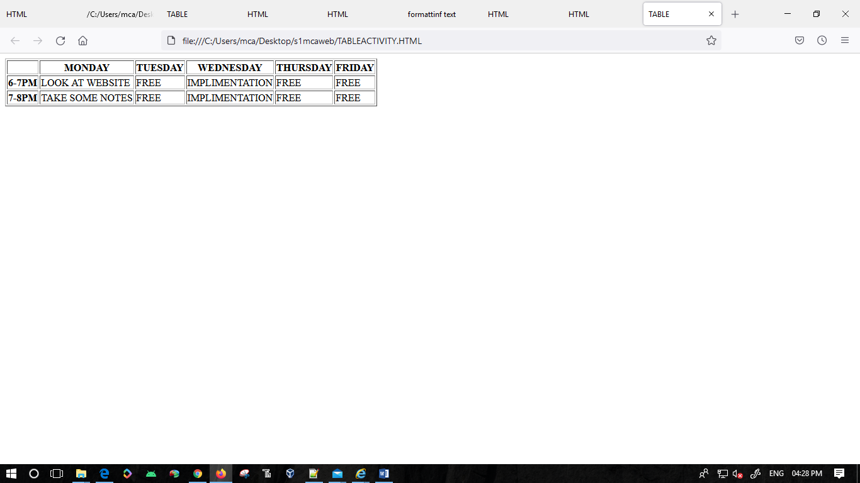

**ACTIVITY 8**

<HTML>

<HEAD>

<TITLE>File name</TITLE>

</HEAD>

<BODY>

<h2>File name</h2>

<p>

LOREM IPSUM DOLOR SIT AMET, CONSECTETUER ADIPISCING ELIT, SED DIAM

NONUMMY NIBH EUISMOD TINCIDUNT UT LAOREET DOLORE MAGNA ALIQUAM

ERAT VOLUTPAT. UT WISI ENIM AD MINIM VENIAM, QUIS NOSTRUD EXERCI

TATION ULLAMCORPER SUSCIPIT LOBORTIS NISL UT ALIQUIP EX EA COMMODO

CONSEQUAT.

<P>

DUIS AUTEM VEL EUM IRIURE DOLOR IN HENDRERIT IN VULPUTATE VELIT ESSE

MOLESTIE CONSEQUAT, VEL ILLUM DOLORE EU FEUGIAT NULLA FACILISIS AT

VERO

EROS ET ACCUMSAN ET IUSTO ODIO DIGNISSIM QUI BLANDIT PRAESENT

LUPTATUM ZZRIL DELENIT AUGUE DUIS DOLORE TE FEUGAIT NULLA FACILISI.

<P>

<A HREF="INDEX.HTML"> HOMEPAGE</A><BR>

<A HREF="FILETWO.HTML"> FILETWO</A><BR>

<A HREF="FILETHREE.HTML"> FILETHREE </A><BR>

<A HREF="FILEFOUR"> FILEFOUR</A><BR>

<P>

<A HREF="HTTP://WWW.SNGCE.AC.IN"> SNGCE </A>

</BODY>

</HTML>

