***CO1-1***

<HTML>

<HEAD>

<TITLE> CO1-1(K3)

</TITLE>

<HEAD>

<BODY BGCOLOR="PINK">

<B>

<I>

<U>

<CENTER><H1>HTML</H1></CENTER>

</U>

</B>

</I>

<BR>

<P>

<UL>

<LI>HTML stands for Hyper Text Markup Language</LI>

<LI>HTML is the standard markup language for creating Web pages</LI>

<LI>HTML describes the structure of a Web page</LI>

<LI>HTML consists of a series of elements</LI>

<LI>HTML elements tell the browser how to display the content</LI>

<LI>HTML elements label pieces of content such as "this is a heading",

"this is a paragraph", "this is a link", etc.</LI>

</UL>

</P><BR>

<FONT COLOR="BLUE"><H3>CSS</H3></FONT><BR>

<H2>CSS stands for Cascading Style Sheets</H2>

CSS describes how HTML elements are to be displayed on screen, paper, or in other media

</BODY></HTML>

***OUTPUT***

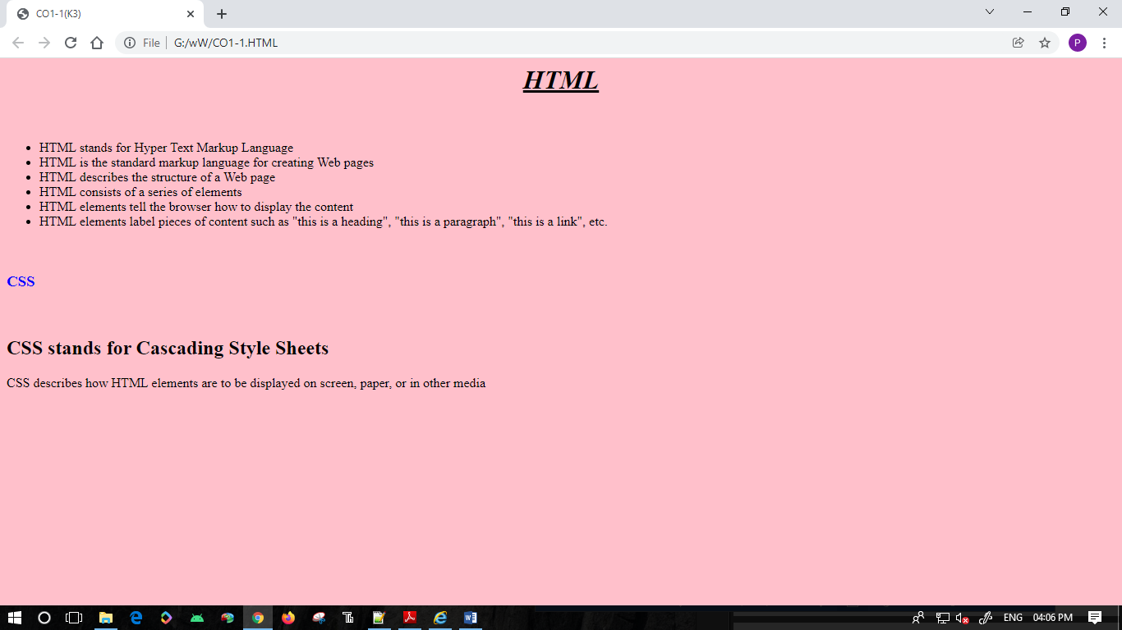

***CO1-2***

<HTML>

<HEAD>

<TITLE>CO1-2(K6)

</TITLE>

<HEAD>

<BODY>

<A HREF="G:\WW\CO1-1.HTML"><BR>

<A HREF="#SECTION_ONE">SECTION ONE</A><BR>

<A HREF="#SECTION_TWO">SECTION TWO</A><BR><BR>

<BR>

<BR>

<A HREF="G:\WW\CO1-1.HTML"><BR>

CLICK HERE TO GO TO HTML PAGE</A>

<BR>

<BR>

<A HREF="G:\WW\IMG1.HTML">CLICK HERE TO GO IMAGE </A>

<BR>

<BR>

<A HREF="G:\WW\TABLE1.HTML">CLICK HERE TO GO TABLR</A>

<BR>

<BR>

<BR>

<U><H1>CO-1</H1></U>

<A NAME="SECTION_ONE">SECTION_ONE</A><P>

1.MODEL A SIMPLE HTML FILE TO DEMONSTRATE THE USE OF DIFFERENT TAGS. (K3)

2. CREATE A HTML FILE TO LINK TO DIFFERENT HTML PAGE WHICH CONTAINS IMAGES, TABLES,

AND ALSO LINK WITHIN A PAGE. (K6)

3. CREATE A HTML PAGE WITH DIFFERENT TYPES OF FRAMES SUCH AS FLOATING FRAME,

NAVIGATION FRAME & MIXED FRAME. (K6)

1.MODEL A SIMPLE HTML FILE TO DEMONSTRATE THE USE OF DIFFERENT TAGS. (K3)

2. CREATE A HTML FILE TO LINK TO DIFFERENT HTML PAGE WHICH CONTAINS IMAGES, TABLES,

AND ALSO LINK WITHIN A PAGE. (K6)

3. CREATE A HTML PAGE WITH DIFFERENT TYPES OF FRAMES SUCH AS FLOATING FRAME,

NAVIGATION FRAME & MIXED FRAME. (K6)

1.MODEL A SIMPLE HTML FILE TO DEMONSTRATE THE USE OF DIFFERENT TAGS. (K3)

2. CREATE A HTML FILE TO LINK TO DIFFERENT HTML PAGE WHICH CONTAINS IMAGES, TABLES,

AND ALSO LINK WITHIN A PAGE. (K6)

3. CREATE A HTML PAGE WITH DIFFERENT TYPES OF FRAMES SUCH AS FLOATING FRAME,

NAVIGATION FRAME & MIXED FRAME. (K6)

1.MODEL A SIMPLE HTML FILE TO DEMONSTRATE THE USE OF DIFFERENT TAGS. (K3)

2. CREATE A HTML FILE TO LINK TO DIFFERENT HTML PAGE WHICH CONTAINS IMAGES, TABLES,

AND ALSO LINK WITHIN A PAGE. (K6)

3. CREATE A HTML PAGE WITH DIFFERENT TYPES OF FRAMES SUCH AS FLOATING FRAME,

NAVIGATION FRAME & MIXED FRAME. (K6)</P>

<BR>

<BR>

<BR><BR><BR><BR>

<BR>

<BR>

<BR>

<BR>

<BR><BR>

<BR>

<BR>

<BR>

<A NAME="SECTION_TWO">SECTION_TWO</A><BR>

<BR>

<BR>

<BR>4. ANALYZE CSS BY APPLYING THE DIFFERENT STYLES USING INLINE, EXTERNAL & INTERNAL

STYLE SHEETS IN A HTML FILE. (K4)

5. DEMONSTRATE A REGISTRATION FORM USING HTML. (K3)

4. ANALYZE CSS BY APPLYING THE DIFFERENT STYLES USING INLINE, EXTERNAL & INTERNAL

STYLE SHEETS IN A HTML FILE. (K4)

5. DEMONSTRATE A REGISTRATION FORM USING HTML. (K3)

4. ANALYZE CSS BY APPLYING THE DIFFERENT STYLES USING INLINE, EXTERNAL & INTERNAL

STYLE SHEETS IN A HTML FILE. (K4)

5. DEMONSTRATE A REGISTRATION FORM USING HTML. (K3)

4. ANALYZE CSS BY APPLYING THE DIFFERENT STYLES USING INLINE, EXTERNAL & INTERNAL

STYLE SHEETS IN A HTML FILE. (K4)

5. DEMONSTRATE A REGISTRATION FORM USING HTML. (K3)

4. ANALYZE CSS BY APPLYING THE DIFFERENT STYLES USING INLINE, EXTERNAL & INTERNAL

STYLE SHEETS IN A HTML FILE. (K4)

5. DEMONSTRATE A REGISTRATION FORM USING HTML. (K3)

</TABLE>

</BODY>

<HTML>

***OUTPUT***

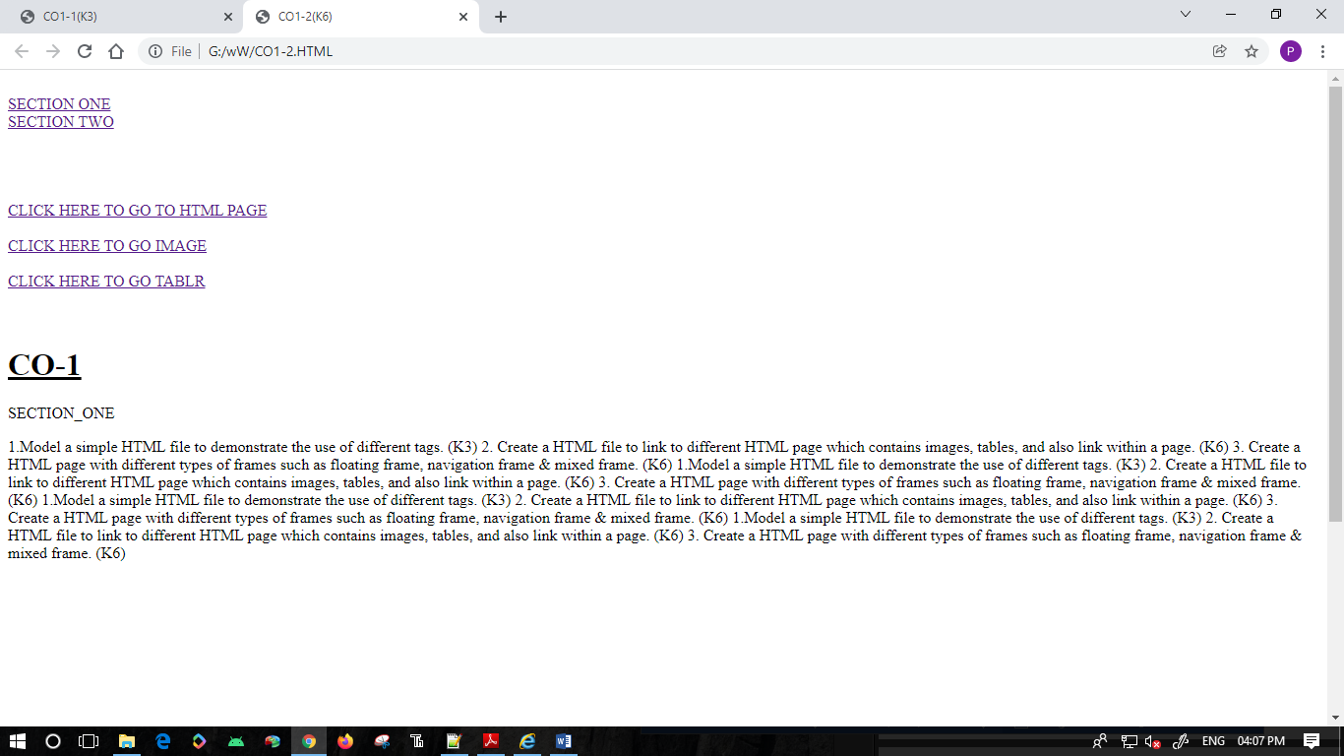

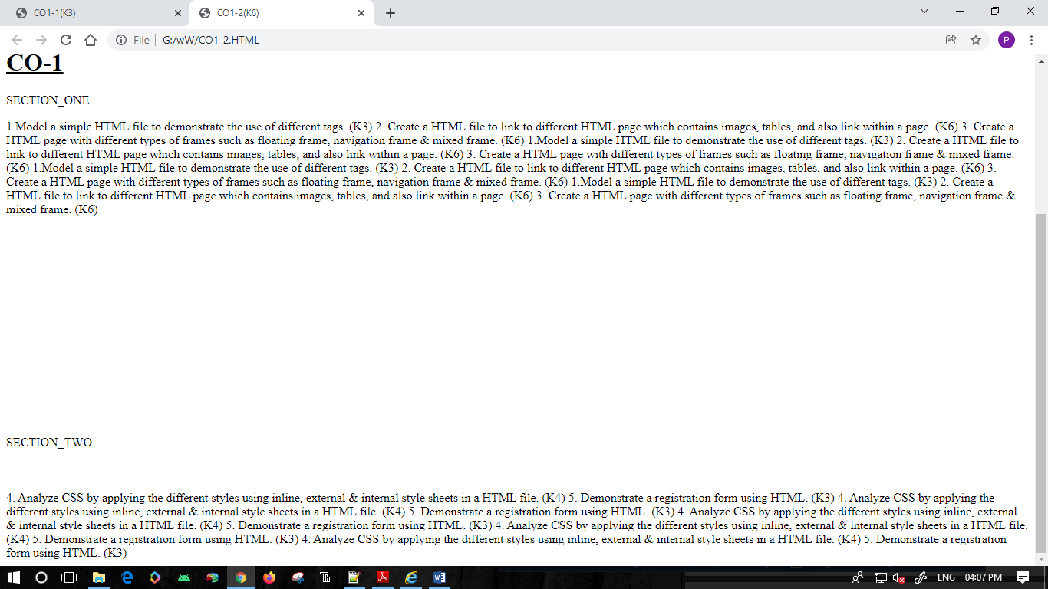

***CO1-3***

***Floating & mixed***

<HTML>

<HEAD>

<TITLE>

CO1-3

</TITLE>

</HEAD>

<BODY>

<CENTER>

<H1>

FLOATING FRAME</CENTER>

</H1>

<FRAMESET ROWS="70,20,10" COLS="40,20,40"><BR>

<UL>

<LI>HTML stands for Hyper Text Markup Language</LI>

</UL><

<IFRAME SRC="CO1-1.HTML" title="HTML"></IFRAME>

<BR><BR>

<BR>

<B>

REG FORM</B>

<BR><BR>

<BR>

<IFRAME SRC="CO1-5.HTML" title="REG FORM">

</IFRAME>

<BR>

<BR><CENTER><B><H1>NAVIGATION FRAME</CENTER></H1></B>

<a href = "FRAMEA.HTML.htm" target="showframe">frame a</a><br>

<a href = "FRAMEB.HTML" target="showframe">frame b</a>

</FRAMESET>

</BODY>

</HTML>

***OUTPUT***

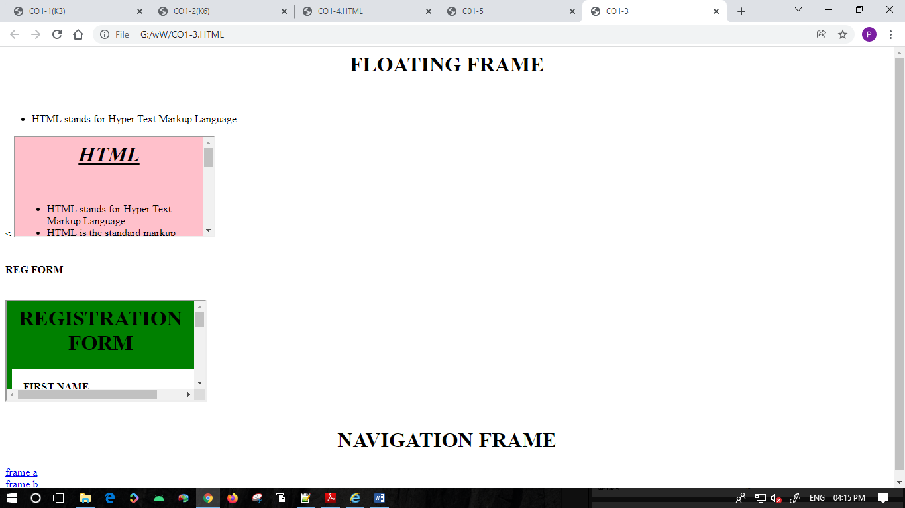

***Navigation***

1.<html>

<frameset cols ="*">

<frame src = "co1-2.html" name="a">

<frame src="co1-1.html" name="a">

</frameset>

</html>

2. <html>

<body>

<a href = "co1-1.html" target="a">frame a</a><br>

<a href = "co1-2.html" target="a">frame b</a>

</body>

</htm>

3. <html>

<head>

<frameset cols="*,*">

<frame src="navi2.html">

<frame src="navi1.html">

</frameset>

</head>

</html>

***Output***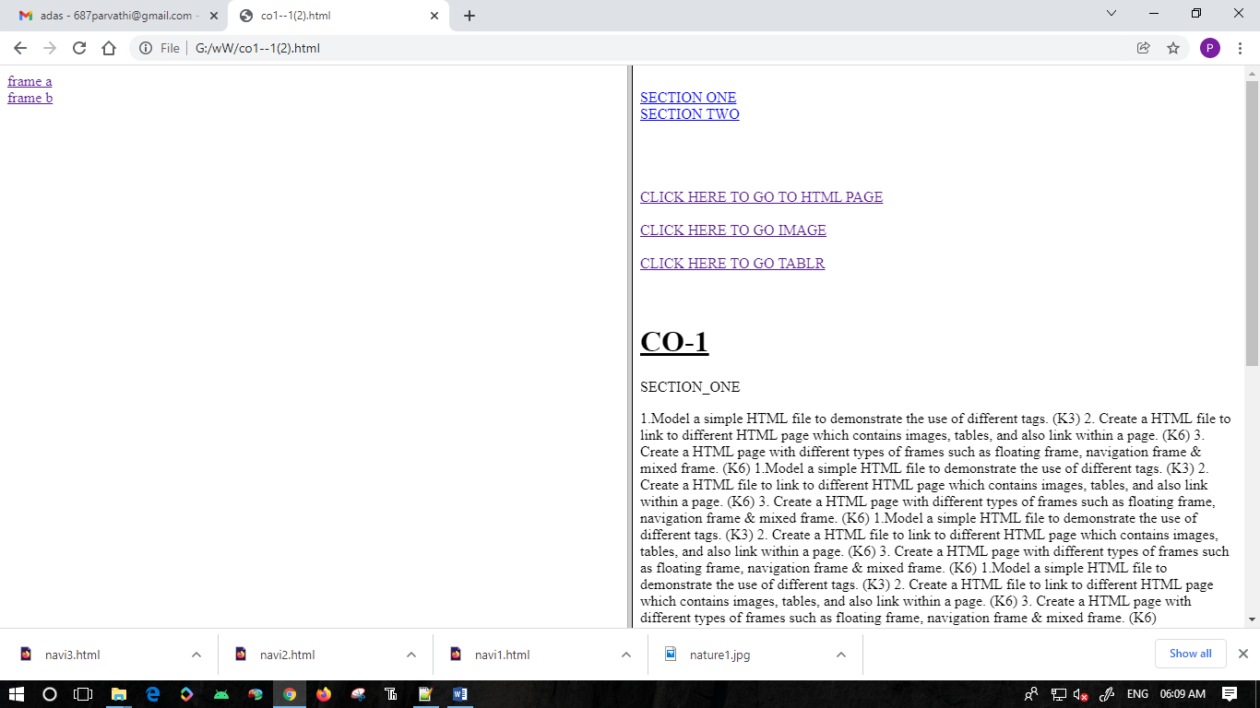

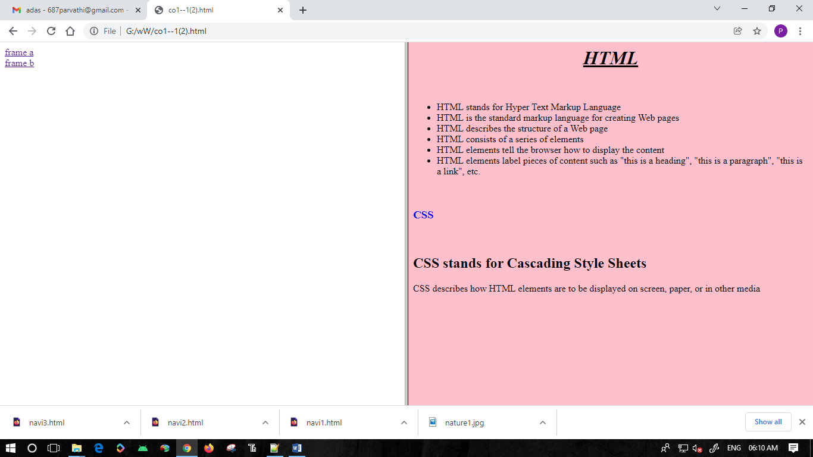

***CO1-4***

<HTML>

<HEAD>

<LINK REL="STYLESHEET" TYPE="TEXT/CSS" HREF="LINK.CSS">

<STYLE>

P {

COLOR: WHITE;

}

H3 {

COLOR: YELLOW;

}

</STYLE>

<BODY BGCOLOR="VIOLET" BORDER="10">

<P>

HTML stands for Hyper Text Markup Language

HTML is the standard markup language for creating Web pages

HTML describes the structure of a Web page</p>

HTML consists of a series of elements

HTML elements <H2>tell the browser how to display the content</H2><H3>

HTML elements label pieces of content such as "this is a heading",

"this is a paragraph", "this is a link", etc.</H3>

<H6 STYLE=COLOR.GREEN>elements </H6>

</BODY></HTML>

***OUTPUT***

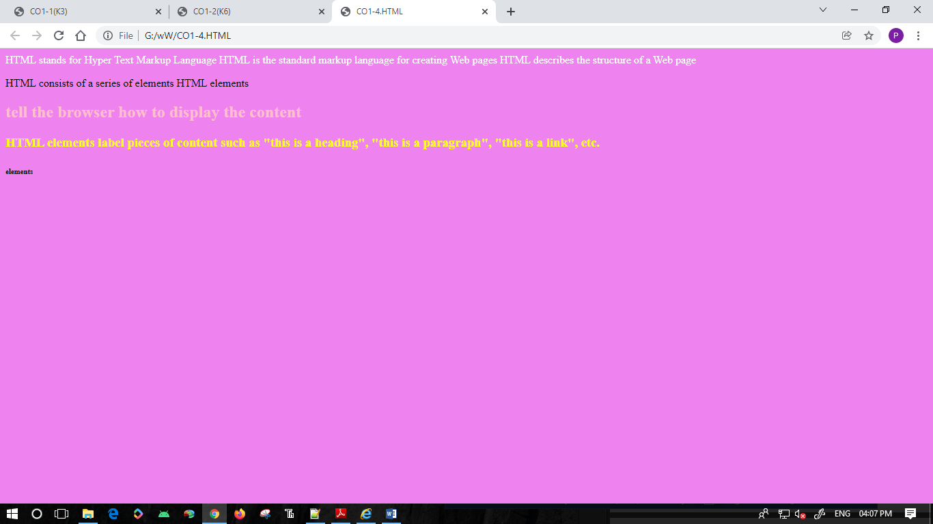

***CO1-5***

<HTML>

<HEAD>

<TITLE>

C01-5

</TITLE>

<HEAD>

<BODY BGCOLOR="GREEN"><FORM>

<B>

<H1>

<CENTER>REGISTRATION FORM</CENTER>

</H1>

</B><CENTER>

<TABLE BGCOLOR="WHITE"CELLSPACING="15">

<TR>

<TH>FIRST NAME

<TD><INPUT TYPE="TEXT">

</TR>

<TR>

<TH>LAST NAME

<TD><INPUT TYPE="TEXT">

</TR>

<TR>

<TH>ADDRESS

<TD><TEXTAREA></TEXTAREA>

</TR>

<TR>

<TH>DISTRICT

<TD><INPUT TYPE="TEXT">

</TR>

<TR>

<TH>STATE

<TD><INPUT TYPE="TEXT">

</TR>

<TR>

<TH>DATE OF BIRTH

<TD><INPUT TYPE="DATE">

</TR>

<TR>

<TH>GENDER

<TD>MALE<INPUT TYPE="RADIO">FEMALE<INPUT TYPE="RADIO">

</TR>

<TR>

<TH>NATINALITY

<TD>INDIAN<INPUT TYPE="CHECKBOX">OTHER<INPUT TYPE="CHECKBOX">

</TR>

<TR>

<TH>PASSWORD

<TD><INPUT TYPE="PASSWORD">

</TR>

<TR>

<TH>CONFIRM PASSWORD

<TD><INPUT TYPE="PASSWORD">

</TR>

<TR>

<TH>REGISTER

<INPUT TYPE="SUBMIT">

<TH>EDIT

<INPUT TYPE="RESET">

</TR>

</TABLE>

</CENTER>

</BODY>

</HTML>

***OUTPUT***

