**CYCLE -1 (HTML)**

**RESULTS AND OBSERVATIONS:**

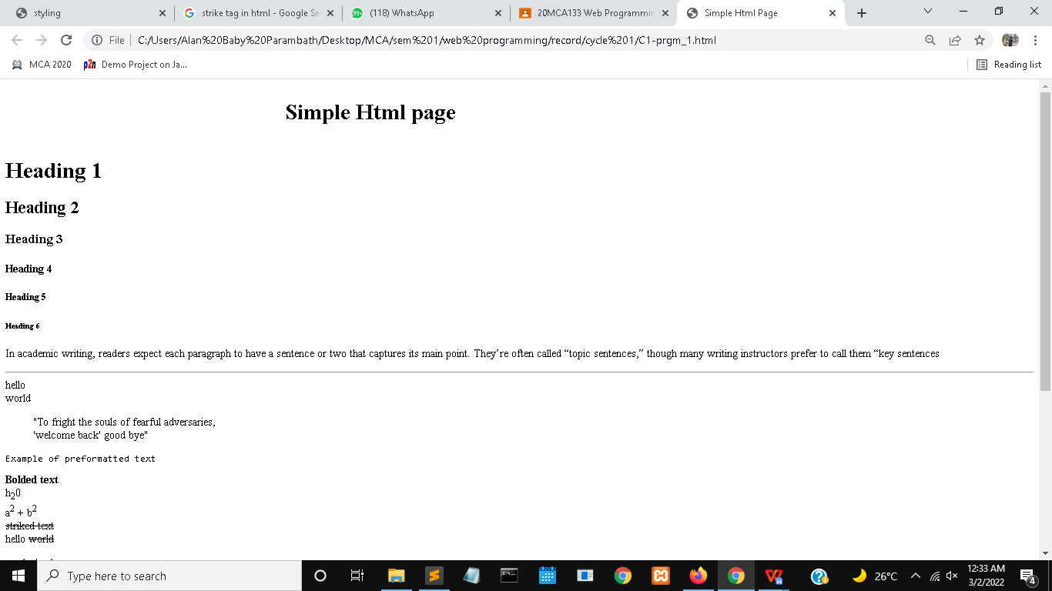

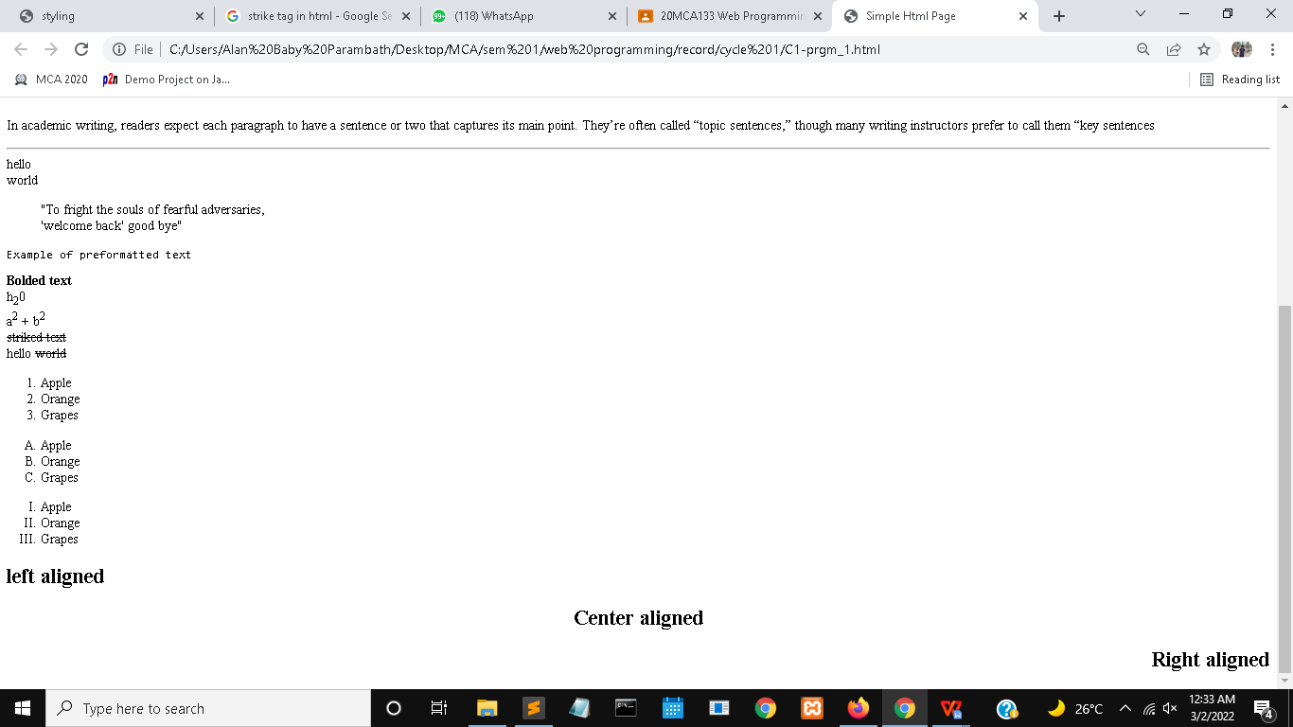

**“**Simple Html page**”** text scroll from left to right using **<marquee>** tag**.** Heading 1 is created using **<h1>** tag and heading 6 is created using **<h6>** tag.List(Apple,Orange,Grapes) are created using **<ol>** tag.Text are aligned using align attribute(left,right,center).Paragraphs are created using <p> tag.

**INFERENCE:**

Basic tags are used for the basic styling of the page and which includes bolding, italics, underlines, etc

**BASIC TAGS**

**PROGRAM NO: 1**  **DATE : 25-11-21**

**AIM:**

Create a simple HTML file to demonstrate the use of different tags. Set the title of the page as "Simple HTML Page" Within the body perform the following.

[ Moving text = “Simple HTML Page”, Different heading tags (h1 to h6), Paragraph, Horizontal line, Line Break, Block Quote (single quote ‘,double “), Pre tag, Different Logical Style (<b>, <sub>,<sup>....), Different Physical style (<strike>, <del>,..), Listing tags ol (with types, and each type provide different “type”attributes),Align tag ]

**THEORETICAL SUPPORT:**

The **<marquee>** tag is a container tag of HTML is implemented for creating scrollable text or images within a web page.

A HTML **heading** tag can be defined as a title or a subtitle which you want to display on the webpage.

**<b> :** specifiesbold text.

**<ol> :** tag defines an ordered list.

**<hr> :** tag is used to insert horizontal rule.

**<strike>** **:** tag which draws a horizontal line over the text.

**CODE:**

<!DOCTYPE html>

<html>

<head>

<title>Simple Html Page</title>

</head>

<body>

<marquee direction="right"><h1>Simple Html page</h1></marquee>

<h1>Heading 1</h1>

<h2>Heading 2</h2>

<h3>Heading 3</h3>

<h4>Heading 4</h4>

<h5>Heading 5</h5>

<h6>Heading 6</h6>

<p>In academic writing, readers expect each paragraph to have a sentence or two that captures its main point. They’re often called “topic sentences,” though many writing instructors prefer to call them “key sentences</p>

<hr>

hello<br>world<br>

<blockquote><q>To fright the souls of fearful adversaries,<br><q>welcome back</q> good bye</q></blockquote>

<pre>Example of preformatted text</pre>

<b>Bolded text</b><br>

h<sub>2</sub>0<br>

a<sup>2</sup> + b<sup>2</sup><br>

<strike>striked text</strike><br>

hello <del>world</del>

<ol>

<li>Apple</li>

<li>Orange</li>

<li>Grapes</li>

</ol>

<ol type="A">

<li>Apple</li>

<li>Orange</li>

<li>Grapes</li>

</ol>

<ol type="I">

<li>Apple</li>

<li>Orange</li>

<li>Grapes</li>

</ol>

<h2 align="left">left aligned</h2>

<h2 align="center">Center aligned</h2>

<h2 align="right">Right aligned</h2>

</body>

</html>

**RESULTS AND OBSERVATIONS:**

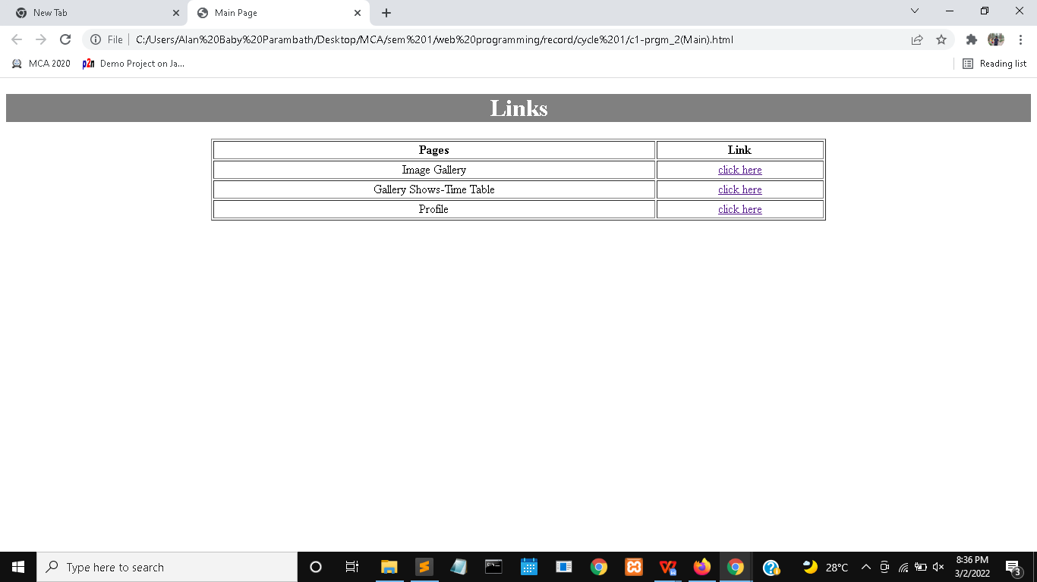

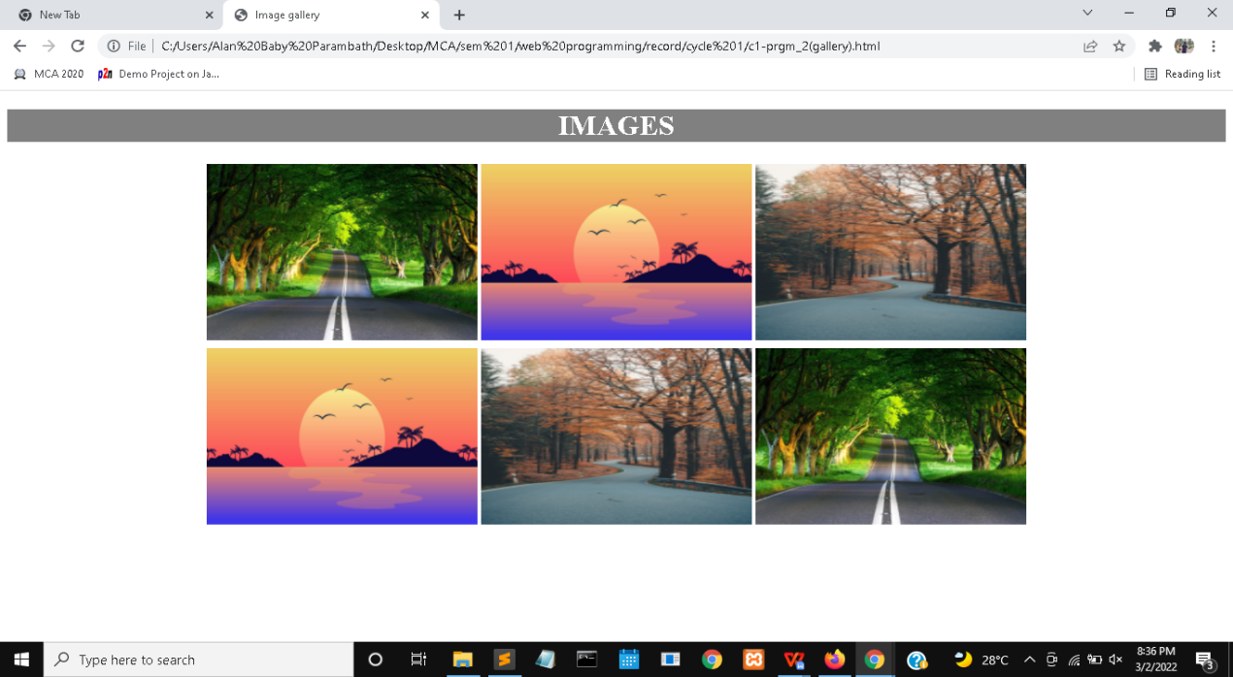

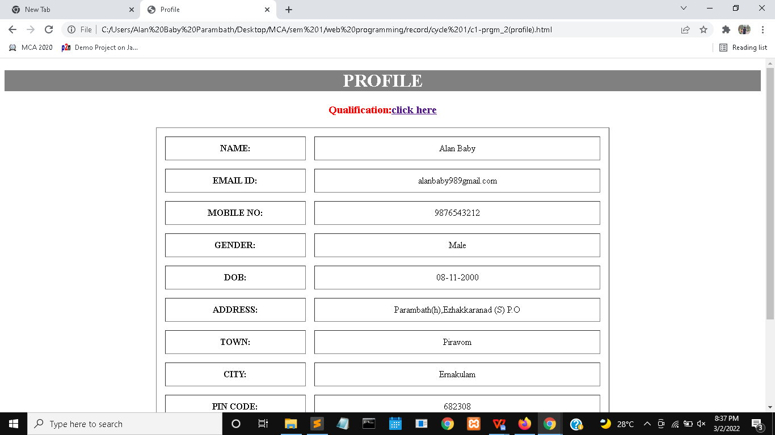

“click here” in the main page is the link to the specified pages,which is created using <a> tag. “click here” in the profile page is the link towards the bottom of the same page.

**INFERENCE:**

We can create links using anchor tag.Link to the another page and link to the different parts of the same page are pos

**LINKING PAGES**

**PROGRAM NO:** **2**  **DATE : 25-11-21**

**AIM:**

Create a HTML file to link to different HTML pages(Image gallery, Time table of Gallery shows, Your Profile with sections) which contains images, tables, and also link within a page(profile)

**THEORETICAL SUPPORT:**

The**<a>** tag defines a hyperlink, which is used to link from one page to another. The most important attribute of the **<a>** element is the**href** attribute, which indicates the link's destination.

* An unvisited link is underlined and blue
* A visited link is underlined and purple
* An active link is underlined and red

**CODE:**

**Mainfile**

<!DOCTYPE html>

<html>

<head>

<title>Main Page</title>

<style type="text/css">

td {

text-align: center;

vertical-align: middle;

}

</style></head>

<body> <center>

<h1 style="background-color:grey;color:white">Links</h1>

<table border=1 width="60%">

<tr>

<th>Pages</th>

<th>Link</th>

</tr>

<tr>

<td>Image Gallery</td>

<td><a href="c1-prgm_2(gallery).html">click here</a></td>

</tr>

<tr>

<td>Gallery Shows-Time Table</td>

<td><a href="c1-prgm_2(table).html">click here</a></td>

</tr>

<tr>

<td>Profile</td>

<td><a href="c1-prgm_2(profile).html">click here</a></td>

</tr>

</table>

</center>

</body>

</html>

**Image gallery**

<!DOCTYPE html><html>

<head>

<title>Image gallery</title>

</head>

<body>

<center>

<h1 style="background-color:grey;color:white">IMAGES</h1>

<table>

<tr>

<td><img src="scene1.jpg" width="300" height="200"></td>

<td><img src="scene4.jpg" width="300" height="200"></td>

<td><img src="scene3.jpg" width="300" height="200"></td>

</tr>

<tr>

<td><img src="scene4.jpg" width="300" height="200"></td>

<td><img src="scene3.jpg" width="300" height="200"></td>

<td><img src="scene1.jpg" width="300" height="200"></td>

</tr>

</table>

</center>

</body>

</html>

**Time table**

<!DOCTYPE html>

<html>

<head>

<title>Time table</title>

<style type="text/css">

td {

text-align: center;

vertical-align: middle;

}

</style>

</head>

<body>

<center>

<h1 style="background-color:grey;color:white">TIME TABLE-GALLERY SHOWS</h1>

<table border="1" width="60%">

<tr>

<th>Gallery Name</th>

<th>Place</th>

<th>Date</th>

</tr>

<tr>

<td>Atrium Gallery</td>

<td>Saint Louis</td>

<td>Feb 10-Apr 1,2020</td>

</tr>

<tr>

<td>Rose Gallery</td>

<td>Santa Monica</td>

<td>Feb 22-Apr 9,2022</td>

</tr>

</table>

</center>

</body>

</html>

**Profile**

<!DOCTYPE html>

<html>

<head>

<title>Profile</title>

<style type="text/css">

td {

text-align: center;

vertical-align: middle;

}

</style>

</head>

<body>

<center>

<h1 style="background-color:grey;color:white"><a name="top">PROFILE</a></h1>

<h3 style="color:red">Qualification:<a href="#qual">click here</a></h3>

<table border="1" width="60%" cellspacing="15px" cellpadding="10px">

<tr>

<th>NAME:</th>

<td>Alan Baby</td>

</tr>

<tr>

<th>EMAIL ID:</th>

<td>alanbaby989gmail.com</td>

</tr>

<tr>

<th>MOBILE NO:</th>

<td>9876543212</td>

</tr>

<tr>

<th>GENDER:</th>

<td>Male</td>

</tr>

<tr>

<th>DOB:</th>

<td>08-11-2000</td>

</tr>

<tr>

<th>ADDRESS:</th>

<td>Parambath(h),Ezhakkaranad (S) P.O</td>

</tr>

<tr>

<th>TOWN:</th>

<td>Piravom</td>

</tr>

<tr>

<th>CITY:</th>

<td>Ernakulam</td>

</tr>

<tr>

<th>PIN CODE:</th>

<td>682308</td>

</tr>

<tr>

<th>STATE:</th>

<td>Kerala</td>

</tr>

<tr>

<th><a name="qual">Qualification:</a></th>

<td>BCA</td>

</tr>

<tr>

<th>Go To Top</th>

<td><a href="#top">click here</a></td>

</tr>

</table>

</body>

</html>

**RESULTS AND OBSERVATIONS:**

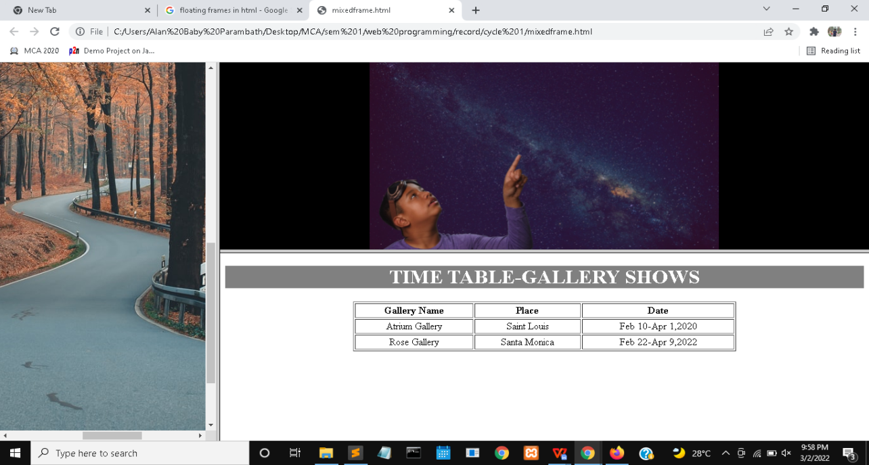

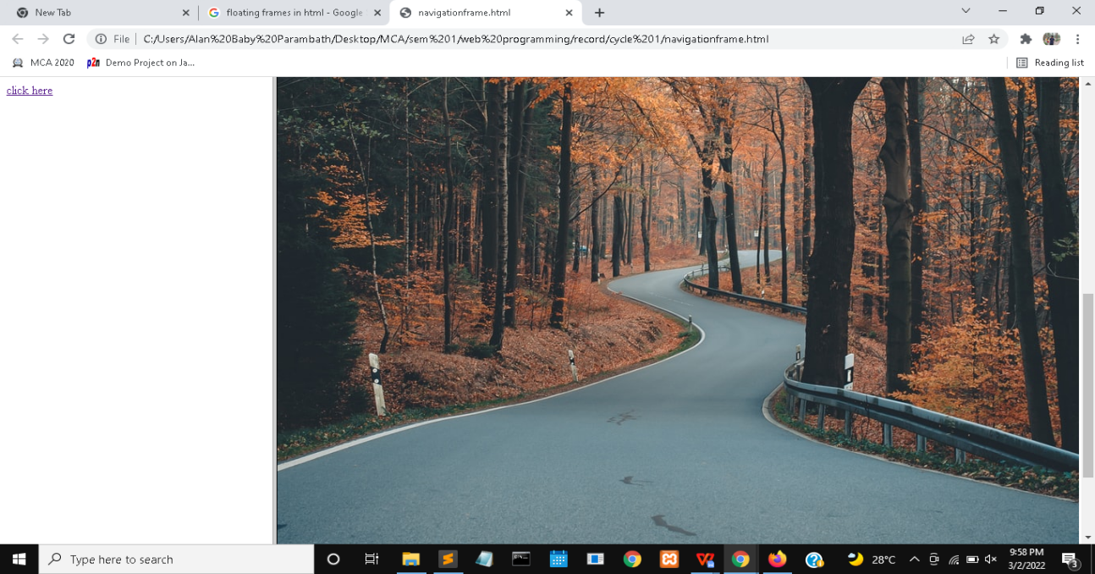

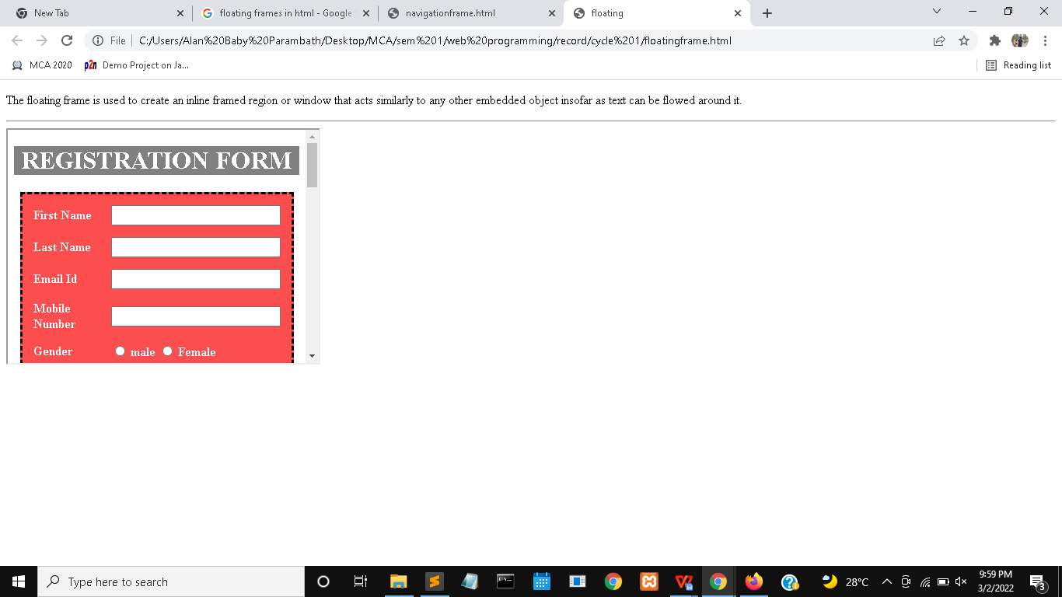

* Mixed Frame is created using 2 framesets and both framesets contains 2 frames. Firstly the window is divided into 2 columns and again the second column is divided into 2 rows.
* Navigation Frame which contains 2 column frames.First frame consist of a link and second frame which displays the content of the link page when user clicks on the link.
* Floating frames are created using **<iframe>** tag and it is left aligned.we can align the floating frames in any part of the page.

**INFERENCE:**

We can divide the window into any number of frames and display the content separately using frames. Floating windows can be created using <iframe> tag and we can display any content inside the floating window

**FRAMES**

**PROGRAM NO:** 3 **DATE:** 2-12-21

**AIM:**

Create a HTML web page file with different types of frames such as floating frame, navigation frame & mixed frame.

**THEORETICAL SUPPORT:**

HTML **frames**  are used to divide your browser window into multiple sections where each section can load a separate HTML document. A collection of frames in the browser window is known as a **frameset.** The window is divided into frames in a similar way the tables are organized: into rows and columns. The **floating frame** is used to create an inline framed region or window that acts similarly to any other embedded object insofar as text can be flowed around it.

**CODE:**

**Mixed frame**

<html>

<frameset cols="25%,75%">

<frame src="scene3.jpg"></frame>

<frameset rows="50%,50%">

<frame src="sample.mp4">

<frame src="c1-prgm_2(table).html" >

</frameset>

</frameset>

</html>

**Navigation frame**

<html>

<frameset cols="25%,75%">

<frame src="frame1.html"></frame>

<frame name="frame2"></frame>

</html>

**Link page**

<!DOCTYPE html>

<html>

<head>

<title></title>

</head>

<body>

<a href="scene3.jpg" target="frame2">click here</a>

</body>

</html>

**Floating frame**

<!DOCTYPE html>

<html>

<head>

<title>floating</title>

</head>

<body>

<p>The floating frame is used to create an inline framed region or window that acts similarly to any other embedded object insofar as text can be flowed around it.</p>

<hr>

<iframe src="c1-prgm_5.html" width="400px" height="300px"></iframe>

</body>

</html>

**RESULTS AND OBSERVATIONS:**

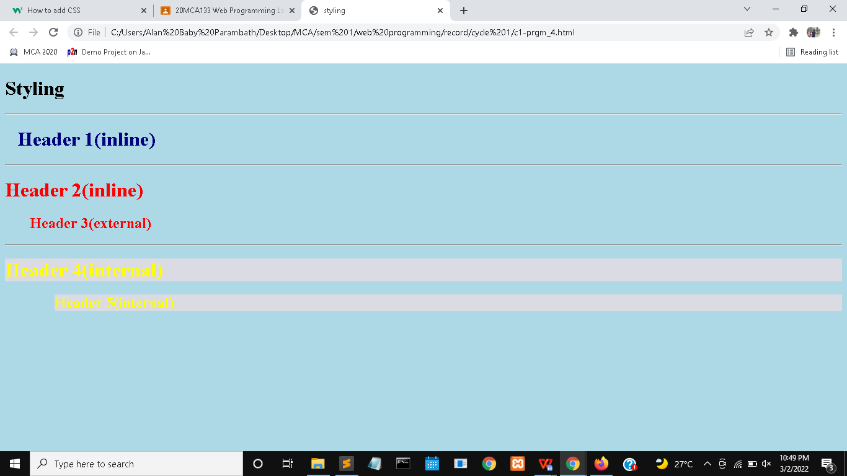

The headings inside the page is created using 3 different styles.External file is linked to the page using **<link>** tag.Internal css is added in the head part using <style> tag.inline css is added inside the tag itself using style attribute.

**INFERENCE:**

We can decorate any page using css and it can be added using any style according to the user. Css gives more formatting options and greater control of presentation

**CSS**

**PROGRAM NO:** 4 **DATE:** 2-12-21

**AIM:**

Create a HTML file by applying the different styles using inline, external & internal style sheets

**THEORETICAL SUPPORT:**

An **inline** style may be used to apply a unique style for a single element. With an **external** style sheet, you can change the look of an entire website by changing just one file!.Each HTML page must include a reference to the external style sheet file inside the <link> element, inside the head section. An **internal** style sheet may be used if one single HTML page has a unique style.The internal style is defined inside the <style> element, inside the head section.

**CODE:**

<!DOCTYPE html>

<html>

<head>

<link rel="stylesheet" href="external.css">

<title>styling</title>

<style>

body {

background-color: lightblue;

}

.h4 {

color:yellow;

background-color:#ebdce1bf;

}

.h5 {

color:yellow;

background-color:#ebdce1bf;

margin-left:80px;

}

</style>

</head>

<body>

<h1>Styling</h1>

<hr>

<h1 style="color:navy;margin-left:20px;">Header 1(inline)</h1>

<hr>

<h1 style="color:red">Header 2(inline)</h1>

<h2>Header 3(external)</h2>

<hr>

<h1 class="h4">Header 4(internal)</h1>

<h2 class="h5">Header 5(internal)</h2>

</body>

</html>

**External css**

h2 {

color:red;

margin-left:40px;

}

**RESULTS AND OBSERVATIONS:**

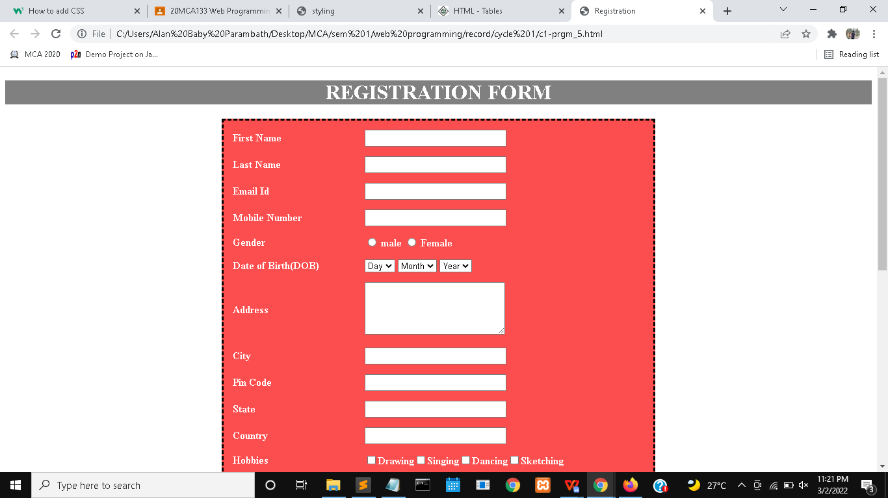

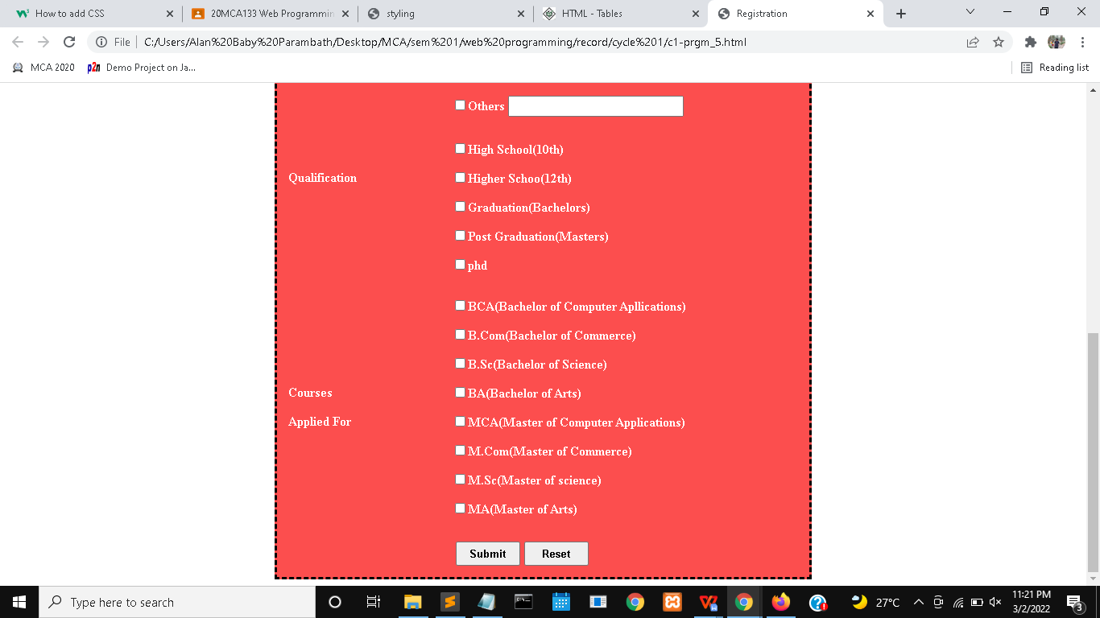

All the elements are placed inside the table.so each elements have equal spacing. Border style is added to the table to produce the dashed lines.buttons are created using **<button>** tag.css is applied to the page for adding background color,textbox-width, textbox-heigh, etc

**INFERENCE:**

Registration forms are created easily using html and we can use table for structuring the Elements.css are useful for creating attractive registration forms.

**REGISTRATION FORM**

**PROGRAM NO:** 5 **DATE:** 5-12-21

**AIM:**

Create a registration form using HTML. Use css and table to structure the elements

**THEORETICAL SUPPORT:**

The HTML tables allow web authors to arrange data like text, images, links, other tables, etc. into rows and columns of cells. The HTML tables are created using the **<table>** tag in which the **<tr>** tag is used to create table rows and **<td>** tag is used to create data cells. The elements under <td> are regular and left aligned by default

**CODE:**

<!DOCTYPE html>

<html>

<head>

<title>Registration</title>

<style type="text/css">

td {

vertical-align: middle;

}

table {

background-color:#fc4e4e;

color:white;

font-weight: bolder;

border-style: dashed;

border-color: black;

}

input[type="text"],input[type="email"] {

width: 210px;

height: 20px;

}

.addr {

width:210px;

}

</style>

</head>

<body>

<center>

<h1 style="background-color:grey;color:white;">REGISTRATION FORM</h1>

<table cellspacing="13px" width="50%">

<tr>

<td>First Name</td>

<td><input type="text" maxlength="50"></td>

</tr>

<tr>

<td>Last Name</td>

<td><input type="text" maxlength="50"></td>

</tr>

<tr>

<td>Email Id</td>

<td><input type="email" maxlength="50"></td>

</tr>

<tr>

<td>Mobile Number</td>

<td><input type="text" maxlength="10"></td>

</tr>

<tr>

<td>Gender</td>

<td><input type="radio"> male <input type="radio"> Female</td>

</tr>

<tr>

<td>Date of Birth(DOB)</td>

<td><select><option>Day</option></select>

<select><option>Month</option></select>

<select><option>Year</option></select>

</td>

</tr>

<tr>

<td>Address</td>

<td><textarea rows="5" class="addr"></textarea></td>

</tr>

<tr>

<td>City</td>

<td><input type="text" maxlength="50"></td>

</tr>

<tr>

<td>Pin Code</td>

<td><input type="text" maxlength="6"></td>

</tr>

<tr>

<td>State</td>

<td><input type="text" maxlength="50"></td>

</tr>

<tr>

<td>Country</td>

<td><input type="text"></td>

</tr>

<tr>

<td>Hobbies</td>

<td><input type="checkbox">Drawing<input type="checkbox">Singing<input type="checkbox">Dancing<input type="checkbox">Sketching</td>

</tr>

<tr>

<td></td>

<td><input type="checkbox">Others <input type="text" maxlength="50"></td>

</tr>

<tr>

<td></td>

<td></td>

</tr>

<tr>

<td></td>

<td><input type="checkbox">High School(10th)</td>

</tr>

<tr>

<td>Qualification</td>

<td><input type="checkbox">Higher Schoo(12th)</td>

</tr>

<tr>

<td></td>

<td><input type="checkbox">Graduation(Bachelors)</td>

</tr>

<tr>

<td></td>

<td><input type="checkbox">Post Graduation(Masters)</td>

</tr>

<tr>

<td></td>

<td><input type="checkbox">phd</td>

</tr>

<tr>

<td></td>

<td></td>

</tr>

<tr>

<td></td>

<td><input type="checkbox">BCA(Bachelor of Computer Apllications)</td>

</tr>

<tr>

<td></td>

<td><input type="checkbox">B.Com(Bachelor of Commerce)</td>

</tr>

<tr>

<td></td>

<td><input type="checkbox">B.Sc(Bachelor of Science)</td>

</tr>

<tr>

<td>Courses</td>

<td><input type="checkbox">BA(Bachelor of Arts)</td>

</tr>

<tr>

<td>Applied For</td>

<td><input type="checkbox">MCA(Master of Computer Applications)</td>

</tr>

<tr>

<td></td>

<td><input type="checkbox">M.Com(Master of Commerce)</td>

</tr>

<tr>

<td></td>

<td><input type="checkbox">M.Sc(Master of science)</td>

</tr>

<tr>

<td></td>

<td><input type="checkbox">MA(Master of Arts)</td>

</tr>

<tr>

<td></td>

<td></td>

</tr>

<tr>

<td></td>

<td><button type="button" style="margin-left:5px;font-weight:bold;width:80px;height:30px;">Submit

</button><button type="button" style="margin-left:5px;font-weight:bold;width:80px;height:30px;">Reset</button>

</td>

</table>

</center>

</body>

</html>