1. Write a program to reverse the String (use char[] or String built in method)

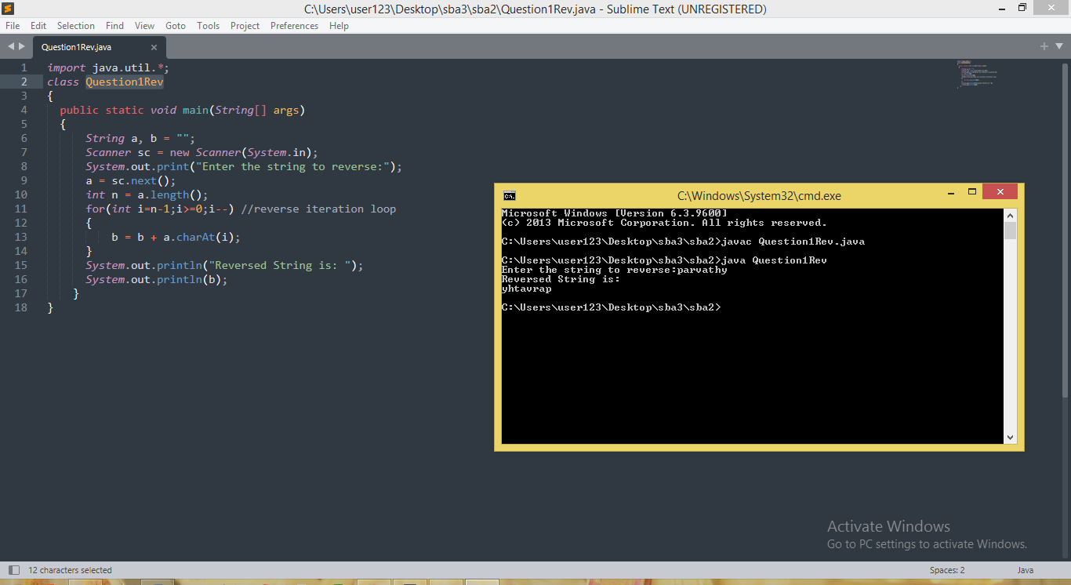

1. Write programs to depict the usage of contains(), length(), replace(), concat(), equals()

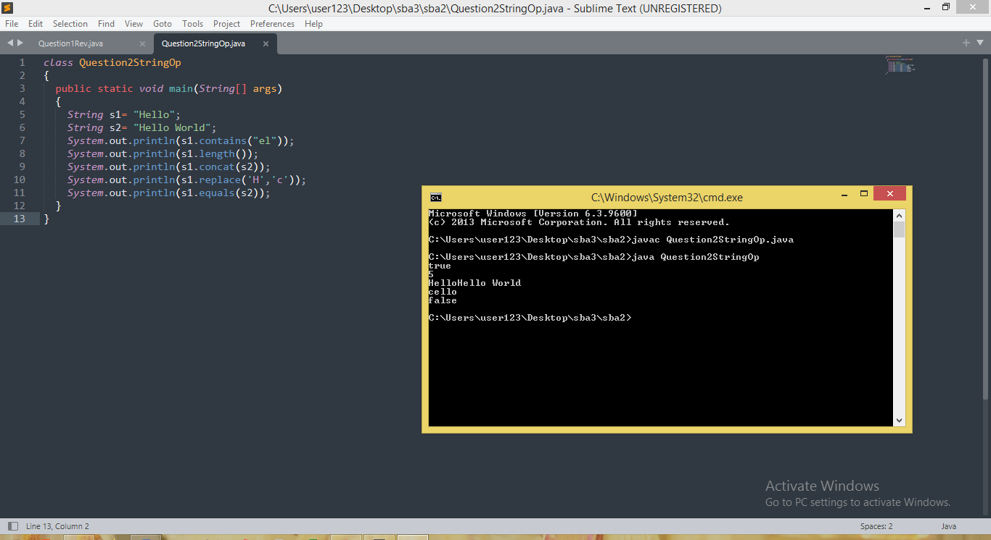

1. Write a customized Exception class for a Banking project

