|  |  |
| --- | --- |
|  | **Project Title**    **Technical Design Document** |
| |  |  |  |  | | --- | --- | --- | --- | |  | **Prepared By / Last Updated By** | **Reviewed By** | **Approved By** | | **Name** | Team 4 |  |  | | **Role** | Scrum Master |  |  | | **Signature** |  |  |  | | **Date** |  |  |  | |
|  |

**Table of Contents**

**1.0 Introduction**

1.1 Purpose of this document

1.2 Project overview

**2.0 Solution Summary**

2.1 Scope

2.2 Assumptions

2.3 Dependencies

2.4 Risks

**3.0 Schematic Diagram**

**4.0 Database Design**

4.1 Data Model

4.2 Table structure

**5.0 Terms & Conditions**

**6.0 Change Log**

**1.0 Introduction**

**1.1 Purpose of this document**

The purpose of this document is to document he technical design component details and Database design. This will also capture the scope, assumptions, risk, dependencies of this project.

**1.2 Project overview**

**1.2.1 Objectives**

Below are the objectives that shall be fulfilled post the execution of this project.

* User Registration and Login.
* User authentication.
* Adding vendor and customer details.
* Adding products and services.
* Booking products and services.
* Generating bill.

**2.0 Solution Summary**

**1. Scope**

Admin:

* Login to the system
* Should be able to update the product and services category’ related details.
* Should be able to listen to the user feedbacks and act on them.

User:

* As a customer:
* Should be able to register and login to the system.
* Should be able to select and avail services/products based on his choice.
* Should be able to order and give feedback.
* Logout
* As a vendor:
* Should be able to register and login to the system.
* Vendor should be able to provide products or services based on his choice.
* Logout

**2.2 Assumptions**

* For admin, we have assumed that there is only one user acting as admin whose login and password has been already stored in the database.

**2.3 Dependencies**

* Availability of database design characteristics and access shall be defined.
* Resource availability throughout each of the sprint.

**2.4 Risks**

None

**3.0 Schematic Diagram**

**New User**

**Existing User**

**Register**

**As Customer**

**As Vendor**

**Customer**

**Admin**

**Vendor**

**Select product/services**

**Provide product/services**

**Update Categories’ details**

**Update product/services**

**Avail Product/Services**

**Update personal details**

**Make a payment**

**Listen to User Feedback**

**4.0 Database Design**

4.1 Data Model

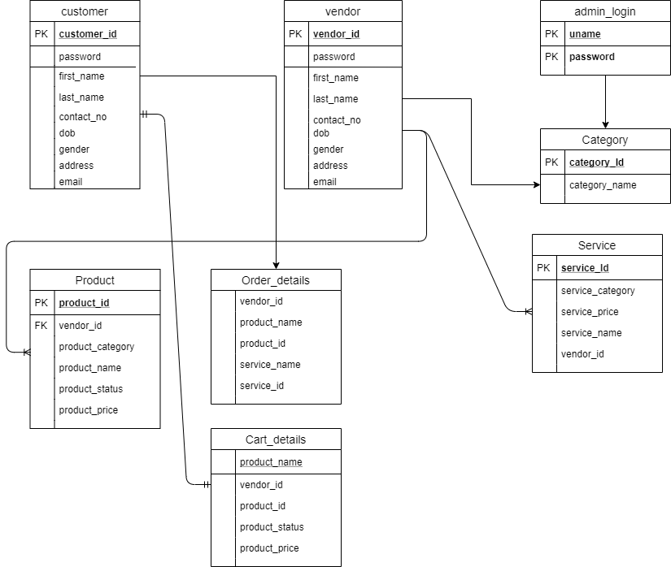

4.2 Table Structures

**Vendor registration:**

|  |  |  |  |
| --- | --- | --- | --- |
| **Column Name** | **Data Type** | **Length** | **Nulls** |
| First Name | varchar | 30 | - |
| Last Name | varchar | 30 | - |
| Email | varchar | - | - |
| DoB | date | 10 | - |
| Gender | char | 2 | - |
| Contact Number | varchar | 30 | - |
| Vendor ID | varchar | 30 | - |
| Password | varchar | 30 | - |
| Address | varchar | 30 | - |
| Zip | varchar | 30 | - |
| City | varchar | 30 | - |
| State | varchar | 30 | - |

**Customer registration:**

|  |  |  |  |
| --- | --- | --- | --- |
| **Column Name** | **Data Type** | **Length** | **Nulls** |
| First Name | varchar | 30 | - |
| Last Name | varchar | 30 | - |
| Email | varchar | - | - |
| DoB | date | 10 | - |
| Gender | char | 2 | - |
| Contact Number | varchar | 30 | - |
| Customer ID | varchar | 30 | - |
| Password | varchar | 30 | - |
| Address | varchar | 30 | - |
| Zip | varchar | 30 | - |
| City | varchar | 30 | - |
| State | varchar | 30 | - |

**Admin login:**

|  |  |  |  |
| --- | --- | --- | --- |
| **Column Name** | **Data Type** | **Length** | **Nulls** |
| User ID | varchar | 30 | - |
| Pass Word | varchar | 30 | - |

**Vendor login:**

|  |  |  |  |
| --- | --- | --- | --- |
| **Column Name** | **Data Type** | **Length** | **Nulls** |
| Vendor ID | varchar | 30 | - |
| Password | varchar | 30 | - |

**Customer login:**

|  |  |  |  |
| --- | --- | --- | --- |
| **Column Name** | **Data Type** | **Length** | **Nulls** |
| Customer ID | varchar | 30 | - |
| Password | varchar | 30 | - |

**Product table:**

|  |  |  |  |
| --- | --- | --- | --- |
| **Column Name** | **Data Type** | **Length** | **Nulls** |
| Product_id | varchar | 30 | - |
| Vendor_id | varchar | 30 | - |
| Product_category | varchar | 30 | - |
| Product_name | varchar | 30 | - |
| Product_price | varchar | 30 | - |
| Product_status | varchar | 30 | - |

**Service table:**

|  |  |  |  |
| --- | --- | --- | --- |
| **Column Name** | **Data Type** | **Length** | **Nulls** |
| Product_id | varchar | 30 | - |
| Vendor_id | varchar | 30 | - |
| Product_category | varchar | 30 | - |
| Product_name | varchar | 30 | - |
| Product_price | varchar | 30 | - |
| Product_status | varchar | 30 | - |

**Cart table:**

|  |  |  |  |
| --- | --- | --- | --- |
| **Column Name** | **Data Type** | **Length** | **Nulls** |
| Product_name | varchar | 30 | - |
| Vendor_id | varchar | 30 | - |
| Product_id | varchar | 30 | - |
| Product_status | varchar | 30 | - |
| Product_price | varchar | 30 | - |

**Category table:**

|  |  |  |  |
| --- | --- | --- | --- |
| **Column Name** | **Data Type** | **Length** | **Nulls** |
| Category_id | varchar | 30 | - |
| Category_name | varchar | 30 | - |

**5.0 Terms & Conditions**