Stock Market Application

Business scenario:
Predicting Stock Market has been goal of investors since its existence. Everyday billions of dollars are traded on exchange, and behind each dollar is an investor hoping to proﬁt in one way or another. Entire companies rise and fall daily based on the behavior of the market. Should an investor be able to accurately predict market movements, it oﬀers a tantalizing promises of wealth and inﬂuence. Few people knew how the market worked or reacted. This application allows user to view stock details and a stock calculator to predict the profit or loss percentage if the user desires to sell his shares.
- User can view stock details.
- 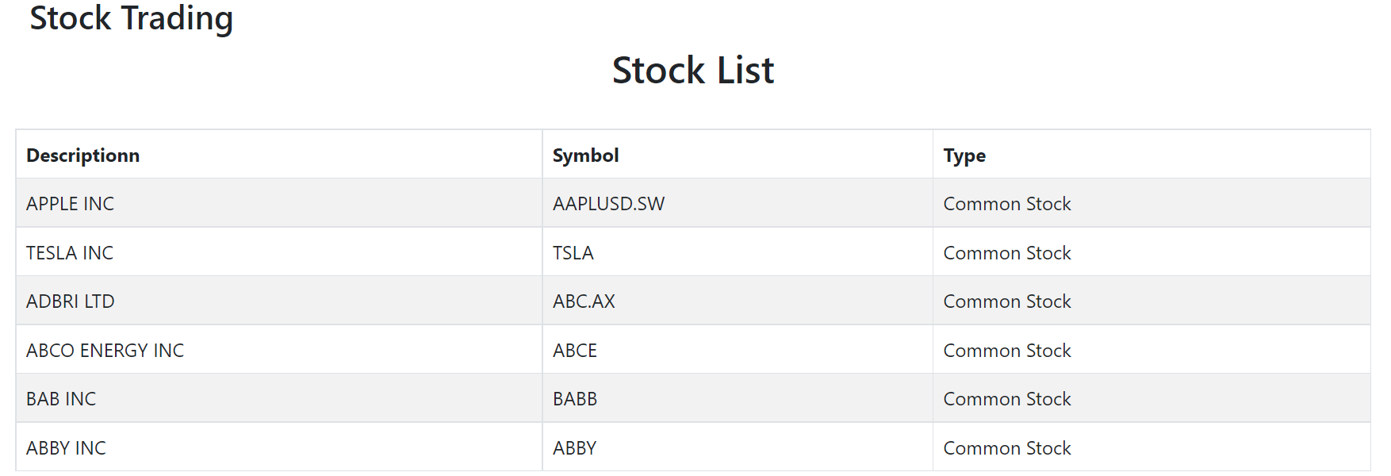
- User can decide to sell his stock using stock calculator. The API that we use for this requirement is finnhub.io. User can enter the stock symbol, purchased price and number of shares purchased and submit the form.
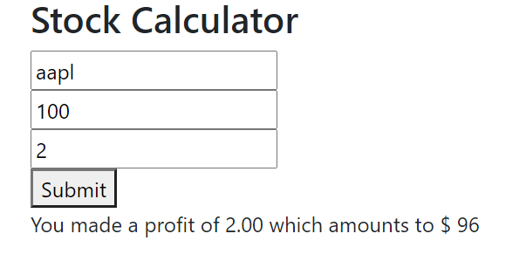
- On form submission, the API endpoint is called with the stock symbol name as query parameter. URL to access the end point : https://finnhub.io/api/v1/quote?symbol=TSLA&token=c07um4f48v6uu9ck9l4g. In this URL symbol is the user input. This endpoint returns the current price for the given stock symbol. With this profit or loss percentage is calculated and displayed to the user. If the user enters invalid symbol, then message “Invalid stock name” should be displayed.

