# SAVEETHA SCHOOL OF ENGINEERING

**CAPSTONE PROJECT**

**Designing and Implementing a Comprehensive University Network**

**NAME: Y.**Parveen

**REGISTER NUMBER:** 192325150 **COURSE CODE:** CSA0747

**COURSE NAME:** Computer Network for IOT

## INTRODUCTION:

Designing a university network with Cisco Packet Tracer involves setting up routers, switches, and wireless access points for seamless connectivity across PCs, laptops, smartphones, and servers. The project includes configuring an email server, optimizing wireless coverage, and presenting the network’s features and benefits to ensure efficient, reliable campus-wide communication.

### Objective:

* Design a robust network infrastructure with routers, switches, and wireless access points for seamless connectivity.
* Configure an email server for effective communication and mailbox management for staff and students.
* Optimize wireless coverage to ensure reliable access for all mobile and stationary devices.
* Create a presentation highlighting the network’s features, benefits, and operational procedures.

## LITERATURE REVIEW

The literature on designing university networks underscores the importance of scalable and reliable infrastructure, achieved through strategic router and switch placement and performance optimization techniques. Effective configuration of wireless access points is crucial for comprehensive coverage and managing interference, while email server setup requires robust security and efficient mailbox management. Research emphasizes the role of simulation tools like Cisco Packet Tracer in visualizing network configurations, ensuring seamless connectivity, and addressing the diverse needs of university environments. Studies also highlight best practices in network design to enhance performance, reliability, and security across campus networks.

# METHODOLOGY

**Software:**

* Cisco Packet Tracer

### Network Design:

Network consist of

* + 4 hubs
  + 4 switches
  + 18 PC/laptop

All hub are interconnected with each hub connecting to every other hub. Each pair of hub is connected to two switches, while the third hub is connected to a single switch. The first four switches each connect to two PCs, providing connectivity for a total of eight PCs. Additionally, the third switch is connected to two servers, facilitating server access within the network.

### IP Address Allocation:

**Step 1:** let us assume hub1 consist of four PCs and 1 laptop then,

- PC0 IP-address be - 192.168.0.1

- PC1 IP-address be - 192.168.0.2

- PC2 IP-address be - 192.168.0.3

- PC3 IP-address be - 192.168.0.4

- Laptop0 IP-address be – 192.168.0.5

**Step 2:** at switch0 consist of two PCs then,

- PC4 IP-address be - 192.168.0.6

- PC5 IP-address be - 192.168.0.

**Step 3:** at switch1 consist of one PCs and one hub then,

- PC6 IP-address be - 192.168.0.

**Step 4:** at switch2 consist of two PCs and one hub then,

- PC9 IP-address be - 192.168.0.11

- PC10 IP-address be - 192.168.0.12

**Step 5:** at switch3 consist of two PCs then,

* PC7 IP-address be - 192.168.0.9
* PC8 IP-address be - 192.168.0.10

**Step 6:** at hub1 consist of two PCs and one hub then,

- PC11 IP address –192.168.0.13

- PC14 IP address –192.168.0.16

**Step 7:** at hub2 consist of two PCs and two hubs then,

- PC12 IP address – 192.168.0.14

- PC15 IP address – 192.168.0.17

**Step 8:** at hub3 consist of two Pcs and one hub then,

- PC13 IP address – 192.168.0.15

- PC14 IP address – 192.168.0.18

**Step 9:** connecting Hub0 to Switch1 and Hub1 to Switch2

### Protocol: - HTTP

* HTTP is the communication protocol used on the World Wide Web.
* It specifies how communications (requests and responses) are prepared and sent between clients (such web browsers) and servers.
* Stateless protocol: Each request-response cycle is distinct; the server does not maintain information from prior encounters**.**

## RESULT:

### Network Design:

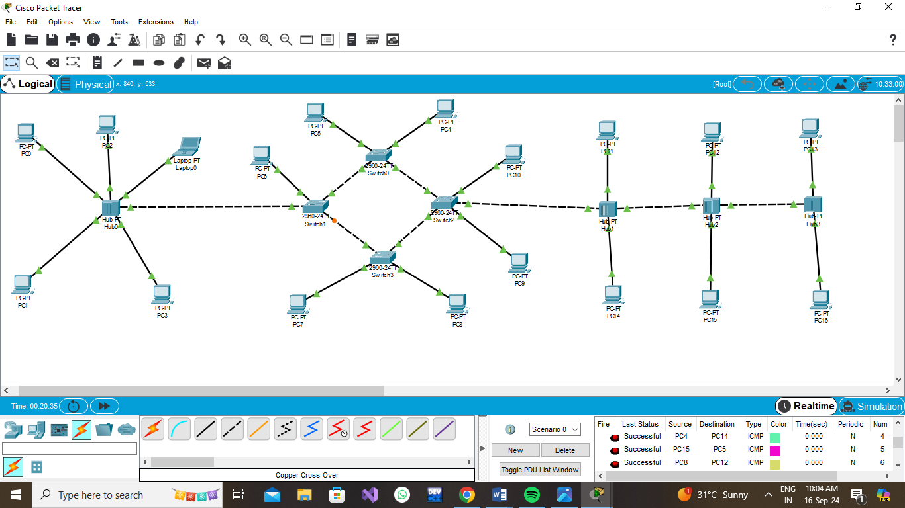

## CONCLUSION:

Cisco Packet Tracer is a versatile network simulation tool that, while not designed to deploy actual web services, can effectively simulate and help you understand how web services operate within a network environment. Here’s what you can achieve with Packet Tracer regarding web services:

* **Simulate Web Server Functionality:** You can configure devices to replicate basic web server behavior. This setup allows you to test and observe how network configurations affect web traffic, offering insights into server-client interactions within the network.
* **Explore Web Service Interactions:** By connecting client PCs and simulated web server devices, you can mimic the process of web browsers requesting and receiving content via protocols like HTTP. This helps in understanding the flow of web traffic and how requests are handled.
* **Practice Network Design for Web Services:** Packet Tracer enables you to visualize and design network architectures involving web servers, clients, and other network components. This is valuable for planning and troubleshooting real-world web service deployments.

Although Packet Tracer does not run real web server software, it serves as an effective platform for learning and experimenting with web services in a controlled, virtual network environment. For actual web service deployment, dedicated web server software on appropriate hardware is required.