Q.8 Least Common Multiple (LCM) of Two Numbers.

Aim :
To find the LCM of two numbers using RAPTOR.
Algorithm :
1. Start.
2. Input two numbers a and b.
3. Find gcd of a and b using the Euclidean method.
4. Calculate lcm = (a * b) / gcd.
5. Display lcm.
6. Stop.
Steps to Build in RAPTOR :
Input: Enter a -> store in a
Input: Enter b -> store in b
Assignment: x <- a
Assignment: y <- b
Loop: exit condition: y = 0
Assignment: temp <- y
Assignment: y <- x mod y
Assignment: x <- temp
Assignment: lcm <- (a * b) / x (x now holds the gcd)
Output: lcm
Input :
a : 4
b : 6
Output :
LCM = 12

Snapshot from Raptor :
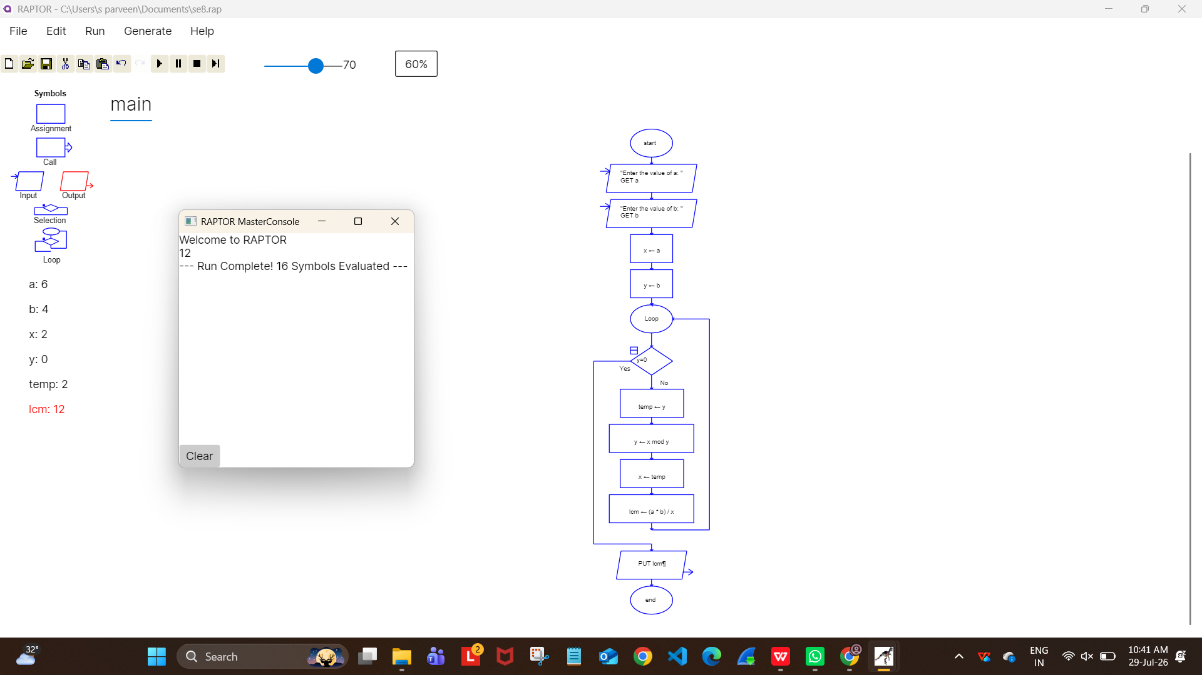
Result :
LCM of two numbers found successfully using RAPTOR.

