Q.10 Length of a String.

Aim :
To find the length of a given string using RAPTOR.
Algorithm :
1. Start.
2. Input the string s.
3. Set length = 0.
4. Repeat for each character in s:
○ length = length + 1.
5. Display length.
6. Stop.
Steps to Build in RAPTOR :
Input: Enter s -> store in s
Assignment: length <- Length_of(s) (Length is a built-in RAPTOR string function)
Output: length
Input :
s : "HELLO"
Output :
Length of string = 5

Snapshot from Raptor :
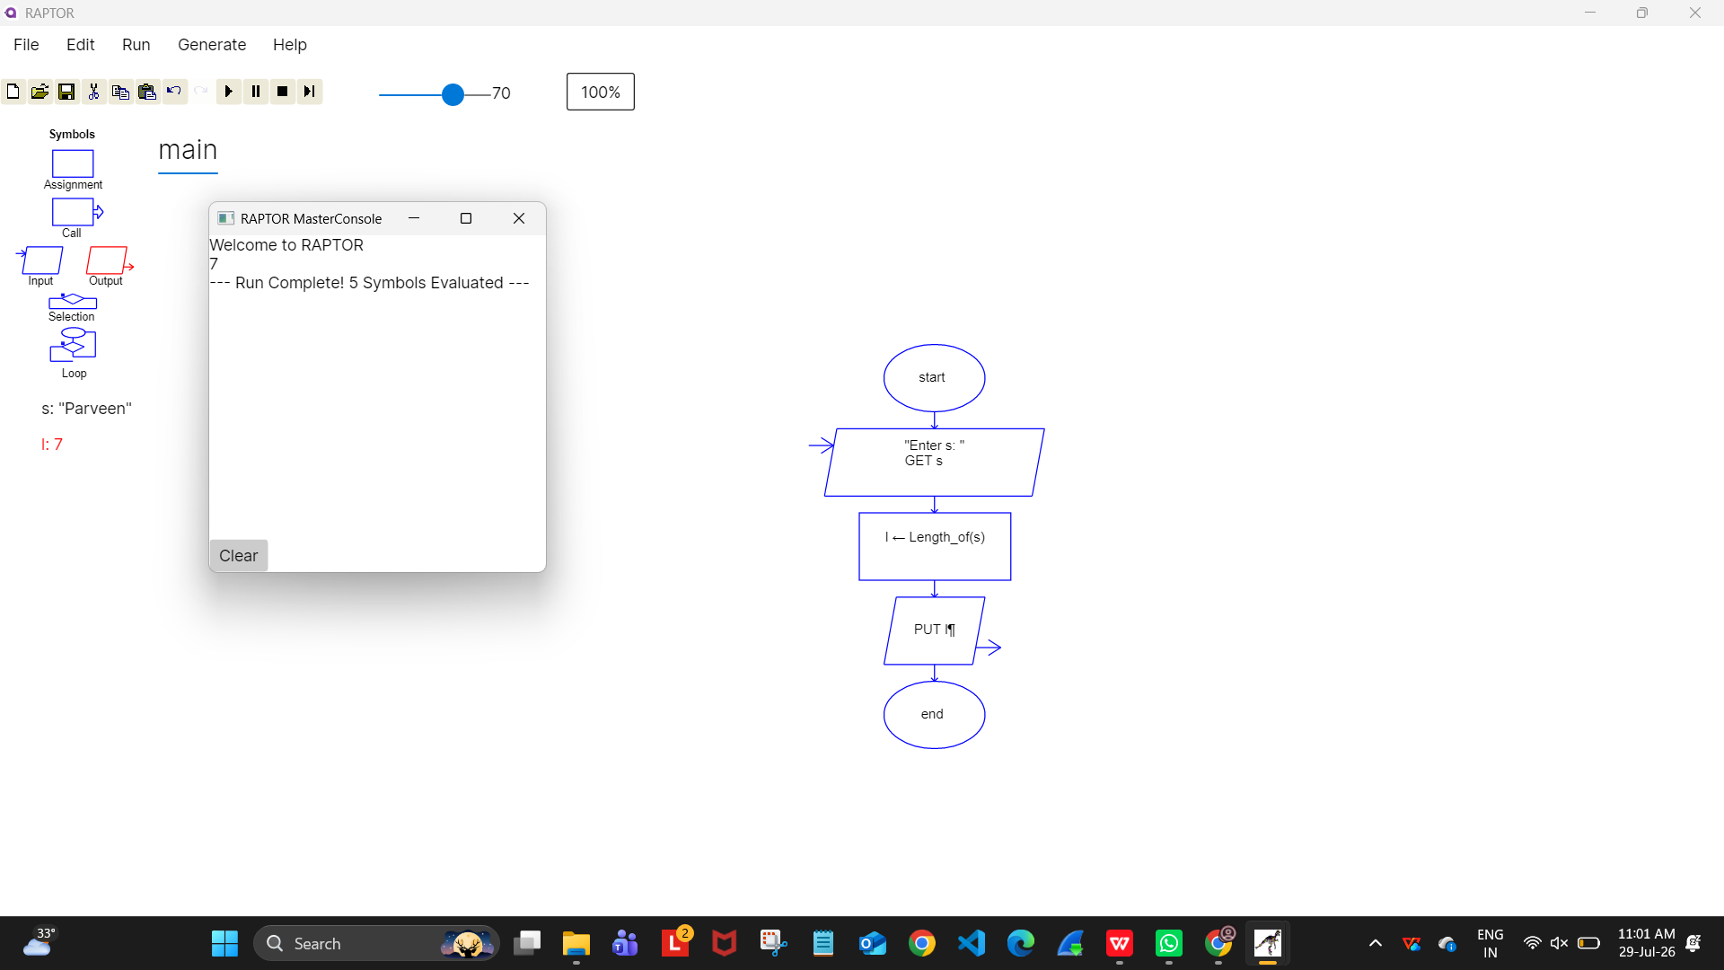

Result :
Length of the string found successfully using RAPTOR.

