Q.17 Anagram Check.
Aim :
To check whether two given strings are anagrams of each other using RAPTOR.
Algorithm :
1. Start.
2. Input string1 and string2.
3. If length of string1 is not equal to length of string2, display "Not an Anagram" and stop.
4. For every letter of the alphabet, count its occurrences in string1 and in string2.
5. If any letter's counts differ, the strings are not anagrams.
6. If all counts match, display "Anagram".
7. Else display "Not an Anagram".
8. Stop.
Steps to Build in RAPTOR :
This uses a letter-frequency comparison (simpler to build in RAPTOR than sorting characters). Build and test with short strings first.
Input: Enter s1 -> store in s1
Input: Enter s2 -> store in s2
Assignment: match <- 1
Selection: condition: Length(s1) <> Length(s2)
Yes branch -> Assignment: match <- 0
Assignment: alphabet <- "abcdefghijklmnopqrstuvwxyz"
Assignment: k <- 1
Loop: exit condition: (k > 26) OR (match = 0)
Assignment: ch <- Substring(alphabet, k, k)
Assignment: count1 <- 0
Assignment: count2 <- 0
Assignment: i <- 1
Loop: exit condition: i > Length(s1)
Selection: condition: Substring(s1, i, i) = ch
Yes branch -> Assignment: count1 <- count1 + 1
Assignment: i <- i + 1
Assignment: i <- 1
Loop: exit condition: i > Length(s2)
Selection: condition: Substring(s2, i, i) = ch
Yes branch -> Assignment: count2 <- count2 + 1
Assignment: i <- i + 1
Selection: condition: count1 <> count2
Yes branch -> Assignment: match <- 0
Assignment: k <- k + 1
Selection: condition: match = 1 (place after the loop)
Yes branch -> Output: "Anagram"
No branch -> Output: "Not an Anagram"
Input :
string1 : "LISTEN"
string2 : "SILENT"
Output :
LISTEN and SILENT are Anagrams
Snapshot from Raptor :
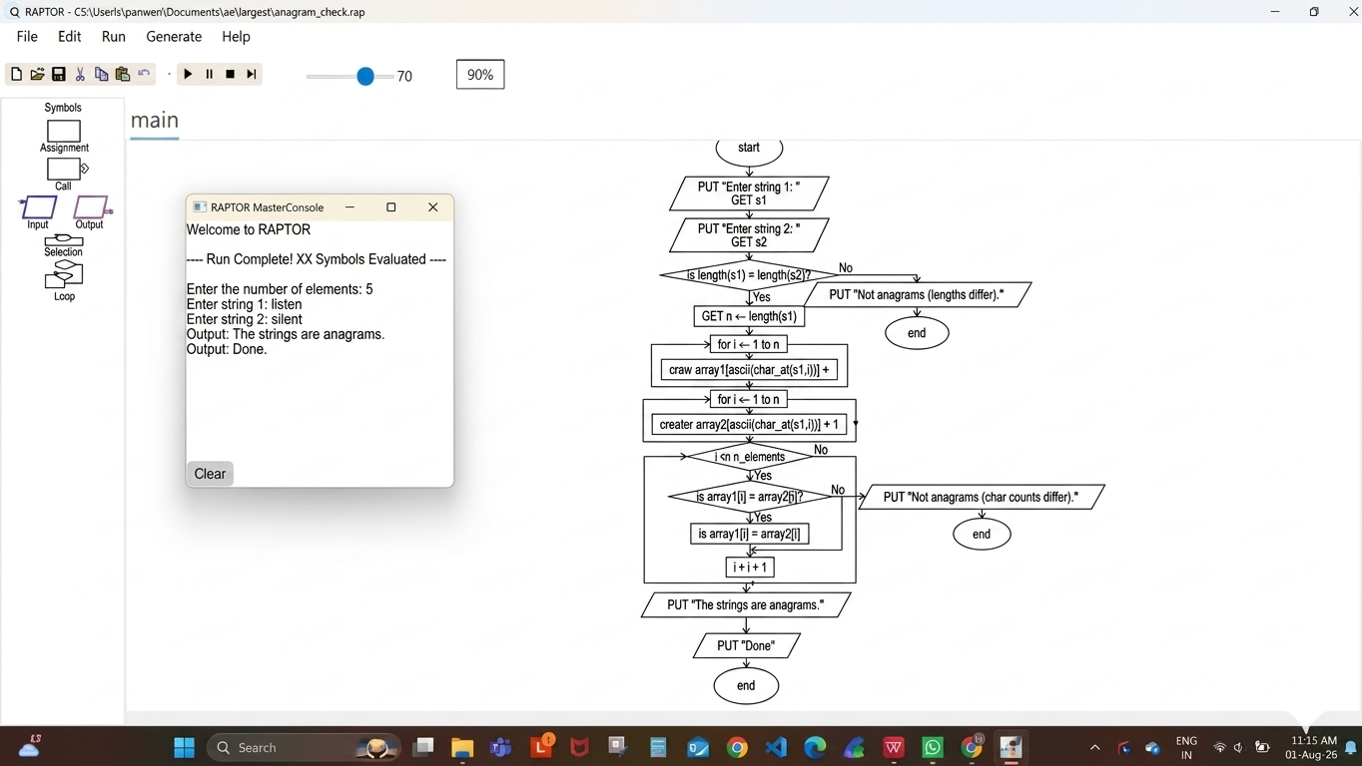
Result :
Anagram check performed successfully using RAPTOR.

