Q.6 Sum of First N Natural Numbers.

Aim :
To find the sum of first n natural numbers using RAPTOR.
Algorithm :
1. Start.
2. Input the number n.
3. Set sum = 0 and i = 1.
4. Repeat while i <= n:
○ sum = sum + i.
○ i = i + 1.
5. Display sum.
6. Stop.
Steps to Build in RAPTOR :
Input: Enter n -> store in n
Assignment: sum <- 0
Assignment: i <- 1
Loop: drag the Loop block; set exit condition: i > n
Assignment: sum <- sum + i
Assignment: i <- i + 1
Output: sum (place after the loop, on the exit path)
Input :
n : 5
Output :
Sum of first 5 natural numbers = 15

Snapshot from Raptor :
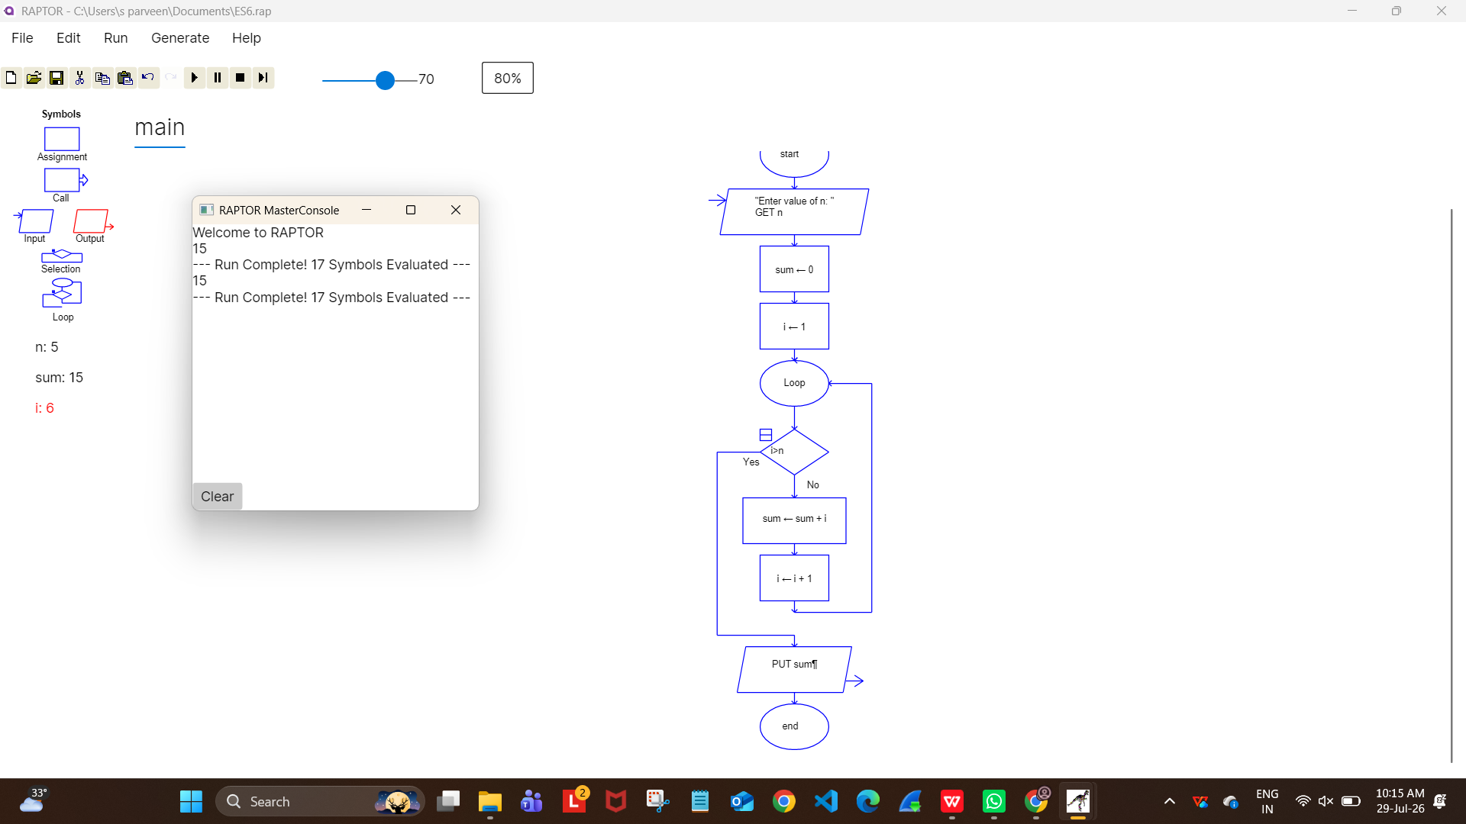

Result :
Sum of first n natural numbers computed successfully using RAPTOR.

