Q.11 Palindrome Check.

Aim :
To check whether a given string is a palindrome using RAPTOR.
Algorithm :
1. Start.
2. Input the string s.
3. Set rev = "" (empty string).
4. Repeat for each character in s from last to first:
○ rev = rev + current character.
5. If s is equal to rev, display "Palindrome".
6. Else display "Not a Palindrome".
7. Stop.
Steps to Build in RAPTOR :
Input: Enter s -> store in s
Assignment: rev <- ""
Assignment: i <- Length(s)
Loop: exit condition: i < 1
Assignment: rev <- rev + Substring(s, i, i)
Assignment: i <- i - 1
Selection: condition: s = rev
Yes branch -> Output: "Palindrome"
No branch -> Output: "Not a Palindrome"
Input :
s : "MADAM"
Output :
MADAM is a Palindrome

Snapshot from Raptor :
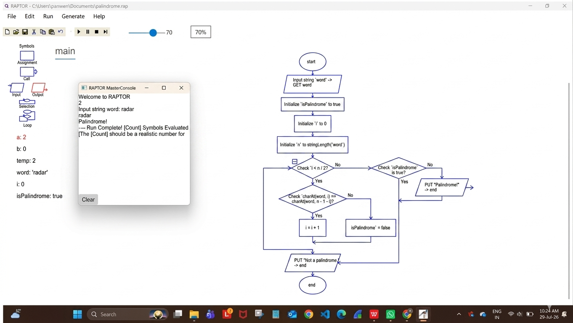

Result :
Palindrome check performed successfully using RAPTOR.

