Q.13 Finding Cyclomatic Complexity.
Aim :
To calculate the Cyclomatic Complexity of a given program / flow graph.
Theory :
Cyclomatic Complexity is a software metric used to measure the number of independent paths through a program's source code. It is calculated from the control flow graph (CFG) of the program, where nodes represent blocks of sequential statements and edges represent the flow of control between them.
Cyclomatic Complexity (V(G)) can be calculated using any of the following formulas:
1. V(G) = E - N + 2P
N = number of nodes in the flow graph,
P = number of connected components (usually 1 for a single program).
2. V(G) = Number of decision (predicate) nodes + 1.
3. V(G) = Number of regions in the flow graph.
Note :
This experiment is a manual/theoretical calculation based on a program's flow graph — it is not built or run inside RAPTOR like the other experiments.
Algorithm :
1. Start.
2. Draw the flow graph of the given program, representing each sequential block as a node.
3. Identify and count the total number of edges (E) connecting the nodes.
4. Count the total number of nodes (N) in the flow graph.
5. Take the number of connected components as P = 1.
6. Compute Cyclomatic Complexity using V(G) = E - N + 2P.
7. Cross-check the result using V(G) = number of decision nodes + 1.
8. Display the Cyclomatic Complexity.
9. Stop.
Example :
Consider a simple program with an IF-ELSE condition followed by a loop:
Flow graph details - Nodes (N) = 6, Edges (E) = 7, Connected components (P) = 1.
Decision nodes (if condition + loop condition) = 2.
Input :
Flow graph with N = 6 nodes and E = 7 edges.
Output :
V(G) = E - N + 2P = 7 - 6 + 2(1) = 3
Cross-check: V(G) = Decision nodes + 1 = 2 + 1 = 3
Cyclomatic Complexity = 3 (i.e. 3 independent paths exist through the program)

Snapshot / Flow Graph :
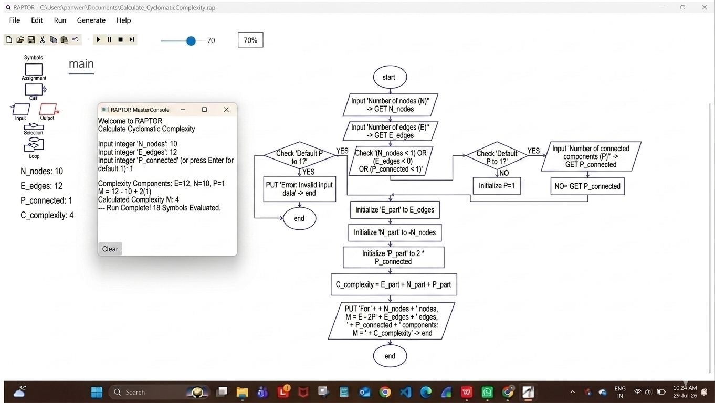
Result :
Cyclomatic Complexity of the given program was calculated successfully.

