Q.7 Greatest Common Divisor (GCD) of Two Numbers.

Aim :
To find the GCD of two numbers using RAPTOR.
Algorithm :
1. Start.
2. Input two numbers a and b.
3. Repeat while b is not equal to 0:
○ temp = b.
○ b = a mod b.
○ a = temp.
4. Display a as the GCD.
5. Stop.
Steps to Build in RAPTOR :
Input: Enter a -> store in a
Input: Enter b -> store in b
Loop: exit condition: b = 0
Assignment: temp <- b
Assignment: b <- a mod b
Assignment: a <- temp
Output: a (on the exit path, this is the GCD)
Input :
a : 36
b : 24
Output :
GCD = 12

Snapshot from Raptor :
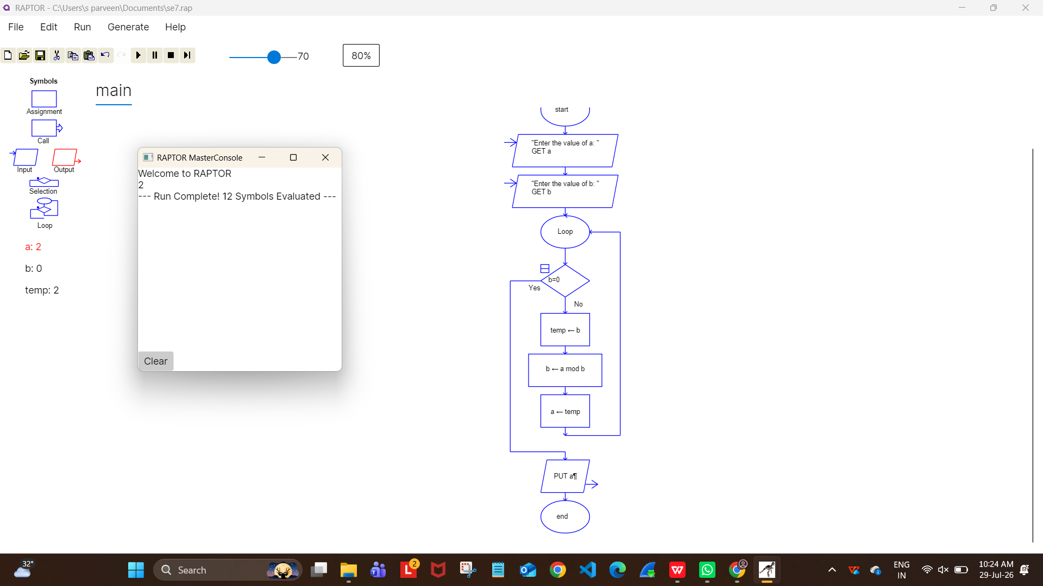

Result :
GCD of two numbers found successfully using RAPTOR.

