Q.15 Largest Number in a Range (Array).
Aim :
To find the largest number among a set of numbers stored in an array using RAPTOR.
Algorithm :
1. Start.
2. Input the number of elements n.
3. Input n elements into array arr.
4. Set max = arr[1].
5. Repeat for i = 2 to n:
○ If arr[i] > max, set max = arr[i].
6. Display max.
7. Stop.
Steps to Build in RAPTOR :
Input: Enter n -> store in n
Assignment: i <- 1
Loop: exit condition: i > n
Input: Enter arr[i] -> store in arr[i] (RAPTOR auto-creates the array)
Assignment: i <- i + 1
Assignment: max <- arr[1]
Assignment: j <- 2
Loop: exit condition: j > n
Selection: condition: arr[j] > max
Yes branch -> Assignment: max <- arr[j]
Assignment: j <- j + 1
Output: max
Input :
n : 5
arr : 12, 45, 7, 89, 34
Output :
Largest number = 89

Snapshot from Raptor :
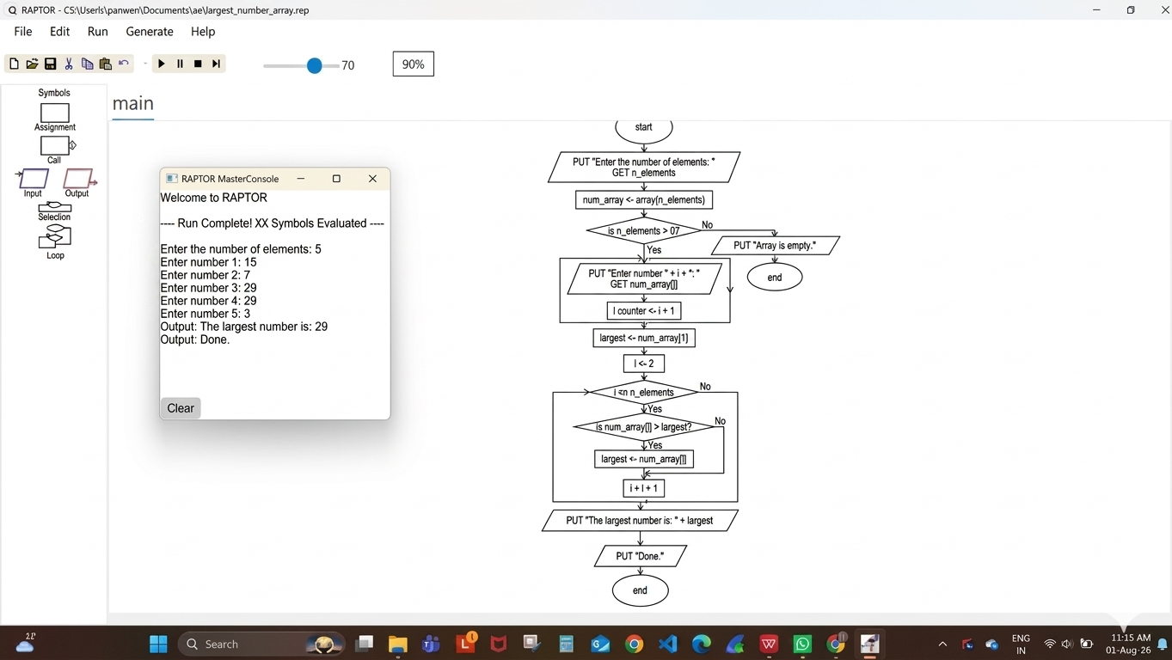
Result :
Largest number in the array found successfully using RAPTOR.

