Q.18 Swapping Two Numbers.

Aim :
To swap two numbers using RAPTOR.
Algorithm :
1. Start.
2. Input two numbers a and b.
3. Set temp = a.
4. Set a = b.
5. Set b = temp.
6. Display a and b.
7. Stop.
Steps to Build in RAPTOR :
Input: Enter a -> store in a
Input: Enter b -> store in b
Assignment: temp <- a
Assignment: a <- b
Assignment: b <- temp
Output: a
Output: b
Input :
a : 5
b : 10
Output :
After swapping: a = 10, b = 5

Snapshot from Raptor :
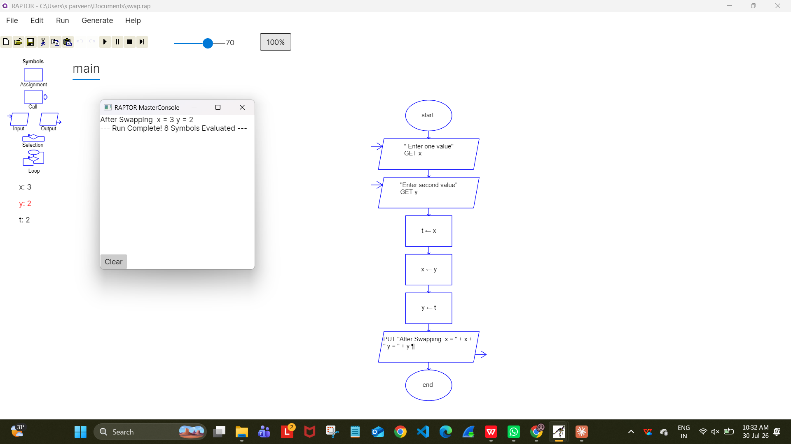
Result :
Two numbers swapped successfully using RAPTOR.

