Q.14 Reverse a String.
Aim :
To reverse a given string using RAPTOR.
Algorithm :
1. Start.
2. Input the string s.
3. Set rev = "" (empty string).
4. Repeat for each character in s from last to first:
○ rev = rev + current character.
5. Display rev.
6. Stop.
Steps to Build in RAPTOR :
Input: Enter s -> store in s
Assignment: rev <- ""
Assignment: i <- Length(s)
Loop: exit condition: i < 1
Assignment: rev <- rev + Substring(s, i, i)
Assignment: i <- i - 1
Output: rev (on the exit path)
Input :
s : "HELLO"
Output :
Reversed string = "OLLEH"

Snapshot from Raptor :
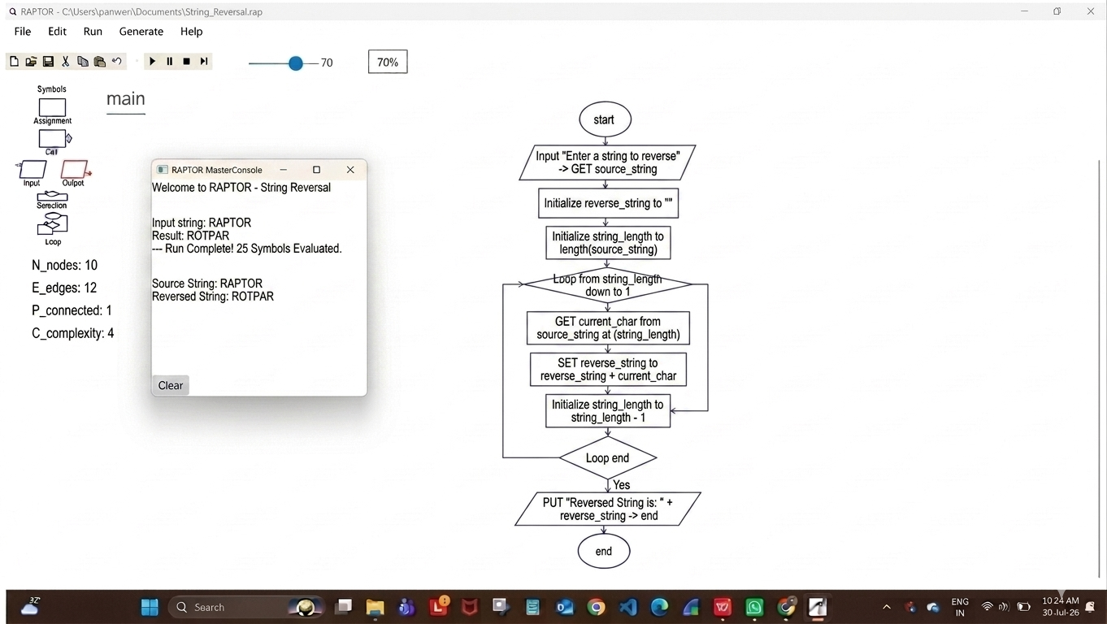

Result :
String reversed successfully using RAPTOR.

