Q.12 Prime Number Check.

Aim :
To check whether a given number is prime using RAPTOR.
Algorithm :
1. Start.
2. Input the number n.
3. Set flag = 1 and i = 2.
4. Repeat while i <= n / 2:
○ If n mod i = 0, set flag = 0 and exit loop.
○ i = i + 1.
5. If flag = 1, display "Prime Number".
6. Else display "Not a Prime Number".
7. Stop.
Steps to Build in RAPTOR :
Input: Enter n -> store in n
Assignment: flag <- 1
Assignment: i <- 2
Loop: exit condition: (i > n / 2) OR (flag = 0)
Selection: condition: n mod i = 0
Yes branch -> Assignment: flag <- 0
Assignment: i <- i + 1
Selection: condition: flag = 1 (place after the loop)
Yes branch -> Output: "Prime Number"
No branch -> Output: "Not a Prime Number"
Input :
n : 7
Output :
7 is a Prime Number

Snapshot from Raptor :
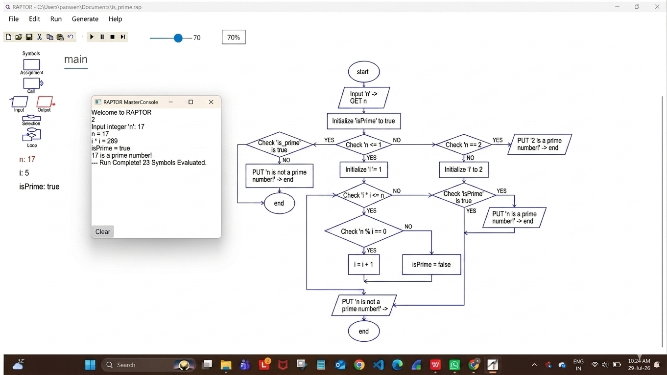
Result :
Prime number check performed successfully using RAPTOR.

