Q.9 Quotient and Remainder for Float Division.

Aim :
To find the quotient and remainder of a floating-point division using RAPTOR.
Algorithm :
1. Start.
2. Input dividend and divisor (as real/float values).
3. Calculate quotient = floor(dividend / divisor).
4. Calculate remainder = dividend - (quotient * divisor).
5. Display quotient and remainder.
6. Stop.
Steps to Build in RAPTOR :
Input: Enter dividend -> store in dividend
Input: Enter divisor -> store in divisor
Assignment: quotient <- Floor(dividend / divisor) (Floor is a built-in RAPTOR math function - type it directly in the expression)
Assignment: remainder <- dividend rem divisor
Output: quotient
Output: remainder
Input :
Dividend : 10.5
Divisor : 3.2
Output :
Quotient = 3
Remainder = 0.9

Snapshot from Raptor :
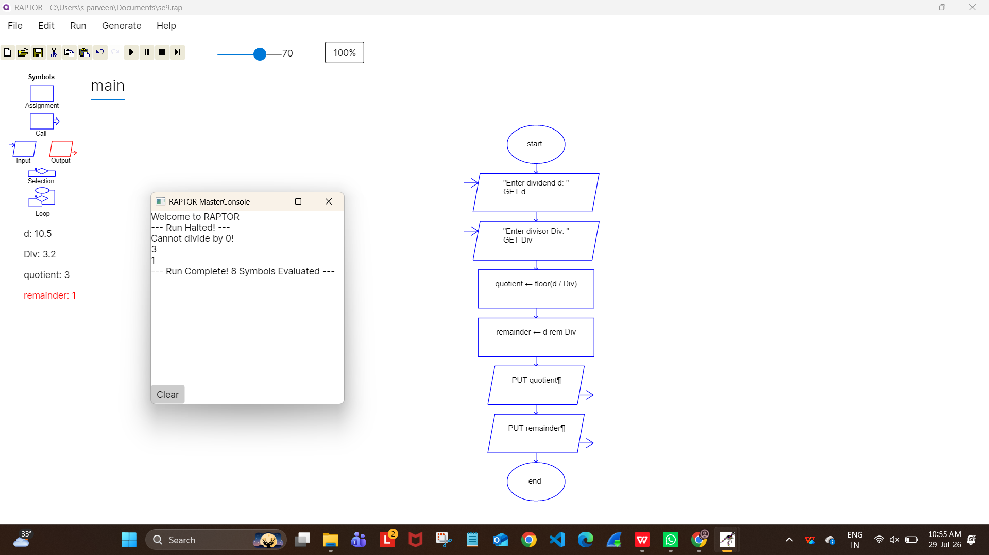
Result :
Quotient and remainder for float division found successfully using RAPTOR.

