Q.16 Smallest Even Prime Number Using Range.
Aim :
To find the smallest even prime number within a given range using RAPTOR.
Algorithm :
1. Start.
2. Input the lower limit and upper limit of the range.
3. Note: 2 is the only even prime number that exists (every other even number is divisible by 2, so it cannot be prime).
4. Check if 2 lies within the given range.
5. If yes, display 2 as the smallest even prime.
6. If no, display that no even prime exists in the range.
7. Stop.
Steps to Build in RAPTOR :
Since 2 is mathematically the only even prime number, the flowchart just needs to check whether 2 falls inside the entered range.
Input: Enter low -> store in low
Input: Enter high -> store in high
Selection: condition: (low <= 2) AND (high >= 2)
Yes branch -> Output: "Smallest even prime number = 2"
No branch -> Output: "No even prime number exists in this range"
Input :
Lower limit : 1
Upper limit : 20
Output :
Smallest even prime number = 2

Snapshot from Raptor :
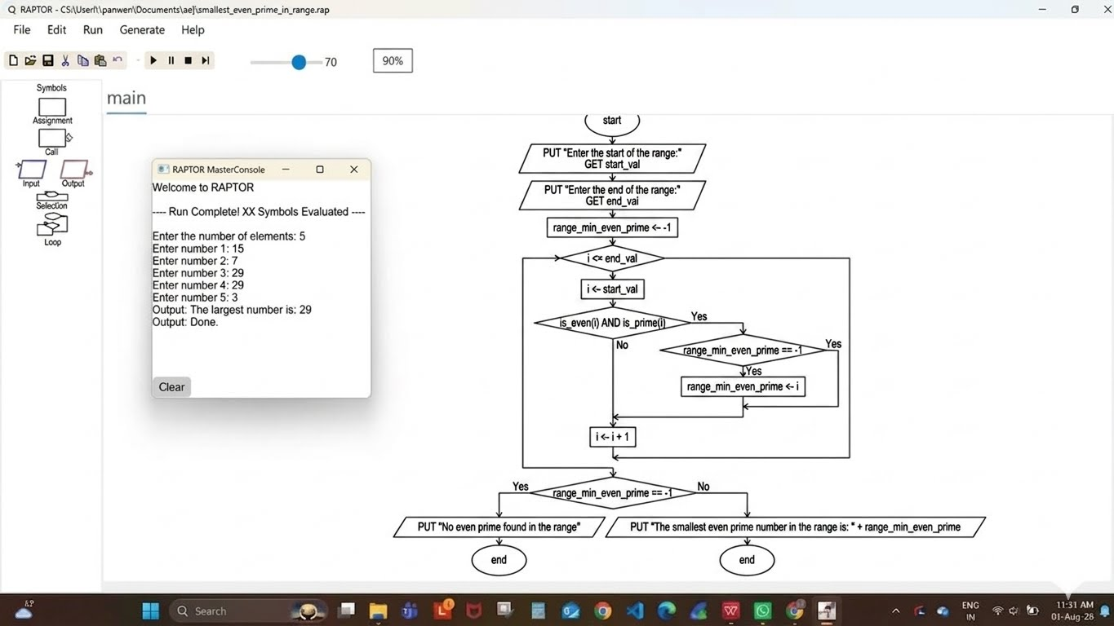
Result :
Smallest even prime number in the given range found successfully using RAPTOR.

