**Definition of market Intelligence research system:**

In simple terms, market intelligence is information that is gathered for the purpose of making business decisions. It is largely synonymous with market research, the systematic gathering, recording, analysis and interpretation of information about a company's markets, competitors and customers.

**Overview of B2B research company:**

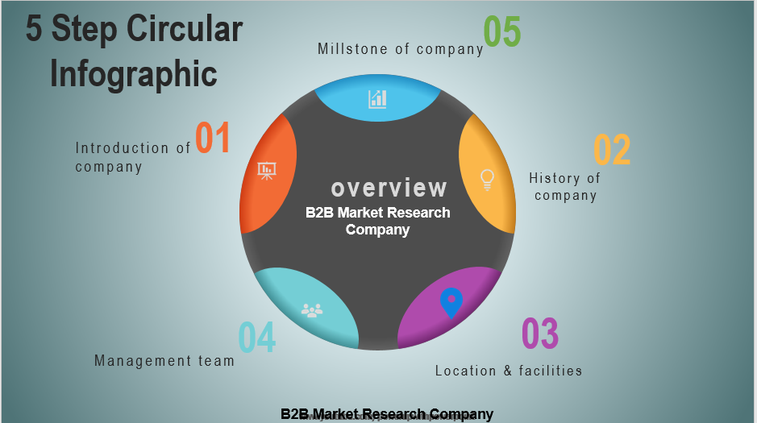

**Introduction of B2B** **research company:**

I have selected an organization named b2b to create this assignment.

The reason is that this company has been researching market intelligence for a long time. b2b is the perfect market research firm's ability to market business with its business and through the fruits of market research, they can explain their clients' strategic goals and help them make decisions.

**History B2B research company:**

The B2B was started in 1999 in Manchester, England. The company was originally created as a family venture between father and son. However, there was a lot of controversy from the beginning as no market intelligence research was known at that time. That was why it was very difficult for the client to gain good faith.

**Millstone B2B research company:**

The main goal of B2B is to create insights for everyone as a world-class brand.

At the same time, clients build more trust in the organization and increase their decision-making capabilities. This institute is very keen to recruit more sharp-minded researchers in the future and is committed to producing the best results possible under any circumstances.

**Location B2B research company:**

The B2B Institute was created as the first institutional office of a research firm in Manchester, England in 1999. However, as the B2B company is currently gaining international reputation and the scope of their work, they have opened their institution offices in high quality cities such as Singapore, New York, Beijing and so on.