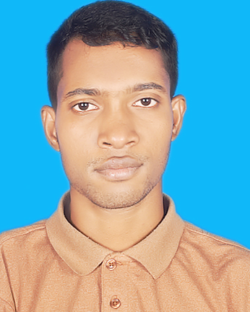

PHP

**MS Engineering& Constraction**

Kazipara,Mirpur, Dhaka

**01/01/2021- to till now.**

IT Support,Admin control, customize the website. **http://msecbd.com/**

**EXPERIENCE**

Wordpress

MD:

**PARVEJ**

Database

**CONTACT**



+880192292834



parvejbinrostom@gmail.com



Dhaka, BD



Parvejbd.com

To work in the IT sector, whether it is the frontend or the backend of the software. I will try my best to give experiences, skill, talent, creativity, sincerity for the better achievement of the organization

**PROFILE**

**HSC**

I have studied are Management, Financial Accounting, Managerial Economics, Marketing and Business Communication.

Python with Django

HTML,CSS

JavaScript

**SKILL**

**Diploma in IT**

I did my diploma and my major subjects were programming in computing and networking.

**B.Sc. Computing**

Subject that we have studied in BSC are

Database, Networking, Object Oriented Programming, Agile and Computer Ethics.

**LANGUAGES**

**ENGLISH**

**BANGLA**

**HINDI**

**HOBBIES**

**Daffodil university**

Dhaka, BD

**NCC**

British Council,UK

**City Collage**

Dhaka, **BD**

**EDUCATION**