<https://www.hackerrank.com/challenges/weather-observation-station-6/problem>

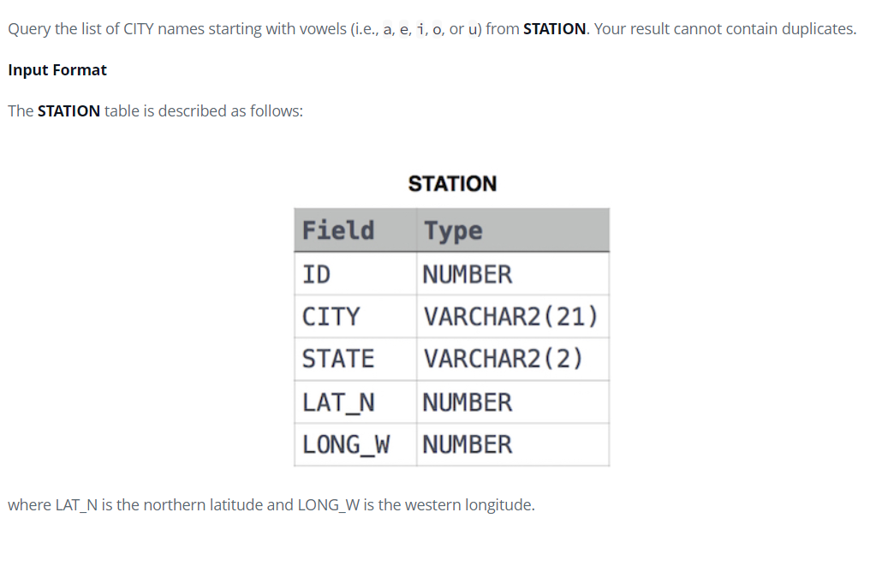

**Solution-1: USING LIKE**

SELECT **DISTINCT(CITY)** FROM STATION

WHERE **LOWER(CITY)** LIKE **‘a%’** OR

LOWER(CITY) LIKE ‘e%’ OR

LOWER(CITY) LIKE ‘i%’ OR

LOWER(CITY) LIKE ‘o%’ OR

LOWER(CITY) LIKE ‘u%’;

**Solution-2: Using REGEXP**

SELECT DISTINCT(CITY) FROM STATION

WHERE LOWER(CITY) **REGEXP** ‘^[aeiou].*’;

**Solution-3 Using RLIKE**

SELECT DISTINCT(CITY) FROM STATION

WHERE LOWER(CITY) **RLIKE** ‘^[aeiou]’;