Curriculum Vitae

PERSONAL INFORMATION | Parvez Miah
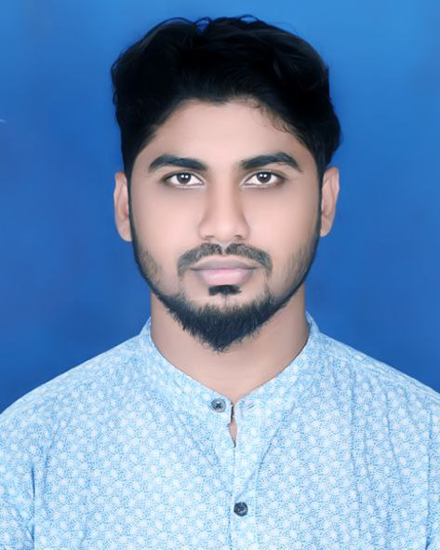 | Khilkhet, Nikunja-2, Dhaka- 1229
 | +8801686172299
 | iamparvezrahman@gmail.com
 | Date of birth 02/07/1997 | Nationality Bangladeshi

PERSONAL STATEMENT  CAREER OBJECTIVES | A motivated individual who takes considerable pleasure in forming a lasting positive impression with the client.  Immensely enjoys with others and is driven to exceed the expectations of customers. Committed to continuing professional development.  To secure a challenging position in a reputable organization to expand my learnings, knowledge, and skills. Secure a responsible career opportunity to fully utilize my training and skills, while making a significant contribution to the success

EDUCATION

2021(Appeared) | Bachelor in Engineering (BEngg)
Tejgaon University College
Major: Computer Science & Engineering
2015 | Higher Secondary School Certificate (H.S.C)
 | Ghatail Cantonment School & College
Science Group
Under Dhaka Board, Bangladesh. Obtained: GPA 4.67 out of 05.00

2013 |  | Secondary School Certificate (S.S.C)
 |  | Elenga High School
Science Group
Under Dhaka Board, Bangladesh. Obtained: GPA 4.63 out of 05.00
 | PERSONAL SKILLS
Mother tongue(s) Bengali Foreign language(s)
UNDERSTANDING |  | SPEAKING |  | WRITING
Listening | Reading | Spoken interaction | Spoken production

English B1 B1 B1 B1 B1
Levels: A1 and A2: Basic user - B1 and B2: Independent user - C1 and C2: Proficient user
WORK EXPERIENCE

03-01-17 To 05-31-17 Apps Development
Project: Lict Bangladesh,

Beginner Program.

Company name: Next Tech Ltd.

Organisational / managerial  skills | - Excellent communication skills.  - Ability to quickly grasp new concepts.  - Positive thinking, self-motivated and flexible.  - Ambitious, hardworking, energetic and well disciplined.

Digital skills  Skill Level | Excellent Computer literacy in Basic applications such as MS (Word, Excel, PowerPoint), Emailing, Internet browsing.  Advanced

Hobbies and Interests | Keeping fit and healthy, socializing, travelling, adventure and lifestyle activities.

ADDITIONAL INFORMATION

- Father Name
- Mother's Name
- Blood Group
- Gender
- Nationality
- Marital Status
- Religion
- Permanent Address

Habibur Rahman
Khaleda Begum
A+
Male
Bangladeshi
Single
Muslim
Elenga, Kalihati, Tangail.

I do hereby declare that all information is true to my knowledge. I am aware of the fact any misrepresentation might be treated as disqualification for me.


Signature

Date: --/--/--.

Page 2 / 2

