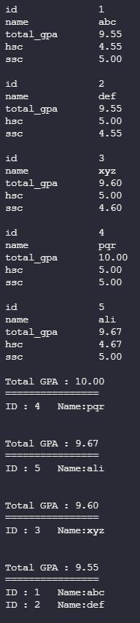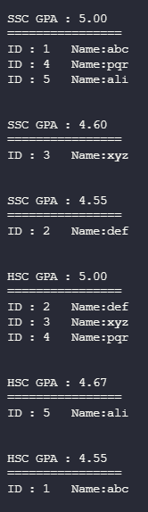Screenshots of the console

Screenshot of the modified files

