*Ahsanullah University of Science & Technology* Department of Computer Science & Engineering



# UNI BUDDY

Software Development III (CSE 2200), Fall2021

|  |
| --- |
| **Submitted to**  Mr. Amir Hossain Raj  Mr.Md Aminur Rahman  Marufa Kamal Labonno |

**ABSTRACT**

The "UNI BUDDY" project is a Notes management application for storing and maintaining semester notes of different students. This mobile application will be built in Android Studio and will be developed in kotlin and the database will be managed by Firebase.

This software primarily focuses on maintaining, viewing, saving, and storing the different things of a student to make life easier. As well as some unique features such as user login. After completing a signup form new users can sign in easily.. One will be able to register using the university id and password. It has also a facility where a student will be getting updates on the official university notifications and will be able to calculate their CGPA.

A user will be able to update his or her account information. Visit their profile search for specific notes, and question, and get an insight view about any course.

Overall, the primary goal of this project is to provide a hassle-free semester for users as well as to save their time looking for notes and questions here and there. It will be a valuable asset while taking preparation for the final

**INTRODUCTION**

## 1.1 Overview

The "UNI BUDDY" project is a utility application for storing and saving university notes. This software primarily focuses on the notes and questions a student needs to take proper preparation for their semester final as well as getting updates from the university.

## 1.2 Purpose

Reliable documentation is always a must-needed thing for a well-structured project. The presence of documentation helps to keep track of all aspects of an application, and it improves the quality of a software product.

The main goal of this project is to provide a friendly environment for the students to maintain the preparation time of the semester in the best way possible while also human efforts. It can assist administrators in managing links or notes more effectively and efficiently.

### 1.2.1 Background Study

The application is developed for automating the searching of notes, and questions, getting news, and calculating CGPA. The application will be a great relief to the backbencher who’s been chilling the whole semester but wants to ace the finals and also to the nerd who’s trying to score 102% in the final. So won’t it be helpful for the person who’s looking to do average? yes, calculate and analyze your results even before the exams and ace the exam according to that plan!

**FEATURES**

* **Onboarding pages**

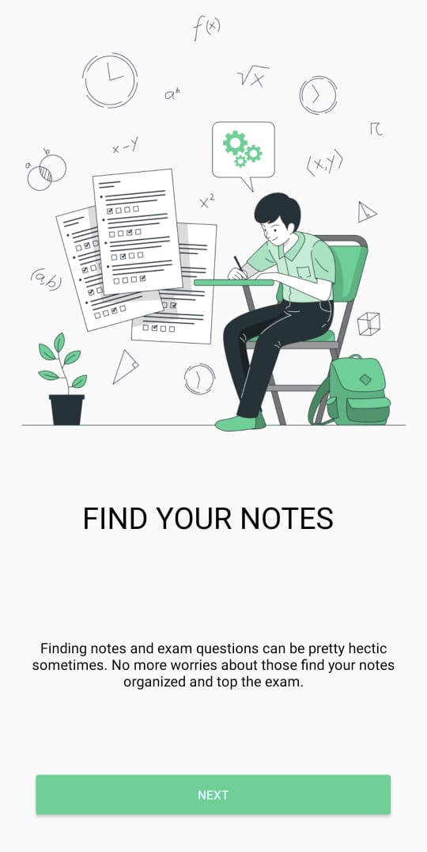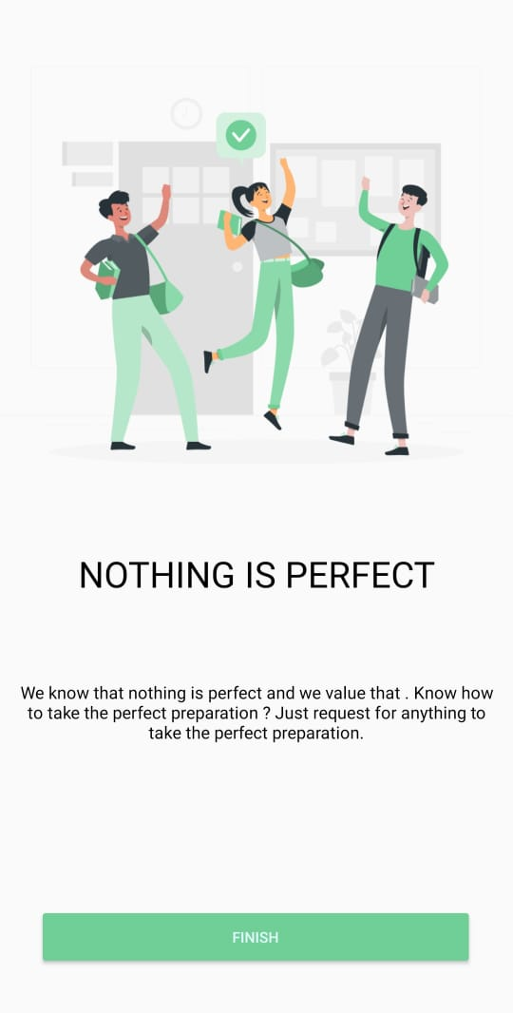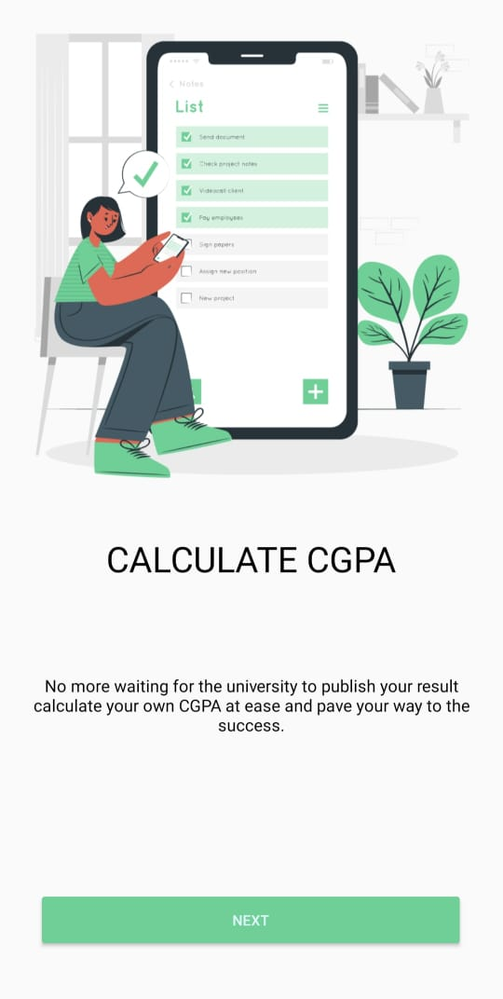When the users will log in for the first time they will get the onboarding pages to get an idea about the app and its features.

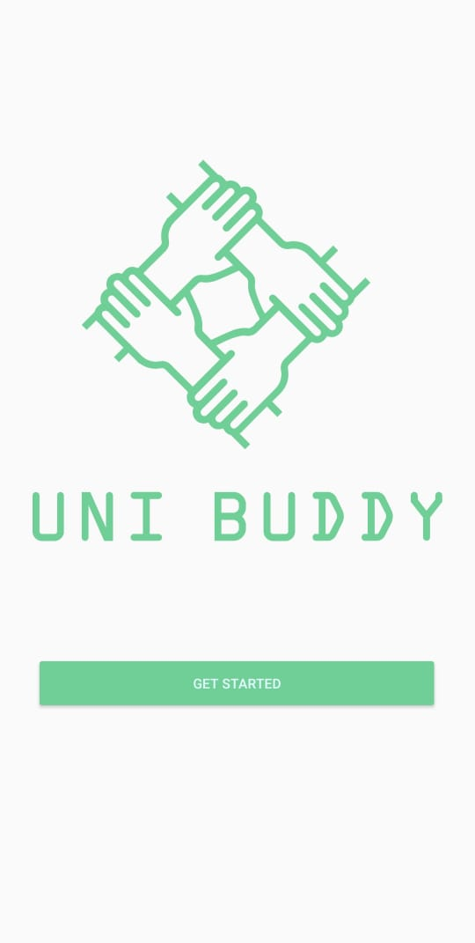

* **Sign In and Sign up.**

Users can register an ID in this application. At first, they need to register using their valid institutional mail and they need to verify their email while trying to login for the first time, and later they need to sign in using those credentials.

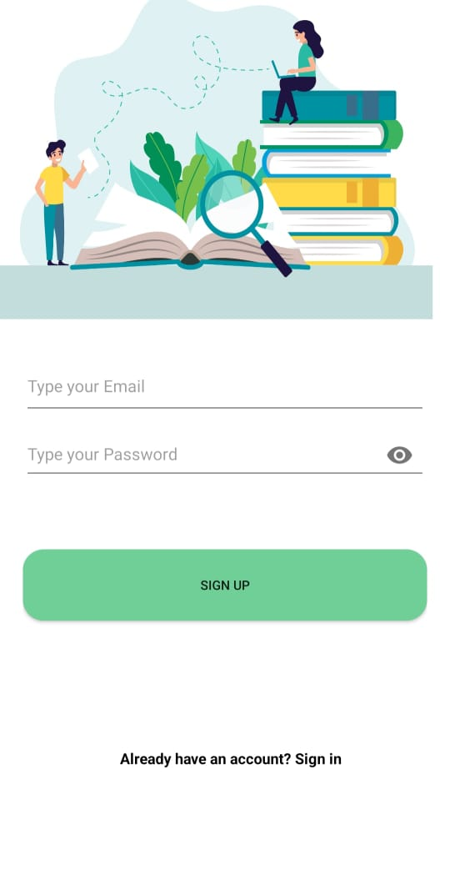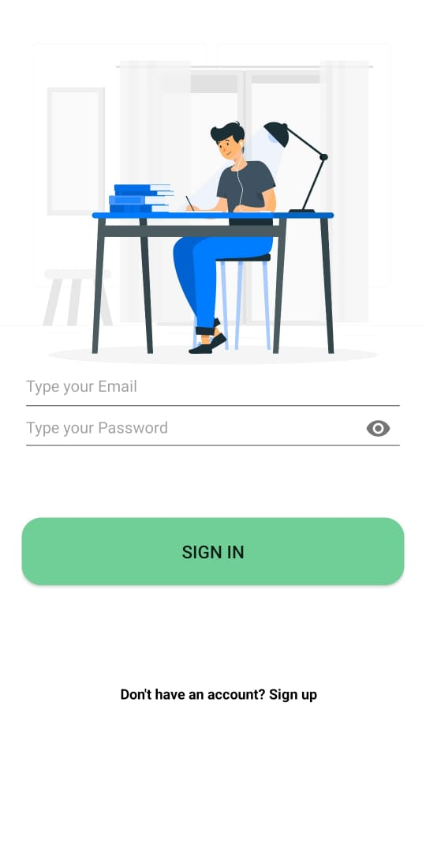

* **Useful Webviews.**

There are several web views on the homepage and bottom navbar which a student might need in their regular life as it is sometimes time-consuming to go to that they can use those features from the app inside the application the added webviews are

1. IUMS – Students can do their educational-related work from here

2. AUST OJ- CSE students can solve problems in this online judge of AUST

3. Teachers – Getting teacher info is essential and sometimes the source is not found so a student can now find them from here

4. Syllabus – syllabus of CSE students can be found

5. Calender- academic calender for every semester can be found here

6. Grading – The grading policy and evaluation system of AUSTcan be found here

7. Notification – Students can check the latest notification of AUST from an option on the bottom nav bar

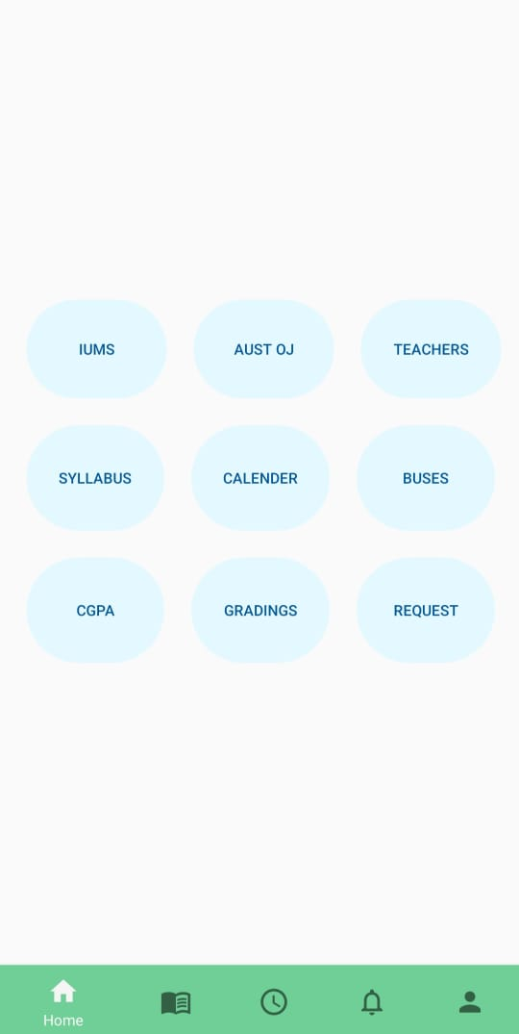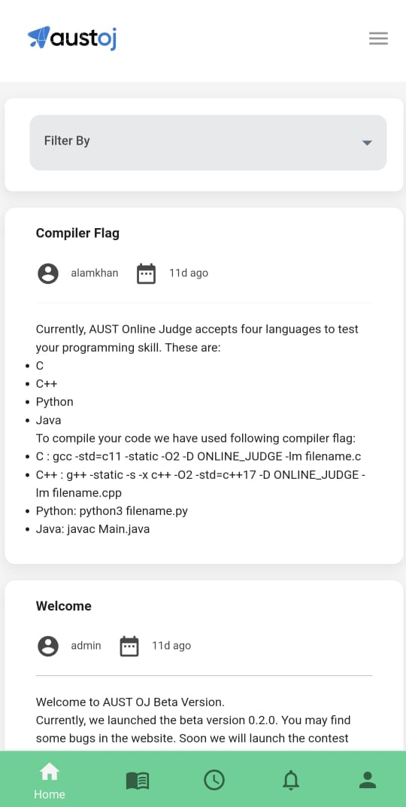

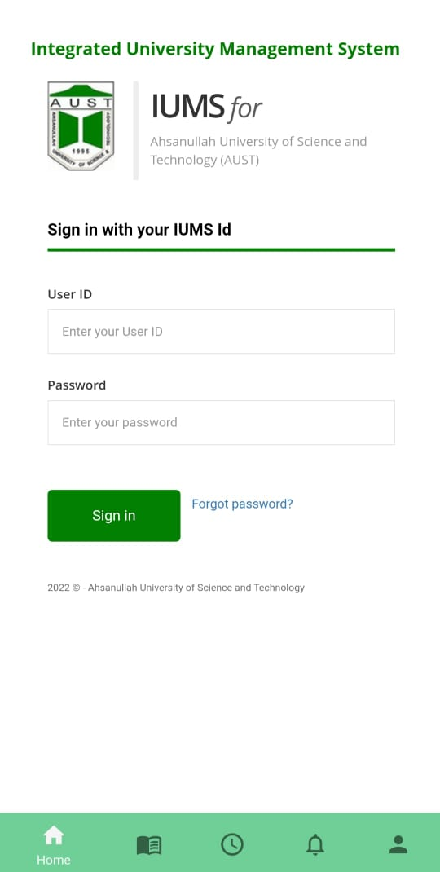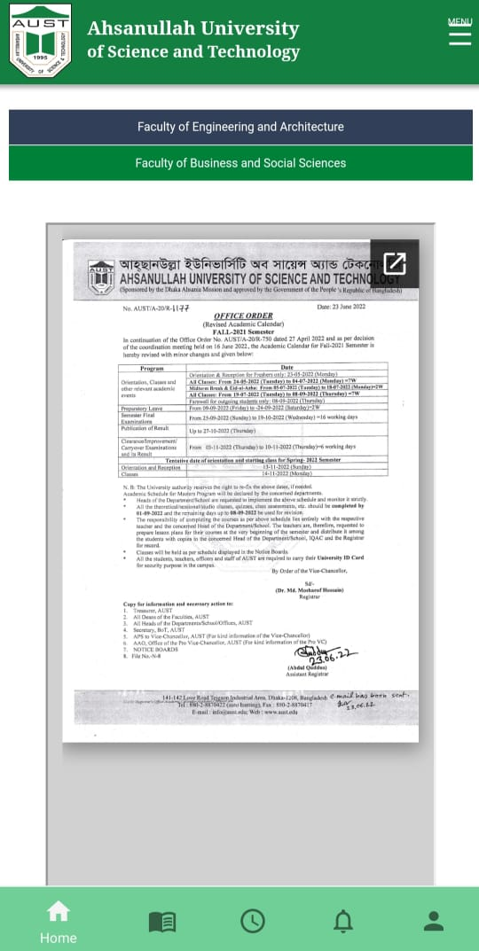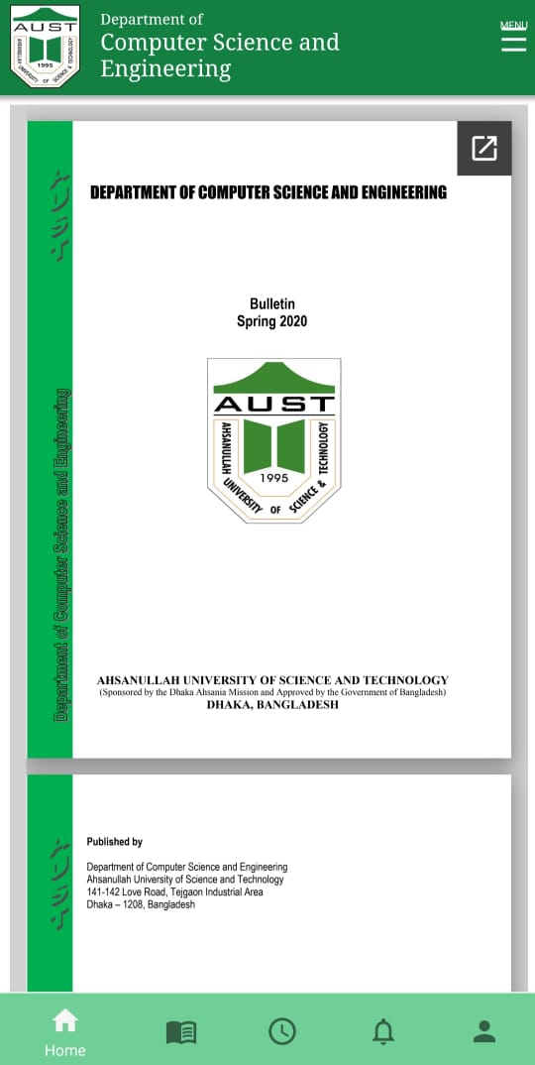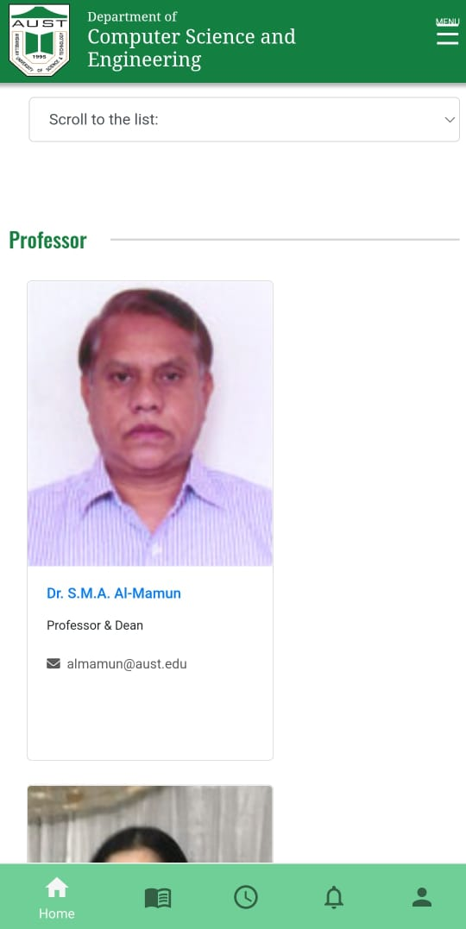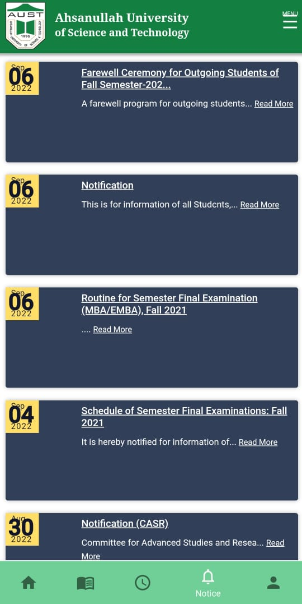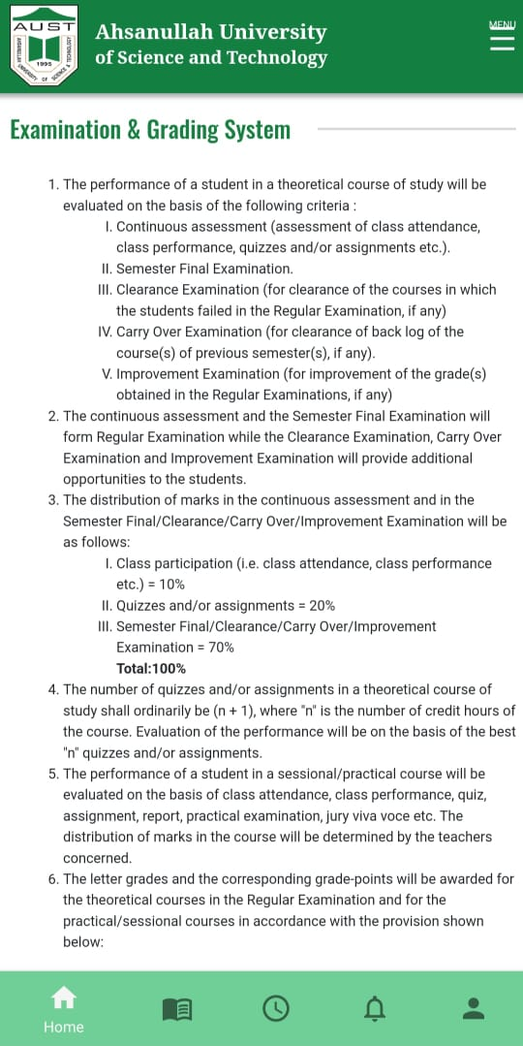

* **CGPA calculator.**

Student can calculate their cgpa by only entering their result on individual courses. And also they can choose their semester which will reset the interface and bring their semester courses credits

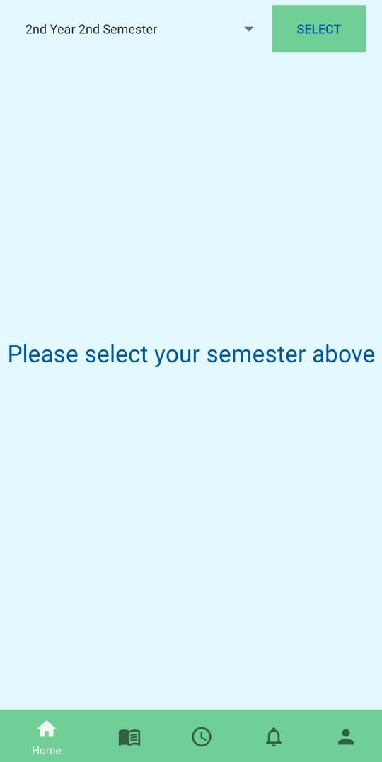

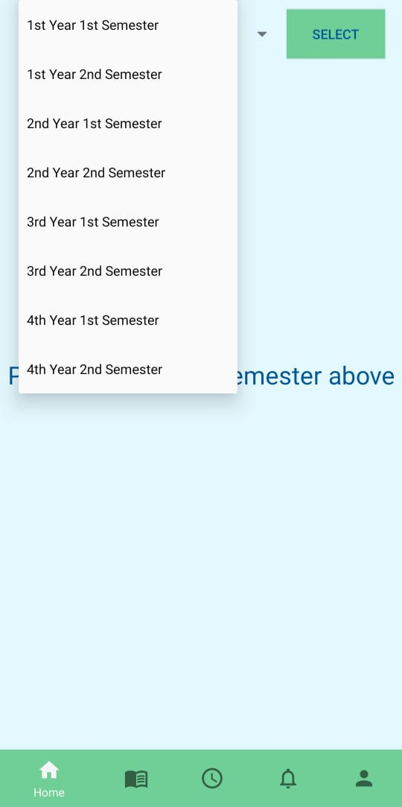

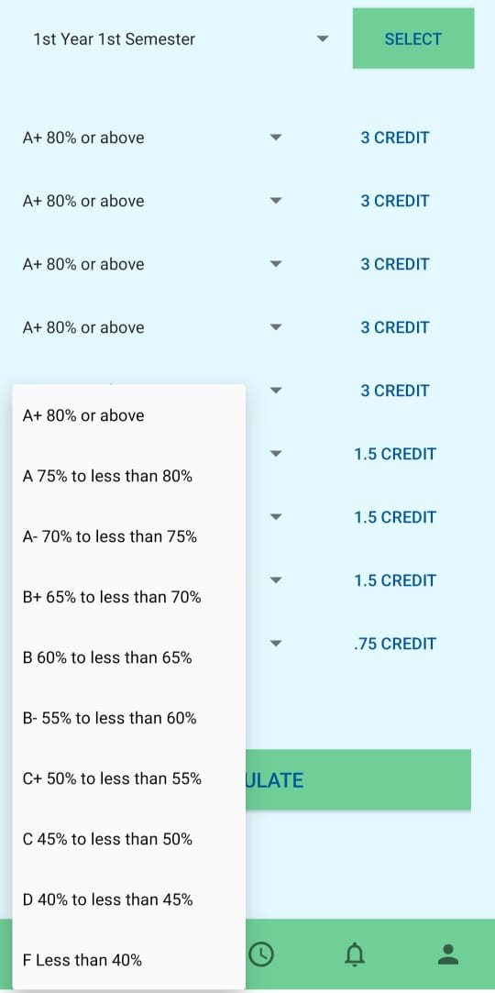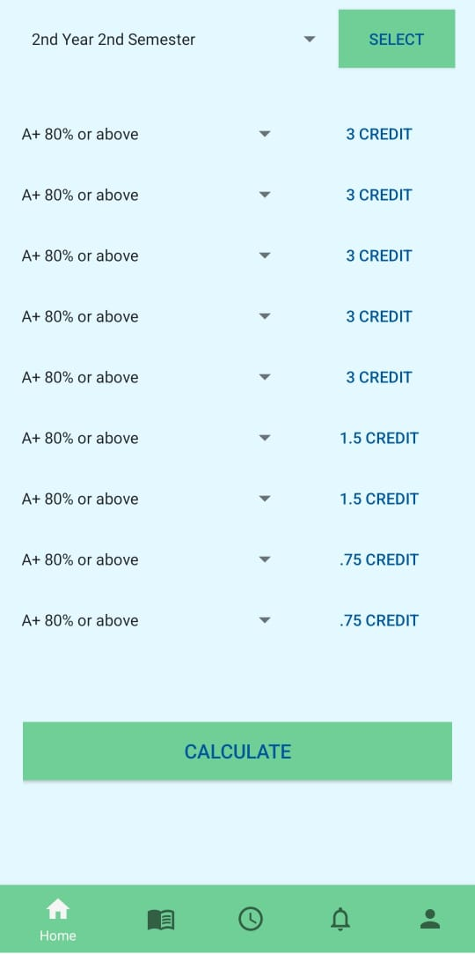

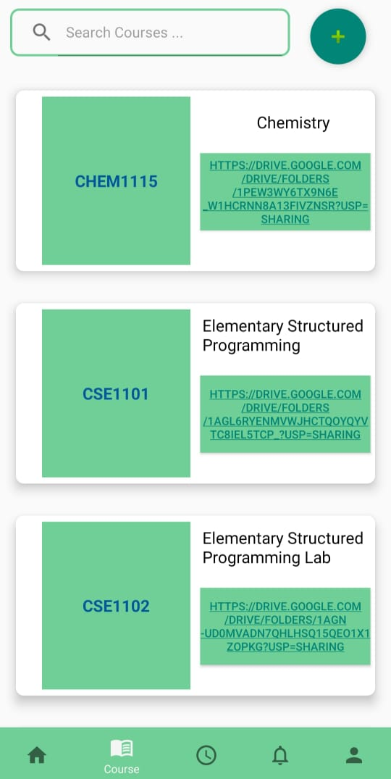

* **Resource links.**

Student can find their desired course resources from here they can find the links and open them on google drive and search through the courses. The drive contains lecture videos, notes, books, and previous semester questions.

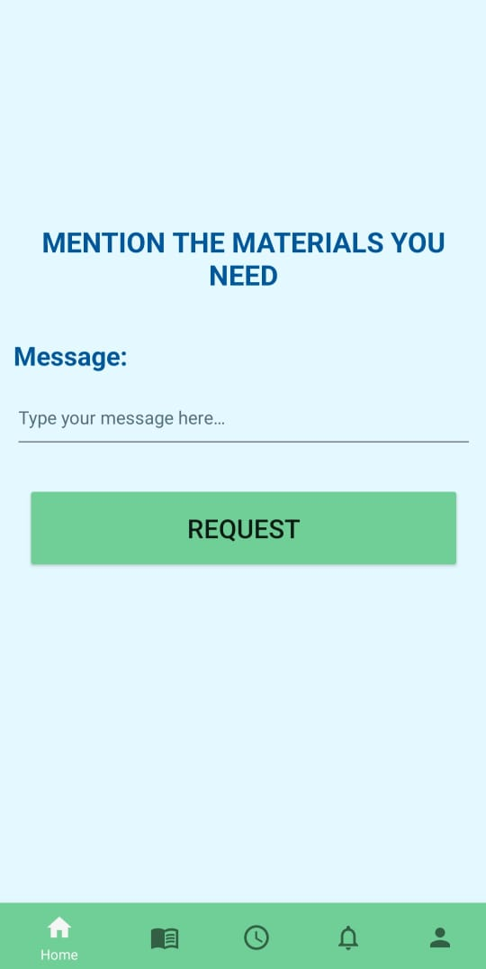

* **Request for materials**

Students can request materials from the admins via their email. The admin then can update the materials via google drive or add a new course via firebase.

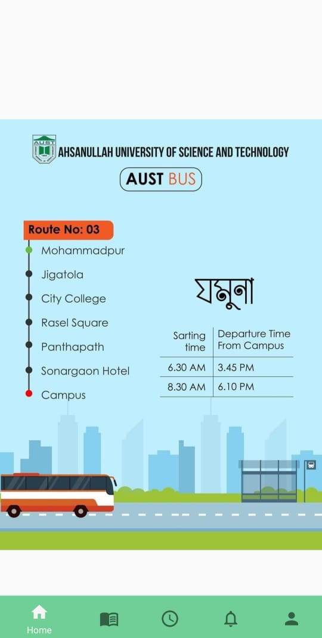

* **Check bus schedule**

Students can check the times for their buses and schedules

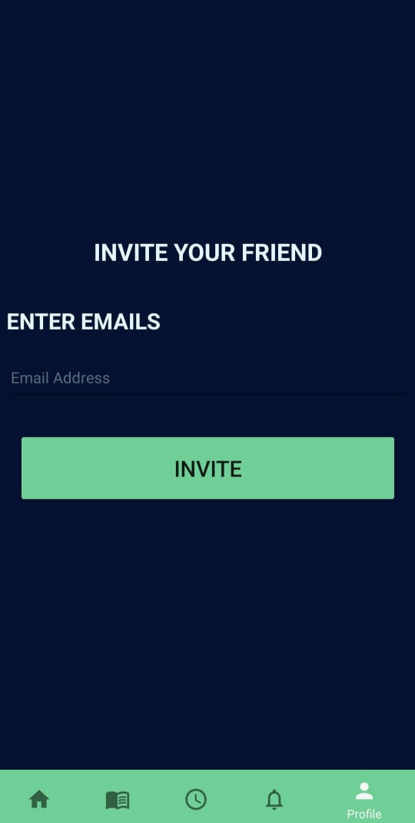

* **Invite friends**

You can invite your friend to use this app via email. Multiple people can be invited at the same time by giving their emails separated by a comma

* **List quizzes**

Students can schedule their quiz and quiz syllabus here. Once done they can also delete that quiz. The data are stored in the real-time database. A pop-up window will arise and take the inputs and save them into the real-time database

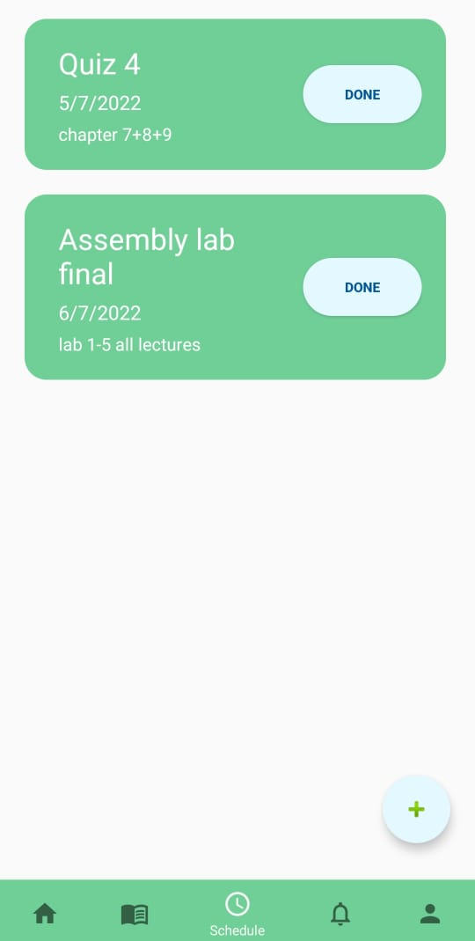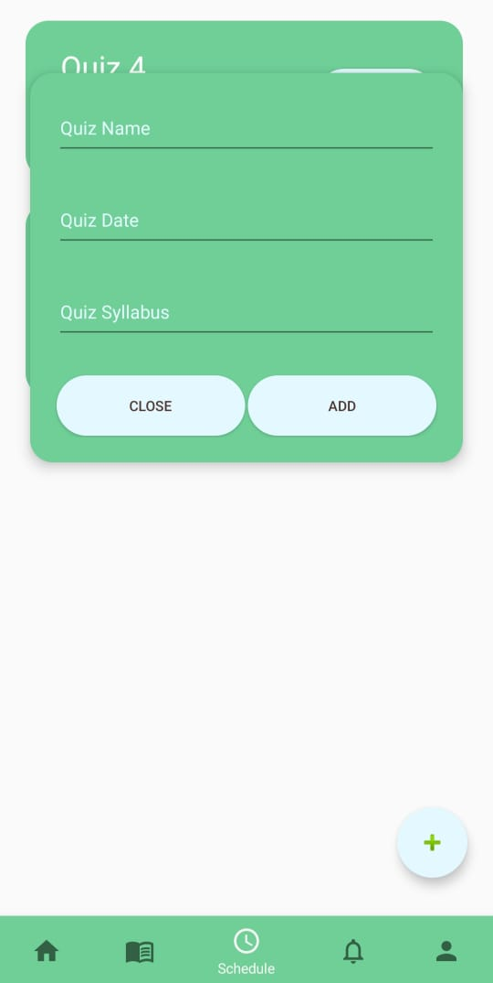

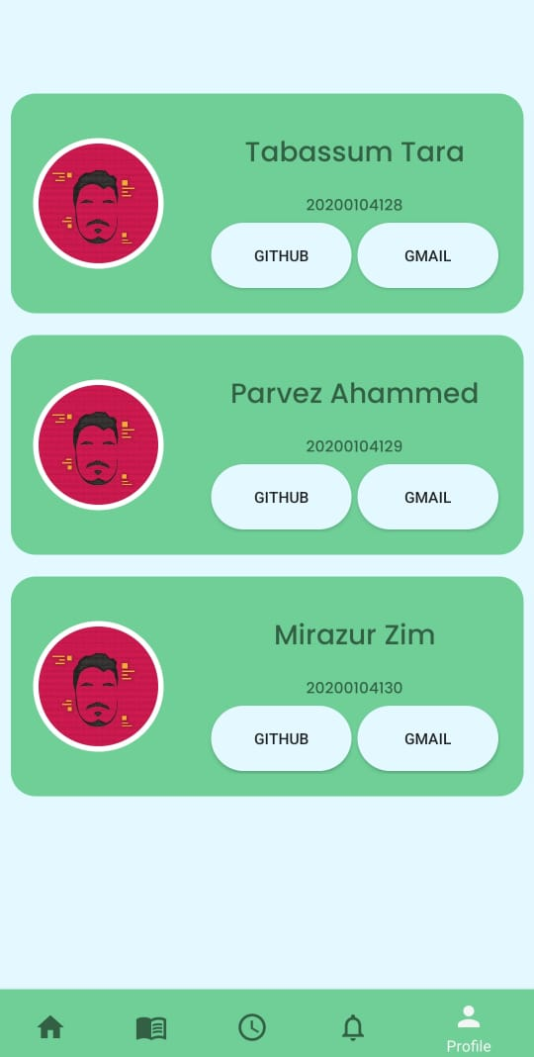

* **About Developers**

Students can contact the developers and share any kind of suggestions they have and see their GitHub profile

* **Other**

They can log out from their account from a profile page. Profile pages UI has been designed.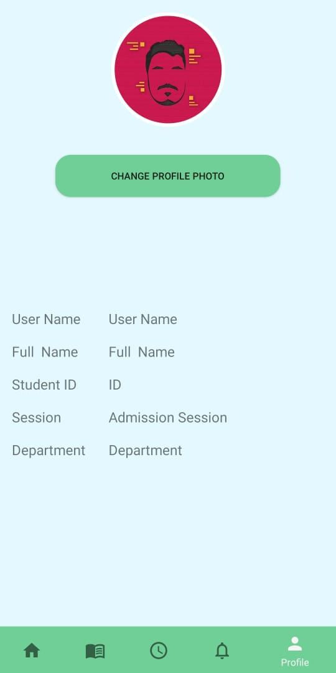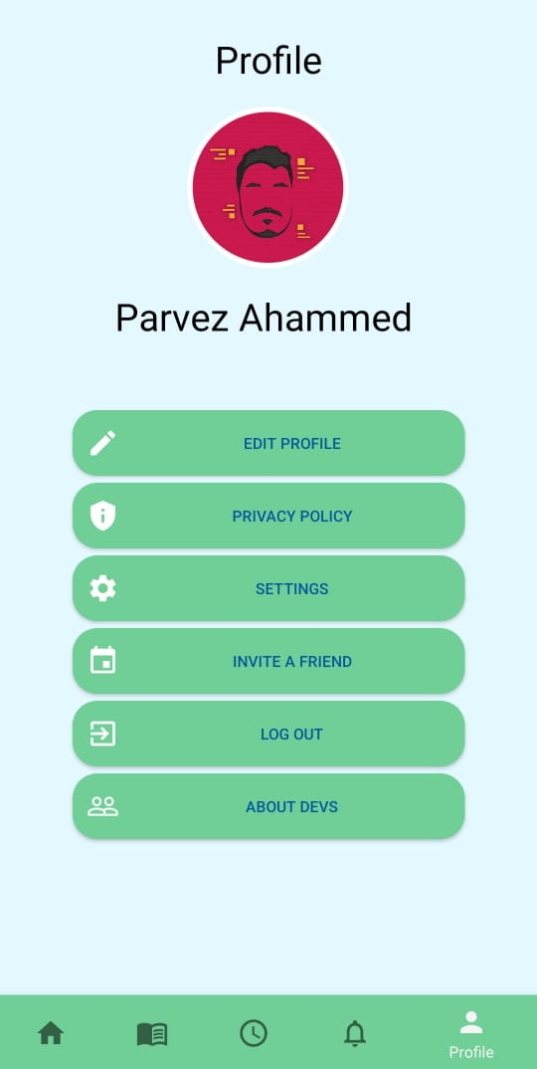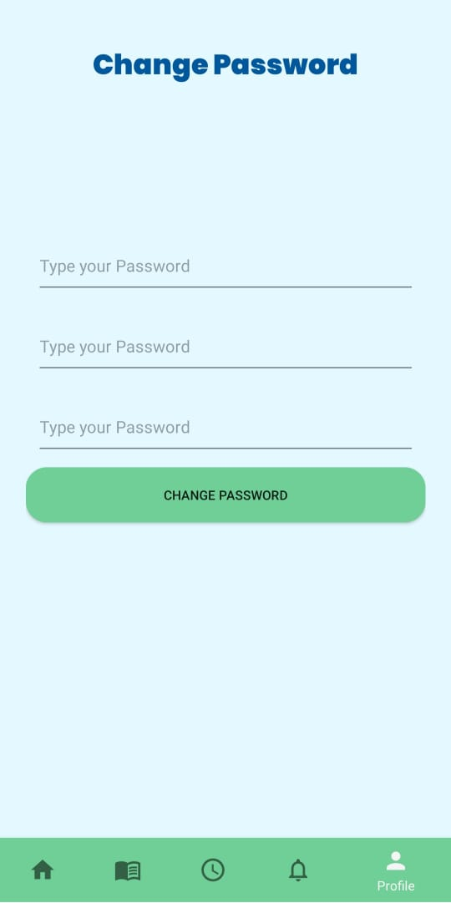

**DATABASE**

Firebase's real-time database has been used to store data and an authentication feature is used to authenticate users. Also firebases email sending feature has been used to verify emails.

All the references

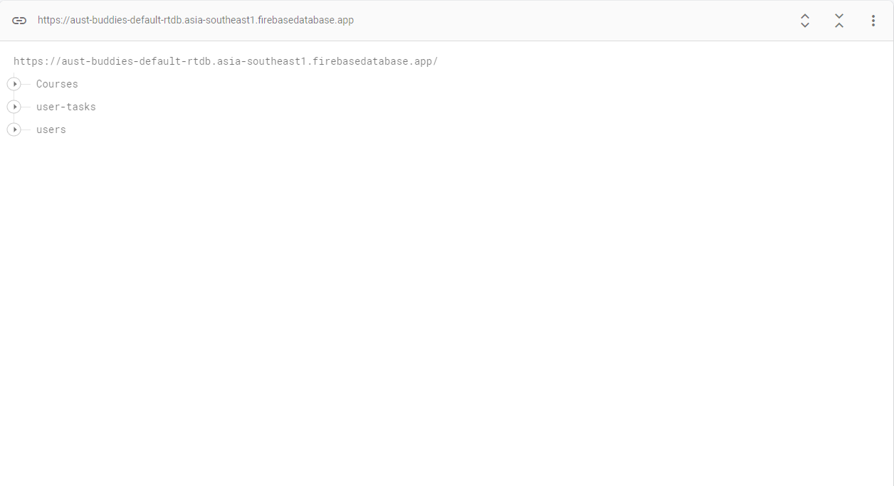

The course details

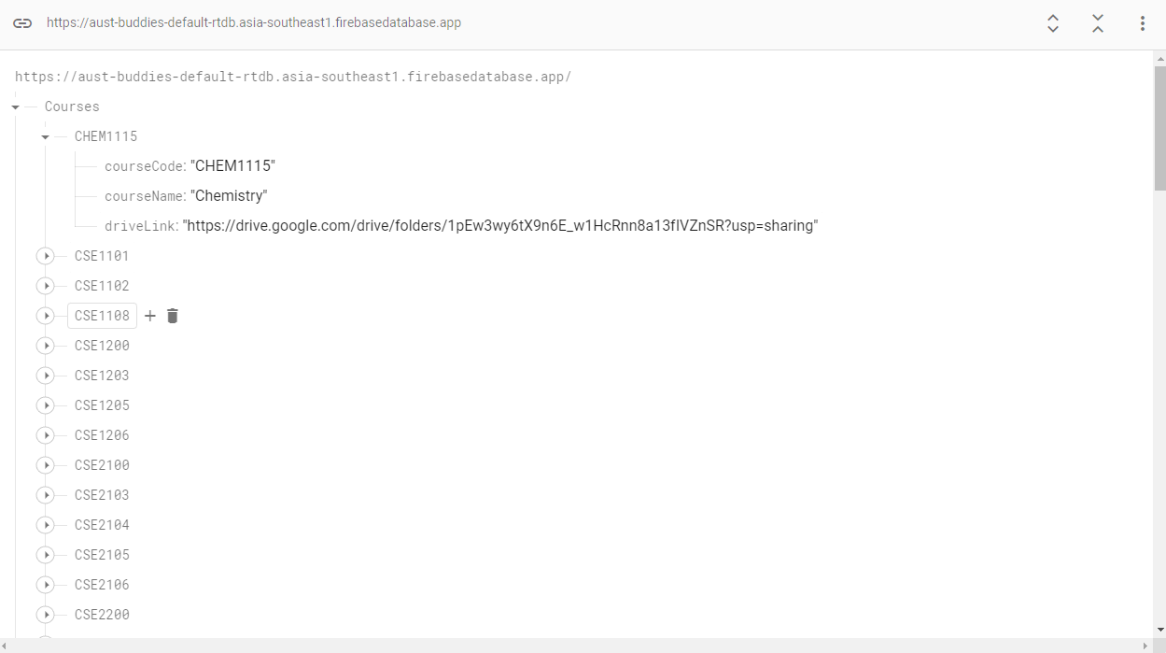

Users' quiz schedules and usernames are stored in the below order

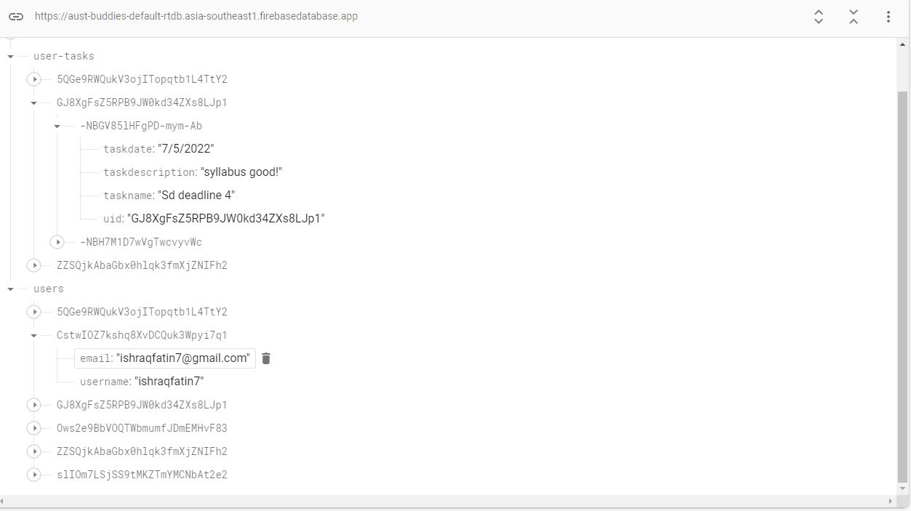

**HARDWARE AND SOFTWARE**

1. Android Studio -chipmunk (IDE)

2. Figma (UI Design)

**FUTURE PLAN**

We hope to develop the project in a way that it can be used by any university student that we are planning to.

1. Create an admin account that can control the course links and add new links for every university
2. Show user details in the profile section
3. Users will be able to change their password
4. Users will be able to upload their profile photo
5. Search for courses
6. Search for teachers
7. Add /remove new courses via the admin account
8. Change password
9. View user details
10. Give an alarm before the quiz date

**CONCLUSION**

Overall we wanted to solve our real-life problems via this application. We tried to make it as usable as we could. We have done user research about the problems they are facing we tried to solve those and we are still working on the project to solve as many problems as we could. We hope to publish it in the playstore and make everyone's life easy.