Hospital Network Design and Implementation

- Network Architecture Diagram

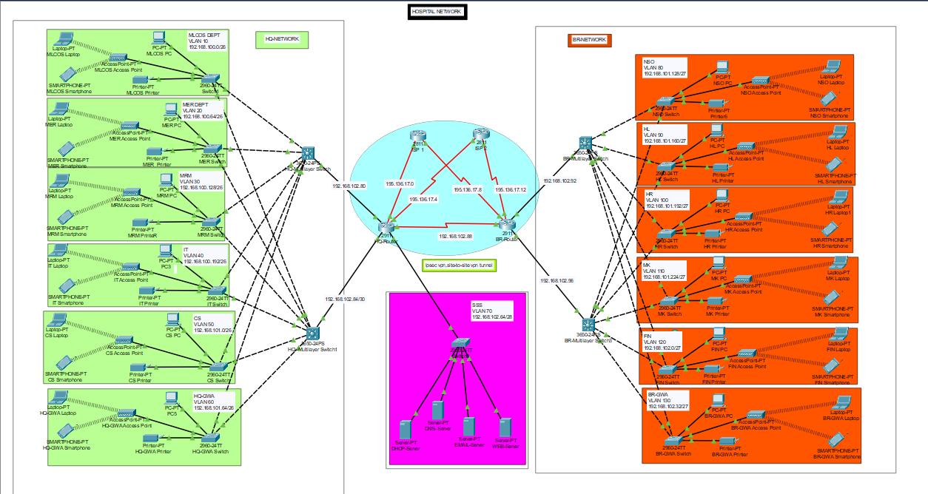
The overall hospital network topology, including the headquarters network, branch network, server-side site (SSS), routers, multilayer switches, VLAN segmentation, and network services, is depicted in the diagram below.

- Introduction
The hospital network design project presents the implementation of a secure, scalable, and highly available infrastructure tailored for a healthcare environment. It connects multiple departments across headquarters and branch locations while delivering centralized services such as DHCP, DNS, Email, FTP, and Web services. Based on a hierarchical network model with core, distribution, and access layers, the design enhances performance, scalability, and ease of management. The network supports both wired and wireless devices, ensuring reliable communication, efficient resource sharing, and secure data transmission throughout the organization.
- Fundamental Infrastructure:
• Site Design: Every site uses a three-tier architecture made up of several department-specific access switches, two multilayer switches (distribution layer), and a core router.
• Connectivity: For site-to-site communication, a serial connection connects the headquarters and branch networks.
• Wireless: Users in every department can access integrated wireless networking.
- Network Architecture Overview
HQ Network: Facilitates internal communication and resource sharing within the headquarters by housing the primary hospital departments, including IT, Customer Service, Medical Records, and Administration.
Branch Network: Denotes a distant medical facility that is connected to the headquarters through routers, enabling safe data sharing and centralized service access.
Server-Side Site: Supports all departments at headquarters and branch locations by hosting centralized network services such as DHCP, DNS, Web, FTP, and email servers.
Hierarchical Architecture: Makes use of routers to facilitate external and inter-site communication, multilayer switches for inter-VLAN routing and traffic management, and access switches to link end devices.
5. VLAN Segmentation & Departments:

For the project I configured, I used three networks for smooth communication. The three networks are has follows:

Network | Department/ Servers | Vlan used
HQ Network | MLOCS, MER, MRM, IT, CS, HQ-GWA | 10-60
Branch Network | NSO, HL, HR, MK, FIN, BR-GWA | 80-130
Server Site Network | DHCP, DNS, EMAIL and Web Server | 70

IP Addressing:

HQ Network

Department | IP address | VLAN
MLOCS | 192.168.100.0/26 | 10
MER | 192.168.100.64/26 | 20
MRM | 192.168.100.128/26 | 30
IT | 192.168.100.192/26 | 40
CS | 192.168.101.0/26 | 50
HQ-GWA | 192.168.101.64/26 | 60

BR Network

Departments | IP addresses | VLAN
NSO | 192.168.101.128/27 | 80
HL | 192.168.101.160/27 | 90
HR | 192.168.101.192/27 | 100
MK | 192.168.101.224/27 | 110
FIN | 192.168.102.0/27 | 120
BR-GWA | 192.168.102.32/27 | 130

Server Site Network

Department | IP addresses | VLAN
Server Side Site | 192.168.102.64/28 | 70

- Configuration
- Between the Routers and ISPs:
Public IP addresses: 195.136.17.0/30, 195.136.17.4/30, 195.136.17.8/30, and 195.136.17.12/30.

- Department MLOCS:
HOSTNAME – MLOS-SW, MLCOS PRINTER
PASSWORD – MLOCSS
- Department MER:
HOSTNAME – MER-SW, MER PRINTER
PASSWORD – MERR
- Department MRM:
HOSTNAME –MRM-SW, MRM PRINTER
PASSWORD – MRMM
- Department IT:
HOSTNAME – IT-SW, IT PRINTER
PASSWORD – ITT
- Department CS:
HOSTNAME – CS-SW, CS PRINTER
PASSWORD – CSS
- Department HQ-GWA:
HOSTNAME – HQ-GWA-SW, HQ-GWA PRINTER
PASSWORD – HQ-GWAA
- Department SSS:
HOSTNAME – SSS-SW, SSS PRINTER
PASSWORD – SSS
- Department NSO:
HOSTNAME – NSO-SW, NSO PRINTER
PASSWORD – NSOO
- Department HL:
HOSTNAME – HL-SW, HL PRINTER
PASSWORD – HLL
- Department HR:
HOSTNAME – HR-SW, HR PRINTER
PASSWORD – HR
- Department MK:
HOSTNAME –MK-SW, MK PRINTER
PASSWORD – MK
- Department FIN:
HOSTNAME –FIN-SW, FIN PRINTER
PASSWORD – FIN
- Department BR-GWA:
HOSTNAME –BR-GWA-SW, BR-GWA PRINTER
PASSWORD – BR-GWAA
- HQ-MULTILAYER-SW:
HOSTNAME – HQ-MULTILAYER-SW
PASSWORD – HQ-ML
- HQ-MULTILAYER-SW2:
HOSTNAME – HQ-MULTILAYER-SW2
PASSWORD – HQ-MLL
- BR-MULTILAYER-SW:
HOSTNAME – BR-MULTILAYER-SW
PASSWORD – BR-ML
- BR-MULTILAYER-SW2:
HOSTNAME – BR-MULTILAYER-SW2
PASSWORD – BR-MLL
- HQ-ROUTER:
HOSTNAME – HQ-ROUTER
PASSWORD – HQ-ROUTERR
- BR-ROUTER:
HOSTNAME – BR-ROUTER
PASSWORD – BR-ROUTERR

- Router to Layer-3 Switch Interconnects
- These point-to-point links use a /30 mask, providing two usable IP addresses per connection—ideal for connecting routers to multilayer switches.
Connection ID | Device Link | Network Address
1 | HQR1 to HQMLSW1 | 192.168.102.80/30
2 | HQR1 to HQMLSW2 | 192.168.102.84/30
3 | BRR1 to BRMLSW1 | 192.168.102.88/30
4 | BRR1 to BRMLSW2* | 192.168.102.92/30
5 | HQR1 to BRR1 | 192.168.102.96/30

- Technologies Implemented:
- Routing Protocols:
- OSPF (Single-Area 10):
OSPF 10 is done on the routers and the multilayer switches.
IN HQ-MULTILAYER SWITCH1:
- IP routing
- OSPF 10
- Network 192.168.100.0 0.0.0.63 area 0
- Network 192.168.100.64 0.0.0.63 area 0
- Network 192.168.100.128 0.0.0.63 area 0
- Network 192.168.100.192 0.0.0.63 area 0
- Network 192.168.101.0 0.0.0.63 area 0
- Network 192.168.101.64 0.0.0.63 area 0
- Network 192.168.102.80 0.0.0.3 area 0
IN HQ-MULTILAYER SWITCH2:
- IP routing
- OSPF 10
- Network 192.168.100.0 0.0.0.63 area 0
- Network 192.168.100.64 0.0.0.63 area 0
- Network 192.168.100.128 0.0.0.63 area 0
- Network 192.168.100.192 0.0.0.63 area 0
- Network 192.168.101.0 0.0.0.63 area 0
- Network 192.168.101.64 0.0.0.63 area 0
- Network 192.168.102.84 0.0.0.3 area 0
IN BR-MULTILAYER SWITCH1:
- IP routing
- OSPF 10
- Network 192.168.101.128 0.0.0.31 area 0
- Network 192.168.101.160 0.0.0.31 area 0
- Network 192.168.101.192 0.0.0.31 area 0
- Network 192.168.101.224 0.0.0.31 area 0
- Network 192.168.102.0 0.0.0.31 area 0
- Network 192.168.102.32 0.0.0.31 area 0
- Network 192.168.102.92 0.0.0.31 area 0
IN BR-MULTILAYER SWITCH2:
- IP routing
- OSPF 10
- Network 192.168.101.128 0.0.0.31 area 0
- Network 192.168.101.160 0.0.0.31 area 0
- Network 192.168.101.192 0.0.0.31 area 0
- Network 192.168.101.224 0.0.0.31 area 0
- Network 192.168.102.0 0.0.0.31 area 0
- Network 192.168.102.32 0.0.0.31 area 0
- Network 192.168.102.96 0.0.0.31 area 0
IN HQ- ROUTER:
- OSPF 10
- Network 192.168.102.80 0.0.0.3 area 0
- Network 192.168.102.84 0.0.0.3 area 0
- Network 192.168.102.64 0.0.0.15 area 0
- Network 192.168.102.88 0.0.0.3 area 0
- Network 195.136.17.4 0.0.0.3 area 0
- Network 195.136.17.0 0.0.0.3 area 0
IN BR- ROUTER:
- OSPF 10
- Network 192.168.102.96 0.0.0.3 area 0
- Network 192.168.102.88 0.0.0.3 area 0
- Network 195.136.17.8 0.0.0.3 area 0
- Network 195.136.17.12 0.0.0.3 area 0
IN ISP1- ROUTER:
- OSPF 10
- Network 195.136.17.8 0.0.0.3 area 0
- Network 195.136.17.0 0.0.0.3 area 0
IN ISP2- ROUTER:
- Network 195.136.17.4 0.0.0.3 area 0
- Network 195.136.17.12 0.0.0.3 area 0
- NAT/PAT :
  - NAT for internet access
  - I configured NAT on HR-ROUTER and BR-ROUTER
  - Configured port address translator on both HQ-ROUTER AND BR-ROUTER
  - So that it can be translate into public Ip address

IN HQ- ROUTER:
- Int se0/1/0 - Ip Nat outside
- Int se0/2/1 – Ip Nat outside
- Int range gig0/0-2 – Ip Nat inside
- Ip Nat inside source list 1 interface se0/2/1 overload
- Ip Nat inside source list 1 interface se0/1/0 overload

IN BR- ROUTER:
- Int se0/1/1 - Ip Nat outside
- Int se0/2/0 - Ip Nat outside
- Int range gig0/0-1 – Ip Nat inside
- Ip Nat inside source list 1 interface se0/1/1 overload
- Ip Nat inside source list 1 interface se0/2/0 overload
- Access Control list:
IN HQ- ROUTER:
- Access-list 1 permit 192.168.100.0 0.0.0.63
- Access-list 1 permit 192.168.100.64 0.0.0.63
- Access-list 1 permit 192.168.100.128 0.0.0.63
- Access-list 1 permit 192.168.100.192 0.0.0.63
- Access-list 1 permit 192.168.101.0 0.0.0.63
- Access-list 1 permit 192.168.101.64 0.0.0.63
IN BR- ROUTER:
- Access-list 1 permit 192.168.101.128 0.0.0.31
- Access-list 1 permit 192.168.101.160 0.0.0.31
- Access-list 1 permit 192.168.101.192 0.0.0.31
- Access-list 1 permit 192.168.101.224 0.0.0.31
- Access-list 1 permit 192.168.102.0 0.0.0.31
- Access-list 1 permit 192.168.102.32 0.0.0.31

- VLANs & Inter-VLAN Routing:
- Inter-VLAN routing using Layer 3 switches

- SSH and Port Security:
- Port security is done in server-side-site switch

- DHCP, DNS, and Server Configurations:
- DHCP for dynamic IP allocation
- DNS for internal name resolution

- Wireless Networking:
- Access Points for each department
- SSID configurations per VL

