JavaScript Popup Boxes:
- Alert Box alert(“This is alert box”);
- Confirm Box confirm(“This contain two button namely ok and cancel”);
- Prompt Box prompt(“This can take input from user”);

JavaScript Events:
- onLoad and onUnload The onLoad and onUnload events are triggered when the user enters or leaves the page. onLoad and onUnload events often are used to deal with cookies. Ex: <body onload=”load()”>
- onFocus When the user moves to a new element, that element triggers a focus event.
onBlur When the user leaves an element, that element triggers a blur event.
onChange The checkEmail() function will be called whenever the user changes the content of the field:
<input type="text" size="30" id="email" onchange="checkEmail()">
onSubmit The onSubmit event may be used to validate form fields before submitting the form. Ex: <form method="post" action="xxx.htm" onsubmit="return checkForm()">
- onMouseOver and onMouseOut onMouseOver and onMouseOut often are used to create Rollover buttons. Ex: <a href="http://www.w3schools.com" onmouseover="alert('An onMouseOver event');return false"><img src="w3s.gif" alt="w3schools" /></a>
- onClick <input type="button" name="language" value="Click for Spanish" onclick="translate()">
Try and catch:
try {
//Run some code here
throw(exception)
}
catch(err) {
//Handle errors here
}
String objects:
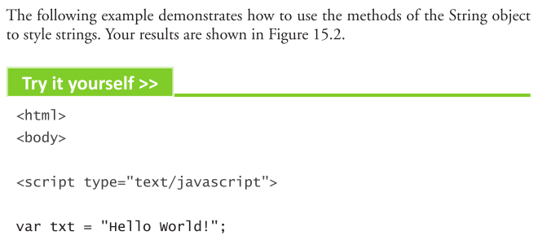
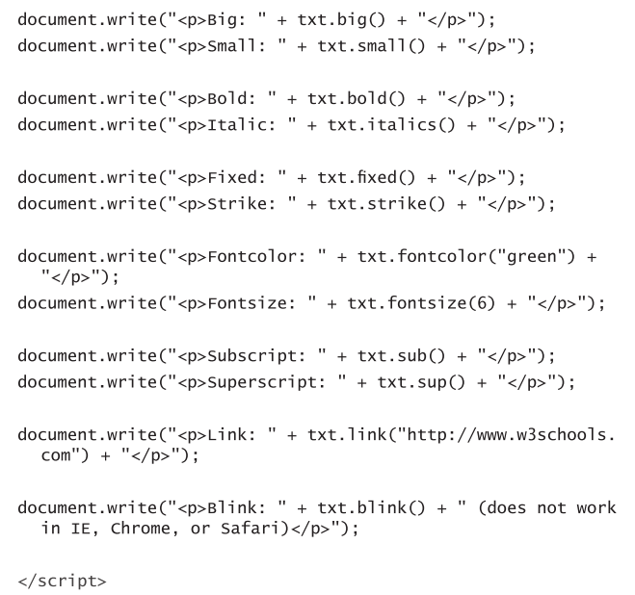
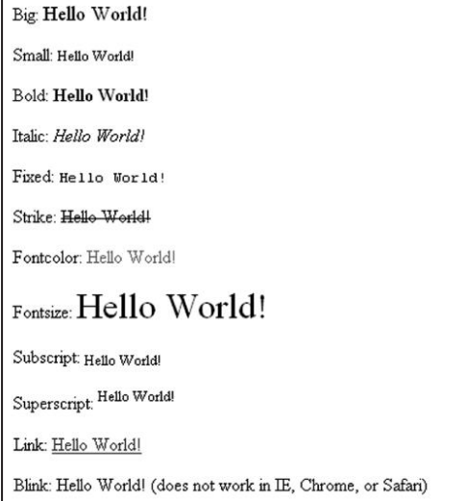
document.write(str.replace("Microsoft","w3schools"));
document.write(str.match("world!"));
document.write(str.indexOf("WORLD") + "<br />");

JavaScript Date Object:
var today=new Date();
var h=today.getHours();
var m=today.getMinutes();
var s=today.getSeconds();
var y=today.getFullYear();
var mon=today.getMonth();
var date=today.getDate();
setTimeout(‘startTime()’,500);//automatically call startTime() function.

JavaScript Array:
- var myCars=new Array();myCars[0]="Saab";
- var myCars=new Array("Saab","Volvo","BMW");
- var myCars=["Saab","Volvo","BMW"];
document.write(myCars.join() + "<br />"); Saab,Volvo,BMW
document.write(fruits.pop() + "<br />"); Saab,Volvo
document.write(fruits.shift() + "<br />"); Volvo
document.write(fruits.sort());

JavaScript Boolean:
var b1=new Boolean(0);
var b2=new Boolean(1);
var b3=new Boolean(“”);
var b4=new Boolean(null);
var b5=new Boolean(NaN);
var b6=new Boolean(“false”);

JavaScript Math:
document.write(Math.round(4.7)); 5
document.write(Math.floor(Math.random()*11));
document.write(Math.max(1.5,2.5));
document.write(Math.min(1.5,2.5));
JavaScript RegExp:
The syntax is as follows:
var txt=new RegExp(pattern,modifiers);
or more simply:
var txt=/pattern/modifiers;
Example: var str = "Visit W3Schools";
var patt1 = /w3schools/i; (i modifier is used to perform case-insensitive matching.
document.write(str.match(patt1)); w3schools

var patt1=new RegExp("e");
document.write(patt1.test("The best things in life are free")); true
var patt1=new RegExp("e");
document.write(patt1.exec("The best things in life are free")); e

