RESUME
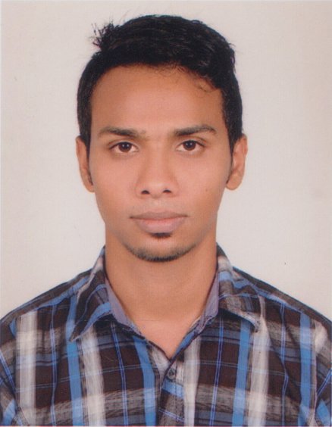
OF
GIASUDDIN PARVEZ

Present Address: House of Abul kasem, Ma Memorial Model Academy School Road, Sharulia Bazar, Demra, Dhaka. Contact : +8801821856449
E-mail: parvez.ka19@gmail.com
Web: parvezahmed.net23.net

Career Objective:
Looking for hard and challenging jobs where I will have the scope to utilize my potentiality, adaptability and skills to do something in olive and from where I will be able to enhance my knowledge.

Special Qualification:
Web Design and Development (Html, Html5, Css, Bootstrap, Word press, PHP, My SQL, and Basic JavaScript, Basic Photoshop)

Academic Achievements:

Diploma in Engineering
Institution : Feni Ideal Polytechnic Institute
Major : Computer Engineering
Passing Year : 2016
Result : GPA- 2.76 out of 4

Secondary School Certificate (S.S.C)
Board : Comilla
Institution : Zamider Hat B.N High School
Group : Business Studies
Result : GPA- 3.94 out of 5
Passing Year : 2011

Professional Qualification:
Certification | Institute | Location | From | To
Web Design and Development | E-Future BD | Prantopath Bata Signal, Dhaka | September 03, 2015 | December 26, 2015

Language Skill:
I am able to write and speak both Bengali and English fluently.

Personal Quality
- Always Creative Thinker
- Quick Learner
- Self Confident
- Punctual and Efficient
- To create strong enough in interpersonal relationship and have the strength to work as a team in competitive and challenging environment.
- Sufficient knowledge about how to prepare a plan and execute it.

Personal Details:
Father’s Name : Md Solaiman Hossain
Mother’s Name : Bibi Sayera
Permanent Address : Vill- Sayestanagor, Post- Zamiderhat
P.S- Senbag, Dist- Noakhali.
Date of Birth : 22-02-1995
Religion : Islam (Sunni)
Nationality : Bangladeshi
Gender : Male
Marital Status : Unmarried
Height : 5′9"
Weight : 60 Kg

GIASUDDIN PARVEZ

