**Convert the document**

**1** Open transaction /n/PLMA/SEL_TO_CONV and navigate yourself to Analysis /Work Package / Create.

**2** Tick in “Use special properties”, enter the status status and select the rightconversion rule.

Use the **F4 help** , if you’re not sure.

The syntax is **DOCTYPE_OFF_WORKSTATIONAPPL2PDF.**

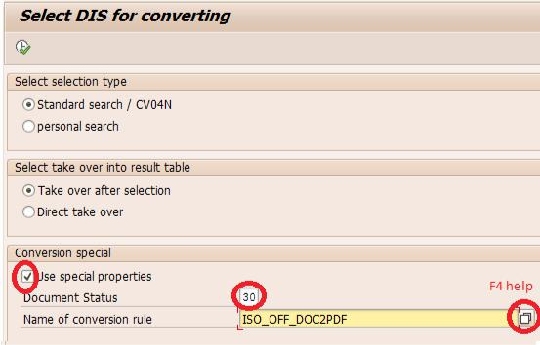

**3** After you finish entering the data click on Execute Button or press F8

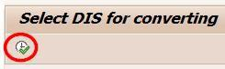

**4** Enter the affected document number and hit Execute.

**5** Mark the row and hit “Takeover for conversion”

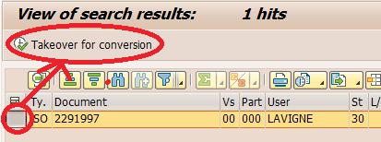

6 Return message (>=1 conversions assigned) indicates successful creation of conversion work package (not yet converted!)



**7** Check after some minutes if conversion was successful.

During main working times or "rush hour", the conversion engine might be very busy with over 100 work items in que. The conversion might take a longer time.

If not --> contact IT Business Product Development / create ticket.